Table of Contents

1 Introduction: 1
2 Problem of Statement: 1
3 Objectives: 1
4 Methodology 1
5 Requirement Identification 1
5.1.1 Study of existing system: 1
5.1.2 Requirement Collection 2
5.1.3 Feasibility Study 3
5.1.4 Technical Feasibility 3
5.1.5 Operational Feasibility 3
5.1.6 Economic Feasibility: 3
5.2.3 High Level design of system: 4
5.2.4 System Flowchart: 4
5.1.7 Methodology of the Proposed System: 4
5.1.8 Working mechanism of the proposed system: 4
6 Gantt Chart 7
7 Expected Outcome: 7
8 References 9

List Of Figures

Figure 1: System Flowchart ........................................................................................... 4
Figure 2: Context Level Diagram ................................................................................... 5
Figure 3: Data Flow Diagram ......................................................................................... 6
Figure 4: Login Page ...................................................................................................... 7
Figure 5: Dashboard ....................................................................................................... 8
Figure 6: Customer Details ..............................................................................................8
Figure 7: ER Diagram ..................................................................................................... 9
A Project Proposal on Second hand buying and selling

Introduction:
Second hand buying and selling products is a web-based application that is designed to sell and buy goods or materials which have been used or even new products. This project aims to supply goods and materials for those who seek to buy desired products at a suitable and reasonable price. This system has many facilities where users can buy goods that are included in the system category. This system will provide a convenient and secure marketplace for individuals to connect and engage in transactions involved in used as well as new items.

Problem of Statement:
The second-hand buying and selling market in Nepal face challenges due to the absence of a centralized platform, lack of trust and security, limited reach and visibility, informal transactions, inefficient search options, and limited promotion of sustainable practices. These challenges hinder the seamless exchange of used products and restrict the market's potential. Addressing these issues and providing a user-friendly platform that fosters trust, expands reach, streamlines transactions, improves search capabilities, and promotes sustainability will contribute to the growth and development of the second-hand market in Nepal.

Objectives:
The objective of the proposed Online Second Hand Buying and Selling is that users can buy and sell goods in an efficient and systematic manner. This project aims to address the growth demand for a convenient and secure marketplace for individuals to engage in transactions involving used items.
With the proposed system, the achievable advantages are as follows:

● To provide easy and convenient transactions.
● To maintain trust and security.
● To promote sustainability and cost-effectiveness.
● To provide faster community engagement.

Methodology

Requirement Identification

Study of existing system:
I have observed two existing systems related to second-hand buying and selling, which are mentioned below:
System 1
Introduction
- The traditional system relies on maintaining records manually in registers, similar to how second-hand buying and selling were historically managed.
Pros
- Cost-Effective – Second-hand items are cheaper than new ones.
- Eco-Friendly – Reduces waste and supports sustainability.
Cons
- Quality Concerns – Items may have wear, tear, or defects.
- Fraud Risk – Possibility of scams and counterfeit products.
System
Introduction:
- Some second-hand buying and selling platforms use inventory management systems designed for bars, as they offer basic stock tracking. However, they lack features like supplier records and detailed reporting, limiting their effectiveness.

Pros:
- Easily Available – Readily accessible and widely used.
- Similar Functionality – Works similarly to bar inventory systems, making it familiar for some users.
Cons:
- No Supplier Information – Does not record details of suppliers.
- Limited Reporting – Lacks the ability to generate required reports.

Requirement Collection

Functional Requirement
Second hand buying and selling System have following functionality:
- User Registration & Login – Account creation, login, and profile management for buyers and sellers.
- Product Listing – Sellers can list items with descriptions, images, and prices.
- Search & Filter – Buyers can search and filter items by category, price, and condition.
- Transaction Management – Secure buying, selling, and payment handling.
- Ratings & Reviews – Users can rate and review transactions and sellers.

Non-functional Requirement
Second hand buying and selling System have following non-functionality:
- Performance – The system should handle a large number of users and transactions simultaneously without lag.
- Security – Ensure secure user data, including encrypted transactions and protection against fraud.
- Scalability – The platform should be able to scale up as the number of users and items increases.
- Usability – The system should have an intuitive interface, easy for both buyers and sellers to navigate.
- Availability – The platform should be accessible 24/7 with minimal downtime.

Feasibility Study

Technical Feasibility
Technical feasibility assesses whether the required technology and resources are available to develop and implement the second-hand buying and selling platform effectively.

Operational Feasibility
Operational feasibility assesses whether the proposed second-hand buying and selling platform can be effectively integrated into the current operational processes and if it can be operated successfully within the organization's environment.

Economic Feasibility:
Economic feasibility assesses whether the proposed second-hand buying and selling platform is financially viable. This involves analyzing the potential costs, revenues, and return on investment (ROI) to determine whether the project is financially sustainable.

5.2 High Level design of system:

5.3 System Flowchart:

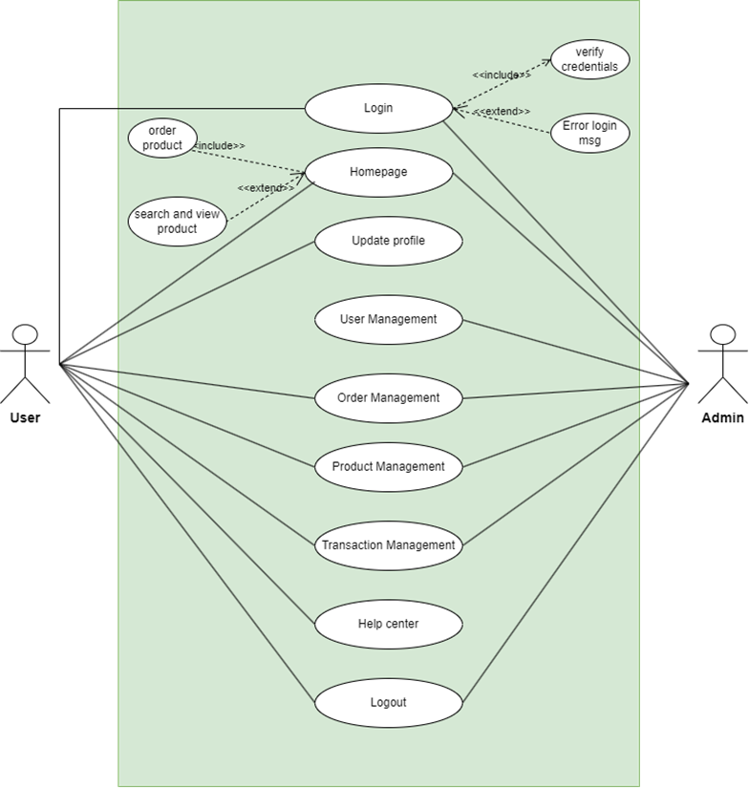
Figure 1: System Flowchart

Methodology of the Proposed System:

The development of the second-hand buying and selling platform will follow Agile principles, focusing on iterative progress, close collaboration, and continuous refinement. Instead of a linear process, the project will be broken down into a series of sprints, each delivering functional increments such as product listing, search filters, user registration, and direct messaging. At the outset, the team will conduct Sprint 0 to outline goals, define an MVP (Minimum Viable Product), and prioritize core user stories—for example, allowing users to browse by category or enabling sellers to upload images and descriptions of their products. Design and development will progress in short cycles, using tools like Java Swing for the user interface and MySQL for database management. UML diagrams will guide system architecture and flow, evolving as user feedback is incorporated from sprint reviews. Each feature will be tested both manually and programmatically during the same sprint it is built, ensuring stability and usability throughout. Feedback loops with real users will drive the prioritization of upcoming features, keeping the product aligned with customer needs. The agile framework supports adaptability, allowing you to insert new requirements, revise UI elements, or optimize backend processes at any stage without disrupting the whole system. This approach ensures that the app grows organically and consistently delivers value through an intuitive, user-driven experience.

Working mechanism of the proposed system:
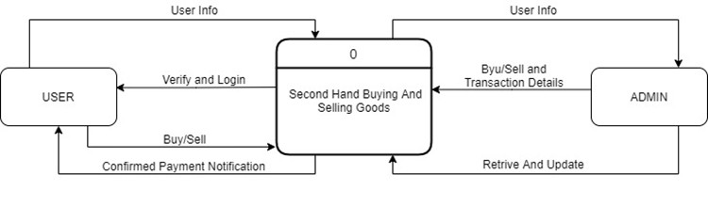

Figure 2: Context Level Diagram

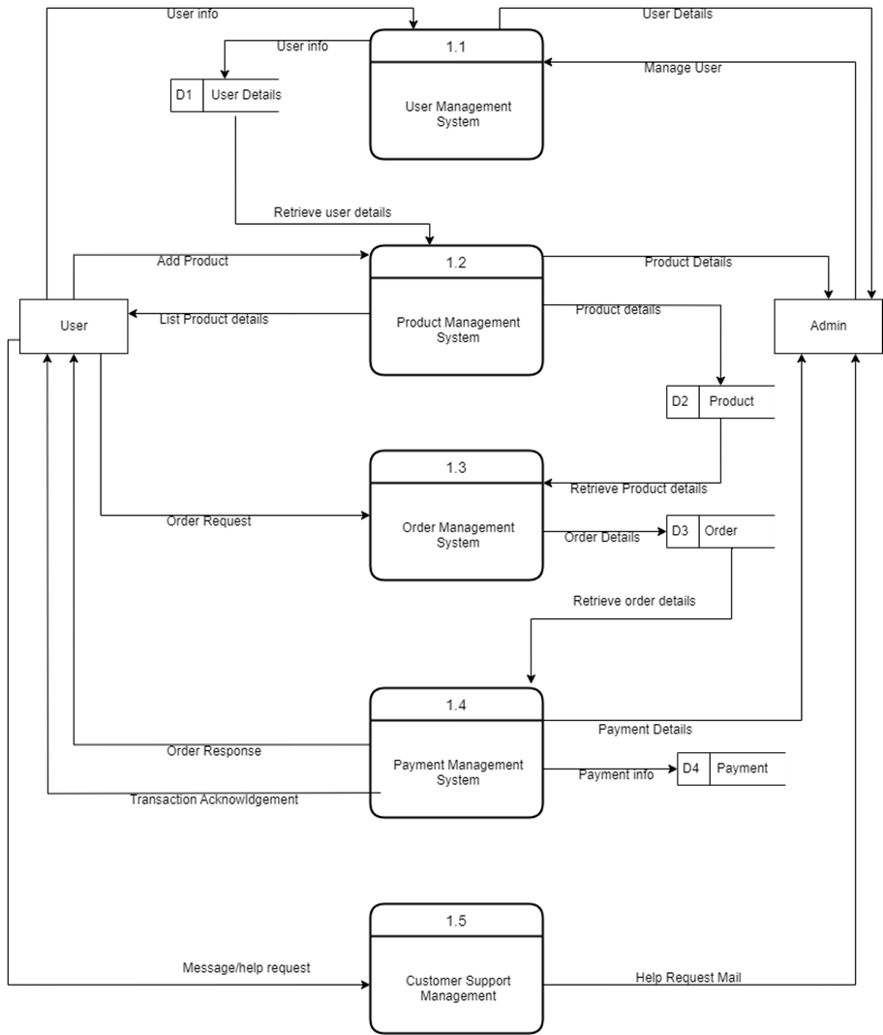

Figure 3: Data Flow Diagram

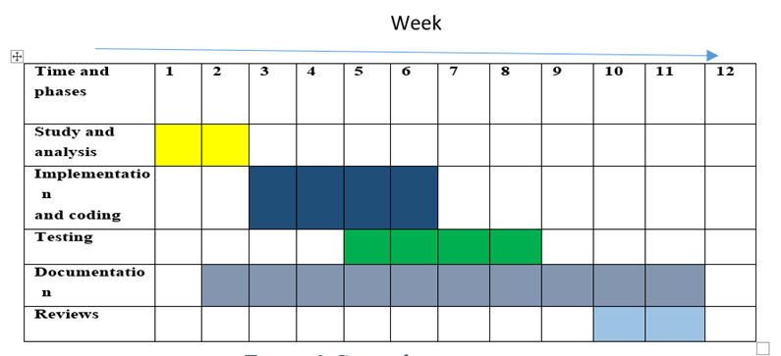
Gantt Chart

Expected Outcome:
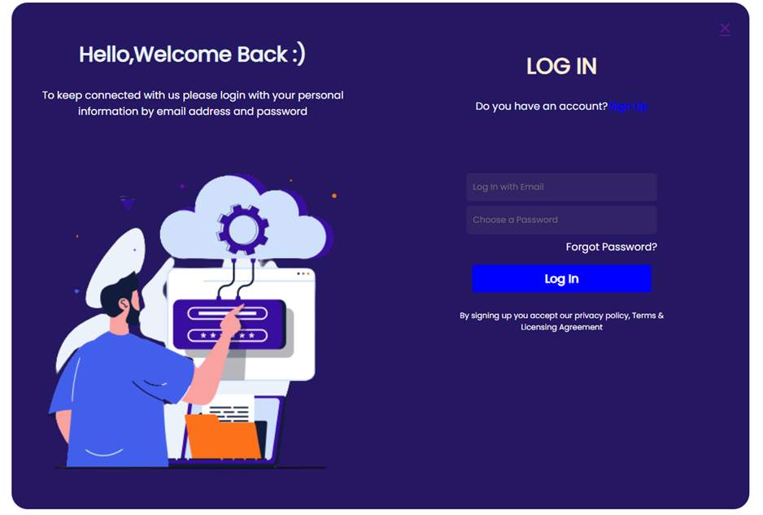
My proposed system will give the outcome as shown below:

Figure 4: Login Page

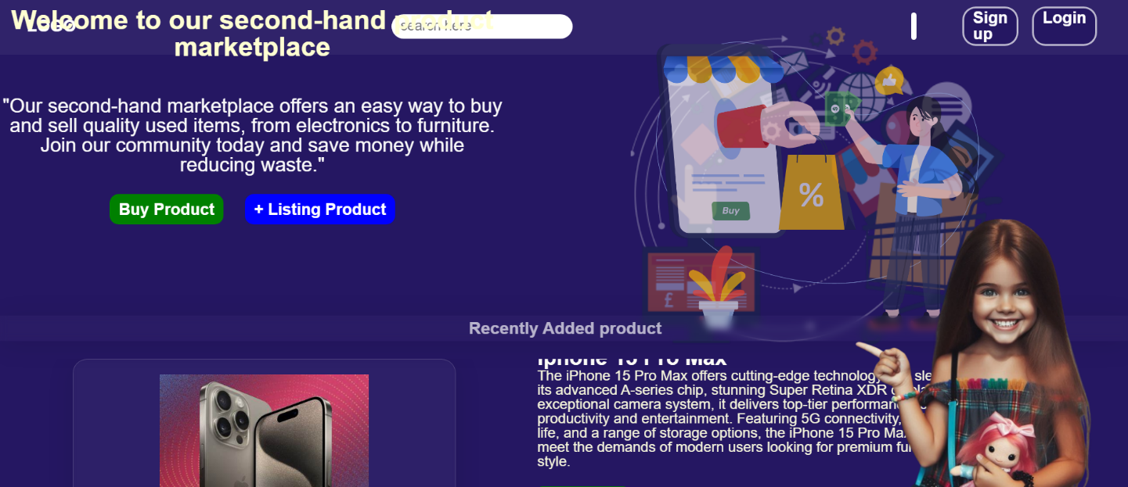
Figure 5: Dashboard

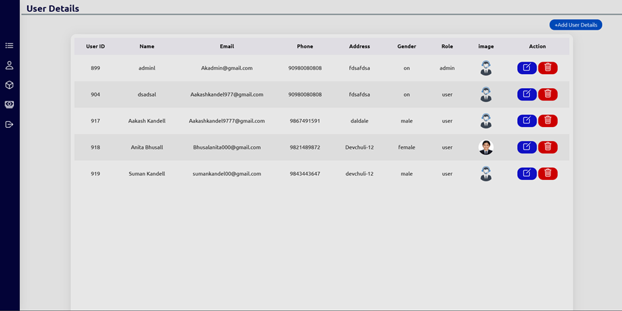
Figure 6: Customer Details

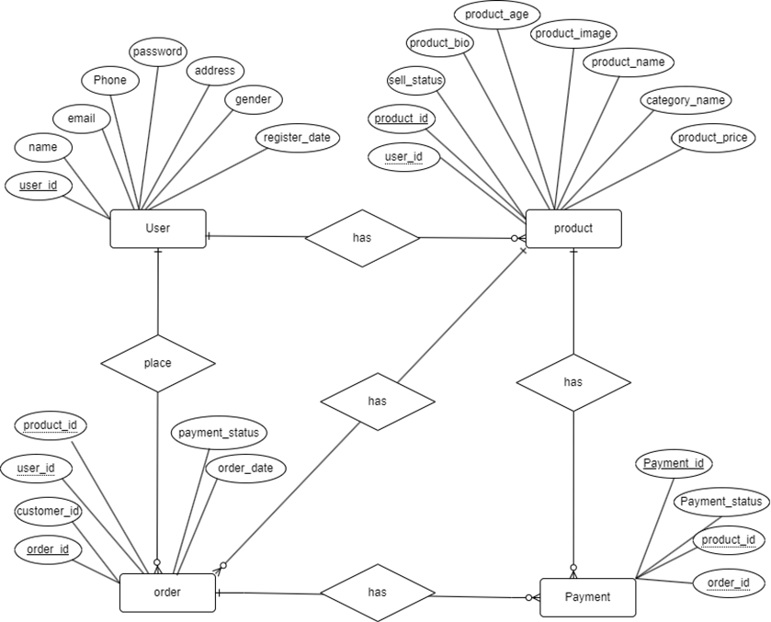
Figure 7: ER Diagram

References
Essays, U. K (2018, November). Methodology The Waterfall Model Information Technology Essay. Retrieved from Information Technology: https://ww.ukessays.com/essays/information-technology/methodology-the-waterfall- model-information-technology-essay.php?vref=1

