Bug inventory

2024.11.30 - First Round of Testing
Main test: Main process
The test questions are listed as follows:
- Windows: Incomplete display interface (optimizable) - (Resolved)
- Draw Action: No withdrawal action after drawing three cards - (By Design)
- Game Interface Stack: Shows the number of cards left in the deck - (Solved)
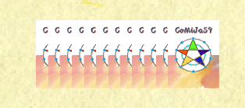

4. Victory Interface: After three people play the game, one hand shows the game victory interface (has been solved)
5. Back Key: When it's not my turn, the back key disappears, but clicking it accelerates the game process - (Solved)
6. Revocation Action: No undo option after selecting a card (can be optimized).
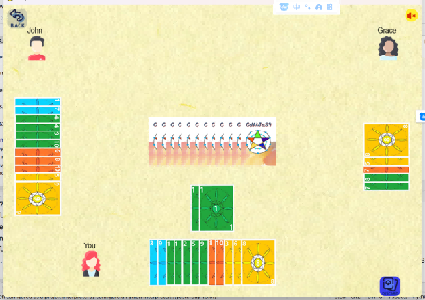

7. HARD Mode Issue: In two-player mode or three-player mode, after the first round, clicking causes a jump - (Solved)Two people mode:
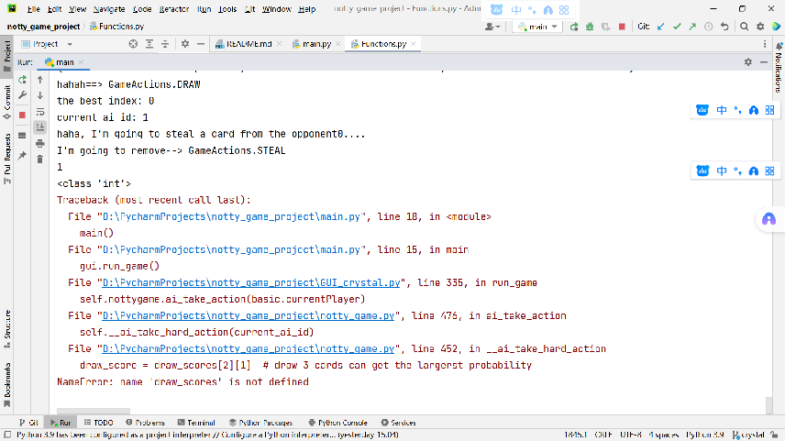
Three-person mode:
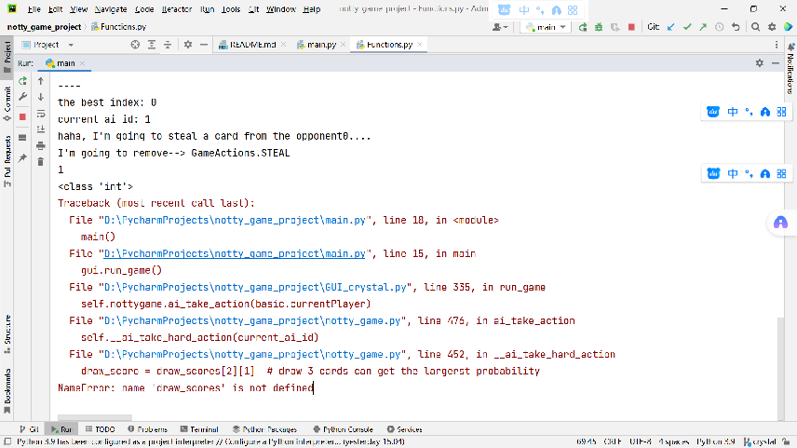

2024.12.01 - Second Round of Testing
Main Test: Checking if the UI button process meets the teacher's requirements.
The teacher's requirements are as follows:
- Simulation of card collection and basic gameplay, including:
Initial card dealing.
Rotating turns.
Performing three actions.
Validating and rejecting actions.
Maintaining the deck and shuffling when needed.
Checking win conditions and announcing the winner. (Satisfied)
- Use Pygame to create a visual interface showing:
- All players' cards.
- Gameplay using clickable cards/buttons.
- Visualization of human and computer players' actions. (Satisfied)
- Design computer players with:
- Basic functionality to choose feasible actions randomly.
- Gradual complexity increase, like evaluating the best action or determining the number of cards to draw.
- Optional strategies for different computer players, allowing users to choose opponents. (Satisfied)
- Add a "Play for Me" button to let the computer play the user's turn. (Satisfied)
- Display a congratulatory message when a player wins. (Satisfied)
- Game rules include:
- Initial shuffle and 5-card deal.
- All cards face-up.
- Stack cards face-down.
- Turn-based actions with valid card combinations (e.g., consecutive cards or same-number cards with unique colors). (Satisfied)

2024.12.01-12.02 - Further Testing
The game test
- Licensing Sound: Game page licensing sound appears before the game started (resolved)
- AI Decision Logic: Reflects in the bubble box - (Solved)
- Restart Issue: After victory, restarting prevents certain actions like "Discard" but allows "Skip" and "Steal" - (Occasional)
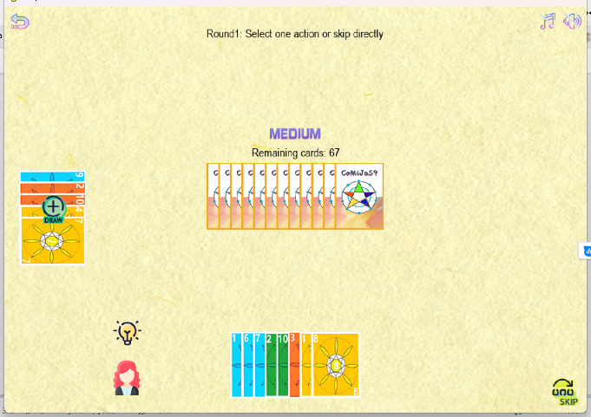
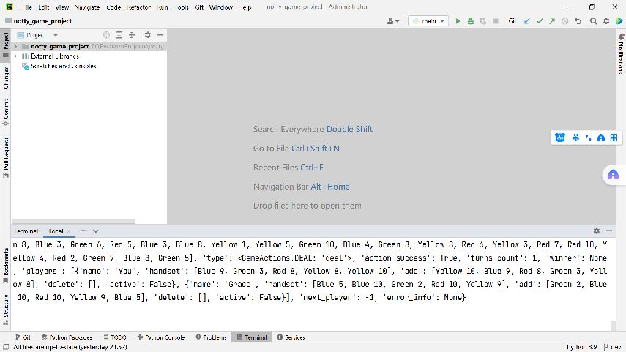

- HARD MODE: There is no response when the number of three-player cards is too much (accidental)
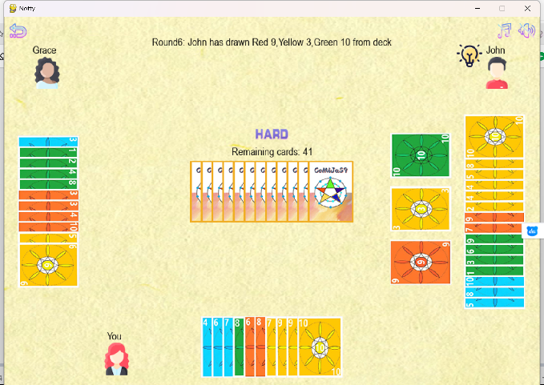
- The background music icon shows the MUTE but still has background music (solved)
- Background Error: Display errors and instability after long inactivity - (Occasional)
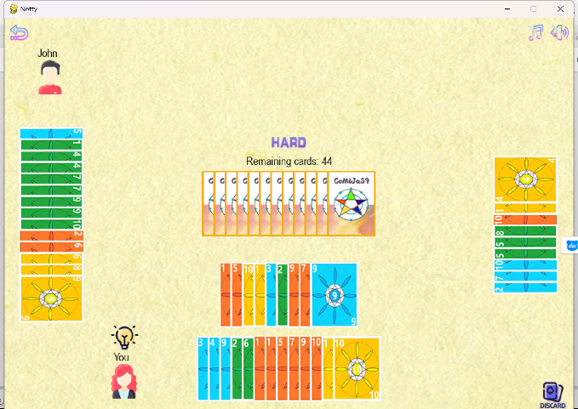
7. Draw Button Issue: Clicking "Draw" adds no cards, and the button disappears - (Occasional)
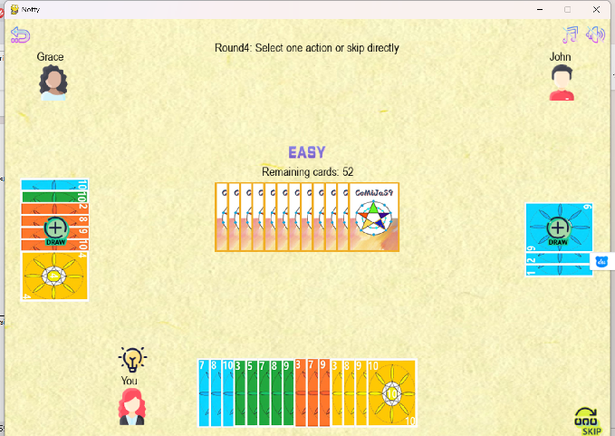

8. EASY Mode: Victory interface doesn't display after all "Grace" cards are taken - (Occasional)
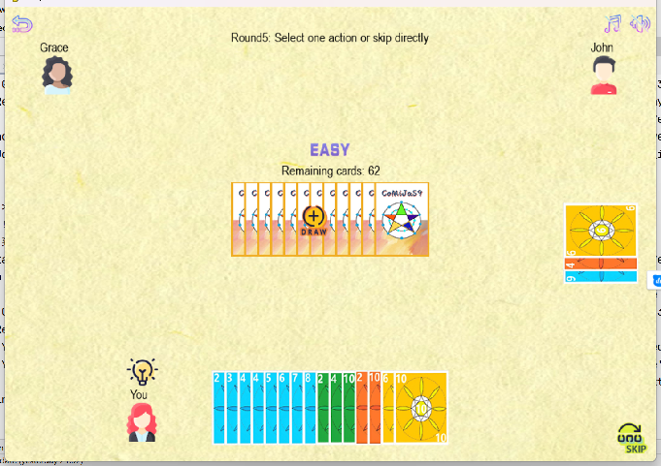
- Help Key: Fails after returning to the desktop post-victory - (Solved)
10. EASY Mode Error: Exceeding hand limit displays errors - (Solved)
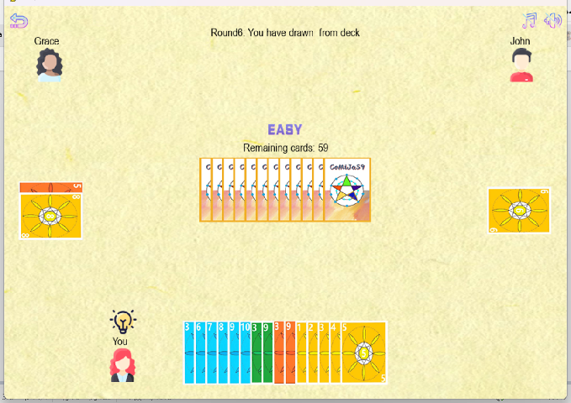

2024.12.03 - Testing
Single/Two-Player Issue: Repeating actions (draw and skip) causes card mismatches. (By Design)
Card Count Mismatch: Selecting three cards from the stack adds only one.

2024.12.04 - Final Testing
1. EASY Mode Issue: "Play for Me" frequently fails; error logs refer to excessive cards or performance lag. Returning to the home page resolves it.
2. EASY Mode: the three men have a chance to click on their hand to interrupt the process
