**DBMD LECTURE**

**UNIVERSITY DATABASE PROJECT**

1. DESIGN UNIVERSITY REGISTRATION DATA MODEL ACCORDING TO THE CROW'S FOOD MODEL BY USING DRAW.IO. THE MODEL HAS SEVERAL PARTS, BEGINNING WITH AN ERD AND FOLLOWED BY A WRITTEN DESCRIPTION OF ENTITY TYPES, CONSTRAINTS, AND ASSUMPTIONS.

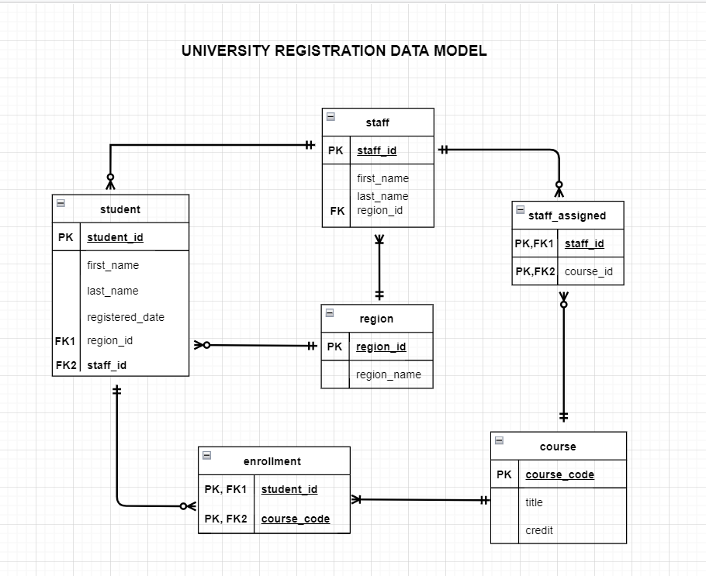

**Entity :**

course (course_code, title, credit)

student (student_id, first_name, last_name, registered_date, region_id, staff_id)

staff (staff_id, first_name, last_name, region_id)

region(region_id, region_name )

enrollment (student_id, course_code)

staff_assigned (staff_id, course_code)

**Constraints :**

A staff member may only tutor or counsel students who are located in the same region as the staff member.

Students are constrained in the number of courses they can be enrolled in at any one time. Students may not enroll for more than 180 points worth of courses at any one time.

The attribute Credit (of Course) has a value of 15 or 30 points.

A student has at most one enrollment in a course as only current enrollments are recorded.

The student's region and the counselor's region must be the same.

**Assumptions :**

A student is not required to enroll in any courses at registration; enrollment in a course can happen at a later time.

Each student has one counselor, allocated at registration, who supports the student throughout his or her university career.

1. CREATE DATABASE TABLES ACCORDING TO YOUR DATA MODEL. CREATE THE NECESSARY INDEXES IN THE TABLES. BUILD RELATIONSHIPS BETWEEN TABLES USING THE KEYS. USE DATA TYPES FOR TABLE FIELDS. CREATE THE APPROPRIATE CONSTRAINTS IN THE TABLES.

**--CREATE TABLES**

**-- create table 'course'**

CREATE TABLE course(

course_code INT NOT NULL IDENTITY (1,1)

CONSTRAINT Course_pk PRIMARY KEY (course_code),

title VARCHAR (256) NOT NULL,

credit INT NOT NULL

CONSTRAINT check_credit CHECK (credit=15 OR credit=30)

);

INSERT INTO course

VALUES ('Fine Arts',15),

('German',15),

('Chemistry',30),

('French',30),

('Physics',30),

('History',30),

('Music',30),

('Psychology',30),

('Biology', 15)

**-- create table 'student'**

CREATE TABLE student (

student_id INT NOT NULL IDENTITY (1,1)

CONSTRAINT student_pk PRIMARY KEY (student_id),

first_name VARCHAR (256),

last_name VARCHAR (256),

register_date DATE NOT NULL,

region_id INT NOT NULL ,

staff_id INT NOT NULL,

CONSTRAINT fk1_region_no FOREIGN KEY (region_id) REFERENCES region (region_id) ON UPDATE CASCADE ON DELETE CASCADE,

CONSTRAINT fk1_staff_no FOREIGN KEY (staff_id) REFERENCES staff (staff_id)ON UPDATE CASCADE ON DELETE CASCADE

);

INSERT INTO student

VALUES ('Alec','Hunter','12.05.2020',1,7),

('Bronwin', 'Blueberry','12.05.2020',2, 8),

('Charlie', 'Apricot','12.05.2020', 3, 2),

('Ursula', 'Douglas','12.05.2020', 2, 1),

('Zorro', 'Apple', '12.05.2020', 3, 6),

('Debbie', 'Orange','12.05.2020', 1, 9)

-- create table ‘region'

CREATE TABLE region(

region_id INT PRIMARY KEY NOT NULL,

region_name VARCHAR (256) NOT NULL

);

INSERT INTO region

VALUES (1,'Wales'),(2, 'Scotland'),(3, 'England'),(4, 'Northern Ireland')

**-- create table ‘staff'**

CREATE TABLE staff (

staff_id INT NOT NULL IDENTITY(1,1)

CONSTRAINT staff_pk PRIMARY KEY (staff_id),

first_name VARCHAR (256),

last_name VARCHAR (256),

region_id INT NOT NULL

FOREIGN KEY (region_id) REFERENCES region (region_id)

);

INSERT INTO staff

VALUES ('Neil','Mango',2),

('Harry','Smith',3),

('Yavette','Berry',4),

('Tom','Garden',4),

('Margeret','Nolan',3),

('Kellie', 'Pear',3),

('October', 'Lime',1),

('Ross', 'Island', 2),

('Victor', 'Fig',1)

**-- create table 'enrollment'**

CREATE TABLE enrollment(

student_id INT NOT NULL,

course_code INT NOT NULL

Constraint PK_Enrollment PRIMARY KEY (student_id , course_code),

FOREIGN KEY (student_id) REFERENCES student (student_id),

FOREIGN KEY (course_code) REFERENCES course (course_code));

INSERT INTO enrollment

VALUES (1, 1),

(1, 2),

(2, 1),

(2, 2),

(3, 1),

(3, 2),

(4, 1),

(4, 2)

--- **create table 'staff_assigned'**

CREATE TABLE staff_assigned(

staff_id INT NOT NULL,

course_code INT NOT NULL,

Constraint PK_staff_assigned PRIMARY KEY (staff_id, course_code),

FOREIGN KEY (staff_id) REFERENCES staff (staff_id),

FOREIGN KEY (course_code) REFERENCES course (course_code)

);

INSERT INTO staff_assigned

VALUES (1,1),

(2,2),

(5,3),

(6,4),

(5,4),

(2,5),

(6,5),

(3,9)

**--CONSTRAINTS**

--1. Students are constrained in the number of courses they can be enrolled in at any one time.

--They may not take courses simultaneously if their combined points total exceeds 180 points.

create function enrollment_constraint (

@student_id int,

@course_code int

)

returns varchar(10)

as

begin

declare @total_credit int

declare @new_credit int

declare @result varchar(10)

select @total_credit = sum(c.credit) from course c join enrollment e on e.course_code = c.course_code JOIN student s ON s.student_id = e.student_id where e.student_id = @student_id

select @new_credit = credit from course where course_code = @course_code

if @total_credit + @new_credit > 180

set @result = 'False'

else

set @result = 'True'

return @result

end

ALTER TABLE enrollment

ADD CONSTRAINT check_enrollment CHECK(dbo.enrollment_constraint(student_id,course_code) = 'True');

--2. The student's region and the counselor's region must be the same.

CREATE FUNCTION check_region()

RETURNS INT

AS

BEGIN

DECLARE @region int

IF EXISTS(SELECT *

FROM region r JOIN student s ON r.region_id=s.region_id JOIN staff p ON p.region_id = r.region_id

WHERE s.region_id != p.region_id)

SELECT @region =1 ELSE SELECT @region = 0;

RETURN @region;

END;

ALTER TABLE staff

ADD CONSTRAINT check_region CHECK(dbo.check_region() = 0);

1. **ADDITIONAL TASKS**

--1. Test the credit limit constraint.

INSERT INTO course VALUES('History', 15)

The statement has been terminated with error message.

--2. Test that you have correctly defined the constraint for the student counsel's region.

UPDATE staff SET region_id = 6 WHERE staff_id=1

The statement has been terminated with error message.

--3. Try to set the credits of the History course to 20. (You should get an error.)

UPDATE course SET credit = 20 WHERE title='History'

The statement has been terminated with error message.

--4. Try to set the credits of the Fine Arts course to 30.(You should get an error.)

UPDATE course SET credit = 30 WHERE title='Fine Arts'

The statement has been terminated with error message.

--5. Debbie Orange wants to enroll in Chemistry instead of German. (You should get an error.)

--6. Try to set Tom Garden as counsel of Alec Hunter (You should get an error.)

UPDATE student SET staff_id = 4 WHERE student_id=1

--7. Swap counselors of Ursula Douglas and Bronwin Blueberry.

UPDATE student Set staff_id = 8 where last_name ='Douglas'

UPDATE student Set staff_id = 1 where first_name ='Blueberry'

--8. Remove a staff member from the staff table.

-- If you get an error, read the error and update the reference rules for the relevant foreign key.

DELETE FROM staff WHERE staff_id=5

ALTER TABLE student DROP CONSTRAINT fk1_region_no

ALTER TABLE student DROP CONSTRAINT fk1_staff_no

ALTER TABLE student

ADD CONSTRAINT fk1_region_no FOREIGN KEY (region_id) REFERENCES region (region_id)

ON UPDATE CASCADE ON DELETE CASCADE,

CONSTRAINT fk1_staff_no FOREIGN KEY (staff_id) REFERENCES staff (staff_id)

ON UPDATE CASCADE ON DELETE CASCADE