**CHARLIES CHOCOLATE FACTORY ENTITY RELATION DIAGRAM**

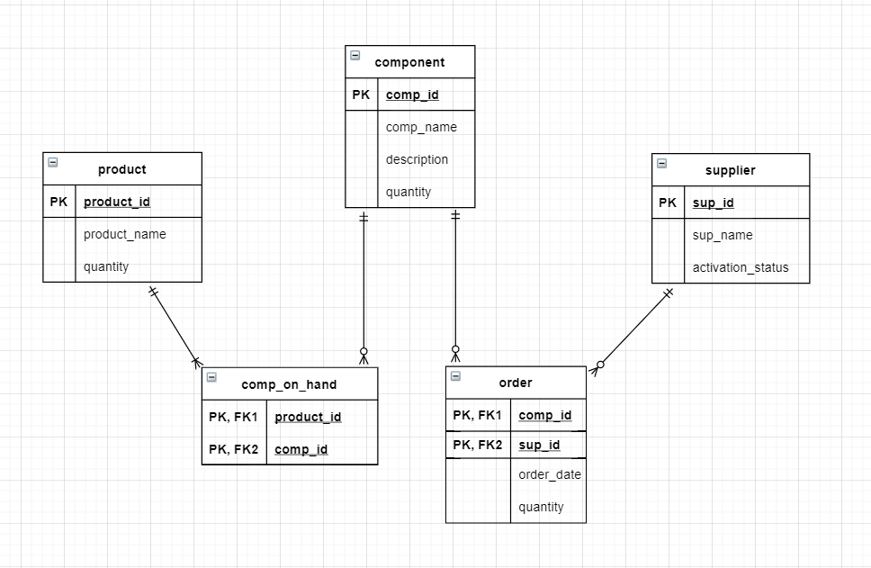

CREATE DATABASE Manufacturer;

USE Manufacturer

CREATE TABLE Product

(

product_id INT,

product_name VARCHAR(MAX),

quantity INT

PRIMARY KEY (product_id)

)

CREATE TABLE Component

(

comp_id INT PRIMARY KEY,

comp_name VARCHAR(MAX),

description VARCHAR(MAX),

quantity INT

);

CREATE TABLE Supplier

(

sup_id INT,

sup_name VARCHAR(MAX),

activation_status BIT,

PRIMARY KEY (sup_id)

)

CREATE TABLE Comp_On_Hand

(

product_id INT,

comp_id INT,

PRIMARY KEY (product_id, comp_id),

FOREIGN KEY (product_id) REFERENCES Product (product_id),

FOREIGN KEY (comp_id) REFERENCES Component (comp_id)

)

CREATE TABLE Order

(

comp_id INT,

sup_id INT,

order_date DATE,

quantity INT,

PRIMARY KEY (comp_id, sup_id),

FOREIGN KEY (sup_id) REFERENCES Supplier (sup_id),

FOREIGN KEY (comp_id) REFERENCES Component (comp_id)

)

