# **CSE 4074 Project Report** – Socket Programming – Travel Agency

150116825 – Onur Can Yücedağ

150115501 – Emre Erdem

## Source Files

We have 4 different projects in total. They are for Client Web App, Trip Advisor Server, Airline Request Handler and Hotels Request Handler.

### Client Web App

It is a Flask[1] project that is used for creating a web app as a GUI to the users. It relatively simple structure consists of single HTML file(index.html), an entry point (app.py), front-end Javascript file (index.js) for handling interactions and lastly a CSS file(style.css) for style. It also has a text file for getting the table names in a dynamic manner, we will talk about this later.

Before we dive in how to use this app, we need to talk about what it does exactly. First, it is a web app as we mentioned above. So, before the actual request handling starts, it will check if the Trip Advisor Server’s socket is open for connection. Because it will forward the client’s requests to the Trip Advisor Server, we need to establish this connection before any HTML pop up to our screens.

By convention, we decided to put the Trip Advisor Server in localhost:54000 address so Client Web App will try to connect to the that socket. If any reason it can’t establish a connection, it will simply output an error to the screen of the user as you can see in Figure 1.

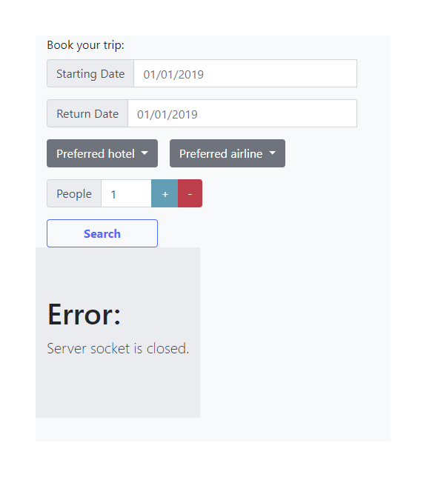This error’s main reason is that connection refused by Trip Advisor Server. So, we need to execute and initialize listening socket in Trip Advisor Server to resolve the error.

Figure : Socket error notification example.

After establishing connection is successful with the Trip Advisor Server, it is good to serve to the clients. In the main route (“/”) it will try to read a table_names.txt file for get the airline and hotel names; if it can’t find the text file or encounters any errors while trying to read the file, it will simply put static elements in the both lists.

When it is up and running without any errors you will see a screen like in Figure 2.

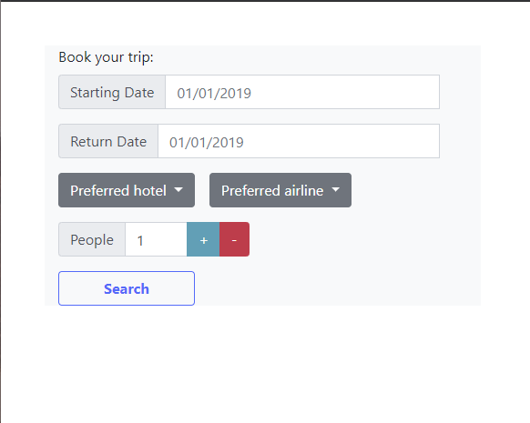When a client enters Starting Date, Return Date, Preferred hotel, Preferred airline and People inputs in the page; Search button will be active for sending the request to the Trip Advisor Server. If a client inputs wrong format of date or below input the 1 in the People input region, front-end Javascript will warn the user as Figure 3.

Figure : Initial page of Client Web App

It will block all days before today’s date for making sense. After a client clicks the Search button; front-end will check if you entered all the inputs in the correct format and change the style of the dropdown buttons for airline and hotels, that is because these dropdowns are selected now and they won’t be un-selected again. They will turn green for displaying this.

Then, it will post this form data in a request to a backend method, CheckDates. This method simply parses form data and send to the Trip Advisor Server. After sending the data it will wait for the response.

Trip Advisor Server will most likely send “Failure|Failure”, “Alternatives|Success” or “Success|Success”. These messages represent the airline and hotel responses to the dates and number of people selections. Basically, they represent if they can book it or not. If any of these messages includes “Failure”, it means we can’t book simple as that. Because we can’t sleep on the streets while we are using airplanes to go there.

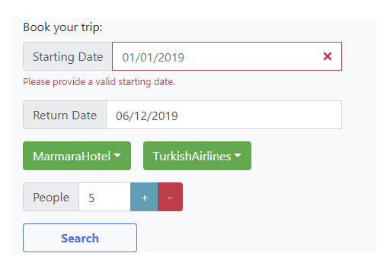

Figure : Warning text for Starting Date input.