 |  | 

CBIO204 – Fundamentals of Databases | spring 2026

Clinic Management System

Name | ID
Yousef elsayed mohamed | 221001880
Abdelrahman nasr | 222000063

Instructor: Dr. Mohamed Elsayeh

1. Introduction
This report documents the design and implementation of the Clinic Management System — a relational database solution developed as part of the CBIO204 Fundamentals of Databases course. The system is built to handle the scheduling of appointments and the management of patient medical history across multiple departments, clinics, and doctors.

Using a relational database model, the system ensures data integrity through foreign key constraints and enables efficient retrieval of medical and administrative information. The project demonstrates the full database development lifecycle — from conceptual ER design through relational schema, SQL implementation, and data population.

2. Database Schema
The Clinic Management System consists of five core entities, each implemented as a relational table:

Entity | Primary Key | Attributes
Department | DepartmentID | Name
Clinic | ClinicID | Name, Address, DepartmentID (FK)
Doctor | DoctorID | Name, PhoneNumber, Address, DepartmentID (FK)
Patient | PatientID | Name, PhoneNumber, Address, BirthDate, Job
Appointment | AppointmentID | Date, PatientID (FK), DoctorID (FK), StartTime, EndTime, Cost, Status, Diagnosis

2.1 Logical Relational Schema
The logical schema below illustrates the relational structure with primary keys (underlined in red) and foreign key references shown as arrows between tables:

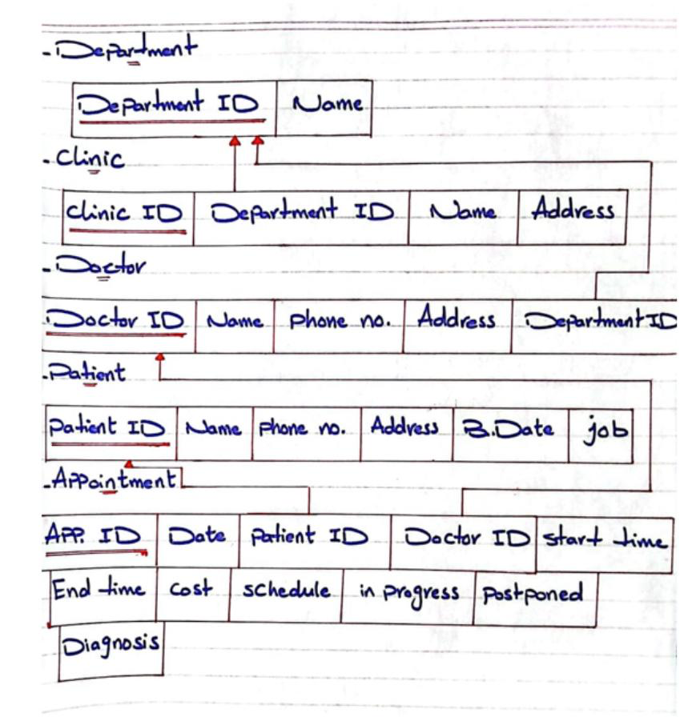
Figure 1 — Logical Relational Schema: primary keys underlined, arrows show foreign key relationships

3. ER Diagram
The Entity-Relationship Diagram below provides the conceptual design of the Clinic Management System, showing all five entities with their attributes, relationship diamonds, and cardinality notations.

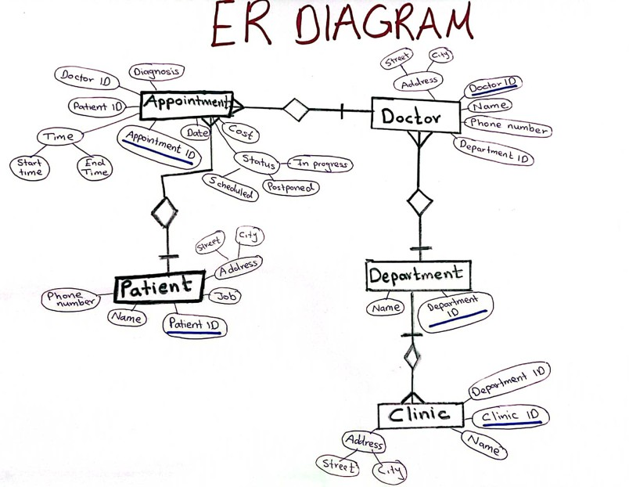

3.1 Relationships & Cardinality
Department → Clinic [One-to-Many (1:N)] One department manages many clinics. Each clinic belongs to exactly one department.
Department → Doctor [One-to-Many (1:N)] One department contains many doctors. Each doctor is assigned to one department.
Doctor → Appointment [One-to-Many (1:N)] One doctor can handle many appointments. Each appointment is assigned to one doctor.
Patient → Appointment [One-to-Many (1:N)] One patient can have multiple appointments over time. Each appointment belongs to one patient.

4. SQL Queries
The following queries were implemented to satisfy key healthcare data retrieval requirements:

4.1 Patients Diagnosed with Fatty Liver (Last Year)
This query retrieves the names of patients diagnosed with 'Fatty liver' within the past 12 months. It uses a correlated subquery against the Appointment table filtered by diagnosis and a dynamic date range using DATE_SUB():

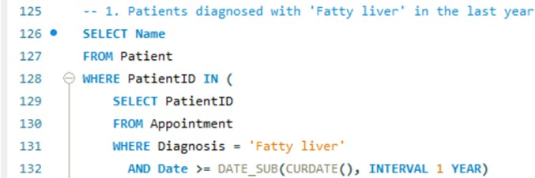

-- 1. Patients diagnosed with 'Fatty liver' in the last year
SELECT Name
FROM Patient
WHERE PatientID IN (
SELECT PatientID
FROM Appointment
WHERE Diagnosis = 'Fatty liver'
AND Date >= DATE_SUB(CURDATE(), INTERVAL 1 YEAR)
);

4.2 Addresses of Cardiology Clinics
This query retrieves clinic addresses for all Cardiology clinics. It uses an INNER JOIN between the Clinic and Department tables, filtering on the department name. This demonstrates multi-table querying with JOIN:

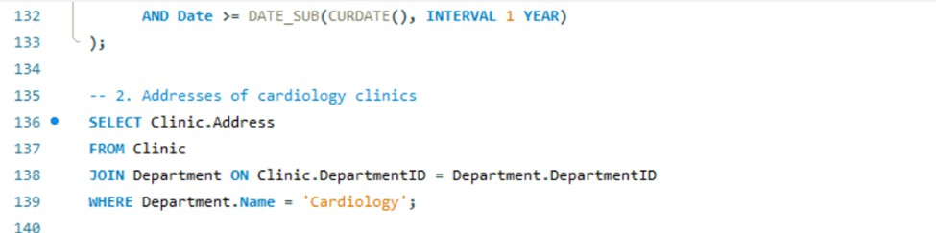
SELECT Clinic.Address
FROM Clinic
JOIN Department ON Clinic.DepartmentID = Department.DepartmentID
WHERE Department.Name = 'Cardiology';

4.3 Total Amount Paid by Patient #12527
This query uses the SQL SUM() aggregate function to calculate the total fees paid by a specific patient across all appointments within the last 3 years. This demonstrates financial analytics on patient records:

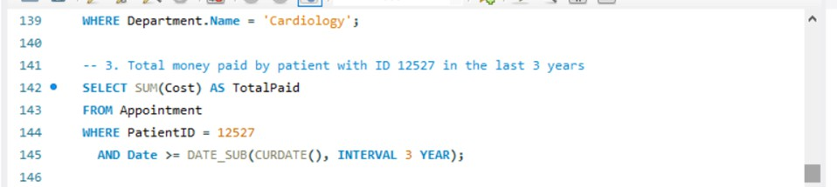

SELECT SUM(Cost) AS TotalPaid
FROM Appointment
WHERE PatientID = 12527
AND Date >= DATE_SUB(CURDATE(), INTERVAL 3 YEAR);

5. CRUD Operations
The system supports full CRUD operations — Create, Read, Update, and Delete — across all five tables. These operations ensure the database can be maintained and kept current in a real clinic environment.

5.1 Create (INSERT)
- INSERT INTO Department — Add new medical specialty departments
- INSERT INTO Clinic — Register new clinics linked to departments
- INSERT INTO Doctor — Add new doctors assigned to departments
- INSERT INTO Patient — Register new patients with personal details
- INSERT INTO Appointment — Schedule new patient-doctor appointments

5.2 Read (SELECT)
- SELECT with subquery — Retrieve patients by diagnosis and date
- SELECT with JOIN — Get clinic addresses by department name
- SELECT with SUM() — Aggregate total payments per patient

5.3 Update (UPDATE)
Sample update operations demonstrating data modification:

-- Update patient contact info
UPDATE Patient
SET Address = 'New Address', PhoneNumber = 'New Phone'
WHERE PatientID = 12530;

-- Update appointment status
UPDATE Appointment
SET Status = 'Postponed'
WHERE AppointmentID = 20003;

-- Update clinic address
UPDATE Clinic
SET Address = '123 New Clinic Address'
WHERE ClinicID = 101;

5.4 Delete (DELETE)
- DELETE FROM Patient WHERE PatientID = [id] — Remove a patient record
- DELETE FROM Appointment WHERE AppointmentID = [id] — Cancel an appointment
Note: All delete operations respect referential integrity enforced by foreign key constraints.

6. Data Population
All five database tables were populated with a minimum of 10 records each, as required by the project guidelines. Below is a summary of the inserted sample data:

Table | Records | Sample Data
Department | 10 | Cardiology, Neurology, Dermatology, Orthopedics, Pediatrics, General Medicine, Oncology, Psychiatry, Gastroenterology, Endocrinology
Clinic | 10 | Heart Clinic, Brain Clinic, Skin Clinic, Bone Clinic, Children Clinic, Family Clinic, Cancer Clinic, Mind Clinic, Stomach Clinic, Hormone Clinic
Doctor | 10 | Dr. Ayman, Dr. Leila, Dr. Sara, Dr. Omar, Dr. Hana, Dr. Adel, Dr. Kamal, Dr. Rania, Dr. Mona, Dr. Youssef
Patient | 10 | Ali Ahmed, Sara Youssef, Omar Adel, Maya Fathy, Noor Khaled, Ziad Hany, Laila Samir, Yara Said, Tamer Sherif, Huda Mostafa
Appointment | 10 | Diagnoses: Fatty liver, Migraine, Acne, Knee pain, Flu, Diabetes, Cancer, Anxiety, Ulcer, Thyroid. Statuses: Completed, Scheduled, Postponed

7. Conclusion
The Clinic Management System demonstrates how a well-designed relational database can simplify medical data management. By combining structured schema design, meaningful foreign key relationships, and practical SQL queries, the project delivers a scalable foundation for real-world clinic operations.

Key achievements of this project:

- Designed a fully normalized relational database with 5 interconnected entities
- Implemented foreign key constraints ensuring referential data integrity across all tables
- Wrote complex SQL queries using subqueries, JOINs, and aggregate functions (SUM)
- Populated all tables with 10+ realistic records covering diverse medical scenarios
- Demonstrated full CRUD operations with real-world UPDATE and DELETE use cases

Future work could integrate a web-based user interface with role-based authentication (separate access for doctors, nurses, and administrators), an analytics dashboard for reporting, and expanded tables for prescriptions, lab results, and billing to make the system production-ready.

