Yucehan Kucukmotor

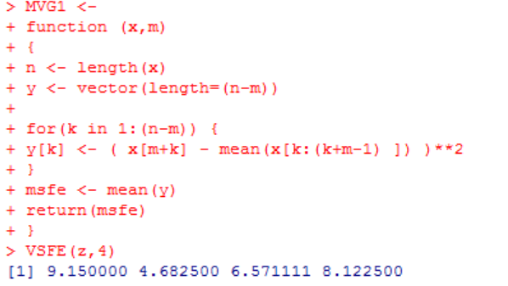Lawrence Tatum, CIS3920, Exercise from LN3

1. Code on the right is to show that MVG1 function is good and working.

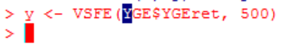y <- VSFE(YGE$YGEret, 500) is to assign function VSFE to “y” and to use it with YGE’s (Yingli Green Energy) stock data. Window length is 500.

* 1. 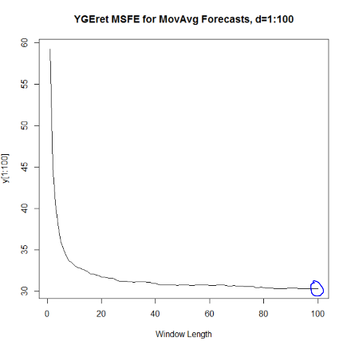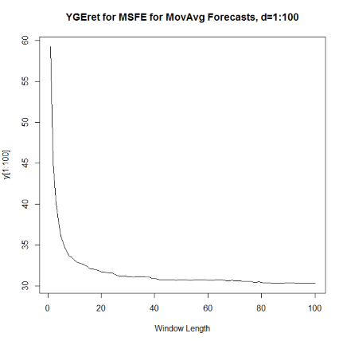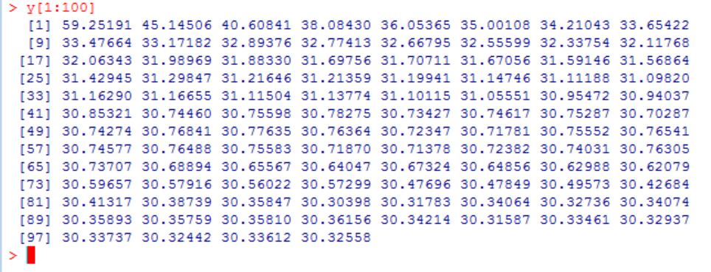Plotted first 100 MSFE values. Graph on the right side of the page shows the plotting of these very 100 MSFE values with a window length of 100. To precisely show what 100 MSFE values are, we can use y[1:100] to list them. MSFE stands for Mean Squared Forecast Error. Graph, as title states, shows YGEret for MSFE for Moving Average Forecasts which is one of the forecast methods that can be used out of countess different methods that are available.
  2. Graph to the right is the same as the one we have for the above question with one minor difference. One of the data points is circled. I’ve circled the 100th data point, which is the last data point we plotted for the question above. X-axis (window length as can be seen) represents which window length the value corresponds to. The reason I chose this point is because the ideal window length for a moving average forecast is when MSFE is minimized. y-axis represents the corresponding MSFE values. Importance of 100th data point (circled) is that that is when MSFE is minimized. Therefore, ideal window length here would be 100. The lesser the error, the better it is for forecasting. Thus, it makes sense for statisticians/data analysts/scientists to choose the data point when MSFE is minimized for their forecasts whatever their method may be. (Except for the unique events that might have occurred within the same period from which data was extracted which may result in otherwise-unlikely results: i.e. 2008 financial crisis).
  3. Question is answered above. When using a moving average forecast as our forecasting method, using data point at which MSFE is minimized is ideal to choose. The lesser the MSFE value is, the better it is. For example, I’ve chosen 100th data point (thus window length=100). It is not necessarily true that this will work the all the time. However, since our responsibility as a scientist is to choose the forecasting techniques that have greater chances to work as intended. For example, if I were to choose 1st data point as my point (and as my window length for that matter), I would have to work with a data point which corresponds to the highest MSFE. Forecast error would be greater than 100th point by a wide margin.
  4. 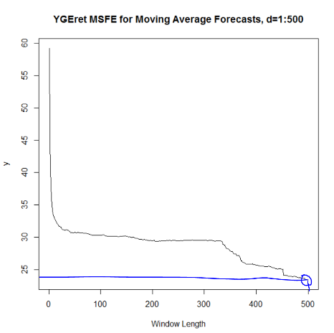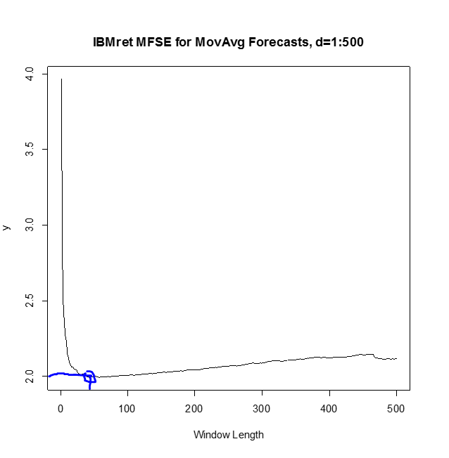C:\Users\Yucehan\AppData\Local\Microsoft\Windows\INetCache\Content.Word\1.4.1.png

To the right we see two different plots for two different data sets: Yingli Green Energy and IBM (Lawrence, CIS-STA 3920 Lecture Notes 3, pg. 14), respectively. If we want to compare the two, we can start off by deciding which data point is ideal (Note: for YGEret’s graph, we plotted using all 500 points unlike what we did above where we plotted using first 100 values. Notice the window length difference). For YGEret MSFE for Moving Average Forecast, we see MSFE has the least corresponding value when our window length is at 500. Thus, choosing MSFE of approximately 23.5 would be our natural option. Plot on the right (Dr. Tatum’s plot) reaches its minimum MSFE value rather before when window length is at around 35-40. Consequently, the ideal choice for the length of the moving average forecast for the following day’s return for Dr. Tatum’s is 35-40, whereas it is at 500 at my own (YGE’s) work. Because YGEret’s MSFE is minimized when length of the moving average forecast for YGEret is 500.



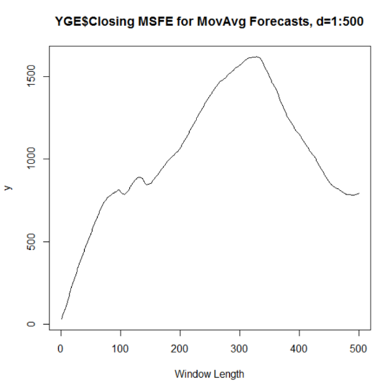

1. C:\Users\Yucehan\AppData\Local\Microsoft\Windows\INetCache\Content.Word\2.2.pngC:\Users\Yucehan\AppData\Local\Microsoft\Windows\INetCache\Content.Word\2.1.pngI used VSFE function we had created earlier, and then used YGE’s closing prices as my object.

C:\Users\Yucehan\AppData\Local\Microsoft\Windows\INetCache\Content.Word\2.4.pngy[1,5] to display first 5 MSFE values.

When we forecast stock prices for the days to come, it is not necessarily an easy task. Different methods of forecasting may yield different results. One of the important tasks is to find the right method, of course. Do you want to use moving average method? What length do you want to choose for your moving average method (that is to say how far back you want to go back and collect data)? Is choosing MSFE with the minimum value sufficient to carry out a valid forecast? Whatever the method is, it is important to decide the unique circumstances that we might encounter. Analyzing the market, data, predictability, trends… are all important aspects of the forecasting that we should consider. Choosing data point where MSFE is minimized may not be the best option. Thus, it is of good value for us to decide which tools, methods, techniques we are going to be using and implementing for our forecasting. We seldom predict the exact stock price of a company even for the very next day.

1. 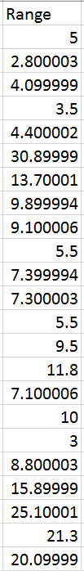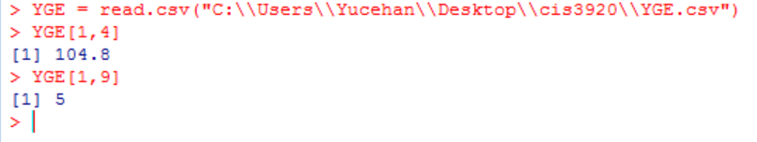

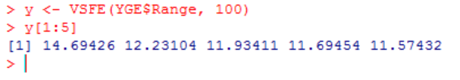C:\Users\Yucehan\AppData\Local\Microsoft\Windows\INetCache\Content.Word\3.4.pngFirst, I added a new column to my Excel file and named it Range. Then I subtracted Low value from the High value to get the range. To the left you can see the Range column of my excel file. Then, I linked the updated excel file of by importing it from R again to have it read by R to get the changes recognized by R.

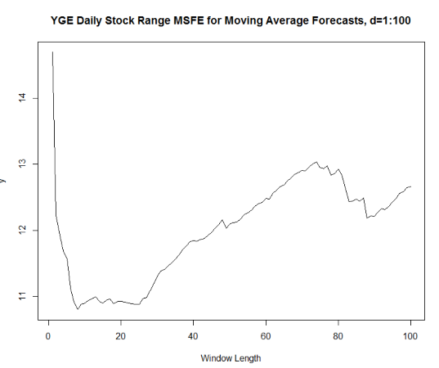 Y[1:5] to help me see what are the first 5 values of the function’s output. Then I used plot function to graph my values and be better able to analyze my data and forecasting method. As we can see on the right side on the graph, where MSFE is minimized, window length is around 8. Thus, a moving average length of 7-9 is idea. MSFE keeps low until around we reach a window length of 26-28, and then follows an upward trend. We could use a moving average length from 7 to 28.

1. 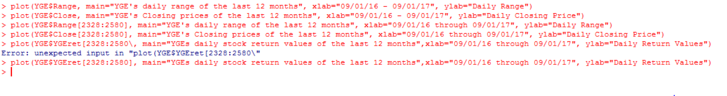

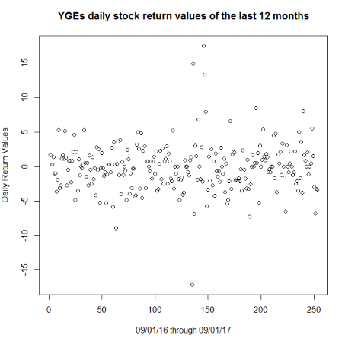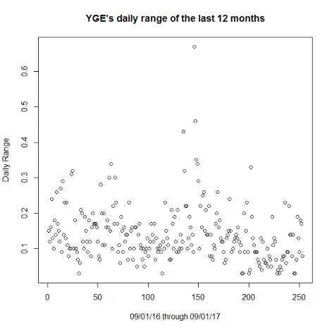

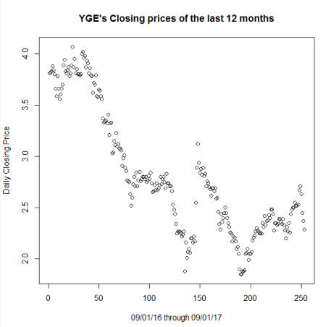First, while plotting, I forgot to include the proper dates (last 12 months). Then I plotted the last 12 months by looking at the proper row numbers from the excel.