E-Cigarette Diffusion Through Peer Networks
USC ADVANCE Study — netdiffuseR Analysis Report
Cohorts 1 & 2 | Grades 10–12 | Past-6-Month Use Outcome

1. Overview
This report summarizes the netdiffuseR diffusion analysis examining how past-6-month e-cigarette use spread through peer friendship networks among high school students (Grades 10–12) in the USC ADVANCE study. Two cohorts across 13 schools were analyzed using 6 grade periods (10th Fall through 12th Spring).

2. Sample: School-Level Summary
Table 1 presents the number of students, adopters, and final prevalence for each school.

Table 1. School-Level Diffusion Summary
School | Cohort | Type | N Students | N Adopters | Final Prev.
101 | C1 | Other | 257 | 46 | 17.9%
102 | C1 | Hispanic-majority | 245 | 32 | 13.1%
103 | C1 | Asian-majority | 190 | 18 | 9.5%
104 | C1 | Other | 364 | 93 | 25.5%
105 | C1 | Asian-majority | 184 | 32 | 17.4%
106 | C1 | Hispanic-majority | 218 | 41 | 18.8%
107 | C1 | Hispanic-majority | 262 | 71 | 27.1%
112 | C1 | Asian-majority | 333 | 72 | 21.6%
113 | C1 | Asian-majority | 371 | 60 | 16.2%
114 | C1 | Hispanic-majority | 362 | 126 | 34.8%
201 | C2 | Other | 199 | 27 | 13.6%
212 | C2 | Asian-majority | 314 | 46 | 14.6%
213 | C2 | Asian-majority | 357 | 41 | 11.5%
214 | C2 | Hispanic-majority | 296 | 76 | 25.7%

- Hispanic-majority schools (102, 106, 107, 114, 214) show the widest range of final prevalence: 13.1% to 34.8%
- Asian-majority schools (103, 105, 112, 113, 212, 213) cluster at lower prevalence: 9.5% to 21.6%
- School 114 (C1, Hispanic-majority) has the highest final prevalence at 34.8%; School 103 (C1, Asian-majority) the lowest at 9.5%

3. Diffusion Patterns

Figure 1. Cumulative Adoption by Grade Period
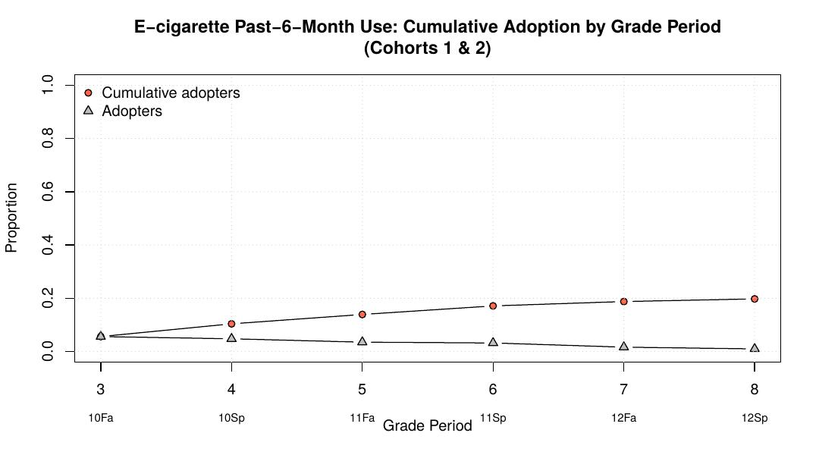
Figure 1. Cumulative proportion of students who adopted past-6-month e-cigarette use across grade periods (Cohorts 1 & 2 combined). Gray band = adopters at each period; line = cumulative.
- Adoption accelerates rapidly between Grade 10 Fall and 11th Spring
- By 12th Spring, cumulative adoption approaches ~20–25% across cohorts
- The S-curve shape confirms classic diffusion dynamics in these networks

Figure 2. Hazard Rate by Grade Period
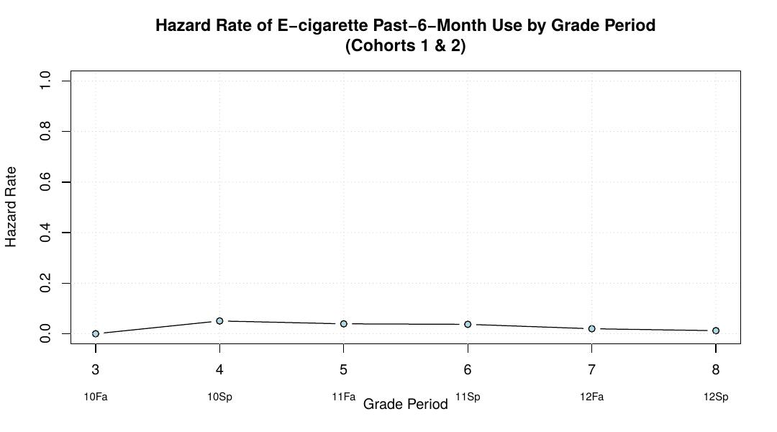
Figure 2. Hazard rate (probability of new adoption at each grade period) among students not yet using.
- Peak hazard occurs at Grade 10 Fall (GP3) — earliest period in analysis — suggesting many initiations happen at the start of 10th grade
- Hazard declines in later grade periods as the pool of susceptible non-adopters shrinks

Figure 3. Cumulative Adoption by School
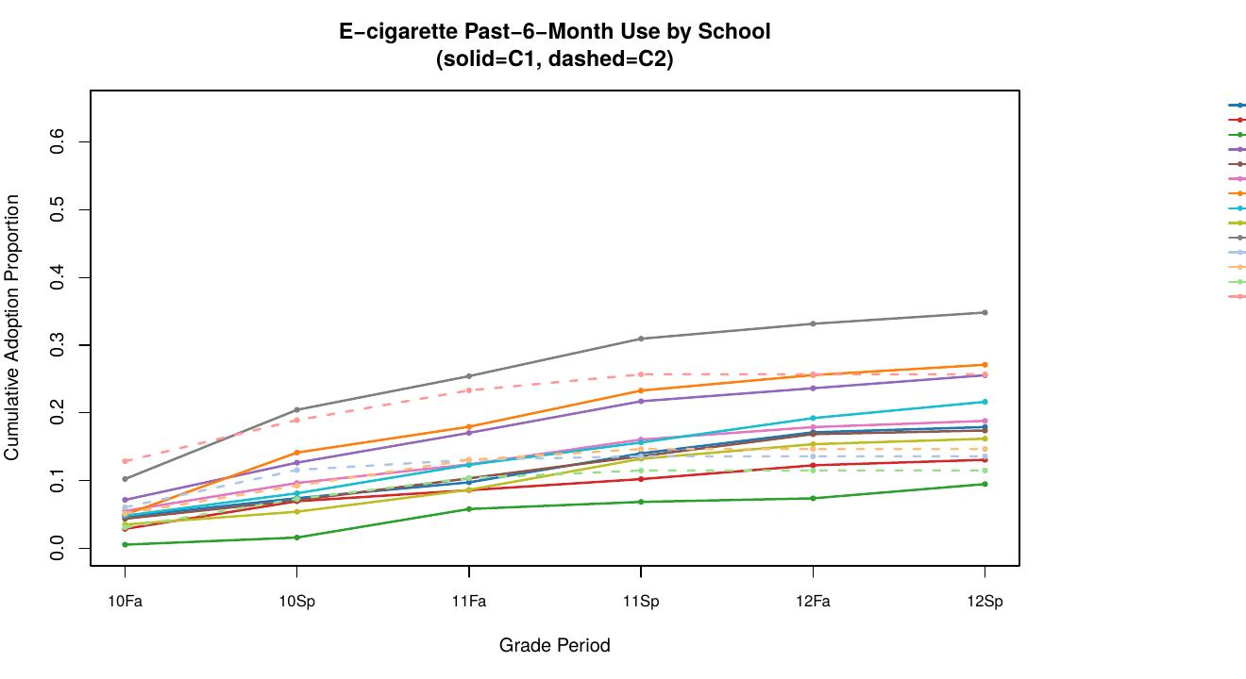
Figure 3. School-level cumulative adoption curves. Solid lines = Cohort 1; dashed lines = Cohort 2. Lines are color-coded by school.
- Substantial between-school variation exists throughout the study period
- Hispanic-majority schools show higher and more variable trajectories
- C1 and C2 schools show similar overall patterns, validating cohort alignment

Figure 4. Adoption Threshold by Grade Period
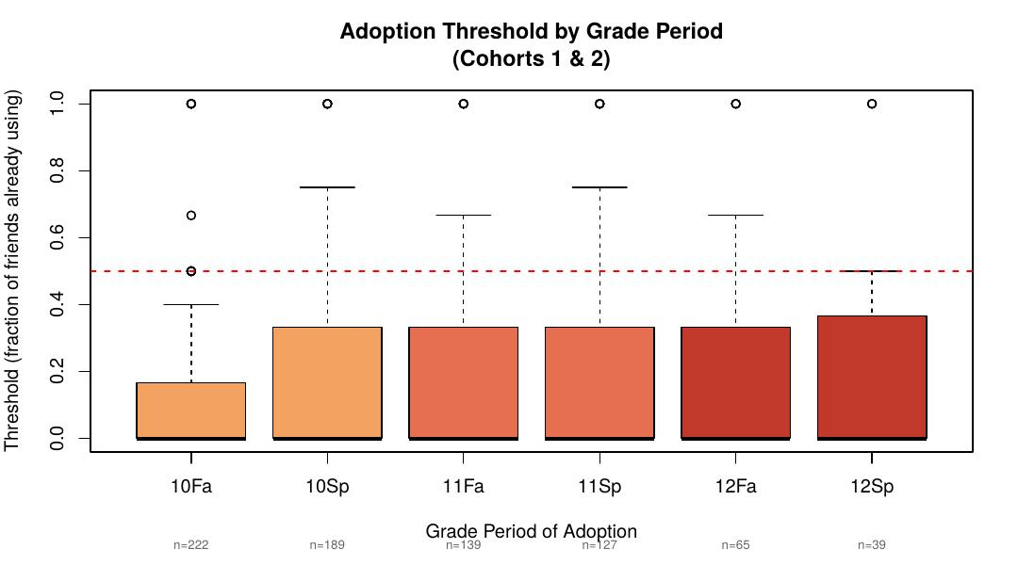
Figure 4. Boxplot of adoption thresholds among adopters by grade period. Threshold = fraction of friends already using at time of adoption. Numbers below x-axis indicate n adopters per period.
- Median threshold is relatively low across all grade periods (~0.1–0.2), indicating most adopters needed fewer than 20% of friends to be using before they started
- Thresholds are slightly higher among late adopters (12th grade), consistent with the expectation that laggards require more social proof
- Large variability within each grade period highlights individual heterogeneity in susceptibility to peer influence

4. Exposure Regression Results
Logistic regression predicting adoption at the next time point among non-adopters, controlling for cohort, demographics, self-reported friend use, and mental health. Two models were run: one with MDD, one with GAD.

Table 2. Exposure Regression (MDD Model)
Parameter | Estimate | SE | z | p | OR
Exposure (network) | 1.0037 | 0.2251 | 4.459 | < .001 | 2.73
MDD | 0.2951 | 0.0753 | 3.918 | < .001 | 1.34
Friends ecig (self-report) | 0.3487 | 0.0400 | 8.709 | < .001 | 1.42
Sex minority | 0.2454 | 0.1207 | 2.034 | .042 | 1.28
Hispanic | 0.2242 | 0.1211 | 1.851 | .064 | 1.25
Asian | -0.2311 | 0.1498 | -1.542 | .123 | 0.79
Cohort C2 | -0.1905 | 0.1316 | -1.448 | .148 | 0.83
GP6 (11th Sp) | -0.6178 | 0.1825 | -3.385 | < .001 | 0.54
GP7 (12th Fa) | -0.7699 | 0.2231 | -3.450 | < .001 | 0.46

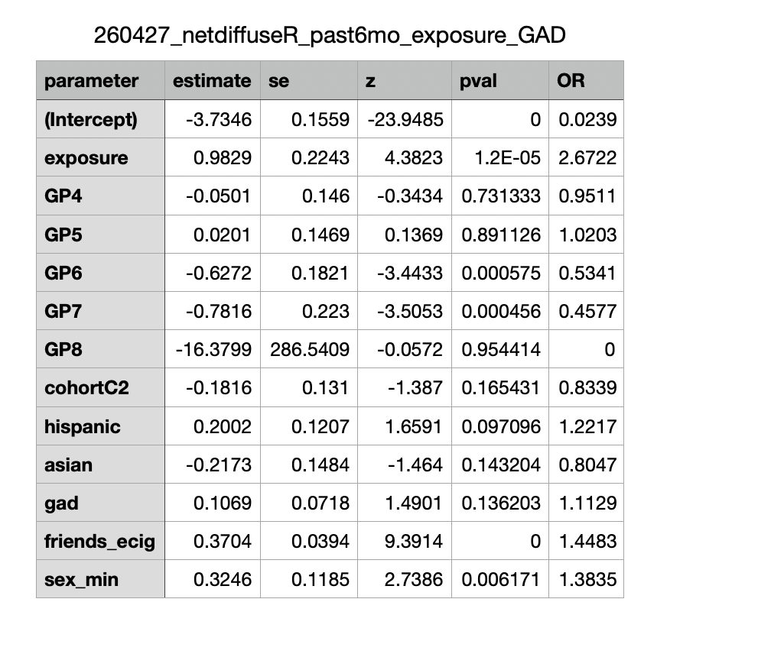
- Peer network exposure (OR = 2.73, p < .001) — every 10% increase in the fraction of friends currently using raises the odds of adoption 2.73x at the next periodPeer network exposure is real and strong:
- MDD (OR = 1.34, p < .001) is a significant predictor above and beyond peer exposure, supporting a self-medication explanationMDD predicts adoption independently:
- When GAD replaces MDD (separate model, OR = 1.11, p = .136), anxiety does not significantly predict adoption — depression uniquely mattersGAD is not significant:
- Self-reported friends using e-cigarettes (OR = 1.42, p < .001) predicts adoption over and above network-calculated exposure, suggesting social norm perception drives behavior separately from actual network contactSubjective peer perception adds independent signal:
- Sex minority students show higher odds of adoption (OR = 1.28, p = .042)Sexual minority status is a risk factor:

5. Threshold Regression Results
Quasibinomial logistic regression predicting adoption threshold (fraction of friends already using at time of adoption) among adopters only. Threshold reflects how much peer pressure a person needed before initiating use.

Table 3. Threshold Regression (GAD Model)
Parameter | Estimate | SE | t | p | OR
Hispanic | 0.5639 | 0.1902 | 2.964 | .003 | 1.76
Friends ecig (self-report) | 0.1229 | 0.0507 | 2.424 | .016 | 1.13
GAD | -0.0026 | 0.1068 | -0.024 | .981 | 1.00
Sex minority | 0.1408 | 0.1866 | 0.755 | .451 | 1.15
Asian | 0.0062 | 0.2625 | 0.024 | .981 | 1.01
Cohort C2 | -0.3506 | 0.2475 | -1.417 | .157 | 0.70

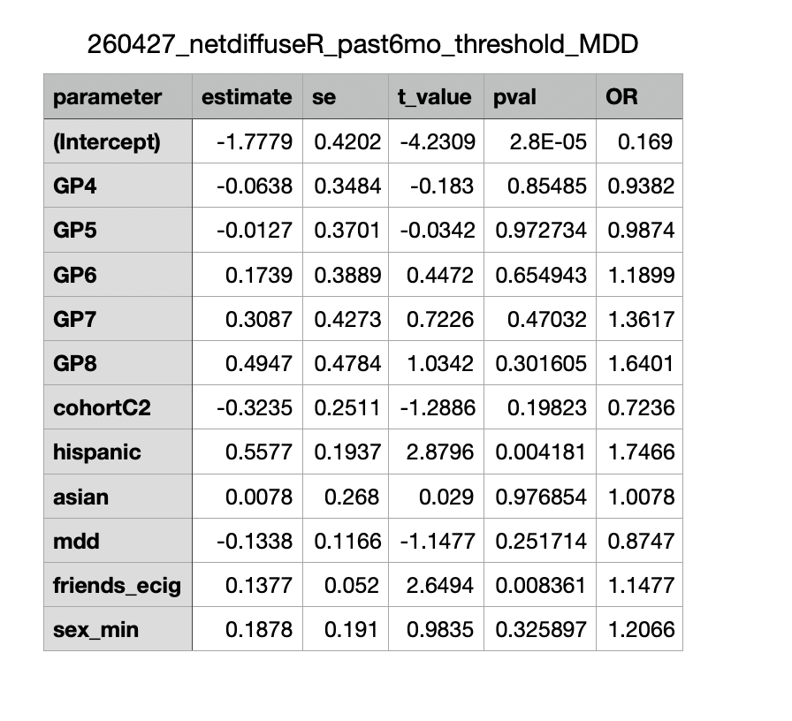
- Hispanic students have significantly higher thresholds (OR = 1.76, p = .003), meaning they needed a greater proportion of friends to already be using before they initiatedHispanic students require more peer pressure before adopting:
- Neither GAD (OR = 1.00, p = .981) nor MDD (OR = 0.87, p = .252) predicted threshold — depression influences whether you adopt, not how much peer pressure you need firstMental health does not affect threshold:
- Despite needing more social proof, Hispanic students end up with higher overall prevalence. This is explained by their network context — Hispanic-majority schools have higher baseline peer use, meaning the threshold is eventually reached regardlessKey paradox:
- Students who were more aware of peers using (friends_ecig OR = 1.13, p = .016) adopted at slightly higher thresholds, consistent with greater social norm awarenessSelf-reported friend use predicts higher threshold:

6. Key Findings Summary
- Network exposure OR = 2.73 — peer network structure is a strong driver of e-cigarette initiation across all schools and cohortsPeer contagion confirmed:
- MDD predicts adoption (OR = 1.34), GAD does not. Self-medication via e-cigarettes may be depression-specificDepression (not anxiety) is the mental health risk factor:
- Network exposure (objective) and self-reported friends using (subjective) independently predict adoption — social norm perception is an independent mechanismBoth objective and perceived peer use matter:
- Higher threshold but higher prevalence in Hispanic-majority schools — network saturation explains this discrepancyHispanic paradox in threshold:
- The gateway to adoption is peer-driven regardless of mental health statusMental health does not shape the adoption threshold:

