Exploratory Data Analysis

Data Miners

2022-12-16

### Gender of Students in the Dataset

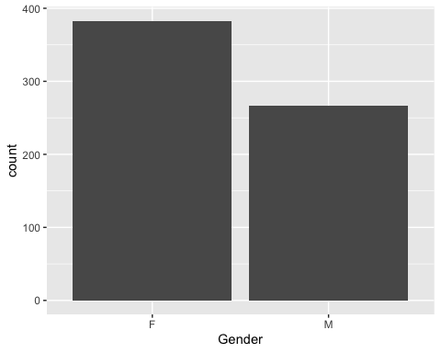

### Ages of the Students in the Dataset

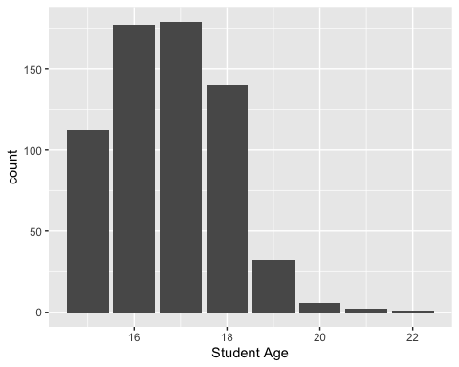

### Number of Students from Each School

* Where:
  + GP: Gabriel Pereira
  + MS: Mousinho da Silveira

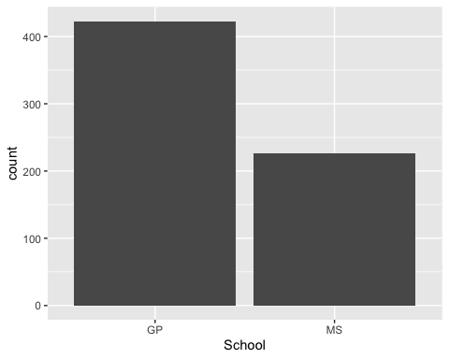

## Distribution of 1st Period, 2nd Period, and Final Grades

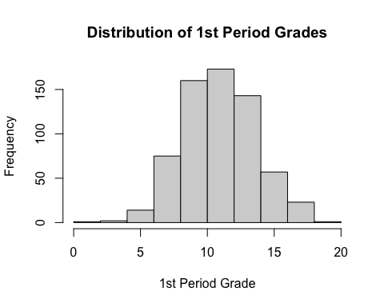

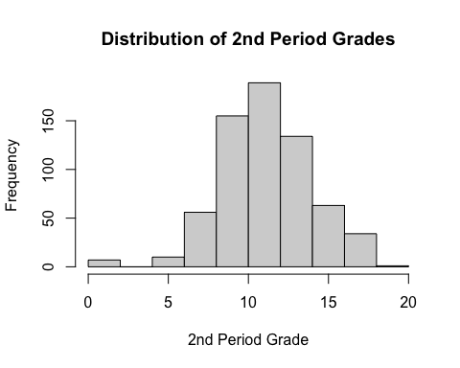

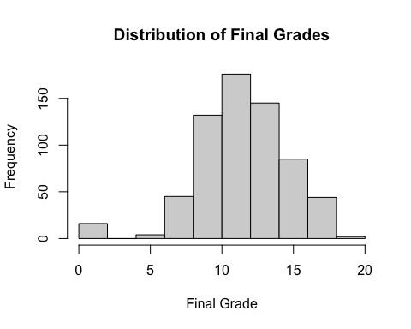

## Relationships Between Discrete Variables and Final Grade

### Mother’s Education

* Where:
  + 0: None
  + 1: Primary Education (4th Grade)
  + 2: 5th to 9th Grade
  + 3: Secondary Education
  + 4: Higher Education

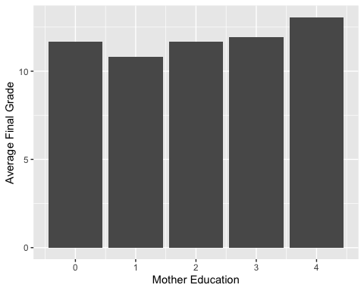

### Father’s Education

* Where:
  + 0: None
  + 1: Primary Education (4th Grade)
  + 2: 5th to 9th Grade
  + 3: Secondary Education
  + 4: Higher Education

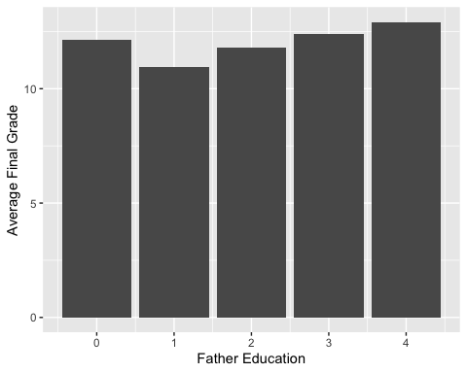

### Travel Time

* Where:
  + 1: Less than 15 minutes
  + 2: 15 to 30 minutes
  + 3: 30 minutes to 1 hour
  + 4: Greater than 1 hour

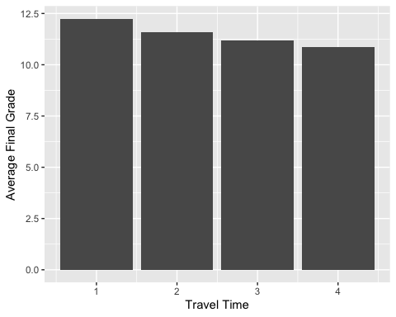

### Weekly Study Time

* Where:
  + 1: Less than 2 Hours
  + 2: 2 to 5 hours
  + 3: 5 to 10 hours
  + 4: Greater than 10 hours

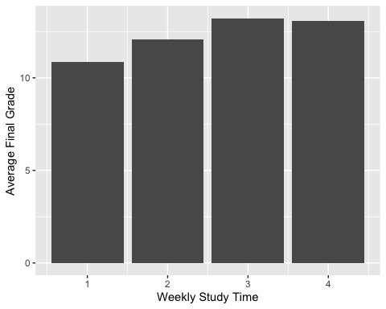

### Number of Past Class Failures

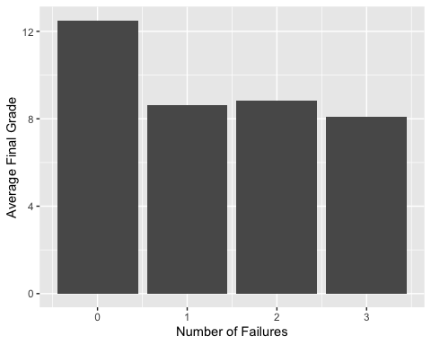

### Quality of Famliy Relationships

* Where:
  + 1: Very Bad
  + 2: Bad
  + 3: Neutral
  + 4: Good
  + 5: Very Good

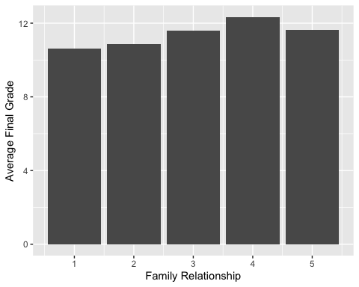

### Free Time After School

* Where:
  + 1: Very Low
  + 2: Low
  + 3: Neutral
  + 4: High
  + 5: Very High

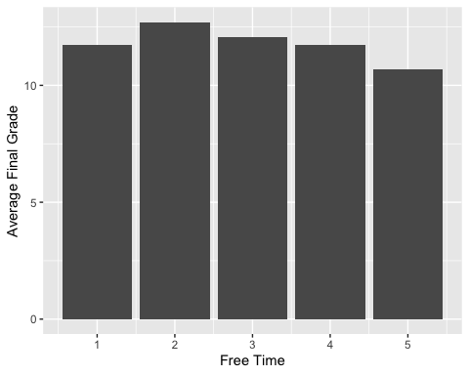

### Going Out With Friends

* Where:
  + 1: Very Low
  + 2: Low
  + 3: Neutral
  + 4: High
  + 5: Very High

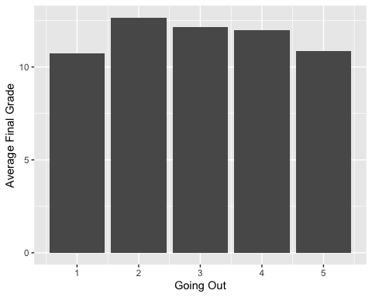

### Weekday Alcohol Consumption

* Where:
  + 1: Very Low
  + 2: Low
  + 3: Neutral
  + 4: High
  + 5: Very High

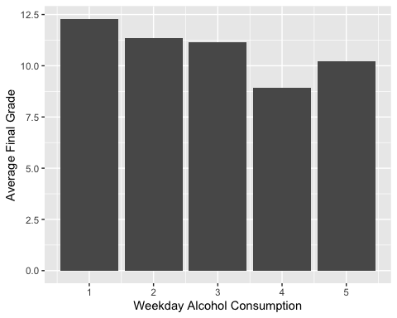

### Weekend Alcohol Consumption

* Where:
  + Very Low
  + Low
  + Neutral
  + High
  + Very High

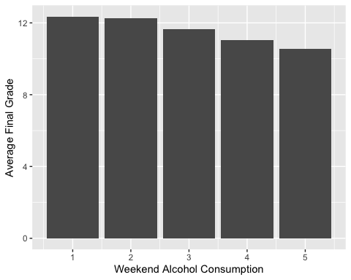

### Current Health Status

* Where:
  + 1: Very Bad
  + 2: Bad
  + 3: Neutral
  + 4: Good
  + 5: Very Good

