Geometric Aspects of Bin Grids
Version | Date | Changes
1 | 2019-08-20 | Bert Kampes, Shell – First release
2 | 2019-09-06 | BK – updated to include P6 parameters in schema. Removed section on performance. Aligned with p6 equations and I,J notation; created test data in accompanying spreadsheet.
2.1 | 2019-09-10 | BK – Updated section SDU schema
2.2 | 2019-10-11 | BK – Review by Marc Crombaghs
2.3 | 2020-04-04 | BK – Added section to test if data is on a given grid

Contents
1 Introduction 2
1.1 Terminology 2
2 Bin grid definition methods 4
2.1 Four-point definition method (“loadsheet”) 4
2.2 IOGP P6/11 definition method 6
2.3 SEG-Y format 8
2.4 SDU AbstractBinGrid and SeismicTraceData schema 8
3 Calculating P6/11 parameters from four-point definition 9
3.1 Handedness 10
3.2 Storage, compute and display precision 11
4 Forward conversion formulas (bin grid to projected coordinates) 11
5 Reverse conversion formulas (projected to bin grid coordinates) 12
6 A test for “squareness” and method for “squaring” 12
7 Seismic trace data referencing a bin grid 13
8 Reprojected Bin Grids (non-original CRS) 13
9 Audit trail 13

Introduction
The purpose of this note is to clarify bin grid defining parameters in SDU and how seismic data relate to the grid. It is intended for domain experts, architects and developers of SDU and OSDU. It contains a description of the bin grid parameterization and the math how to convert and QC the grid. The objective is to come to a clear and unambiguous definition of a bin grid with in practice a low risk of being incorrectly used. Optimization of parameters or math performance is not considered for the definition.
A bin grid is always designed on a map projection and it defines how to map horizontal “local coordinates” (inline, crossline) to “global coordinates” (Easting, Northing in the projected CRS). Two bin grid definitions are considered identical if their mapping from local coordinates to global coordinates yield the same (regardless of extent and increment). Refer to the IOGP p6/11 user guide for general description.
This document is accompanied by a spreadsheet demonstrating the formulas and containing test data.

Terminology
There is much confusion on naming and definitions between disciplines.
One source of confusion is between the direction of a constant inline vs. the direction of the inline axis (the direction of increasing inline coordinates), and whether spacing (“bin width”) is between coordinates on a line or between lines (e.g., "inline spacing", which is generally understood to be the distance between two inlines and not between two traces on an inline). More verbose variable names such as “Inline2InlineSpacingAtIncrement1” can help but are cumbersome in formulas and as headers in applications.
The notation dRΔI and dRΔJ is used in this document to define the distance between two incremented bins (i.e., the “real” spacing between traces in a volume loaded to a subsurface application).
Bearing is the surveyor term that defines a direction using the clockwise angle from grid north. A bearing is always reported in degrees in the range from 0° to 360°. Bearing is dependent on the projected CRS. “Inline bearing” is understood to be the bearing of a line in the direction of increasing crossline coordinates, but long variable names, e.g., “BearingOfAConstantInlineDirectionInDegrees” would disambiguate, albeit lengthily. It is common to see the term azimuth instead of bearing (where azimuth should be associated with true north).
Another issue is whether the coordinates represent the center of the bin, or its edge. In the P6 format and SDU parameterization an integer (inl,xln) is located at the center of a bin. During acquisition it is common for lines to be sailed and shots to be located at the edge of the bins, leading to potential confusion, particular if integer line coordinates are used during planning.
Additionally, there are many names and conventions, e.g., bin grid inline and crossline coordinates may be referred to as I, J, in-line, InLine, xline, trace, track, T, bin, B, IBL, IBP, etc. The same holds for projected X,Y coordinates and their order, and for angles, for example whether they are defined from East counter-clockwise or from (grid) North clockwise.
- Inline (I) and crossline (J) are preferred terms for local bin grid coordinates, although “inl” and “xln” may be used as more intuitive abbreviations. The IOGP p6/11 parameterization purposely uses axis I and J and does not prescribe inline or crossline. However, for practical reasons in SDU I coordinates are equated with inline coordinates.
- Easting (E) and Northing (N) are preferred terms for projected coordinates. Nonetheless, in this document the abbreviations “X” and “Y” are used for the projected coordinates. Note that internationally the abbreviations X and Y are not consistently used: in about 30% of countries Y indicates Easting.
- The order used in this document is inline before crossline and Easting before Northing.

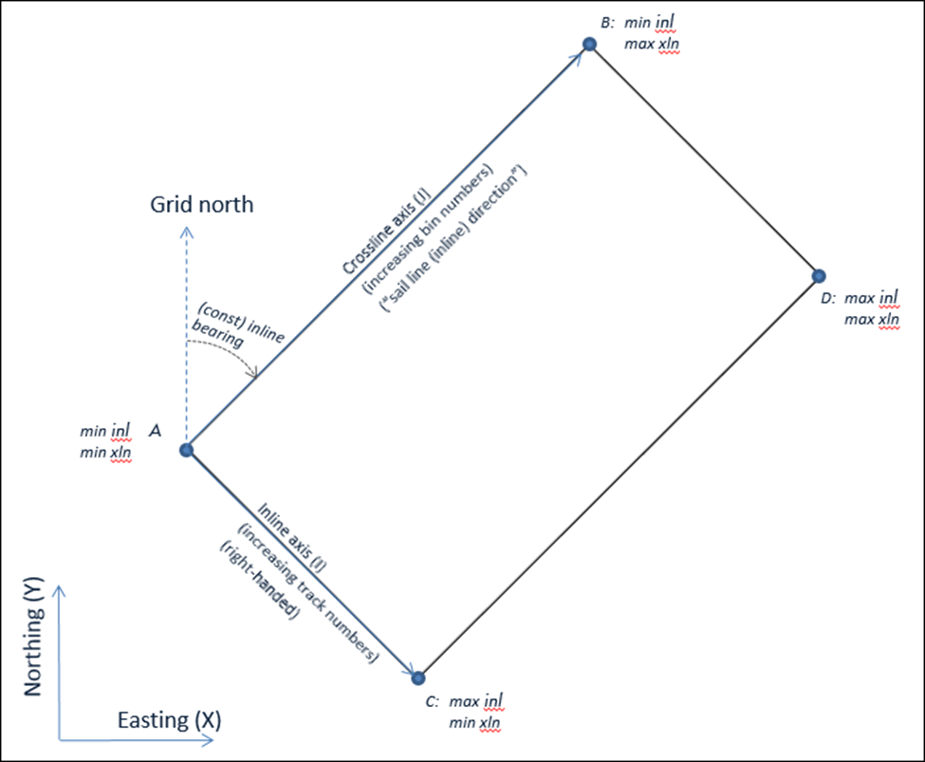Figure 1: Four-point bin grid definition using the projected and bin grid local coordinates at 4 corner tie points. The bearing and bin spacings are derived (calculated) from the given corner coordinates. See Figure 2 for a diagram how the bins fall on the grid and bin spacings are defined.

Bin grid definition methods
There are many bin grid parameterizations, but they all fall in one of two fundamental ways of defining a bin grid: origin/bearing/spacing (translation, rotation, scaling) vs. tie points at the corners (“four-point method”).
Acquisition designers and processors generally prefer to use the former method to define the grid (often use the local origin (0,0) and the mathematical definition of a counterclockwise angle from horizontal). Such parameters are needed to convert “real-world” coordinates to local coordinates, and this method by definition creates an isometric grid for binning data. However, the definition does not contain redundancy and may be ambiguously interpreted as to its axes directions and covered area of data.
Grid definitions delivered with processed data often use coordinates of 4 tie points (or 3) given on an external “load sheet”, processing report, or in the SEGY EBCDIC header. This method has the advantage that it more clearly shows spatial coverage for loading data into a subsurface application, and it enables some QC.
The only industry documented bin grid data exchange format is the IOGP P6/11 format. Relevant formulas are documented below and in IOGP GN 07-2.
Formulas are provided in this document to calculate the parameters from one definition method to another, but it is important to keep track of the original defining parameters.
- It is mandatory to compute and populate the parameters of the four-point method if the P6/11 was the defining method, and vice versa.

Four-point definition method (“loadsheet”)
The bin grid four-point definition method uses the parameters shown in Table 1.
Table 1: Defining bin grid parameters using the four-point method with example values (in red). The example points do not spatially correspond to the bin grid conceptually sketched in Fig. 1.
CRS: | NAD27 / UTM zone 15N |  | CRS Code: | EPSG::26715
Point | Inline (I) | Crossline (J) | Easting (X) | Northing (Y)
A | 14100 | 5161 | 423081.91 | 3227689.59
B | 14100 | 9409 | 491345.95 | 3309043.51
C | 17700 | 5161 | 395504.31 | 3250829.95
D | 17700 | 9409 | 463768.35 | 3332183.87

Required metadata to position the bin grid on earth is the projected CRS (identified by its EPSG code).
Scale factor, and increments (as used in the p6/11 definition method) are not considered part of the four-point definition, but if provided as P6 parameters should be used in the equations. More details are provided below.
The 16 defining parameters (+projCRS) can be stored with 16+1 attributes or by using 2 lists containing 4 points. In SDU these 16 coordinates are stored in an array of four (inl,xln) coordinates and in a SpatialLocation containing an array of four (easting, northing) coordinates, in the order A, B, C, D.
The SpatialLocation contains a reference to the projected CRS as well as metadata on QC performed. The vertical (geodetic) datum (e.g., MSL, NAVD88, etc.) should be defined in the SpatialLocation such that a seismic datum can be offset from it.
See also Fig. 1. Conceptually, the 4 points define (infinite) inline and crossline axes in a 2D Cartesian space of the projected CRS (by given coordinates on these lines rather than angles), and do not define the extent of the data. The min/max inl,xln used for the grid definition should be outside the data inl,xln range, but in a sense it would be a coincidence if the data exactly share the min/max inl,xln used in the four-point bin grid definition.
The inline and crossline local coordinates at the ABCD points are expected to be positive integers for the bin grid definition, generally no larger than 99,999, but possibly so. The data on the bin grid may go outside this range and go negatively (not expected). Conversion from projected coordinates to local coordinates yield floating points.
By definition
- Point A is the point with minimum inline and crossline.
- Line AB is a constant inline (increasing crossline coordinates).
- Line AC is a constant crossline (increasing inline coordinates).
- Point D complements a rectangle. Point D is redundant and used for QC. It would be trivial to extend the SDU format to include a three-point definition method by omitting the D point, but this is not recommended because the D point facilitates QC and spatializing the grids.
To draw a rectangle the points should be drawn from A to B to D to C to A.
Only isometric grids should be stored definitively (after QC) in SDU. Rather than assuming that the corner points form an isometric space (straight lines intersecting under 90°, forming bins with same dimensions across the grid), an ingest application should check for orthogonality using point D, or a preliminary staging area may be used to store received grid information, e.g., read from SEGY or received p6 files or SEGY headers. A test for “squareness” and a method for “squaring up” a grid are provided in this document and demonstrated in the spreadsheet.

IOGP P6/11 definition method
The P6/11 bin grid parameters are included in the SDU schema as shown in Table 2. The p6/11 method uses generic letters “I” and “J” for the bin grid coordinates. In the SDU implementation and in the formulas given in this document, the inline coordinate and the I coordinate are synonymous, as well as the J coordinate and the crossline coordinate, i.e., the I-Axis is set to be the inline axis and the J-Axis is the crossline axis.
Table 2: Defining bin grid parameters using the p6/11 method. In SDU “I” refers to the inline coordinate, “J” to the crossline coordinate (i.e., the J-Axis is parallel with the direction of constant inline). Example values (in red) do not spatially correspond to the conceptual sketch in Figure 2.
CRS: | NAD27 / UTM zone 15N |  | CRS Code: | EPSG::26715
Parameter | Symbol | Description |  | Example
P6TransformationMethod | n/a | EPSG code. See IOGP GN 373-07-2 and 483-6.  9666 for right-handed grids, 1049 for left-handed. |  | 9666
P6BinGridOriginI | I0 | Inline coordinate of tie point (often point A, not (0,0), but this could also be the center of ABCD as used in this document for the squaring algorithm). |  | 14100
P6BinGridOriginJ | J0 | Crossline coordinate of tie point |  | 5161
P6BinGridOriginEasting | X0 | Easting coordinate of tie point |  | 423081.91
P6BinGridOriginNorthing | Y0 | Northing coordinate of tie point |  | 3227689.59
P6BinWidthOnIaxis | dRΔI | Distance between two inlines at the given increment apart. Unit from projected CRS. |  | 30.000000
P6BinWidthOnJaxis | dRΔJ | Distance between two crosslines at the given increment apart. Unit from projected CRS. |  | 25.000000
P6MapGridBearingOfBinGridJaxis | Θ | Clockwise angle from grid north (requires projCRS), as seen from above, in degrees from 0 to 360 of the direction of increasing crosslines (constant inline), i.e., bearing of vector A to B (Θ, “Theta”, “inline bearing”). |  | 2.48019694
P6ScaleFactorOfBinGrid | SF | Scale factor for Bin Grid. Expected to equal 1 for all bin grid definitions in SDU. If not provided, then 1 is assumed. Unit is unity. |  | 1.00000
P6BinNodeIncrementOnIaxis | ΔI | Increment (positive integer) for the inline coordinate. If not provided, then 1 is assumed. The bin grid definition is expected to have increment 1 and the increment stored with the SeismicTraceData (“inline increment”) takes precedence over the increment set at the BinGrid, but alternatively the increments are allowed to be defined with the BinGrid. (see section “Seismic Trace Data”). |  | 1
P6BinNodeIncrementOnJaxis | ΔJ | Increment (positive integer) for the crossline coordinate. If not provided, then 1 is assumed. The bin grid definition is expected to have increment 1 and the increment stored with the SeismicTraceData (“crossline increment”) takes precedence over the increment set at the BinGrid, but alternatively the increments are allowed to be defined with the BinGrid. (see section “Seismic Trace Data”). |  | 4

The projected CRS is set in the SpatialLocation as described in the previous section on four-point definition.
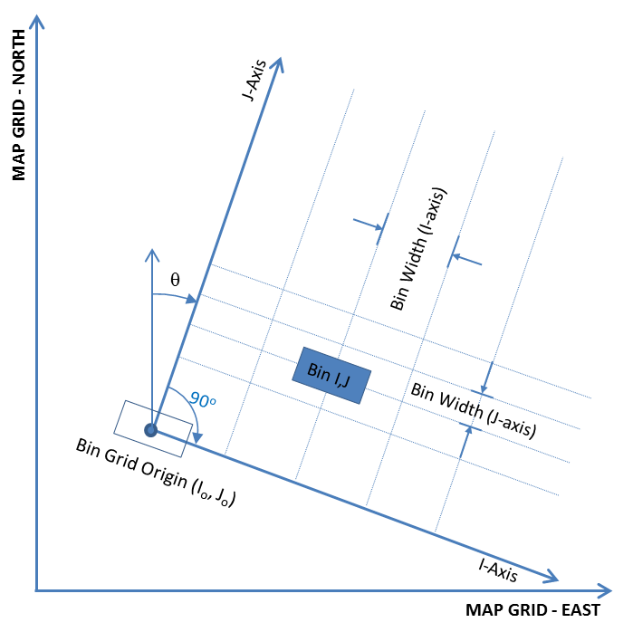
Figure 2: P6/11 defining parameters (clockwise example shown). From p6/11 user guide.
Notes
- Increments and scale factor are preferred to be equal to one, always, for the bin grid definition, but are included in the SDU BinGrid schema to enable storage of grids that make use of these parameters. The scale factor is initially equal to one because grids are defined on a projected CRS, and after a reprojection the spacings are generally updated (although scale factor could be used). The increments are expected to equal one at the BinGrid level, because the SeismicTraceData defines the increment used for the actual data (i.e., a BinGrid can be defined once at increment one, and be used for data using increment 1 and 2, for example).
The coordinates of the four corner points can be computed from these parameters using the formulas given in the IOGP Guidance Notes (repeated in this document for convenience). Vice versa, the P6/11 parameters can be derived from the four-point definition.
In the P6/11 data file the P6 specific header records would read (defining I as inline and J as crossline):
H6,3,0,0,I Axis Name… ,1,5,inline,,
H6,3,0,0,I Axis Description… ,2,5,Axis with increasing line number,,
H6,3,0,0,I Axis Direction/Orientation… ,3,5,92.48019694,3,Degrees
H6,3,0,0,J Axis Name… ,4,5,crossline,,
H6,3,0,0,J Axis Description… ,5,5,Axis with increasing crossline number,,
H6,3,0,0,J Axis Direction/Orientation… ,6,5, 2.48019694,3,Degrees
Where in this example the orientation of the inline axis is approximately east and the crossline axis north (as indicated in red), i.e., a right-handed grid (see section below on handedness).
In the P6/11 data file the transformation parameters would be stored as (example values in red):
HC,1,8,2,Transformation Method… ,4,9666,P6 (I = J+90°) seismic bin
grid transformation,1,10
HC,1,8,4,Bin grid origin I… ,4,8733, 14100.0 ,7,bin,0
HC,1,8,4,Bin grid origin J… ,4,8734, 5161.0 ,7,bin,0
HC,1,8,4,Bin grid origin Easting… ,4,8735, 423081.91 ,1,metre,0
HC,1,8,4,Bin grid origin Northing… ,4,8736, 3227689.59 ,1,metre,0
HC,1,8,4,Scale factor of bin grid… ,4,8737, 1.0 ,4,unity,0
HC,1,8,4,Bin width on I-axis… ,4,8738, 30.0 ,1,metre,0
HC,1,8,4,Bin width on J-axis… ,4,8739, 25.0 ,1,metre,0
HC,1,8,4,Map grid bearing of bin grid J-axis… ,4,8740, 2.48019694 ,3,degree,0
HC,1,8,4,Bin node increment on I-axis… ,4,8741, 1.0 ,7,bin,0
HC,1,8,4,Bin node increment on J-axis… ,4,8742, 4.0 ,7,bin,0
The ABCD points should be written to a P6/11 data file as detailed in the format specification, using test points records or perimeter points.

SEG-Y format
The SEG-Y format has provision for verification points that are defined to facilitate the validation of bin grid conversions and/or transformations, but these are rarely used. Use of the P6/11 format provides better integrity checking of the position data all the way back to the pre-acquisition planning and acquisition CRSs, and thus it is a more suitable data exchange format for binned data.
The latest versions of SEG-D (r3.1 - October 2015) and SEG-Y (r2.0 - January 2017) include support for the P-Formats Common Header method of defining coordinate reference systems. SEG-Y r2.0 can also be used for the definition of survey coverage perimeters and the listing of bin node coordinates, following the IOGP P6/11 (v1.1) format.

SDU AbstractBinGrid and SeismicTraceData schema
The following SDU schemas are used to define the location of seismic trace data.
- SeismicTraceDataWorkProductComponent.json: schema for trace data, references a BinGridID; using its coordinates.
  - AbstractBinGrid.json: schema containing parameters to define a bin grid geometry, i.e., how to convert local bin grid coordinates to projected coordinates (“real-world”).
    - ABCDBinGridLocalCoordinates: ref AbstractCoordinates.json: array used to store the inline and crossline coordinates
    - ABCDBinGridSpatialLocation: ref AbstractSpatialLocation.json:
      - ProjectedCoordinates: ref AbstractCoordinates.json: array for storing the projected coordinates
      - ProjectedCRSID: ref HorizontalCRS.json: defines the projCRS of bin grid
      - VerticalCRSID: ref VerticalCRS.json: defines the geodetic vertical datum (e.g., MSL)
      - CoordinateTransformation: ref AbstractCoordinateTransformation.json used to store the transformation used in case grid is not original
      - CoordinateQualityCheckRemark: Description of quality, e.g., the maximum squaring error if a grid was reprojected.
  - LiveTraceOutline: ref AbstractSpatialLocation.json: used to store mapping coordinates (WGS 84)
The SDU AbstractBinGrid schema includes properties to store the P6/11 parameters as well as the more straightforward four-point definition (“loadsheet”). This enables bin grid definition by either method, though the parameters of the other definition method must be calculated (using the formulas given in this document) and stored in SDU.
A flag is used to identify which was the original defining method:
- BinGridDefinitionMethodTypeID = 4 // four-point method
- BinGridDefinitionMethodTypeID = 6 // P6/11 method
This is important for audit trail purposes, but also to avoid imprecision of calculated values (e.g., bin width calculated using the corner coordinates vs. given bin width). Table 3 summarizes the defining and optional parameters for each method.
Table 3: Overview of mandatory parameters depending on bin grid definition method. Note that (aside from coordinates) the SpatialLocation object includes the projected CRS and additional information.
BinGridDefinitionMethodTypeID | 4 (four-point method) | 6 (P6/11 method)
Mandatory | ABCDBinGridLocalCoordinates  ABCDBinGridSpatialLocation | P6TransformationMethod  P6BinGridOriginI  P6BinGridOriginJ  P6BinGridOriginEasting  P6BinGridOriginNorthing  P6BinWidthOnIaxis  P6BinWidthOnJaxis  P6MapGridBearingOfBinGridJaxis
Optional | P6ScaleFactorOfBinGrid  P6BinNodeIncrementOnIaxis  P6BinNodeIncrementOnJaxis | P6ScaleFactorOfBinGrid  P6BinNodeIncrementOnIaxis  P6BinNodeIncrementOnJaxis

Calculating P6/11 parameters from four-point definition
The formulas to compute the bin spacings and bearing of a line of increasing crosslines (constant inline) from a four-point definition are as follows.
R_{A,C} = sqrt{(Y_{C}-Y_{A})² + (X_{C}-X_{A})²},
R_{B,D} = sqrt{(Y_{D}-Y_{B})² + (X_{D}-X_{B})²},
dRΔI = ΔI * average{R_{A,C}, R_{B,D}} / (I_{C}-I_{A})

R_{A,B} = sqrt{(Y_{B}-Y_{A})² + (X_{B}-X_{A})²},
R_{C,D} = sqrt{(Y_{D}-Y_{C})² + (X_{D}-X_{C})²},
dRΔJ = ΔJ * average(R_{A,B}, R_{C,D}) / (J_{B}-J_{A})

θ_{A,B} = atan2(X_{B}-X_{A}, Y_{B}-Y_{A}),
θ_{C,D} = atan2(X_{D}-X_{C}, Y_{D}-Y_{C}),
θ = atan2(sin(θ_{A,B})+sin(θ_{C,D}), cos(θ_{A,B})+cos(θ_{C,D}))
If θ<0 then θ += 360;
Where
- dRΔI and dRΔJ are the bin widths between inlines and crosslines, respectively, at the given increment separation (in unit of the projCRS); These are positive numbers.
- θ is the average bearing of a line with increasing crossline coordinates (constant inline). Euler’s formula is used to avoid discontinuous wraparound issues when averaging the bearings, e.g., as a convenient formula to calculate the average bearing of 359° and 2° as 0.5°;
  - An alternate method is:
// Take care to properly average bearings across wraparound effect at 0°
// (e.g., average(1°,357°)=359°; average(3°,359°)=1°, average(1°,359°)=0°)
// All bearings must be in degrees in the interval [0,360>.
If (abs(θ_{A,B} - θ_{C,D})<10) then θ = (θ_{A,B} + θ_{C,D})/2
Else if [(θ_{A,B} + θ_{C,D} +360)/2 < 360]
then θ = (θ_{A,B} + θ_{C,D} + 360)/2
Else θ = (θ_{A,B} + θ_{C,D} + 360)/2 - 360
- Atan2(y,x) is the four-quadrant arc-tangent function equal to arctan(y/x) in the first quadrant.
- Computed bearings are reported in degrees in the interval [0,360>. Mapping into this interval can be achieved by an if statement (as shown) or by using the mod() function (again, also be aware of language dependent implementation of the mod function).

Handedness
A grid is said to be “right-handed” (or “clockwise”) if the inline axis points to the right of the crossline axis (when viewed from above the plane containing the two axes). Said differently, standing at a constant inline, looking from A to B (in the direction of increasing crosslines), then the grid is “right-handed” if the next higher inline is to the right.
For the P6/11 parameters, in SDU the P6 I-Axis is defined to be identical to the inline axis (the direction of increasing inline coordinates), and the J-Axis corresponds to the crossline axis (the direction of increasing crossline coordinates, direction of a constant inline). The P6/11 format uses a different transformation method (different math) for right-handed and left-handed grids.
A mathematical formula to determine handedness is:
If { (X_{C}-X_{A})*cos(θ) > (Y_{C}-Y_{A})*sin(θ) } then right-handed, else left-handed
This test is based on rotating the bin grid counterclockwise around point A by the bearing of a constant inline (direction of increasing crosslines). After executing such rotation, the vector AB’ points due north by definition. If the grid is right-handed then the rotated vector AC’ would point to the east, and if the grid is left-handed it would point to the west. Hence, the test for right-handedness only needs to consider whether the X coordinate after translation and rotation is positive (using X’= X*cos(θ) – Y*sin(θ) for counterclockwise rotation).
An alternative method to determine handedness is given by the following algorithm:
θ_{A,C} = atan2(X_{C}-X_{A}, Y_{C}-Y_{A}),
If θ_{A,C} <0 then θ_{A,C} += 360;
θ_{rot90} = θ + 90; // add 90 degrees to const inline direction for handedness test
If θ_{rot90} > 360 then θ_{rot90} -= 360; // ensure in interval [0,360>.
// grid is right-handed if θ_{rot90} roughly aligns with θ_{A,C}:
If { abs(θ_{rot90} - θ_{A,C})<10 or abs(θ_{rot90} - θ_{A,C})>350) } then
right-handed
else
left-handed

Storage, compute and display precision
Projected coordinates of the ABCD points should be entered using 3 or 2 decimal places but may only be available as integers from the header or loadsheet. Therefore, derived bearing and bin spacings may not be exactly “nice” but suffer from computation imprecision when displayed (e.g., 24.99991m). Bin spacing should be shown to 6 decimal places and angles to 5 decimal places to keep precision of ~1cm per 100km; for computation full computational (double) precision should be used. There is a risk of error propagation when storing rounded computed angles and spacings if these are consequently used to compute coordinates (with the equations given below).

Forward conversion formulas (bin grid to projected coordinates)
Given the P6/11 parameters (symbols as defined in Table 2), formulas to convert from bin grid coordinates to projected coordinates are per IOGP GN 07-2:
Right-handed bin grids:
X = X0 + [(I-I0)*cos(θ)*SF*dRΔI/ΔI] + [(J-J0)*sin(θ)*SF*dRΔJ/ΔJ]
Y = Y0 – [(I-I0)*sin(θ)*SF*dRΔI/ΔI] + [(J-J0)*cos(θ)*SF*dRΔJ/ΔJ]
Left-handed bin grids:
X = X0 – [(I-I0)*cos(θ)*SF*dRΔI/ΔI] + [(J-J0)*sin(θ)*SF*dRΔJ/ΔJ]
Y = Y0 + [(I-I0)*sin(θ)*SF*dRΔI/ΔI] + [(J-J0)*cos(θ)*SF*dRΔJ/ΔJ]
These equations can be combined into a single expression by defining an additional parameter in the application for handedness that equals 1 for right-handed grids and -1 for left-handed grids, i.e.,
X = X0 + handednesssign* [(I-I0)*cos(θ)*SF*dRΔI/ΔI] + [(J-J0)*sin(θ)*SF*dRΔJ/ΔJ]
Y = Y0 – handednesssign* [(I-I0)*sin(θ)*SF*dRΔI/ΔI] + [(J-J0)*cos(θ)*SF*dRΔJ/ΔJ]
Additionally, for performance the constant parts of the formula could be pre-computed for the bin grid and/or vectorized using matrix notation as shown in IOGP GN 07-2, which would be useful when converting an array of many local coordinates at once.

Reverse conversion formulas (projected to bin grid coordinates)
Given the P6/11 parameters (symbols are defined in Table 2), formulas to convert from bin grid coordinates to projected coordinates and vice versa are given in IOGP GN 07-2 as:
Right-handed:
I = I0 + { [(X-X0)*cos(θ) – (Y-Y0)*sin(θ) ] * [ΔI / (SF*dRΔI)] }
J = J0 + { [(X-X0)*sin(θ) + (Y-Y0)*cos(θ)] * [ΔJ / (SF*dRΔJ)] }
Left-handed:
I = I0 – { [(X-X0)*cos(θ) – (Y-Y0)*sin(θ) ] * [ΔI / (SF*dRΔI)] }
J = J0 + { [(X-X0)*sin(θ) + (Y-Y0)*cos(θ)] * [ΔJ / (SF*dRΔJ)] }
Combined into a single expression as:
I = I0 + handednesssign* { [(X-X0)*cos(θ) – (Y-Y0)*sin(θ) ] * [ΔI / (SF*dRΔI)] }
J = J0 + { [(X-X0)*sin(θ) + (Y-Y0)*cos(θ)] * [ΔJ / (SF*dRΔJ)] }

A test for “squareness” and method for “squaring”
Given the coordinates at the four corners (ABCD points), a test can be done for “squareness” and an optimally “squared up” grid can be computed, as well as an intuitive measure of “non-squareness” in a physically meaningful way (i.e., expressed in meters or bins, and not as, e.g., an orthogonality factor of 0.998231). A bin grid defined using P6/11 parameters is isometric by definition and cannot be “squared up”.
Testing whether the ABCD points span a rectangle is useful to QC provided bin grid definitions (e.g., a vendor loadsheet or coordinates from SEGY header, which may be integer), particularly when a grid is reprojected (which causes a warping that may be approximated by a fitted rectangle).
A simple method to test for squareness is to calculate the P6/11 parameters as shown above, and then to use the forward equations to compute modeled projected coordinates. The difference between the original ABCD coordinates and the modeled coordinates reveals the “squareness”. If the P6/11 origin is defined at the center of the ABCD points, then automatically a “best-fitting” rectangle is modeled, and the difference with the original coordinates indicates a maximum mis-location error in unit of the projected CRS (max. mis-location will be at the corners). Conversely, the original projected coordinates can be used to compute modeled bin grid coordinates.
This method is demonstrated in the accompanying spreadsheet.
During QC of a received bin grid a threshold can be set, e.g., 1.5 m, which can be used to signal further investigation is needed. The “best-fitted” squared-up coordinates could be stored, or preferably, coordinates computed from a logical P6/11 parameterization (i.e., with “nice” round spacings and bearing values used during imaging).
When loading a re-projected bin grid into a subsurface interpretation package a threshold of 1 (incremented) bin could be used.

Seismic trace data referencing a bin grid
Given the definition of a bin grid, the spatial extent of seismic trace data in a 3D volume can be defined by its minimum and maximum inline and crossline coordinates. Decimated data can be loaded by defining its increment with the trace data. In some applications it is required to define incremented grids explicitly, generally with the condition that the max inl,xln is an exact integer multiple of the increment.
For data loading the increment is considered "skip counting" or subsampling of a higher resolution grid as shown in the Figure below. If the bin grid is defined from min:max = 1:10 then the data could have increment 2 and min=3, max=9; or min=2, max=8, for example, where traces would be posted starting at the given minimum.
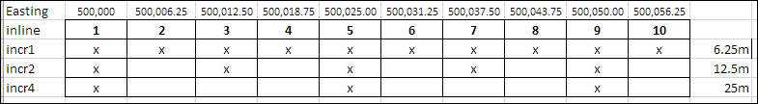

How to detect if a dataset is on an already defined bin grid
The objective of managing bin grids is to avoid a situation in which millions of datasets all have their own grid definition of which the location cannot be verified. Therefore it is convenient to be able to search through a database of technically assured bin grids, returning the bin grid that matches the data.
It is assumed that new SeismicTraceData work products that are loaded to the SDU will reference a bin grid, hence establishing that relation from the beginning. However, legacy data are sourced to SDU and they may not have that relation to a bin grid established, and duplicates should be avoided. Hence, the following algorithm should be used when loading legacy data into SDU
- First retrieve following parameters for the existing SeismicTraceData volume:
  - Projected CRS and the I,J,X,Y coordinates at points A,B,C,D
    - When possible, coordinates should be in the original projected CRS (before transformation/reprojection), if these are stored in the source system.
  - The “real” spacings (dRΔI, dRΔJ) between loaded traces
    - E.g., if traces were loaded with increments 1x4 on a bin grid that had spacing 30x6.25m at increment 1, then the “real” spacings are 30m and 25m.
- Then iterate over all bin grids stored in SDU (or other corporate database used to manage bin grids) to find a match:
  - Compute (X’,Y’) at the (I,J) of points A,B,C,D using the bin grid
  - Compute max(dA,dB,dC,dD) for distances d = sqrt{(X-X’)^2 = (Y-Y’)^2} for A,B,C
- Then find all grids for which max(dA,dB,dC,dD) < 0.5*min(dRΔI, dRΔJ), i.e., within half a bin
  - If >1 grids found then
    - Remove grids for which the projCRS of the data is not equal to that of the bin grid
    - If there is a duplicate in the bin grid database then remove the duplicate in the database and rerun the algorithm.
    - If the database has a grid with the same increments as the dataset then take that (i.e., if the system defines duplicates grids with specific increments; the recommendation is not to store duplicated grids that only differ in increment).
    - Potentially the grid type could be used (e.g., if a velocity grid exists and a processing grid)
    - Assign the grid with the smallest distance criterion.
  - If 1 grid found then assign it to the dataset.
    - If the projCRS of the data is equal to that of the bin grid
  - If 0 grids found then create the bin grid definition in SDU (or other corporate bin grid management system) and repeat the above steps.
    - Note: only bin grids for actual SeismicTraceData are stored, not synthetic grids created for models. It may happen grids are defined in work stations that are not for SeismicTraceData and such grids are not expected to be defined in the database.
Note:
A bin grid database may store all grids in CRSs that use meters, while data loaded to interpretation systems utilize US survey foot, specifically for US GOM, NAD27 / UTM zone 15N [EPSG::26715] vs. NAD27 / BLM 15N (ftUS) [EPSG::32065] – similar for zone 16N.
Therefore, an exception is made in the above steps to allow a match if actual coordinates in ftUS match a grid defined in meter. This is specifically for CRS codes 26715<>32065 and 26716<>32066. To convert between these systems, multiply coordinates in ftUS by factor 1200/3937 to get meters.
Practically this could be implemented in the iteration loop by adding in converted versions (i.e., by adding a version multiplied by 1200/3937 and a version multiplied by 3937/1200), for which the projCRS then can be checked in the evaluation loop, reviewing grids that matched within half a bin.
The alternative is to ensure bin grids in the database are defined with the CRS used for interpretation.

Reprojected Bin Grids (non-original CRS)
Only original bin grids should be stored in SDU, ideally, i.e., using the original projected CRS that the data was binned in and received in. Applications or delivery agents then can execute the transformation or reprojection to the desired projected CRS used in the application, and properly deal with any non-squareness caused by such coordinate operation.
However, it is likely that grids are defined that were transformed or reprojected, which need to be stored in SDU. If a bin grid definition is persistently transformed or converted to another CRS then metadata should be included such that a user can see what the original CRS was and which operations were applied. In that case, the LineageAssertion should be used, i.e., the transformed grid is to be linked back to its SOURCE Bin Grid using its SRN serial number. This is particularly important if a large squaring error was needed to make the grid isometric in the reprojected space.
The ABCDSpatialLocation coordinate quality fields should be used to remark that the bin grid was transformed, and the approximation error due to squaring. The CoordinateTransformation should be populated with the coordinate transformation used.
An extension to a 2D polynomial of degree and order two can describe bin centers in the reprojected space to high accuracy. This may yield a convenient method to visualize bin grids in such reprojected space, e.g.,
X = a0 + a10*I + a20*I^2 + a01*J + a02*J2 + a11*I*J
Y = b0 + b10*I + b20*I^2 + b01*J + b02*J2 + b11*I*J
And similar for reverse. For numerical reasons the coordinates may need to be normalized when estimating the coefficients, and orthogonal base functions could be used instead.

Audit trail
This note focuses on the geometric aspects of bin grids and calculations. However, additional metadata is needed, for example to describe the source document of the grid definition source and QC audit trail are required (Lineage).

Report 483-6-1 “P6 Format Specification”, 483-6u “User Guide”, and 483-6g “Guidelines for the use of the P6/11 GIS Data Model”, freely available via www.iogp.com/bookstore.
IOGP Geomatics Guidance Note 373-07-2 “Coordinate Conversions and Transformations including Formulas”, freely available via www.iogp.com/bookstore.
SEG documents available via http://seg.org/Publications/SEG-Technical-Standards.
Beware of programming language dependent implementation differences, notably in Excel y and x are reversed (i.e., in Excel atan2(y,x)=atan(x/y)). When implementing these formulas ensure to use good test cases to ensure that all possible situations are covered (all quadrants).
Alternatively only points A and D could be used, or ABC if only those are stored.

