Wellbore trajectory calculations in OSDU

Version | Date | Changes
0.1 | 2019-08-25 | Bert Kampes, Shell Geomatics. Draft. Initial internal note.
1 | 2019-09-06 | BK – Incorporated feedback from Wells via Marcus Ridgway.
2 | 2019-09-14 | BK – Finalized for workshop (not all decisions are final – to be updated).
3 | 2019-10-02 | BK – Incorporated workshop output on decisions.
4 | 2021-03-26 | BK – Added minimum curvature interpolation formulas and test data.
5 | 2021-09-14 | BK – Changes for OSDU
6 | 2023-02-25 | BK – Added Inclination-only appendix. Clarified that the decisions to normalize stored data in tables are not followed in OSDU. Instead the original data is stored and no relational database but csv/witsml files.

Table of contents
1 Introduction 3
1.1 Definitions 3
1.2 Survey observables to wellbore local coordinates 4
1.3 Wellbore local to geodetic coordinates 4
2 Minimum Curvature 5
2.1 Forward case 5
2.2 Rates of change 6
2.3 Minimum Curvature Interpolation at MD 6
2.3.1 Interpolation at a regular MD interval 8
2.4 Inverse Minimum Curvature 9
3 Local coordinates to geodetic coordinates in 3D space 11
3.1 Depth calculation 12
3.2 Rotating local (n,e) from True North to Grid North and vice versa 12
3.3 Wellbore local to projected (GNL) 13
3.4 Wellbore local to geographic (LMP) 15
3.5 Grid offset coordinates 16
4 Industry data exchange protocols and file formats 18
5 Implementation 19
5.1 General 19
5.2 Directional survey observables (stations) 20
5.3 Calculation of local coordinates 22
5.4 Calculation of geodetic coordinates 23
Appendix A. Inclination-only surveys or stations (survey program) 25
A1. Replacement MD,INC,AZI for loading into subsurface applications 27
A2. An algorithm to deal with “mixed inclination-only” (composite) surveys 28
Appendix B. ZDP types 30
Appendix C. Magnetic declination and grid convergence 31
C1. Magnetic declination 31
C2. Grid convergence 31
C3. Impact of change of convergence to computed wellbore path 33
Appendix D. Point scale factor and depth correction factor 34
D1. Impact of ignoring (change of) scale factor to computed wellbore path 36
D2. Thought experiments on the need for advanced geodetic calculations 36

Introduction
The purpose of this note is to clarify wellbore trajectory calculations in OSDU and the API. It is intended for domain experts and developers of OSDU. Sharing with OSDU members is allowed. It contains description of the parameters and math formulas how to convert and test. It is accompanied by a spreadsheet implementing the provided equations and test data.

Definitions
Borehole survey observables are measured depth (MD), inclination (I), and azimuth (A); given at survey stations at increasing depth along the wellbore. These are used to calculate local offset coordinates, which are then converted to geodetic coordinates representing the wellbore path in 3D space. The measured depths are referenced to a known Zero-depth Point (ZDP). The azimuth angles are referenced to Grid North or True North. The calculated local offset coordinates are oriented in the same direction as the azimuth reference, and have the same unit as the MD.
There is some confusion on naming and definitions between disciplines, even on sign convention for depth. Notably local offsets and TVD are ambiguously defined. The following notation is used in this document:
- Directional survey observables: M,I,A (at stations s=1:S down the borehole)
- Wellbore local coordinates: n,e,d (sometimes referred to as +N/-S, +E/-W, TVDZDP)
- Geodetic coordinates: N,E,D (In wellbore community referred to as Y, X, TVDSS)
It should be noted that the directional survey observables are derived from underlying raw sensor measurements and that not all survey types yield M,I,A data. The following survey types are generally classified, where the first two are most common and do come with a full set of observables.
- Magnetic surveys: Magnetometers are used to measure azimuth from Magnetic North (converted to True North or Grid North); Gravity accelerometers to measure inclination.
- Gyro surveys: Gyroscopes are used to measure azimuth from True North (possibly converted to Grid North). Accelerometers to measure inclination.
- Inertial surveys: High-frequent gyroscopes and accelerometers are used to estimate n,e,d directly. May yield M,I,A observables as well. Often interpolated to 10 or 20 ft MD interval for practical reasons.
- Inclination-only surveys: Also known as ‘TOTCO’ surveys after the manufacturer of a tool. Azimuth observations are not available. This type of survey was typically used for vintage vertical wells. A vertical path must be assumed but the inclination measurements can be used to compute a worst-case offset from vertical.
- Blind surveys: Inclination nor azimuth are available. If the MD at total depth is available a vertical straight-line projection can only be assumed (with large uncertainty).
- Utility surveys: Horizontal directional drilling for utility installation.

Survey observables to wellbore local coordinates
Over the years many methods have been devised to calculate local offsets from the directional survey observables Measured Depth, Inclination and Azimuth. These methods include the following. The first three model the wellpath as a straight line between survey stations.
- Tangential: Simple “dead reckoning” method using constant Inclination and Azimuth of first station in the interval. Can lead to large errors.
- Average angle: Slight improvement to Tangential using the average Inclination and Azimuth.
- Balanced tangential: Another slight improvement, applying the Inclination and Azimuth angles observed at the survey station halfway back into the previous interval and halfway forward into the next.
- Radius of curvature: Assumes that the wellpath fits on the surface of a cylinder and therefore can have a horizontal and vertical radius.
- Minimum curvature: Effectively the industry standard. Assumes the wellpath fits on the surface of a sphere and hence is modeled by a single radius in a plane in 3D space which minimizes the curvature required to fit the angular observations.
Minimum curvature is the nowadays accepted method used and the Shell Wells standard as specified in the Borehole Survey Manual. The math is provided in Section 2, interpolation at MD in Section 2.3, and the reverse case equations in Section 2.4. However, there may be cases for planning wells from only a few points or specific error cases where another method is more suitable. Since it assumes a constant arc from one station to the next this may be unlikely to be the case, particularly when using mud motors that slide and rotate between stations.
For all methods the survey frequency must be high enough to satisfy the wellbore objective, i.e., relative to the acceptable inaccuracy of the calculated trajectory. In general, a survey will be taken every pipe stand (90 ft), but it may be done every pipe joint (30 ft) if the build rate is high (or even more frequent with continuous rate gyro or inertial methods).
Detailed discussion of adequate survey interval to accurately determine the trajectory is outside the scope of this note, though comes in play during automated QC of loaded data (in its simplest form by checking the average course length, or more advanced methods like data snooping).

Wellbore local to geodetic coordinates
Historically the calculation methods to convert local coordinates to geodetic coordinates has not been described with much rigor, implying it is simply a 3D translation using the known surface location coordinates. This led to some operators and service providers to correct for scale factor, even depth correction factor, and some not. The EPSG methods for this step are given in Section 3.

Minimum Curvature

Forward case
The minimum curvature algorithm calculates cubical local coordinates from one station to the next based on the measured Inclination and Azimuth angles at station 1 and 2, and the difference in MD. The equations provided below yield identical results as the equations given in the ISCWSA eBook.
The provided equations use trigonometric identities to limit the number of evaluations and explicitly deal with special cases for simple yet safe practical implementation (avoiding domain errors in inverse trigonometry functions due to numerical rounding).
First, Dogleg (DL) and Ratio Factor (RF) for the part of the wellbore between survey station 1 and 2 are computed from the observed Measured Depth, Inclination and Azimuth at these station as:
DL = cos⁻¹ [sin(I₁)*cos(A₁)*sin(I₂)cos(A₂) + sin(I₁)*sin(A₁)*sin(I₂)*sin(A₂) + cos(I₁)*cos(I₂)]
= cos⁻¹ [cos(I₁)*cos(I₂) + sin(I₁)*sin(I₂)*cos(A₂-A₁)]
= cos⁻¹ [cos(I₂-I₁) – sin(I1)*sin(I₂)*(1–cos(A₂-A₁))]
= cos⁻¹ [max(-1,min(1, cos(I₂-I₁) – sin(I₁)*sin(I₂)*(1–cos(A₂-A₁)) ))] // safe implementation
= 2*sin⁻¹ {sqrt[ sin²((I₂-I₁)/2) + sin(I₁)*sin(I₂)* sin²((A₂-A₁)/2) ]} // SPE84246 recomm.
RF = 1, if DL=0
2*tan(DL/2) / DL, else
The offsets of the second point from the first point are:
Δn_{1,2} = n₂ – n₁ = ΔM * (RF/2) * (sin(I₁)*cos(A₁) + sin(I₂)*cos(A₂))
Δe_{1,2} = e₂ – e₁ = ΔM * (RF/2) * (sin(I₁)*sin(A₁) + sin(I₂)*sin(A₂))
Δd_{1,2} = d₂ – d₁ = ΔM * (RF/2) * (cos(I₁) + cos(I₂))
where
ΔM = M₂-M₁, the course length between station 1 and 2.
The Δn offset is aligned with the north reference direction of the input azimuths (grid north or true north) and Δe with the east direction. These offsets are computed between each pair of survey observables down the borehole and integrated up to yield the sought local coordinates (n,e,d) as:
n₁ = 0, e₁ = 0, d₁ = 0 // initialize first point in array
n₂ = n₁ + Δn_{1,2}, e₂ = e₁ + Δe_{1,2}, d₂ = d₁ + Δd_{1,2}
n₃ = n₂ + Δn_{2,3}, e₃ = e₂ + Δe_{2,3}, d₃ = d₂ + Δd_{2,3}
etc.
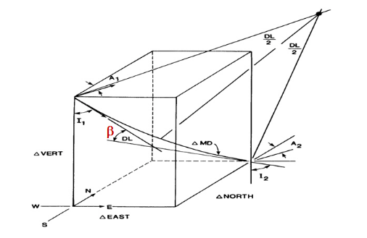
Figure 1: Minimum curvature path calculation using MD,INC,AZ observables given at station 1 and station 2.

Rates of change
The following formulas are not required for the Minimum Curvature calculations but often reported to users in tables and given here for completeness. Convert all distances to meter and angles to degree.
Dogleg severity (expressed here in degrees per 30 m of course length, alternatively use deg/100 ft):
DLS = 30 * DL / ΔM
Build up rate (rate of change of inclination expressed in degrees per 30 m):
BUR = 30 * (I₂-I₁) / ΔM
Rate of turn (rate of change in azimuth in degrees per 30 m):
ROT = 0, if I₁<0.0001
30*(A₂-A₁) / ΔM, else if abs(A₂-A₁)<180 // normal case
30*(A₂-A₁-360) / ΔM, else if A₂>A₁
30*(A₂-A₁+360) / ΔM, else
Average course length (distance between stations in meters):
ACL = (M_{S}-M₁) / (S-1), // S is number of (real) surveys stations; M_{S} the MD at the last station.
ACL = (M_{S}-M₂) / (S-2), // for deepwater start at second point if first real survey is at seabed.

Minimum Curvature Interpolation at MD
In this section (minimum curvature) interpolation refers to the computation of local coordinates at some given Measured Depth in between two survey stations, on the arc computed by the minimum curvature algorithm. Interpolation (or extrapolation) of other parameters are possible, for example to obtain the MD at a given inclination. Equations are based on the SPE paper of Sawaryn and Thorogood.
Let M_{i} be the Measured Depth at the point of interpolation in between surveyed station 1 and 2. Then DL_{i,}, the Dog Leg between the first point and the point of interest, is calculated by its linear relation with course length on the interpolation arc as:
DL_{i} = DL_{1,2} * (M_{i}-M₁) / (M₂-M₁),
where DL_{1,2} is the Dog Leg between surveyed stations 1 and 2 as per section 2.1. In the Sawaryn paper DL is denoted by α and DL_{i} by α* as a subtended angle. Note also that the Sawaryn paper recommends the following equation to compute DL:
DL = 2*sin⁻¹ {sqrt[ sin²((I₂-I₁)/2) + sin(I₁)*sin(I₂)* sin²((A₂-A₁)/2) ]} // SPE84246 recommended
Because of its increased precision for small angles using the arcsine rather than the arccosine as provided in the equation in section 2.1 of this note. When tested in MS Excel both formulations yielded identical results.
The inclination and azimuth are interpolated using the interpolated Dog Leg DL_{i} as:
I_{i} = I₁ // if DL_{i}=0
cos⁻¹ [ (sin(DL-DL_{i})/sin(DL))*cos(I₁) + (sin(DL_{i})/sin(DL)*cos(I₂) ] // else
A_{i} = A₁ // if DL_{i}=0
ATAN2 (sin(I₁)*sin(A₁)*sin(DL-DL_{i}) + sin(I₂)*sin(A₂)*sin(DL_{i}) , // else
sin(I₁)*cos(A₁)*sin(DL-DL_{i}) + sin(I₂)*cos(A₂)*sin(DL_{i}) )
The equation for I_{i} was derived from equation A-23 in Sawaryn. It seems to yield the same results in a more direct manner than the solution provided in the paper. In the SPE paper a more general solution is given (Eq. 16-18 solving A-28) which requires the interpolated azimuth. The equation for A_{i} is identical to Eq. 23 in the paper but made explicit to yield azimuth from 0 to 360 degrees. Note that if DL_{i}=0 then DL=0 and I₁=I₂ and A₁=A₂.
The cubical offsets at the interpolation point from station 1 are obtained using the standard minimum curvature equations given in section 2.1 but using the interpolated DL_{i} , I_{i} and A_{i}:
RF_{i} = 1, if DL_{i}=0
2*tan(DL_{i}/2) / DL_{i}, else
Δn_{1, i} = n_{i} – n₁ = ΔM_{i} * (RF_{i}/2) * (sin(I₁)*cos(A₁) + sin(I_{i})*cos(A_{i}))
Δe_{1, i} = e_{i} – e₁ = ΔM_{i} * (RF_{i}/2) * (sin(I₁)*sin(A₁) + sin(I_{i})*sin(A_{i}))
Δd_{1, i} = d_{i} – d₁ = ΔM_{i} * (RF_{i}/2) * (cos(I₁) + cos(I_{i}))
where
ΔM_{i} = M_{i}-M₁, the course length from station 1 to the point of interpolation.
Finally, the local coordinates at the interpolated point are found by adding these cubical offsets to the local coordinates of point 1.

Interpolation at a regular MD interval
It is important to note that interpolation should always be performed between surveyed stations and that interpolated cubical offsets should always be added to the calculated coordinates at point 1 and not to previously interpolated locations. One can easily imagine the location error accumulating if small course lengths would be used, and the next point would be computed from the previous interpolated point.
Iteratively apply the equations given in the previous section to interpolate a directional survey wellbore path at a regular interval (e.g., every meter):
- Given M_{k}, I_{k}, A_{k} observables at k=1:S surveyed stations, use the minimum curvature formulas given in section 2.1 to compute local coordinates n_{k}, e_{k}, and d_{k} at each station, and DL_{k} the dog length for the arc between station k-1 and k.

- For MD_{i} = MD[1] : stepsize : MD[S]
  - Find the surveyed stations k and k+1 for which MD_{k} <= MD_{i} < MD_{k+1}.
  - Compute DL_{i}, I_{i} and A_{i} at the interpolation point
  - Compute RF_{i}, Δn_{k, i}, Δe_{k, i}, and Δd_{k, i}
  - Compute n_{i}, e_{i}, d_{i} by adding the deltas to station k.
Of course, efficiency can be gained in step 2a by keeping track of the survey station k and reusing the value of DL valid at the arc between station k and k+1. However, the reason for describing the algorithm is to point out that the cubical offsets need to be added to surveyed points, and not to previously interpolated data.
Providing densely interpolated Inclination and Azimuth to an application to compute a wellbore path with minimum curvature should be avoided. Instead the wellbore path in 3D space or the original survey should be passed on and interpolated as required. If it cannot be avoided, at least 3 decimal places (in degrees) should be stored for the interpolated Inclination and Azimuth and a flag to indicate original surveyed data vs interpolated data. If densely interpolated Inclination and Azimuths are used to calculate the wellbore path then the computed bottom hole location should be compared to the source, to identify possible algorithm issues caused by rounding or algorithm imprecision.
Note that the presented interpolation is using the minimum curvature to reconstruct the path. An alternative could be to interpolate the 3D coordinates in the space domain, e.g., by natural cubic splines, and then apply inverse minimum curvature to compute inclination and azimuth at the interpolated locations. However, in that case it is not guaranteed that the length between stations is identical to the minimum curvature path, nor that the computed inclination and azimuths will be the same as the original ones. A similar uncertainty happens when interpolating inclination and azimuth with other methods than provided in this section.

Inverse Minimum Curvature
The normal scenario is to convert directional survey observables to local coordinates and then to a wellpath in 3D geodetic space. However, sometimes we may only have local coordinates and want to back-compute the (possible) M,I,A observables, e.g., for inertial surveys (for better or worse, and note the requirement to preserve the original inertial survey local coordinates at original frequency) or because only a path was loaded in a subsurface application.
The equations are as follows,. They are based on material created by PetroSigns. Indicated in red is a safe implementation to avoid going outside of the domain of arcsine and arccosine due to small noise.
Given M₁, I₁, A₁, at the first station and n,e,d arrays of local coordinates down the wellbore, iteratively compute:
Δn_{1,2} = n₂ – n₁
Δe_{1,2} = e₂ – e₁
Δd_{1,2} = d₂ – d₁
R = sqrt(Δn^2 + Δe^2 + Δd^2)
DL = 2*cos⁻¹ [max(-1,min(1, {Δn*sin(I₁)*cos(A₁) + Δe*sin(I₁)*sin(A₁) + Δd*cos(I₁)} / R ))]
If DL=0
RF = 1
ΔM = R
else
RF = 2*tan(DL/2) / DL
ΔM = 0.5*DL*R / sin(DL/2)
M₂ = M₁ + ΔM
I₂ = cos⁻¹ [max(-1,min(1, Δd/(0.5*ΔM*RF) – cos(I1) ))]
A₂ = 0 if I₂<0.00001 deg
sign(A2_{E}) * A2_{N} else, where:
A2_{N} = cos⁻¹ [max(-1,min(1, {Δn/(0.5*ΔM*RF) – sin(I₁)*cos(A₁)} / sin(I₂) ))]
A2_{E} = sin⁻¹ [max(-1,min(1, {Δe/(0.5*ΔM*RF) – sin(I₁)*sin(A₁)} / sin(I₂) ))]
Notes:
- When the inclination is zero the azimuth A₂ is undetermined and set to 0.
- The initial
- Store the computed M,I,A with at least 3 decimal places to get the same path using the forward equations.
- The Azimuth north reference is equal to the north direction of the input local north. In general, this will be grid north relative to a projected CRS, which then is required to be stored as metadata.
- To express A₂ in degrees in the interval [0,360> one could use MOD(A₂*180/PI, 360).
- The formula for A2_{E} is given for completeness. Technically it is not necessary to evaluate the arcsine because its sign equals that of the argument. Hence one could take the sign of {Δe/(0.5*ΔM*RF) – sin(I₁)*sin(A₁)}.

Local coordinates to geodetic coordinates in 3D space
The IOGP published depth calculation and two methods to convert wellbore local horizontal coordinates to geodetic coordinates, see Guidance Note 373-07-2.
- Wellbore Local to Projected (GNL): “Grid North Local” method describes the classic approach of simply adding the calculated Grid North aligned local offset coordinates to the well reference point, performing translations in three dimensions (optionally applying a point scale factor).
- Wellbore Local to Geographic (LMP): “Lee’s Modified Proposal” method uses True North local coordinates as input and outputs geographic coordinates.
The main benefit of using the LMP method is that it circumvents grid north and associated grid convergence, which sign convention is not the same everywhere, has different values for each well, and requires the projected CRS as metadata. A second benefit is that the LMP method automatically applies the correct point scale factor of the map projection and accounts for the change of grid convergence along the wellpath. These systematic errors should be accounted for when they become significant (i.e., more than 1/10 of the uncertainty), which is expected to be the case only for extreme extended reach wellbores.
The drawback of the LMP method is that it requires a geodetic engine and the method is less straightforward to understand compared to the GNL method.
Both wellbore local to geodetic methods are defined in the horizontal 2D domain, independent of the (geodetic) depth calculation, which is always executed as a simple depth shift.
Table 1: Comparison between GNL and LMP method.
 | Pro | Con
GNL | - Aligns with storing GN azimuths.  - Established, straightforward method (simple adding and scaling).  - Easy to implement and understand.  - Aligns with regulatory reported or received data in countries that mandate Grid North (appears many but not all, e.g., Canada reports True North). | - Requires the projected CRS to interpret GN.  - Less straightforward to load a wellbore in a subsurface application project in zone 15 and 16 (for example) or received in state plane zone while project is in UTM.  - Not suitable to plan extended reach well (>10km). Does not apply advanced geodetic corrections which are important for extreme reach wellbores and arguable should always be applied as (generally not significant) systematic error that can be removed. Unsuited for applying variable convergence corrections along hole.  - Also requires geodetic engine to compute projected coordinates if well has geographic, and to output WGS.
LMP | - Aligns well with storing True North azimuths in normalized form in OSDU and a single algorithm to compute wellpaths. Does not prevent a well planning application to use unscaled locals internally or back computed from output projected coordinates.  - Less risk of incorrectly applying grid convergence.  - Applies point scale factor adaptively along wellpath. Also applies change in grid convergence automatically.  - Suitable for extreme extended reach wellbores.  - Ideal for computing WGS 84 Latitude, Longitude. | - Less traceable method.  - Potential confusion that local horizontal coordinates are True North oriented.  - Requires geodetic engine and access to ellipsoid parameters (but this is available and required for GNL and OSDU also for computing WGS 84 coordinates, convergence, etc.)

Depth calculation
The local depth (d) is given in a 1D vertical CRS with origin at the well Zero-Depth Point (ZDP) and with orientation “down”.
Local depth is transformed to depth in the target CRS by applying the vertical offset method (EPSG coordinate operation method code 9616):
D[i] = d[i] + D_{ZDP}
where:
- D_{ZDP} is the depth of the ZDP point below the vertical reference surface (VRS) of the target vertical CRS, negative if the ZDP is above the VRS);
- d[i] is the local depth at survey station i;
- D[i] is the Depth below the VRS at survey station i (positive below VRS).
If the ZDP is referenced to a height vertical CRS, which often the case, its height must first be converted to a depth using a Height Depth Reversal (EPSG coordinate operation method code 1068). Combining this with the vertical offset above:
D[i] = d[i] – H_{ZDP}
Before application of these formulas care must be taken that the local depths are converted to the same unit as used by the target CRS, if necessary through using a Change of Vertical Unit (EPSG method code 1069). Such operations should be part of the audit trail.
Note: in the borehole survey community d is often referred to as TVD or TVDZDP and D as TVD or TVDSS.

Rotating local (n,e) from True North to Grid North and vice versa
The GNL method requires local northing and easting referenced to Grid North, and the LMP method True North. Gyro directional survey data is referenced to True North and often reported as such, and in some countries that may be regulatory required. Hence, it may be required to change the reference of the local coordinates that are received or stored.
The easiest way to change the reference direction of the local (n,e) coordinates is to convert the reference direction of the azimuths before input in the minimum curvature algorithm.
Alternatively, e.g., if the local (n,e) are stored in True North but are needed in Grid North, a 2D rotation can be performed as follows (in matrix notation):
[e_{GN}] = [cos(conv) -sin(conv)] * [e_{TN}]
[n_{GN}] [sin(conv) cos(conv)] [n_{TN}]
And from Grid North to True North:
[e_{TN}] = [cos(-conv) -sin(-conv)] * [e_{GN}] = [cos(conv) sin(conv)] * [e_{GN}]
[n_{TN}] [sin(-conv) cos(-conv)] [n_{GN}] [-sin(conv) cos(conv)] [n_{GN}]
Where conv is the grid convergence as defined in Appendix C. The spreadsheet demonstrates this in worksheet “2drot”. Convergence is generally assumed constant along the wellbore.

Wellbore local to projected (GNL)
(EPSG Dataset coordinate operation method code 1077)
The GNL method requires as input (an array of) unscaled local coordinates with the local north axis aligned with grid north of the projected CRS.
If the input local coordinates are not aligned with grid north, but instead with magnetic north or true north, then they should be changed to grid north reference before input in the algorithm. In practice this is often done by applying a constant rotation using the map grid convergence and/or magnetic declination at the surface location to all stations. It is also possible to compute these corrections along-hole, e.g., iteratively or using the planned trajectory. However, the LMP method is recommended whenever the inputs are aligned with true north or corrections which vary along-hole (convergence or scale) are desired. See appendix A for details.
The GNL method has options for the application of two corrections:
- point scale factor (psf) is used to scale horizontal offsets to the local scale for the projected CRS: (i) no psf correction is applied, (ii) the psf at the well reference point is applied to the complete wellbore, and (iii) the psf at each point along the wellbore is applied.
- depth correction factor (dcf) is used to scale horizontal offsets according to the depth (D) of the point in the wellbore: (i) no dcf correction is applied, or (ii) a dcf correction is applied at each point along the wellbore.
The inputs are:
- E_{WRP} : Easting of the Well Reference Point in the target projected CRS;
- N_{WRP} : Northing of the Well Reference Point in the target projected CRS;
- psf_flag : 0 for none; 1 for constant at first point; 2 to apply a variable point scale factor;
- dcf_flag : 0 for none; 2 to apply a variable depth correction factor along the path;
- n[] : Array of length num_points containing local northing coordinates, oriented to Grid North of the target projected CRS;
- e[] : Array of length num_points containing local easting coordinates, oriented to Grid East of the target projected CRS;
- D[] : Array of length num_points containing depths below the Vertical Reference Surface at survey stations down the wellbore.
Care must be taken to convert local easting and northing to the same unit as used by the target projected CRS before applying the following equations.
The method is specified for three of the six possible combinations of psf_flag and dcf_flag. Formulas can readily be extended. However, it is considered not sensible to apply a variable point scale factor without depth correction factor, nor to apply depth correction factor without scale factor. The LMP method is recommended when it is desired to apply variable corrections along the wellbore.
If psf_flag=0 and dcf_flag=0 then the target coordinates are computed using a simple 2D translation:
E = E_{WRP} + e
N = N_{WRP} + n
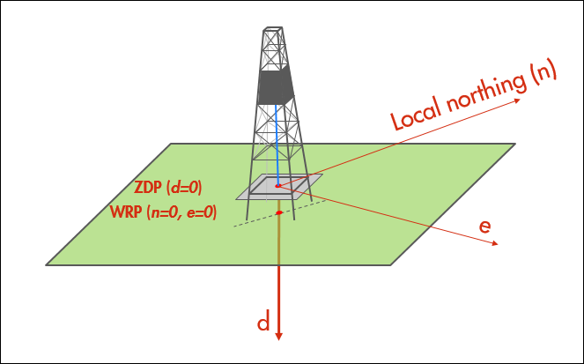 | 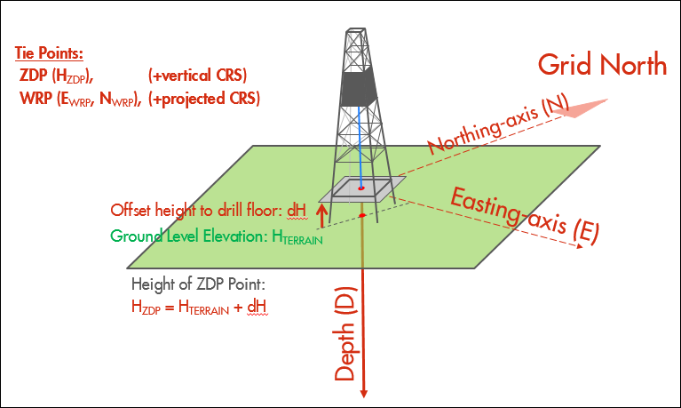
Figure 2: schematic depiction of applying the GNL method without point scale factor and depth correction factor.
If psf_flag=1 and dcf_flag=0 then the target coordinates are computed using a scaled offset as:
E = E_{WRP} + e * psf_E
N = N_{WRP} + n * psf_N
If psf_flag=2 and dcf_flag=2 then an iterative method is needed to compute the variable point scale factor and depth correction factor along the wellbore. The LMP method is recommended in this situation, but if the GNL method is used then map convergence should also be calculated variable along-hole to reference the local coordinates to grid north.
Output arrays E and N of length num_points are computed as follows:
For i=1:num_points
for psf_E and psf_N, compute_psf(E[i-1], N[i-1])
dcf = R / (R – D[i])
E[i] = E[i-1] + (e[i] – e[i-1]) * psf_E * dcf
N[i] = N[i-1] + (n[i] – n[i-1]) * psf_N * dcf
where
- for i=1, for the first station: E[0] = E_{WRP}; N[0] = N_{WRP}; e[0] = 0; n[0] = 0, and
- compute_psf() is a function that returns the local point scale factors in easting and northing directions at the given location;
- R = 6371000 m. Note: Using a constant rather than the ellipsoidal local radii of curvature for the depth correction factors in easting and northing directions at the given location results in an insignificantly small error (e.g., for a lateral of 10 km at 10 km depth the worst case difference is 8 centimetres: 6371/(6371-10)=1.001572 vs. 6340/(6340-10)=1.001580).
Reverse case
Equations for the reverse case to compute (n,e) from given (E,N) are straightforward and presented in IOGP Guidance Note 373-07-2. They are implemented in the accompanying spreadsheet.

Wellbore local to geographic (LMP)
(EPSG Dataset coordinate operation method code 1076)
The LMP method is described by N.D. Zinn in SPE paper 96813 "Accounting for Earth Curvature in Directional Drilling", 2005. LMP requires that the input local horizontal coordinates are referenced to true north, and that depths (here referred to as D, but as TVD in the SPE paper) are referenced to the reference surface of the vertical CRS.
The output of LMP is ellipsoidal coordinates in a geographic 2D CRS. Projected coordinates of the wellbore may be calculated from the geographic coordinates using the relevant map projection formulas.
Inputs are:
- Latitude of the Well Reference Point in the target 2D geographic CRS;
- Longitude of the Well Reference Point in the target 2D geographic CRS;
- dcf_flag : 0 for none; 2 to apply a variable depth correction factor along the path;
- n[] : Array of length num_points containing local northing coordinates, oriented to true north;
- e[] : Array of length num_points containing local easting coordinates, oriented to true east;
- D[] : Array of length num_points containing depths below the Vertical Reference Surface at survey stations down the wellbore (referred to as TVD in the SPE paper).
the method has an option for the application of the depth correction, to accommodate subsurface applications that do not correct for earth curvature:
- depth correction factor (dcf) is used to scale horizontal offsets according to the depth of the point in the wellbore: (i) no dcf correction is applied, or (ii) a dcf correction is applied at each point along the wellbore. For option (ii), depths D[] are required as input but are not changed by the algorithm. The depths are used to compute a depth correction and therefore a depth of zero must be close to Mean Sea Level. For option (i), D[] is not required.
The following equations assume that the local coordinates (n,e) and depth D are in meters. If these use a different unit of measure, then as a first step they should be converted to meters.
output arrays LAT, LON (in radians) are computed as:
for i=1:num_points
ρ = a * (1 – e²) / {1 – e² * sin² (LAT[i-1])}^{3/2}
ν = a / {1 – e² * sin² (LAT[i-1])}^{1/2}
LAT[i] = LAT[i-1] + (n[i] – n[i-1]) / (ρ – D[i])
LON[i] = LON[i-1] + (e[i] – e[i-1]) / (ν– D[i]) / cos(LAT[i-1])
where for i=1, for the first station: LAT[0] and LON[0] are the geographic coordinates of the WRP in radians; n[0] = 0, e[0] = 0; and (per the Implementation Notes in GN07-2):
- a is the semi-major axis of the reference ellipsoid;
- e² is the squared eccentricity of the reference ellipsoid (not to be confused with local easting);
  - 1/f = a/(a-b); the inverse flattening; e² = 2f-f²
- ρ is the radius of curvature in the meridian;
- ν is the radius of curvature in the prime vertical.
Subtraction of D[i] from the radii of curvature in the above equations effectively accomplishes a depth correction as described in the SPE paper and may also be used in the GNL method. This correction should not be applied if the wellbore path is to be loaded into a subsurface application which is using a cubic model that does not apply a similar correction for its (seismic) data.
When dcf_flag = 0, the equations above are modified to:
LAT[i] = LAT[i-1] + (n[i] – n[i-1]) / ρ
LON[i] = LON[i-1] + (e[i] – e[i-1]) / {ν * cos(LAT[i-1])}
For WGS 84 input coordinates this then becomes (ignoring depth correction):
a = 6378137 // WGS 84
1/f = 298.2572236 // WGS 84
b = 6356752.314 // WGS 84
e² = 0.00669438 // WGS 84
ρ = a * (1 – e²) / {1 – e² * sin² (LAT_WGS84[i-1])}^{3/2}
ν = a / {1 – e² * sin² (LAT_WGS84[i-1])}^{1/2}
LAT_WGS84[i] = LAT_WGS84[i-1] + (n[i] – n[i-1]) / ρ
LON_WGS84[i] = LON_WGS84[i-1] + (e[i] – e[i-1]) / {ν * cos(LAT[i-1])}
Reverse case
Equations for the reverse case are presented in IOGP Guidance Note 373-07-2.

Grid offset coordinates
Local eastings (e) and northings (n) coordinates are the output of an algorithm such as minimum curvature. They are reported unscaled, have the unit of MD, and may be oriented to True North if AZ_REF is TRUE.
Local coordinates may be confused with grid offsets ΔN, ΔE (+N/-S and +E/-W) from the WRP, which are often reported in applications or used to load wellbore paths.
Grid offsets represent the local offsets from the WRP in the unit of the projected CRS and are always aligned with grid North of the projected CRS. They are computed as:
ΔN[i] = N[i] – N_{WRP}
ΔE[i] = E[i] – E_{WRP}
Local depths (d) may be calculated in a different unit (the MD unit) than the unit associated with the vertical CRS. TVDZDP (“true vertical depth” below the ZDP) is the same as d but is converted to the unit of the vertical CRS. It is computed as:
TVDZDP[i] = D[i] - D_{ZDP} = D[i] + H_{ZDP}
Alternatively, TVDZDP can be calculated simply by scaling the local depths from MD_unit to the unit of the vertical CRS.

Industry data exchange protocols and file formats
The IOGP P7/2000 is the industry standard data exchange file format intended for definitive composite surveys and calculated wellpaths. It consists of a simple ASCII text file with header followed by survey and calculated data. It is recommended to be used in OSDU for file-based transfer of definitive composite directional drilling surveys and calculated path to subsurface applications, as appropriate. An update to the P7 format is expected to be released in 2020.
WITSML is the industry reference for the transmission of data from rig-site to the offices of oilfield service companies, integrators and operators. It is also used to share information among partners, vendors and government agencies. The current inventory of WITSML standard capabilities includes: wellsite-to-office data transfers, completions (equipment, events and flows), wireline and LWD well logs, as well as calculated and planned well trajectories. Data Assurance Metadata is part of the standard. Energistics recommends The Energistics Transfer Protocol (ETP) method to ensure near-real-time continuous data transfers. WITSML is recommended to be used in OSDU where appropriate to facilitate such transfers.

Implementation
This section provides an overview of miscellaneous things.

General
- The OSDU directional survey data model should be aligned with terminology in this document and published in IOGP Guidance Notes and by SPE ISCWSA, where possible and reasonable, also if other terms are used in legacy applications (the issue being there inaccuracy or ambiguity).
- OSDU applications should use the same terms and, where applicable, show a sketch to clarify the geometry, as well as refer to online user manual and tool tips, etc. such that end-users fully and clearly understand the data.
- The data model should be designed such that there is an audit trail that enables applications to show end-users what the original input was, and which operations were performed to convert (normalize) data and to compute coordinates
  - Examples are conversion from grid to true use the convergence, applying the minimum curvature to compute local coordinates, GNL to compute geodetic coordinates, etc.
  - Original input may refer to be a directional survey data referenced to TN or GN or be Inclination-only data, the unit of MD, the original ZDP referenced and MD units, as well can be inertial survey with only local or geodetic coordinates.
  - If original input was ingested from a file then that file should be stored and linked.
  - If input was from a source document (e.g., a tiff, txt, pdf etc.) that cannot be parsed then such document should be stored as well and linked to the survey.

- The directional survey should have a survey header and survey table to store the directional survey observables. The ZDP reference for the survey may be different (elevation and unit) than the wellbore header (then total depth comparison for example requires depth shifting or normalization).
- Store Reference Geomagnetic model (incl. IFR) and gravity model information, as appropriate. It is important to capture the Date of the Magnetic Declination. Potentially the survey table can contain field with the magnetic parameters at each station.
  - The survey header additionally should store Vendor, Tool Name/Instrument, Error Model and Date for both Header and Station to better understand provenances.
  - The directional survey table should have additional fields, e.g., for
    - Flags to indicate which stations are actual surveyed data points used in the wellbore computation, for interpolated or extrapolated points, etc.
    - Field to store (a reference to) the Survey Tool Error Model used (either a reference to a standard error model such as from OWSG/ISCSWA, or a yet non-existing entity with the defining model terms as done in p7 format)
    - Six fields to store the variance-covariances in N,E,D orientation.
    - etc. (see p7/11 for potential list). This document will not list all properties of the schema.

- The OSDU API shall be used for core geodetic calculations and wellbore path calculations defined in this document, including
  - Coordinate operations (conversions and transformations)
  - Scale factor and grid convergence
  - Forward minimum curvature (using this document and test data)
  - MCF interpolation of wellbore to regular MD interval (could be option of above)
  - Reverse minimum curvature (using this document and test data)
  - GNL method. Geographic coordinates in the base geographic CRS of the projected CRS are expected to be output for the computed wellpath, as well as error terms.
  - LMP method for WGS 84 calculation.
  - Helper functions might be implemented to avoid the risk of applications incorrectly rotating or (de)normalizing stored data (endpoints and payload to be scoped).

- No decisions were made for storing raw sensor data, error models, etc., as the current focus is on storing the definitive composite survey and define how to calculate the local and geodetic coordinates (do not boil the ocean).

Directional survey observables (stations)

- Directional survey observables will be normalized using meter and degree as units.
  - MD_normalized
    - Normalization (example: MD 0 -25 m for H_{ZDP}=25 m above MSL)
MD_normalized = convert_to_meter(MD_input) – convert_to_meter(H_{ZDP})
    - Unit=meter (stored normalized)
    - zero=VRS (e.g. MSL, but can be NAVD88 etc. cannot be normalized)
    - direction: positive down along-hole
    - min=-5km (minus 5 after normalization; if on a mountain);
    - max=50km
  - INC_normalized (equal to input INC)
    - Unit=degree
    - zero=straight down (gravity vector)
    - min=0;
    - max=180 deg (use 180 to avoid submitting data to OSDU; use 130 as another QC flag to warn QC person – but allow submitting)
  - AZ_normalized (stored True North)
    - Unit=degree
    - zero=True North (stored normalized).
AZ_normalized = convert_to_TN_and_wrap_0_360_deg(AZ_input)
(i.e., AZ_TRUE = AZ_GRID + grid convergence)
    - min=0.
    - max=360.

- The (relation to the) original directional survey received will be stored. There are several options (i) store original survey parameters in the survey header; (ii) additionally store explicit original survey data in the directional survey array parameters in the survey header; (iii) by Lineage to an original survey (this requires header parameters to indicate the survey data are not normalized which will be confusing). Preferred may be option (i) but this needs to be worked out by architect.
  - Architect to advise on options.
  - Required parameters for option (i)
    - “original_AZ_reference”: TRUE_NORTH, GRID_NORTH, INCLINATION_ONLY, INERTIAL_SURVEY
      - MAGNETIC_NORTH is excluded and assumed not to be needed for a survey array; but for Wells applications the magnetic model parameters etc. will be.
      - In case of GRID:
        - The original projectedCRS
        - The value of the grid convergence applied [deg]
          - (assuming constant; it could be a correction array part of the table TBD). Note: when correcting for grid convergence the Azimuth should be re-wrapped in the principal interval [0,360> deg.
    - Original ZDP_type, ZDP_elevation, ZDP_unit & ZDP_VRS (or value & VerticalCRS)
    - Original MD unit

  - If the original survey was type “Inclination only”:
    - Use a flag in header “original_AZ_reference=INCLINATION_ONLY”
    - Store “NULL” in the “AZ_original” where not measured i.e. Inclination-Only. This prevents certain software from projecting wellpaths due North (interpreting AZ=0 deg) when they should be straight down.

  - If the original survey type was “Inertial” and local (n,e,d) were received then leave the above blank.
    - This is a fringe case and may be later implemented as it would require perhaps a bit of effort and guidance from Wells.
    - Decided in a workshop in 2019 was to not bother with inertial surveys. If we get an inertial survey we will ask Wells to perform analysis and compute M,I,A using inverse minimum curvature – and then load it; most likely.
    - Use a flag in header “original_AZ_reference=INERTIAL_SURVEY”
    - Store somehow (n_original, e_original, d_original) and perform reverse minimum curvature in order to store M,I,A assuming that is a requirement for applications. (it would be better to simply use GNL to compute geodetic coordinates)
    - Ensure to track the projCRS for inertial to grid north referenced AZ_GRID, then to convert that to AZ_TRUE and store.
      - It is possible to put those AZ_GRID in the “AZ_original” as long as there is a clear flag the original data was initial and the original n,e,d are stored in OSDU and not lost.
      - However, there are some complications as for an inertial survey the (n,e,d) are main output, but the system also (can) output (MD,INC,AZ) attitudes as measured/derived from the inertial sensors. However those (MDAZINC) will not be linked to the (n,e,d) by means of min. curvature. Hence the “originals” should contain the original data from the inertial.
    - Then perform forward min. curvature and double check the calculated path is within 1m; warn user if not/Qc remark/crash.

  - As described in general requirements, flags should be used which are the actual surveyed stations vs. interpolated or extrapolated points. Many input formats and EDM transfer will have this information that should be preserved. In particular for subsurface loading, extrapolation.

- Display computed (normalized) data as (may be stored to more, but ridiculous to use 15 decimal places as is done in json)
  - MD normalized in meters to 2 decimal places. QC for valid range [-5000, 50000]
  - AZ normalized to AZ_TRUE in degrees to 3 decimal places. QC for valid range [0,360>
  - INC in degrees to 3 decimal places. QC for valid range [0,180] (perhaps warn if I>150).

Calculation of local coordinates
- Local n and e are by definition (0, 0) at the well reference point (we do not allow local coordinates from a site reference point).
- Use minimum curvature as the default method to compute local coordinates.
  - Output is (automatically) NORMALIZED as:
    - Output (n,e,d) are unscaled in meters (based on above normalization of MD to meters. (i.e., no unit conversion, no point scale factor or depth correction factor applied to (n,e,d) coordinates; plain output of minimum curvature).
    - Output (n,e,d) are oriented true north (based on normalized TN azimuths as inputs)
      - In general if (n,e,d) are required in (a different) grid north orientation then there are two equivalent options to compute this (assuming constant grid convergence along path), namely (i) rotate (n,e) with the convergence, (ii) rotate the azimuths and recompute min. curvature. Both methods are demonstrated in the spreadsheet (worksheet “rot2d”).
- Show local coordinates to 2 decimal places but compute with higher precision (at least 3 or 4 or leave at full precision) because they need to be integrated up which need to be done numerically at full precision.

Calculation of geodetic coordinates
- Depth correction factor should not be applied in either LMP or GNL methods.

- The GNL method will be used in OSDU to compute the wellpath and that path will be used in all applications.
  - No scale factor or depth correction will be applied in GNL (psf_flag=0 and dcf_flag=0).
  - The impact of ignoring point scale factor (err_{ꓕ}) and change of convergence along the wellbore path (err‖) will be computed and available to end-user (displayed/recorded).
    - The error will be computed using formulas given in Appendix C3 and D1.
    - A warning will be given if the error exceeds a threshold of 10 m, if interactive, and a QC remark will be written with the Wellbore (e.g., when ingest by agent):
WARN if error>10m with error = sqrt(err_{ꓕ}² + err‖²)
  - The reason for sticking in OSDU with GNL without scale factor is simplicity, legacy, and expectation that the error made by ignoring these factors is insignificant for practically all wells. If the computed warning indicates a significant impact, then options that would be used to mitigate are (preferred is LMP as it elegantly handles with scale and change of convergence)
    - Use LMP. This aligns well with storing AZ_TRUE and with storing a path in geographic coordinates. It automatically applies varying convergence and scale along path in case we ever work with extreme extended reach.
    - Use GNL (psf_flag=1; i.e., apply a constant point scale factor).

- In OSDU there is (currently) no concept of a “project/asset” with a default projected CRS. Hence wells may not have surface coordinates in a projected CRS. This may need to be reviewed, i.e., how to associate a projected CRS with the data (if that is needed, e.g., when receiving TN azimuths). An approach computing the wellbore path on demand for an application, requested given the projCRS and ZDP resolves this issue. But understanding is that OSDU does store a Wellbore path. It would simplify if a projected CRS is mandated for an operated Well or Asset.

- In order to load paths in applications that use different UTM zones, e.g., one project loads data in UTM zone 15, the other the same path in UTM zone 16N
  - In OSDU only store the MD, INC, AZ and definitive survey for loading, and load WGS 84 to visualization and search. When an application needs to path in a projected CRS then the geodesy API shall be used to create it. Alternatively, a lineage of several surveys in different CRSs could be created and stored, but why do that). Another alternative is to compute WGS 84 and transform that when needed – but both of these alternatives are inferior to the selected solution of using the geodesy API on the fly.

- Display (not necessarily storage)
  - Be capable of showing geographic coordinates in degree and DMSH representation; following OSDU standard for quoting coordinates.
    - Show geographic coordinates as decimal degree to 7 decimal places.
    - Show surface location as DMS to 3 places for arc seconds.
    - Show projected coordinates to 2 decimal places.
  - MD to 2 decimal places (in m or ft)
  - INC, AZ to 3 decimal places (in degrees)
  - Scale factor and depth factor to 5 decimal places
  - Grid convergence to 3 decimal places (in degrees)
  - Magnetic Declination and dip to 3 decimal places
  - Field strength in nT to 0 decimal places (integer)
  - Gravity in m/s2 (not milli-g) to 5 decimal places

- On ingest or after loading perform simple automated QC where possible, including:
  - Double check convergence given (if available and read) and warn if significantly different then computed with API (more than 0.01 deg).
  - Double check scale factor given (if available and read) and warn if significantly different then computed with API (more than 0.0001).
  - Compute average course length of input MD and warn if it is more than 400 ft (converted to meters threshold = 125 m)
  - Compute the distance the survey has been projected out from last real survey station with data to the bottom hole (when available, i.e., if the input data has a flag with the survey array e.g., in p7/2000 file or from EDM), and warn if it is more than 200 ft (converted to meters threshold = 65 m).
  - Compute the path based on the MDINCAZ read and compare the compute bottom hole location vs. that in the input file (if available). Warn if it is off by more than 5 m in either N, E, or D.
  - For Inclination-Only: compute the path assuming AZ=0, then compute max-stepout and enter a QC remark. Warn if more than a threshold. Store BHL as vertical (i.e., follow but automate SIEP loading procedure).
  - A complete description of QC tests and data quality rules has been created.

- Inclination-only surveys or stations (survey program)
Inclination-only, undefined azimuth, survey data do not have recorded azimuth values. No information is available on the horizontal direction (azimuth, e.g., North or East) in which the wellbore is departing.
Such surveys are often of older vintage and were used to confirm that a planned vertical wellbore indeed was drilled vertically (enough). Often the inclination is recorded to multiples of 0.25° and the tool may have a maximum inclination it can measure (which should be checked during QC). For some surveys the MD interval between stations may be larger than for modern surveys, possibly a few hundred meters between stations or more. However, also for modern data we may have to deal with such data.
The wellbore path for inclination-only surveys is calculated as straight down (in the absence of azimuth values). However, there is a small difference between the MD at the bottom hole and TVD that should be correctly computed, due to the geometry as sketched in Figure 3.
Some software applications cannot deal with missing azimuth and set it to zero during calculations. This results in a path that is going due north, which is obviously incorrect. The path may go North, but it could just as well go into any other direction or have a more or less random azimuth at each station. The horizontal error is given by this offset (and pretty much an indication of the maximum offset that the wellbore could have, assuming random inclination errors).
In general, a segment of the wellbore is completely surveyed by inclination-only tools, potentially the complete wellbore from top to bottom. However, there are two practical cases to consider for loading surveys into subsurface applications, received from Wells survey management applications:
            - A side track is kicked off from a primary wellbore that only has an inclination-only survey. In that case one might receive a survey that is “stitched together”, i.e., one may receive a survey that for the first N stations has inclination-only or has azimuth equal to zero for the first N stations. One could (should) make two calculations, first for the primary wellbore and then for the side track, the second tied on to a known survey station of the first. Such cases should be detected and dealt with.
            - A survey is missing an azimuth value for a single station, e.g., if the mud pulse telemetry was corrupted to pump up the data for that station or the sensor for some reason failed or did not record the value. In that case it may be best to remove the station, even though it has a correct inclination. In some software the engineer may mark the single station (or a few stations) with an inclination-only survey tool error model. In some software this will then force the calculations to compute a (1 point) trajectory for this segment (dropping the path straight down), and use the error model associated with the inclination-only (increasing the cone of uncertainty). This is incorrect if the wellbore path would be inclined and under an azimuth, i.e., it would probably be better to interpolate the azimuth and use an appropriate error model for it. But it happens, and then azimuth may be missing or set to 0 for such survey stations in the middle of an otherwise perfectly fine MWD survey. This should be detected as well. It can be dealt with by dropping the path straight down. Then the error message and computed dogleg severity will indicate to a QC party whether that is acceptable or the survey station should be removed or interpolated.

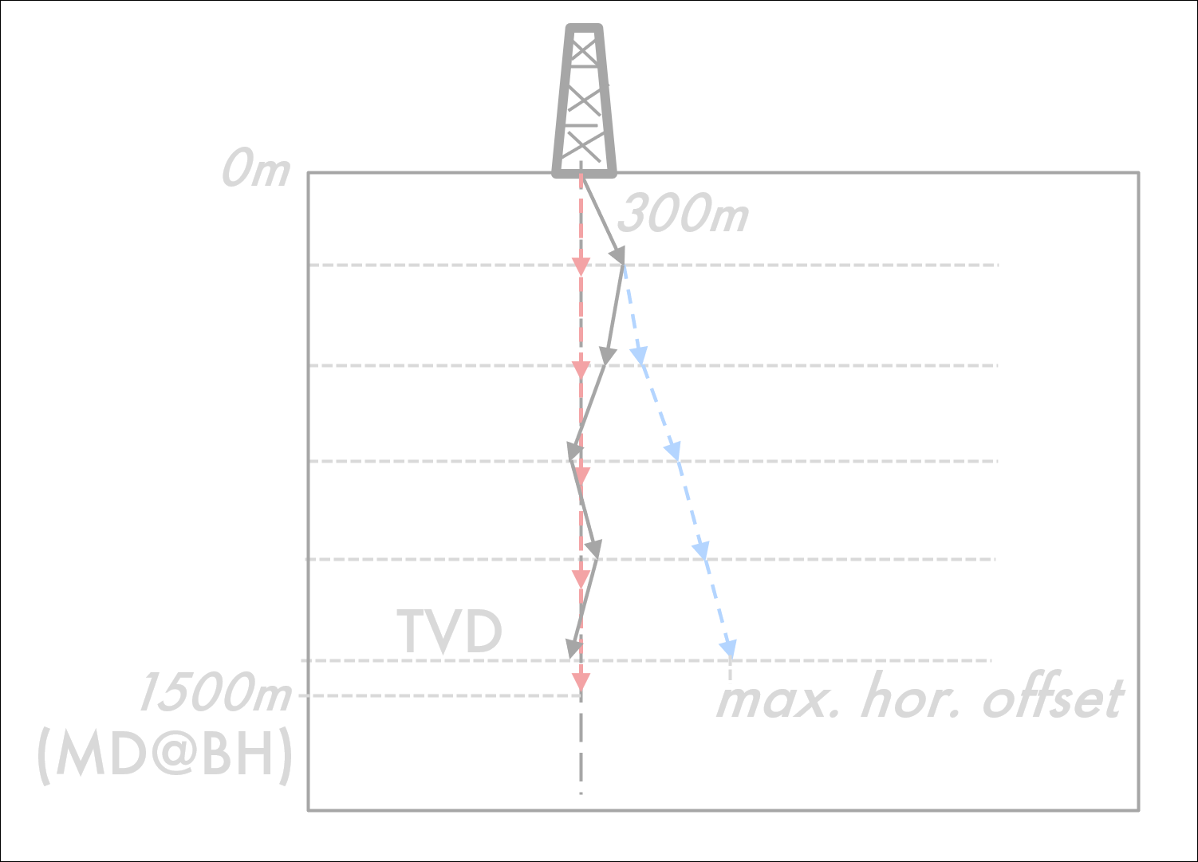
Figure 3: Exaggerated example of inclination-only survey in an assumed-vertical well. There are 5 measurements at MD=0, 300, 600, 900, and 1200m. The real path may be like the black or blue line, but the calculated path will be exactly vertical to TVD at the last station. The TVD at the Bottom Hole is not exactly equal to the MD of the last station due to the inclinations. The horizontal direction of the wellbore path is unknown, and the best estimate of the path is vertically down to TVD. If the path would be oriented in a single horizontal direction, e.g., due North, then the max. horizontal offset is as sketched in blue. As can be seen by the horizontal dashed lines, TVD calculations are independent of azimuth.
If, temporarily, the wellbore path is assumed to go due north (all azimuths equal to zero), then the horizontal and vertical offsets of the second station, relative to the first, can be computed with the full minimum curvature equations given in Section 2.1 using A_{i}=0, or these can be simplified as follows (where Δe_{1,2} = 0 by definition):
DL = I₂ - I₁ // in case of inc-only data only!
RF = 1, if DL=0
2*tan(DL/2) / DL, else
Δn_{1,2} = n₂ – n₁ = ΔM * (RF/2) * (sin(I₁) + sin(I₂)) // recommended local implementation
≈ ΔM * sin(I_{avg}) // good approximation to cm level
Δd_{1,2} = d₂ – d₁ = ΔM * (RF/2) * (cos(I₁) + cos(I₂)) // recommended
≈ ΔM – 0.5 * Δn_{1,2} * tan(I_{avg}) // good approximation to cm level
≈ ΔM – 0.5 * ΔM * sin(I_{avg}) * tan(I_{avg})
≈ ΔM * (1 – 0.5 * sin(I_{avg}) * tan(I_{avg}))
≈ ΔM * (2 – 1/cos(I_{avg})) // Δd_{1,2} = 0 for I_{avg}=90° (horizontal).
Where:
DL: the Dogleg between station 1 and 2 (in radians).
RF: the Ratio Factor between station 1 and 2 (in radians).
ΔM = M₂-M₁, the course length between station 1 and 2 (in given MD length unit).
I_{avg} = (I₁+I₂)/2, the average inclination at the two stations (in radians).
These formulas can be used to calculate the TVD at the bottom hole (and all intermediate stations), as well as its difference with the MD at the bottom hole, and an indication of the maximum horizontal offset between the calculated path and a worst case path where the wellbore is tracking in a consistent azimuth. The approximation
Max. hor. error = Δn_{1,2} + Δn_{2,3}, + … + Δn_{S-1,S} = sum_i=2:S(Δn_{i-1,i}) = n_{S}
TVD correction = Δd_{1,2} + Δd_{2,3} + … + Δd_{S-1,S} – MD_{S} = d_{S} - MD_{S} = sum_i=2:S(0.5 * Δn_{i-1,i} * tan(I_{avg_i}))
TVD correction is negative, i.e., TVD is always equal to or smaller than MD at every station. In general the approximation formulas should not be used, but it might be possible to implement in an SQL statement connected to a survey database, where the full equations are too cumbersome to use.
  - Replacement MD,INC,AZI for loading into subsurface applications
Some (subsurface) applications requires (MD,INC,AZI) data to be available and cannot deal with undefined azimuths or loading (Δn, Δe, Δd) data to create the path. In such cases a feasible strategy is to replace the inclination-only survey data with “made up” survey data, forcing calculated path to be straight vertical, with correct TVD calculation. There are two viable options to do this, where the second option that preserves the original stations is preferred.
- Option 1: Reduce the full inclination-only survey to two stations.
- Option 2: Keep all stations, replacing the MD and INC values
Option 1:
- First use the original minimum curvature or the equations given above to compute n_{i} and d_{i} at the survey stations, by temporarily setting A_{i}=0.
- Then replace the survey with a survey consisting of only 2 stations as:
  - MD₁ = 0; INC₁ = 0; AZI₁ = 0
  - MD₂ = d_{S}; INC₂ = 0; AZI₂ = 0
- Store a remark with the survey indicating that this originally was an inclination-only survey but has been simplified. Indicate the size of the max. horizontal error and TVD correction made due to ignoring the inclination values. Store the original MD at BH in the comment.
  - “Original survey was inclination-only with <S> survey stations and average inclination <avg> deg. Original MD at BH was <origMD> <unit>, replaced by computed TVD = <d_{s}> <unit>. MD/TVD correction = <CORR> <unit>. Max. horizontal offset from the assumed vertical path by ignoring the measured inclinations is <n_{S}> <unit> (at the bottom hole).”.
Option 2:
- First step as above.
- Replace all survey station with
  - MD₁ = 0; INC₁ = 0; AZI₁ = 0
  - MD_{i} = d_{i}; INC₂ = 0; AZI_{i} = INC_{i}
- Store a remark with the survey indicating that this originally was an inclination-only survey, and it was modified to enable loading. The MD values were replaced by the TVD to ensure the Bottom Hole is at its correct depth when a straight vertical path is calculated. The measured INC values were are replaced by zero to force a straight vertical path calculation. The original inclination values are stores in the AZI column. Indicate the size of the max. horizontal error and TVD correction made due to ignoring the inclination values. Store the original MD at BH in the comment.
  - “Original survey was inclination-only. The original inclination values were copied into the azimuth column and then set to zero to force a vertical path. Original MD at BH was <origMD> <unit>, replaced by TVD <d_{s}> <unit>. Max. horizontal error <n_{S}> <unit>”.
  - Alternatively/and if there is enough room in the comment field then the AZI values can be set to 0 and a string should be built as an audit trail which values were replaced.
    - “Station <i> replaced MD=<MD_{i}> with <d_{i}>, INC was <INC_{i}>; etc.
Note: after replacing the survey, the Azimuth reference needs to be set to True North or Grid North. It does not matter what is selected, because the replaced survey enforces a vertical path for a complete inclination-only survey. It may be prudent for path calculation in geodetic space to require a projected CRS.
  - An algorithm to deal with “mixed inclination-only” (composite) surveys
This section suggests an algorithm to compute the wellbore path in case of a “mixed inclination-only survey”. This term is used to indicate that data is received for which some stations do not have azimuth values, or zero values for azimuth, or with rows flagged as being inclination-only.
An application should deal with individual survey runs as part of a survey program and combine them appropriately including error propagation. However, if a (subsurface) application requires (MD,INC,AZI) data as input and the definitive survey received has some stations that are missing azimuth values then these may need to be dealt with appropriately in order to load data into subsurface applications.
A good way of dealing with this if a survey program is available that flags segments would be to iterate over each segment down the wellbore, compute a path from MD start to MD end, and tie this relative to its tie-on point (last point of previous segment).
But if a replacement survey is needed then, given a survey with S stations with expected (M,I,A) observables and an automatic transfer. However, please note, this approach is considered quite complicated and only useful in cases where a definitive composite survey truly consist of inclination-only data and these data cannot be loaded otherwise.
- Detect all stations i that are inclination-only.
  - Any stations flagged as inclination-only (with the error model).
  - Any station with missing Azimuth value or /0 or null azimuth value.
  - The first s stations with Azimuth exactly equal to 0 (note: this may not work if azimuths were converted from GN to TN or v.v., so potentially need to detect the first s stations with the same AZI).
- Perform temporary calculation to enable estimation of the error that will be made by ignoring the measured inclinations:
  - Temporarily set A_{i}=0 for the inclination-only stations (this will cause the calculated path to go due north at inclination-only segments, but compute the correct TVDs). Leave MD_{i} and INC_{i} as-is.
  - Compute the minimum curvature local (n,e,d)_{tmp} offsets for the complete path with the normal formulas.
    - n_{S_tmp} and e_{S_tmp} are the computed horizontal offsets at the last station S.
    - d_{S_tmp} is the TVD computed vertical offset at the last station S.
- Replace the surveys at the inclination-only stations with
  - MD_{i} = MD_{i}; INC_{i}=0; AZI_{i}=0;
    - Leave MD_{i} as-is because it is too complicated to replace.
    - (it should be considered to depth shift the MDs for all subsequent stations after the first s that are detected as inclination-only, to deal with the common case that the first part of the survey is inclination-only).
  - Compute the minimum curvature local (n,e,d) offsets for the complete path.
    - This will force a vertical path for the inclination-only parts of the survey, though it will not 100% accurately compute the TVD (it will compute slightly deeper by ignoring actual inclination).
    - This also will compute an incorrect path if an azimuth value is missing in a part of the wellbore that is actually inclined. However, QC rules and computed max error should flag this after path generation based on DLS or computed max errors.
- Compute the TVD error and max. horizontal error at the bottom hole by
  - TVD error = d_{S} – d_{S_tmp}
    - Note: this is a negative number, indicating the computed path is too deep by this amount due to ignoring inclination. Appropriate MDs could be replaced iteratively to create a survey that corrects for this, particularly in the case the survey starts with an inclination only segment in the survey program.
  - Max. horizontal error = sqrt((n_{S} - n_{S_tmp})^2 + (e_{S} - e_{S_tmp})^2)
- Store a QC Remark indicating which survey data were replaced and the errors.
  - “Original survey had inclination-only stations. The following stations were replaced with zero inclination and azimuth. Station <i> MD=<MD_{i}> original inclination <INCi>; … (list all replacements); computed TVD error <TVD error> <unit>. Max. horizontal error <n_{S}> <unit>”.
- Flag survey as unreliable if the errors are too large, e.g., vertical more than 15 ft error and horizontal more than 150 ft, or DLS>12 deg.
- ZDP types
Following ZDP types are expected in the domain values
Abbrev. | ZDP Type | Description
BR | Rig Bracing | The point where the wellbore meets the rig bracing.
CV | Crown Valve | Also known as a swab valve. This is the uppermost valve on the vertical bore of the christmas tree above the flowing outlet, sometimes used as a reference point for wellbore measurements.
DF | Derrick Floor | The point where the wellbore intersects the platform, usually 10 feet or more above the ground, or the derrick on which drilling operations are carried on. Also called Drill Floor.
GL | Ground Level | Onshore. The earth's surface where the drillstring enters the ground. This reference point is not appropriate for an offshore well.
KB | Kelly Bushing | The point in a wellbore where the wellbore intersected the top of the Kelly bushing.
LAT | Lowest Astronomic Tide | Depth Datum - The lowest predicted level of the sea surface under normal meteorological conditions.
MLLW | Mean Lower Low Water | Depth Datum - Mean Lower Low Water. Mean of observed lowest water levels over a certain period. Used as Chart Datum on US nautical charts.
PT | Pipe Top | The top of the wellbore pipe.
SF | Sea Floor | Offshore. The point where the wellbore intersects the sea floor. This is sometimes used as a reference point for wellbore measurements.
TBF | Top Bottom Flange | The top point of the bottom flange.
TC | Top Cellar | Onshore, “hard” point generally close to Ground Level.
TWH | Top Wellhead Housing | May be used offshore to reference the top of the subsea wellhead housing.
UN | Unknown | The type of reference point is unknown.
Table 2: List of ZDP types and their abbreviations.
Note: Additional points may be defined as needed. However, Rotary Table (RT), Rig Floor (RF), Drilling Floor Mat (MT) are purposely not listed to drive standardization; these are considered to be at same level as Derrick Floor (DF). No geodetic vertical datums are found in this list, with the exception of LAT and MLLW. A geodetic vertical datum is never used as intermediate depth level (except for the aforementioned two offshore datums potentially used during offshore well operations, with data permanently stored relative to Mean Sea Level).

- Magnetic declination and grid convergence
When originally acquired, directional survey azimuths are referenced to Magnetic North (magnetic surveys) or True North (north-seeking gyro surveys). Conventional gyro surveys are referenced to a surface reference object. As part of the data processing, azimuths are converted to a common reference direction, invariably True North or Grid North. This common reference direction will typically apply to all an Operator’s wells in a field, country or region.
Conversion of azimuths to the common reference direction requires knowledge of the magnetic declination (the true bearing of Magnetic North) and/or the grid convergence (the true bearing of Grid North). Magnetic declination varies in both space and time, grid convergence varies in space, but is constant in time. Both magnetic declination and grid convergence can be either positive or negative, so it is advisable to check the correction to the common azimuth reference direction with the help of a diagram (see Figure 4 below). The convention applied in OSDU shall be +ve = clockwise.
Table 3: Preferred terms and symbols (not generally used, in wellbore survey community uses “Magnetic Azimuths”, “True Azimuths”, and “Grid Azimuths”).
Symbol | Term | Meaning
α | TN Azimuth | Direction from True North (clockwise positive, in range 0-360°)
β | GN Bearing | Direction from Grid North (clockwise positive, in range 0-360°)
γ | Grid Convergence | Azimuth of the Grid North direction (angle from TN to GN)
δ | Magnetic Declination | Azimuth of the Magnetic North direction (angle from TN to MN)
μ | Magnetic bearing | Direction from Magnetic North (clockwise positive, in range 0-360°)
  - Magnetic declination
The magnetic north direction is important for wellbore positioning because measurements may use magnetic north as observation reference.
Magnetic declination, sometimes called simply declination, is the clockwise positive angle on the horizontal plane from the direction of True North to Magnetic North. The local direction to Magnetic North aligns with the magnetic field lines and changes with time. See also SPE paper 17212 ‘Directional drilling azimuth reference systems’ by JW Wright and C Eastman.
To convert a direction referenced to Magnetic North to one referenced to True North, use
AZ_TRUE = AZ_MAGN + magnetic declination
It is often acceptable to use a constant declination computed at the surface location to satisfy the well objective. However, there may be applications for which it is important to take the change of magnetic declination with location in to account. In particular, this may become more important for wells located in areas with more magnetic variation and/or with extreme extended reach (>10 km).
It is important to store the date and geomagnetic model used with the declination applied.
  - Grid convergence
Grid convergence is important in wellbore positioning if azimuth angles are reported referenced to Grid North and observations need to be corrected.
Grid convergence is the angle between the meridian as represented in the map plane and the N (North) grid line. Unlike for magnetic declination, the rotation convention of grid convergence is not universally defined in a consistent way. This is described in IOGP GN 373-21.
Two opposing conventions exist for the sign of grid convergence (ibid.). The “Gauss-Bomford” convention is mandatory in OSDU. Under this convention, grid convergence is positive when Grid North lies east of True North. To convert a direction referenced to True North to one referenced to Grid North, use
AZ_GRID = AZ_TRUE – grid convergence.
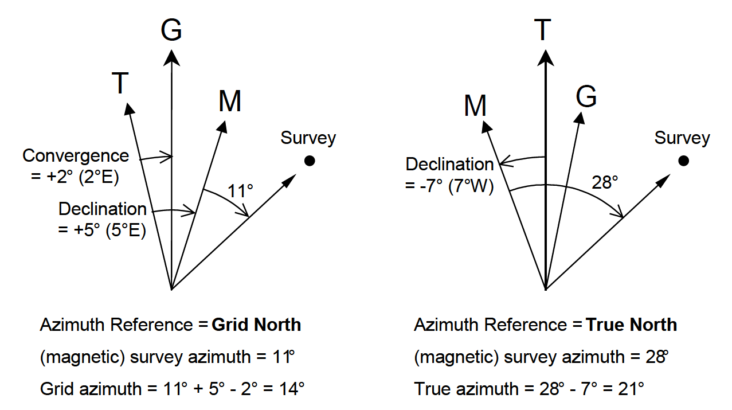
Figure 4: Two examples of azimuth reference correction.
Grid convergence changes with location in the map. There may be applications for which it is important to take the change of convergence with location in to account. In particular, this may become more important for wells located towards the poles and/or with long extended reach.
It is often acceptable to use a constant grid convergence computed at the surface location to satisfy the well objective. However, there may be applications for which it is important to take the change of convergence with location in to account. In particular, this may become more important for wells located towards the poles and/or with extreme extended reach (>10 km). It is recorded as applied at the first station, and the format enables recording varying convergence applied at each station in the position log.
N.B. Note that if the projected CRS of the well is changed, then any associated grid azimuth or X/Y offset will also change. This is because the magnitude (and possibly the direction) of the convergence angles are dependent on the projected CRS.
  - Impact of change of convergence to computed wellbore path
Magnetic declination and grid convergence vary with location. Hence, if a constant value is assumed then some error is made, which is likely larger the larger the reach of the wellbore. Some mathematical analysis has been done on the topic, but in this section a straightforward practical method is proposed to assess the impact.
A constant error in the grid convergence Δγ applied at the surface location leads to a rotation of the wellbore around the location. The positional error increases with the horizontal distance away from the point and is perpendicular to that vector. The perpendicular error is given by:
err_{ꓕ} = d * tan(Δγ)
This formula could be used to estimate how much the bottom hole position changes if grid convergence is not applied (e.g., assuming true north azimuths while they are grid north) or if it was applied with the wrong sign (doubling the error). A rule of thumb is that for every degree the perpendicular error is 2 m per 100 m (because 100*tan(1°)=1.75).
Similarly, the formula can be used to assess the positional error due to change of grid convergence if the correct grid convergence was given at the surface and bottom hole location:
err_{ꓕ} = 0.5 * (d*tan(γ_{SHL}) – d*tan(γ_{BHL}))
= 0.5 * d * (tan(γ_{SHL}) – tan(γ_{BHL}))
≈ 0.5 * d * Δγ // Δγ in radians
where d is the horizontal reach of the wellbore computed using Pythagoras using the surface and bottom hole coordinates. As a rule of thumb, the perpendicular error is equal to the difference in convergence in degrees per 100 m stepout:
err_{ꓕ} ≈ 0.5 * d * (π/180)*Δγ_{DEG} ≈ 0.0087 * d * Δγ_{DEG} ≈ Δγ_{DEG} per 100m
- Point scale factor and depth correction factor
The objective of this section is to explain the meaning of point scale factor and depth correction factor, and to consider when these corrections are appropriate in wellbore survey calculations.
The definitions are:
- Ground distance: Normal to the gravity between two points.
- Geodetic distance: Along the ellipsoid used for the map projection.
- Grid distance: Along the map projection surface.
- Point scale factor (psf): Multiplier to correct a distance along the ellipsoid (“geodetic distance”) to the grid plane of the map projection (“grid distance”). Note: only a conformal map projection has the same point scale factor in all directions at a given location.
- Depth correction factor (dcf): Multiplier to correct a distance measured at depth (“ground distance”) to a distance along the ellipsoid used for the map projection (“geodetic distance”).
- Combined scale factor: Multiplier to convert measured “ground distances” in one step to “grid distances” (the product of point scale factor and depth correction factor).
These correction factors are multiplication factors when going from horizontal measurements in the terrain to computing horizontal coordinates on the grid, as that is the normal mapping workflow. For positioning a well or intercepting a location the factors would be applied in the opposite direction.
Depth measurements are unaffected by these corrections.
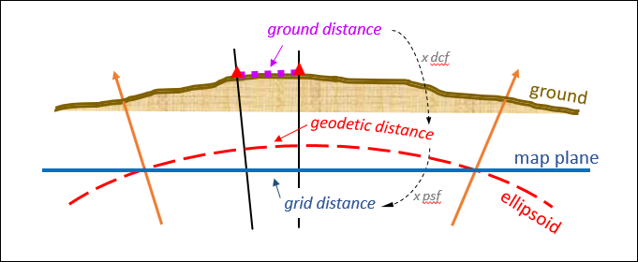
Figure 5: Relation between ground distance, geodetic distance and grid distance. Points on the black lines have the same projected coordinates.
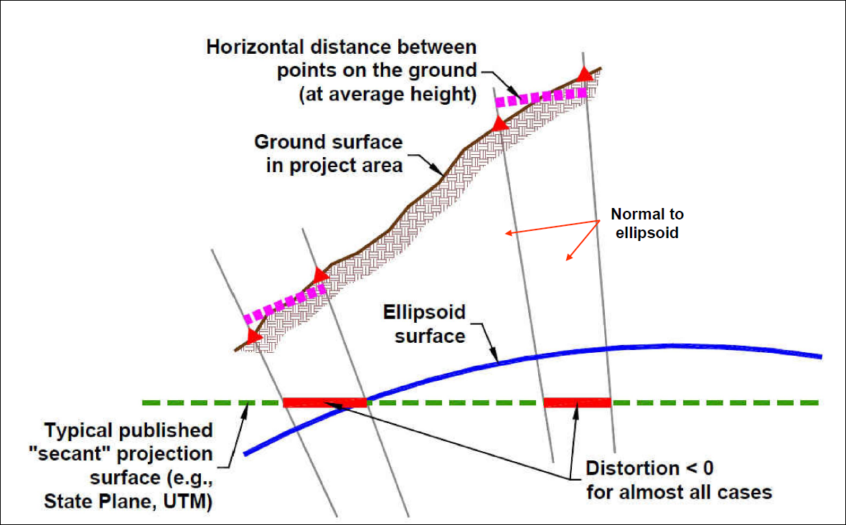
Figure 6: Measured horizontal ground distance measured in the terrain are corrected for their average height using depth correction factor and to grid plane using point scale factor, e.g., for pipeline construction (source: NOAA presentation).
Depth correction factor
The formula for depth correction factor is
dcf = R / (R + H[i]) = R / (R – D[i])
where R = 6371000 m and H[i] is the height of the point above the VRS. Using a constant rather than the ellipsoidal local radii of curvature for the depth correction factors in easting and northing directions at the given location results in an insignificantly small error (e.g., for a lateral of 10 km at 10 km depth the worst case difference is 8 cm: 6371/(6371-10)=1.001572 vs. 6340/(6340-10)=1.001580). The distance correction in this case is 15.72m, i.e., the geodetic distance is computed as 10,000*1.001572 = 10,015.72m.
Referring to Figure 6, one could imagine that, instead of a pipeline, the depicted ground surface is a wellbore, planned on a map grid, and the red triangles are survey stations with measured depth between them. However, it is not clear to me that this analogy holds and whether it implies depth correction should in principle be applied to hit the target, or not. See the last thought experiment in the next section.
Point scale factor
A general formula for point scale factor is not available and is computed based on the location and map projection equations.
In general, psf will not exceed 5 in 10,000 for an UTM projection inside of its Area of Use. However for the CRS commonly used in Brunei, “Timbalai 1948 / RSO Borneo (m)” [EPSG::29873], psf=1.00334 at 1°N, 119°E (a location at the very edge of its Area of Use), yielding a distance correction of 33.4 m per 10 km, which may be significant.
As a rule of thumb, psf can be considered constant for horizontal distances smaller than 10 km and can be computed at the start of the line (well surface location). For larger distances Simpson’s rule offers a very good approximation. This rule computes an effective line scale factor as:
lsf = [psf(start) + 4*psf(mid) + psf(end)] / 6,
which is then multiplied by the geodetic distance to yield the grid distance of the line. However, reporting or applying such line scale factor is unnecessarily complex. If point scale factor needs to be accounted for, then use the LMP method, which automatically corrects for varying point scale factor and convergence along the wellpath.
  - Impact of ignoring (change of) scale factor to computed wellbore path
The point scale factor for an appropriate projected CRS is close to one, and hence ignoring scale factor is generally appropriate for the application of wellbore trajectory calculations. The error in horizontal distance when ignoring scale factor is computed as
err‖ = d * (1 – psf)
where d is the horizontal distance from the surface location. A positive error indicates the grid distance is larger than the geodetic distance (psf<1).
As shown above, the impact is typically a few meters per 10,000 meters, and hence would only get important if the point scale factor is much larger (i.e., not using an appropriate projected CRS), or for extreme reach wellbores.
The scale factor varies with location and increase rapidly (quadratically) outside of the intended area of use for the map projection. A simple practical method is proposed to assess the impact of ignoring (change of) point scale factor, given the point scale factor at the surface and bottom hole location:
err‖ = average{d*(1 – psf_{SHL}), d*(1 – psf_{BHL})} = 0.5 * d * (2 – psf_{SHL} – psf_{BHL})
where d is the reach of the wellbore computed using Pythagoras using the surface and bottom hole coordinates.
  - Thought experiments on the need for advanced geodetic calculations
The following thought experiments are used to identify whether point scale factor and depth correction factor should “in principle” be applied when loading a wellbore into a subsurface application, and when planning to drill a wellbore based on analysis in a subsurface application (i.e., from measurements in the terrain to map, and from map to measurements).
I reached the conclusion that depth correction should never be applied, and that there is no need to apply point scale factor correction (as long as a reasonable map projection is used with no more than 5m per 10,000m scale error). A “parallel” and “perpendicular” error can be computed based on the point scale factor and grid convergence at the surface location and bottom hole, warning when the calculated path is impacted by more than 10m error due to ignoring these effects. That keeps calculations extremely simple (if GNL is used) and recognizable while no practical issue with placement.
First, imagine that an engineering firm has been tasked with construction of a road which is exactly 10,000 m long as designed on a map (grid distance). The average height of the terrain is 1500 m above MSL (dcf=0.999765). Assume that a proper CRS is used with point scale factor psf=0.999820 at the center of the construction area. When the firm goes to stake out the start and end of the road in the terrain, they will account for these factors, yielding a measured ground distance of the road of 10,000/0.99982/0.999765 = 10,004.15 m.
- This example makes it clear that there is an analogy with well planning based on seismic and geological models designed on a map grid, and then translating this to distances measured in the “real world”. The question is when point scale factor and depth correction factor are important, compared to other uncertainties.
- It also makes it clear that there is an analogy with computing geodetic coordinates (using “geodetic distances”) from borehole survey measurements (“ground distances”) and when spatializing directional surveys on a map.
For our second thought experiment, imagine two offshore platforms that are 10 km apart, both having drilled a vertical well to a depth of 5 km. This can be visualized (extremely exaggerated) as the orange lines in Figure 5.
- The distance between the platforms over the surface of the sea is 10 km (this is both the “ground distance” and “geodetic distance” in this case).
- The (“ground”) distance between the bottom holes at a depth of 5 km will be less. At a depth of 5 km the depth correction factor is 1.000785. Hence, the distance at depth (following a line normal to gravity) is 10,000/1.000785 = 9,992.15. That is about 8 m shorter than on the surface.
  - However, as the surveys are loaded into a cubical coordinate system, the distance measured in the subsurface application at depth will be 10,000 m.
- As these wells are loading into a subsurface application using a projected CRS, the point scale factor may also come into play when the projected coordinates are used to calculate (“grid”) distances. This is further ignored for this example as it will be clear how multiplying by psf will further impact the distance calculations.
- For well intersection dcf and psf are not significant
  - When intersecting the first wellbore at a depth of 5km, drilled from the second platform 10 km away, the depth correction is half that, i.e., around 4m. Since intersection is done from much nearer relief well locations at shallower depth, dcf and psf do not need to be taken into account (additionally, ranging would be used to find the object wellbore).
- There is no need to apply dcf and psf when computing wellpaths with a horizontal stepout of less than 6 km when working in an appropriate projected CRS with psf better than 5 in 10000.
  - This includes all national projected CRSs used in their Area of Use, and a very large percentage of planned wells.
  - A reasonable approach would be to compute but not apply these corrections in OSDU by default. Then, a warning could be given if a threshold is exceeded, e.g., when planning extreme extended reach or using an unsuitable projected CRS. In that case the need for these corrections could be discussed and applied.
  - When drilling unconventional laterals of 2500m, computing the wellpath with or without psf correction may change the bottom location at the meter level. It is possible when trying to drill (or complete) exactly up to a hardline (based on field rules, e.g., 330 ft away from a lease boundary) that recomputing the wellpath leads to trespass.
  - Economically the apparent additional distance gained when applying psf and dcf is insignificant, in the order of 0.02% (assuming a state plan projected CRS with psf=0.99980 at the location).
Thirdly, imagine a case where a seismic volume is processed on a projected CRS with point scale factor psf=2.0 (highly exaggerated, i.e., 10 km on the map is 5 km on the ground, though possible for Web Mercator). A well is loaded at location X=500,000; Y=2,000,000. The objective is to drill to a target that in the seismic volume is exactly 10 km to the east.
- This example makes clear that point scale factor should in principle be applied when loading a directional survey with “real earth” measured distances, as well as when planning a well “in the real world” that was designed on a map projection (and similarly account for change of convergence along hole).
- Again, the question is when does the approximation become significant compared to other errors (e.g., in seismic position and wellbore placement), or should scale factor always be corrected for.
- However, if scale factor is so large all computed depths will be off, since the distance in the horizontal are so wrong.
Fourthly, imagine a similar situation where a seismic volume was processed using an appropriate projected CRS, say psf=1. The seismic source and receiver locations at MSL were used to compute and post the traces in a cubical volume. It is our task to load a directional survey (the computed wellpath in geodetic coordinates) inside this seismic volume. The wellpath is such that it goes straight down to about 31.5 km and then abruptly due east for 20 km (distances as surveyed). This is an extremely exaggerated example in order to demonstrate the effect of a large depth correction factor (dcf=1.005 at 31.5 km).
When loading the wellbore, should the lateral part of the wellpath extent 20,000 m (as measured “ground distance” at depth) or be corrected to 20,100 m (“geodetic distance” along ellipsoid)?
- Depth correction should not be applied if the seismic volume is not depth corrected; and this is unlikely to be the case.
- If the above is true (no dcf for loading a wellpath into a volume), then it appears logical to hold that also for the inverse workflow depth correction should not be applied. That is, for well planning to hit a target identified in the seismic volume, the planned path should not be shortened to compensate for depth.
– seismic intermezzo –
Case as sketched below. The psf of course is not equal to 1 over this area. The question is how during seismic processing the reflector is posted. Since the source and receiver “GPS locations” are used, scale factor is taken into account to go from geodetic distance to grid distance, i.e., the distance between source and receivers.
- Imagine there is a perfect point reflector visible in the seismic data exactly at a trace in the volume 20 km away from the well surface location. That trace will be posted going “straight down” in the seismic cube, and hence at depth will still be 20 km away.
  - To my understanding this correction is not made during seismic processing. Instead a local engineering CRS “cube” is used, ignoring earth curvature. Suppose in a more realistic case the deepest underground layer imaged is at 12 km depth (dcf=1.002) then the relative horizontal mis-location between two traces 50 km apart would be 100m, due to ignoring earth curvature.
  - Imagine a vertical well that is loaded on top of the volume. The vertical well is positioned along the vertical, the trace as well.
  - The larger spatial extent and the deeper the volume, the more ignoring dcf may impact relative positioning.

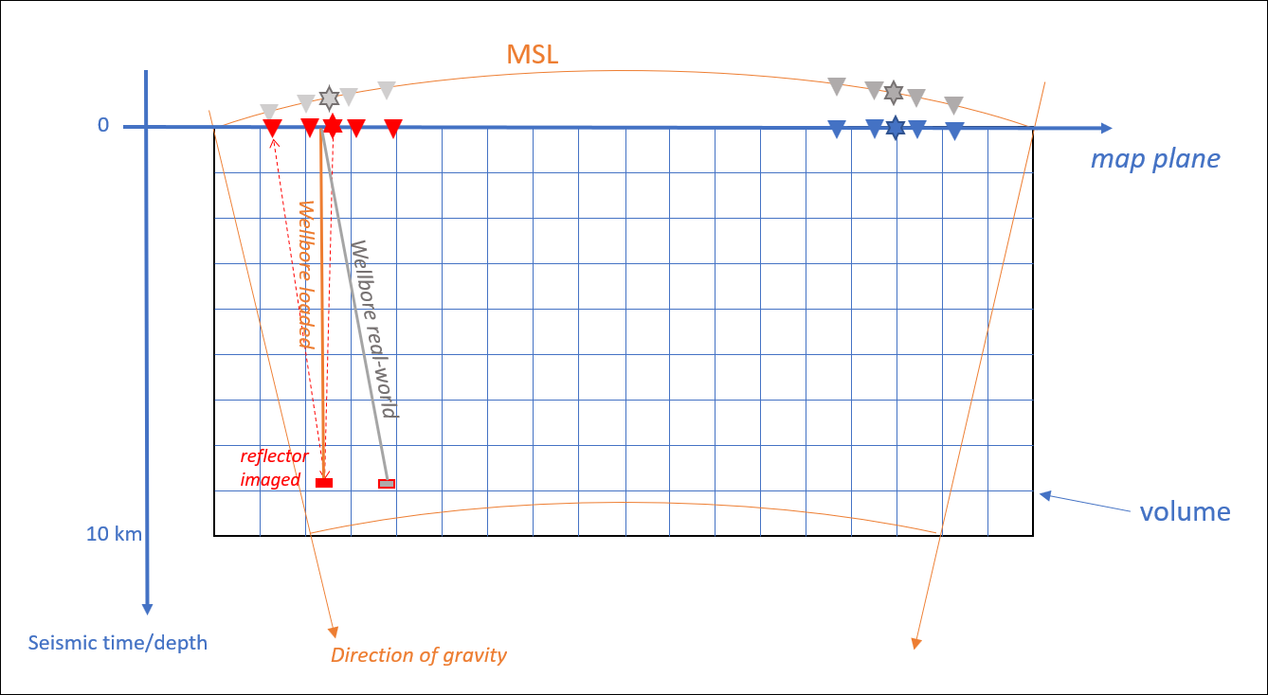
Figure 7: reflector at depth, where is it imaged in the volume? The “real vertical wellbore” is aligned with the direction of gravity but loaded in the cube straight down. The seismic is also processed ignoring earth curvature. Hence the wellbore path and the imaged reflector at the bottom of the wellbore line up.

+N/-S and +E/-W indicate Grid North oriented offsets in the same unit as the projected CRS, that are possibly scaled. Local coordinates (n,e) may be oriented True North and have different unit than +N/-S, +E/-W.
True Vertical Depth below Sea Surface. Often TVD is used instead of TVDSS, but TVD may be below the ZDP.
ISCWSA Ebook “Introduction to wellbore positioning” (v9_10, 2017; available on the internet).
Sawaryn, S.J., Thorogood, J.L., “A Compendium of Directional Calculations Based on the Minimum Curvature Method”, SPE Drilling & Completion paper 84246, March 2005.
ATAN2() denotes the four quadrant arctangent, ATAN2(y,x)=atan(y/x) in quadrant 1. Note that this is implemented in MS Excel with switched arguments.
Section 4.9 of IOGP Geomatics Guidance Note 373-07-2 “Coordinate Conversions and Transformations including Formulas”, freely available via www.iogp.com/bookstore.
Issue 1, revision 5, October 2002, freely accessible via https://www.iogp.org/geomatics/#
See https://www.energistics.org/portfolio/witsml-data-standards/
Numeric data (excl. coordinates) should be consistently stored. This applies to all Wells data attributes, across OSDU. Software should not have to look at each numeric value to assess what the UOM was. Note 2023/02: this was not implemented. Original units and data are preserved in the system.
2023/02: Only True or Grid was used in the end. Inclination-only and Blind were seen as Survey Tools. Composite data should be handled similarly, e.g., to indicate part of the wellbore is surveyed with inclination-only tool.
See also “Recommendations for management of Inclination-Only survey data”, ISCWSA, Rev D., March 2018 (https://www.iscwsa.net/articles/recommendations-for-management-of-inclinationonly-survey-data/).
Geomatics Guidance Note 373-21 ‘Grid convergence’, IOGP publication 373-21, freely available at https://www.iogp.org/bookstore.
Williamson and Wilson, Directional Drilling and Earth Curvature, SPE paper 62114, 2000.

