**Document Jest**

*This project is developed by YU Chen and MA Yuxin*

* **Lauch the game**

To lauch the game, make sure the folder “resources” where you execute your java command.

* **How to play**

Launch the game, choose how many human players and AI players.

And choose from the two game: Jest and Lucky

And also be able to choose jest game difficulty: eazy mode and difficult mode

Player can be entered via consoler and graphical interface

* **Implemented**

Implemented a visual game interface( with help of Observer design pattern)

Virtual players can pick the difficulty of the game(via Strategy design pattern)

Player information access and collection(via Visitor design pattern)

Multiple game modes: Add more cards, different rules, different calculating way for our “varient” game

Both console input and graphical interface can control the game output

Implement the MVC design pattern

* **Deficiencies**

The code is not concise

Failure to visualize the second game mode

* **First UML**

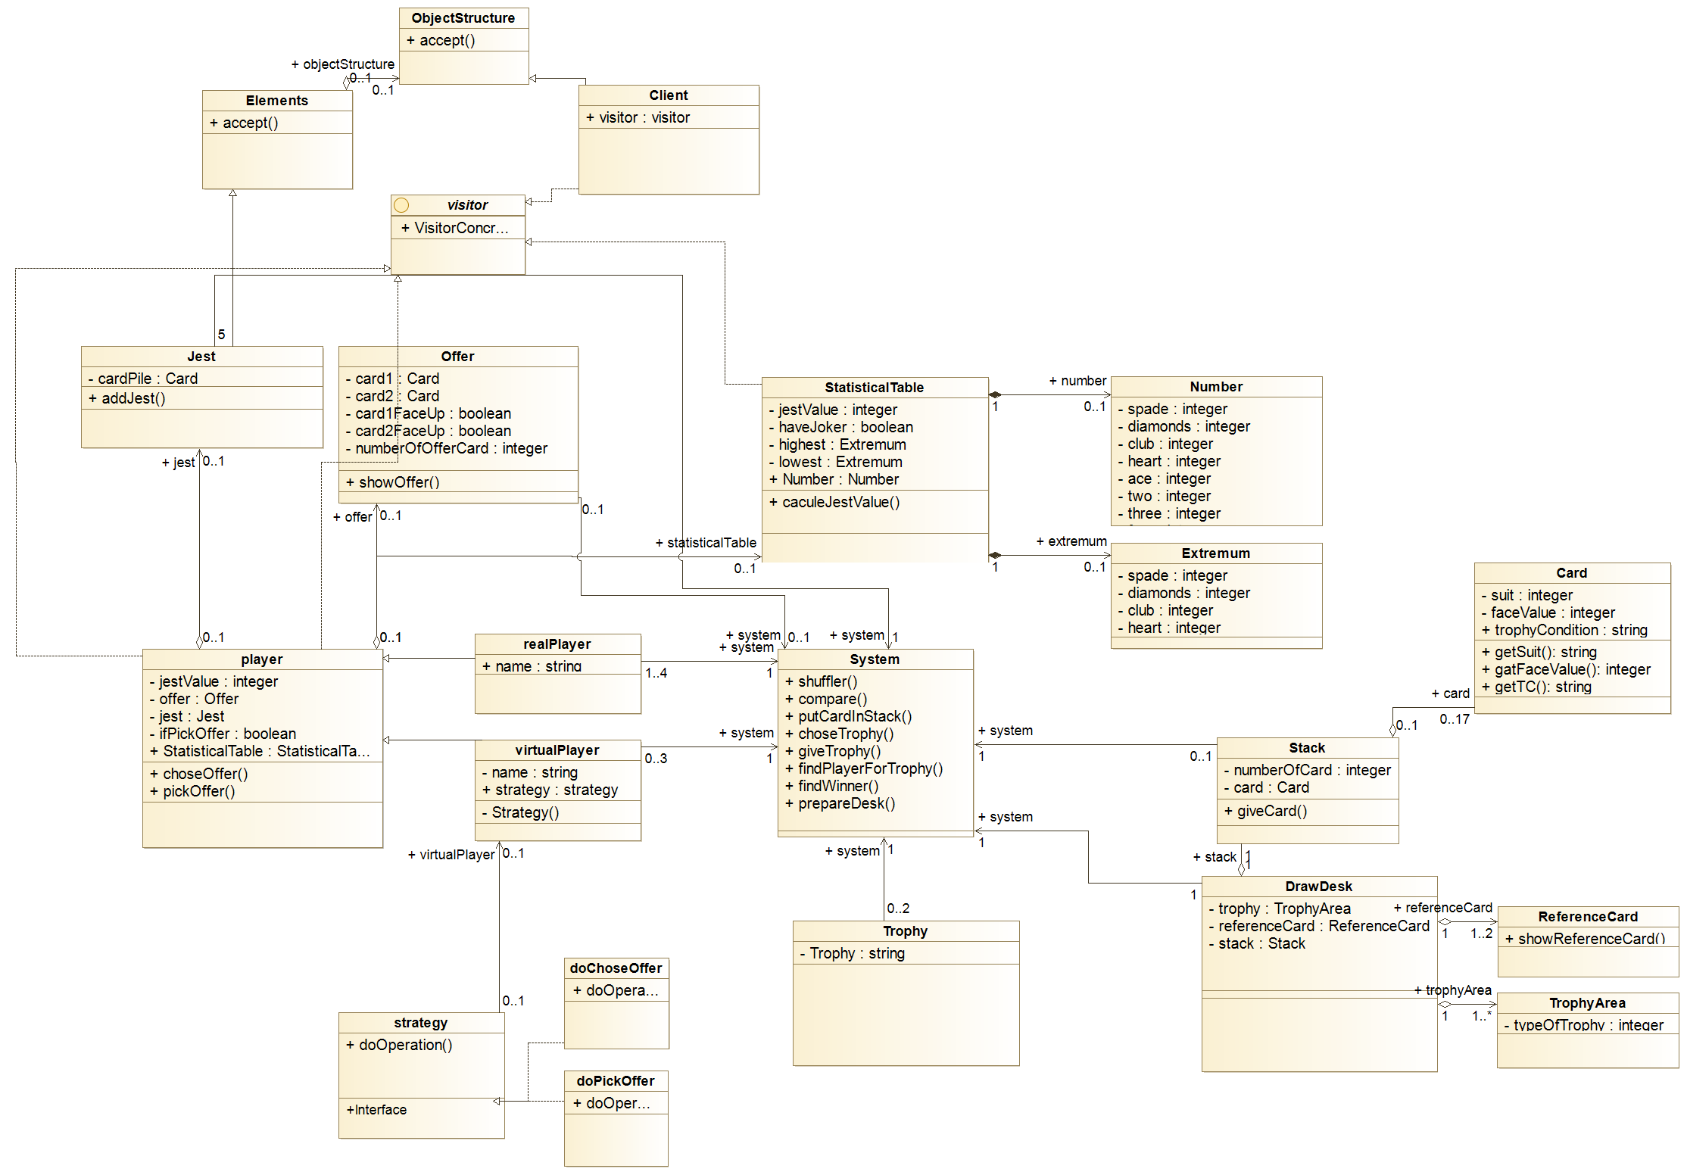

* **Final UML**

