**Lab3: Temporal Difference Learning**

Lab Objective:

In this lab, you will learn temporal difference learning (TD) algorithm by solving the 2048 game using an $n$-tuple network.

Important Date:

1. Experiment Report Submission Deadline: 4/05 (Thu) 23:59

2. Demo date: 4/12 (Thu)

Turn in:

1. Experiment report (.pdf)

2. Source code [NOT including model weights]

Notice: zip all files with name “DLP_LAB3_StudentId_Name.zip”,  
e.g.: 「DLP_LAB3_987654321_李駿逸.zip」

Lab Description:

* Understand the concept of (before-)state and after-state.
* Learn to construct and design an $n$-tuple network.
* Understand TD algorithm.
* Understand Q-learning network training.

Requirements:

* Implement TD(0) algorithm
  + Construct an $n$-tuple network
  + Action selection according to the $n$-tuple network
  + Calculate TD-target and TD-error
  + Update V(state), not V(after-state).
  + Understand temporal difference learning mechanisms

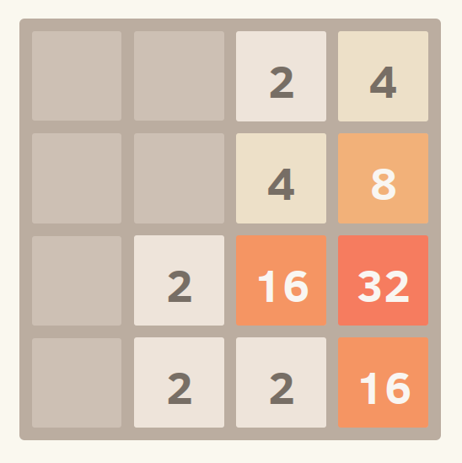Game Environment – 2048:

* Introduction: 2048 is a single-player sliding block puzzle game. The game's objective is to slide numbered tiles on a grid to combine them to create a tile with the number 2048.
* Actions: **Up**, **Down**, **Left**, **Right**
* Reward: The score is the value of new tile when two tiles are combined.
* A sample of two-step state transition

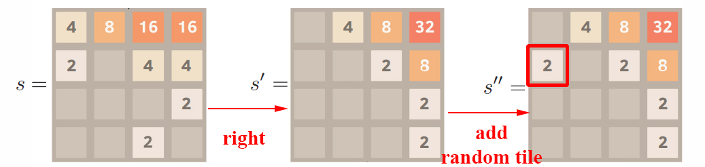

Implementation Details:

**Network Architecture**

* $n$-tuple patterns: $4×6$-tuples with all possible isomorphisms

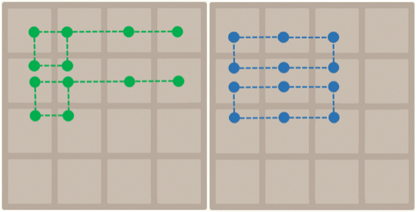

**Training Arguments**

* Learning rate: 0.1
  + Learning rate for features of $n$-tuple network with $m$ features: $0.1 ÷ m$
* Train the network 500k ~ 1M episodes

Algorithm:

**A pseudocode of the game engine and training.** (modified backward training method)

|  |
| --- |
| **function** PLAY GAME $$score←0$$ $s←$ INITIALIZE GAME STATE  **while** IS NOT TERMINAL STATE($s$) **do $a←\underset{a'∈A(s)}{argmax}{ }$**  EVALUATE($s,a’$) $r,s^{'},s^{''}←$ MAKE MOVE($s, a$)  SAVE RECORD($s, a, r, s’, s’’$) $$score←score+r$$ $$s←s''$$**for** ($s, a, r, s’, s’’$) FROM TERMINAL DOWNTO INITIAL **do**  LEARN EVALUATION($s, a, r, s’, s’’$)  **return $score$**  **function** MAKE MOVE($s, a$) $s^{'},r←$ COMPUTE AFTERSTATE($s, a$) $s''←$ ADD RANDOM TILE($s'$)  **return $(r,s^{'},s^{''})$** |

**TD-state**

|  |
| --- |
| **function** EVALUATE $(s, a)$ $s^{'}, r←$ COMPUTE AFTERSTATE $\left(s,a\right)$ $$S^{''}←ALL POSSIBLE NEXT STATES\left(s^{'}\right)$$**return $r+Σ_{s^{''}∈S^{''}}P\left(s,a,s^{''}\right)V\left(s^{''}\right)$**  **function** LEARN EVALUATION $\left(s,a,r,s^{'},s^{''}\right)$ $$V\left(s\right)←V\left(s\right)+α(r+V\left(s''\right)-V\left(s\right))$$ |

**TD-after-state**

|  |
| --- |
| **function** EVALUATE $(s, a)$ $s^{'}, r←$ COMPUTE AFTERSTATE $(s,a)$ **return $r+V(s^{'})$**  **function** LEARN EVALUATION $\left(s,a,r,s^{'},s^{''}\right)$ $$a_{next}←\underset{a'∈A(s^{''})}{argmax}{EVALUATE(s^{''},a^{'})}$$ $$s_{next}^{'},r_{next}←COMPUTE AFTERSTATE\left(s^{''},a_{next}\right)$$ $$V\left(s^{'}\right)←V\left(s^{'}\right)+α(r_{next}+V\left(s_{next}^{'}\right)-V\left(s^{'}\right))$$ |

Rule of Thumb:

* You can design your own $n$-tuple network, but do NOT try CNN.
* 2048-tile should appear within 10,000 episodes.

Scoring Criteria:  
Show your work, otherwise no credit will be granted.

* Report (60%)
  + A plot shows episode scores of at least 100,000 training episodes (10%)
  + Describe the implementation and the usage of $n$-tuple network. (10%)
  + Explain the mechanism of TD(0). (5%)
  + Explain the TD-backup diagram of V(after-state). (5%)
  + Explain the action selection of V(after-state) in a diagram. (5%)
  + Explain the TD-backup diagram of V(state). (5%)
  + Explain the action selection of V(state) in a diagram. (5%)
  + Describe your implementation in detail. (10%)
  + Other discussions or improvements. (5%)
* Demo Performance (40%)
  + The 2048-tile win rate in 1000 games, $\left\lceil \text{winrat}{\text{e}}_{\text{2048}}\right\rceil$.(20%)
  + Questions. (20%)

References:

1. Szubert, Marcin, and Wojciech Jaśkowski. "Temporal difference learning of N-tuple networks for the game 2048." 2014 IEEE Conference on Computational Intelligence and Games. IEEE, 2014.
2. Kun-Hao Yeh, I-Chen Wu, Chu-Hsuan Hsueh, Chia-Chuan Chang, Chao-Chin Liang, and Han Chiang, Multi-Stage Temporal Difference Learning for 2048-like Games, accepted by IEEE Transactions on Computational Intelligence and AI in Games (SCI), doi: 10.1109/TCIAIG.2016.2593710, 2016.
3. Oka, Kazuto, and Kiminori Matsuzaki. "Systematic selection of n-tuple networks for 2048." International Conference on Computers and Games. Springer International Publishing, 2016.
4. moporgic. “Basic implementation of 2048 in Python.” Retrieved from Github: <https://github.com/moporgic/2048-Demo-Python>.
5. moporgic. “Temporal Difference Learning for Game 2048 (Demo).” Retrieved from Github: <https://github.com/moporgic/TDL2048-Demo>.
6. lukewayne123. “2048-Framework” Retrieved from Github: <https://github.com/lukewayne123/2048-Framework>.