**ECE 448 FALL 2020**

**Assignment 2: Planning, Games**

**Oct. 26, 2020**

**Yucheng Jin**

**Yiqing Xie**

**Hangtao Jin**

**Part I**

A CSP contains two sets, one is the variable set, which contains all variables we need to assign, the other is the constraint set, which contains all constraints for the problem. In the part I of this MP, we try to put a set of pentominos into a board, fulfilling the board without overlap.

Our algorithm just goes through all blocks on the board and make sure that all blocks are covered. We first choose an empty block(a block not covered by any pentomino) and check if there is a pentomino that can cover the block without overlap and cross the board boundary. If there is no such pentomino, then the branch ends. We do choose which blank block we will fill first. We will first try to fill shorter one between the first column and the first row. That means, is we have 6 rows and 10 columns, we will fill the first column, then second column, etc. That is the heuristics for our code.

To reduce the branch, I add a test after we put a new pentomino. We check whether there is a set of adjacent blocks that has an area less than the that of the smallest pentomino. In our MP, that means there is no any set of adjacent blocks has area less than 5 blocks.

Our code can solve any combination of board and shape set within 20 seconds. The combination of board_3x20 and petnominos spends longest time to solve.

**Part II**

1. maxPlayer goes first: offensive(minimax) vs defensive(minimax)

1. maxPlayer goes first: offensive(minimax) vs defensive(alpha-beta)

1. minPlayer goes first: offensive(alpha-beta) vs defensive(minimax)

1. minPlayer goes first: offensive(alpha-beta) vs defensive(alpha-beta)

**Part III**

The defensive agent won 18 out of 20 games, so the percentage of winning is 90%, and the number of of expanded nodes for each game is [123217, 118257, 109941, 124952, 124851, 114675, 118809, 123046, 110293, 114521, 122356, 109842, 123102, 112349, 113293, 126573, 123913, 120011, 109942, 118942]. Our evaluation function for the defensive agent is simple, we just assign more utility score for preventing the offensive agent from forming three-in-a-row (e.g. for each prevention, decrement the utility score by 500). This works well because it emphasizes that the defensive agent’s strategy is to at least not lose the game. For example, the pictures below show how the defensive agent prevents the offensive agent from forming three-in-a-row. As we can see, every orange line indicates one successful prevention.

**Part IV**

We played with our agent for more than 10 times, and we tried:

1. maxPlayer goes first, human is offensive, my agent uses minimax

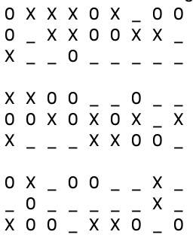

minPlayer wins

1. maxPlayer goes first, human is defensive, my agent uses minimax

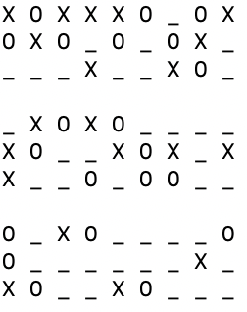

maxPlayer wins

1. maxPlayer goes first, human is offensive, my agent uses alpha-beta

minPlayer wins

1. maxPlayer goes first, human is defensive, my agent uses alpha-beta

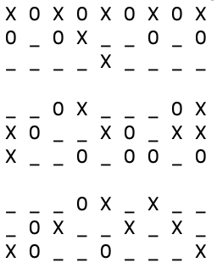

maxPlayer wins

Because the strategy for my agent is to prevent me from winning, therefore, it pays more attention on stopping me from winning the game, so its most important advantage is that it is somehow “undefeatable”, but I have to consider a lot to choose the next step and may have mistakes.

**Part V**

Yiqing Xie finished Part I, Yucheng Jin finished Part II, and Hangtao Jin wrote this report.