Basic 1:

Design a system that scales to millions of users on AWS

<https://github.com/donnemartin/system-design-primer/blob/master/solutions/system_design/scaling_aws/README.md>

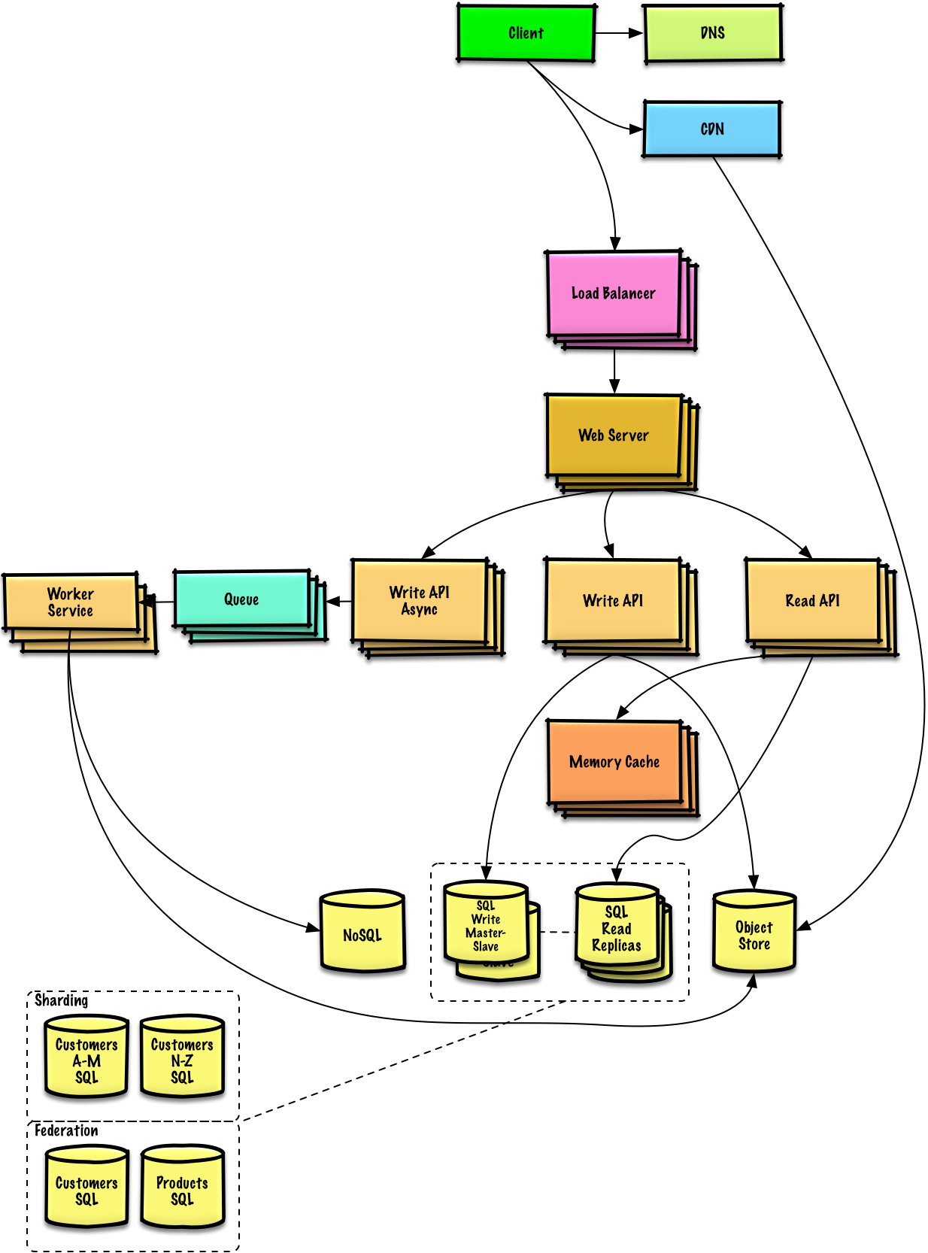

Design Pastebin.com (or Bit.ly):

<https://github.com/donnemartin/system-design-primer/blob/master/solutions/system_design/pastebin/README.md>

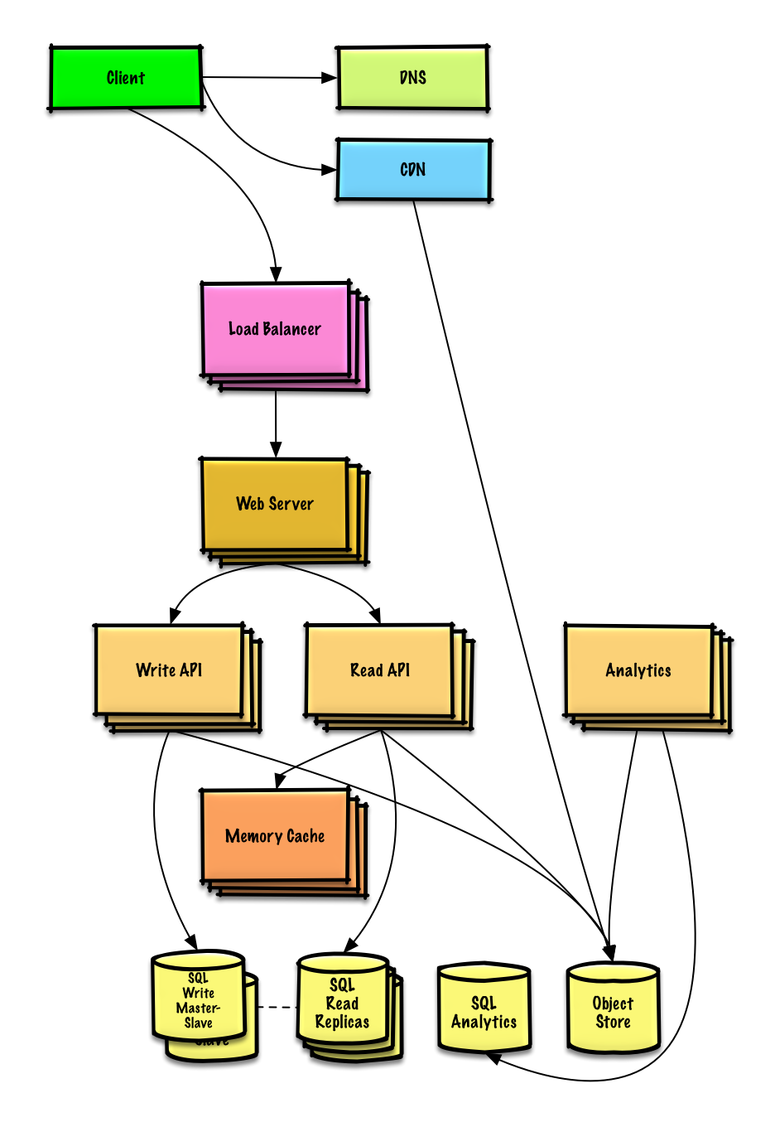

Design the Twitter timeline and search (or Facebook feed and search):

<https://github.com/donnemartin/system-design-primer/blob/master/solutions/system_design/twitter/README.md>

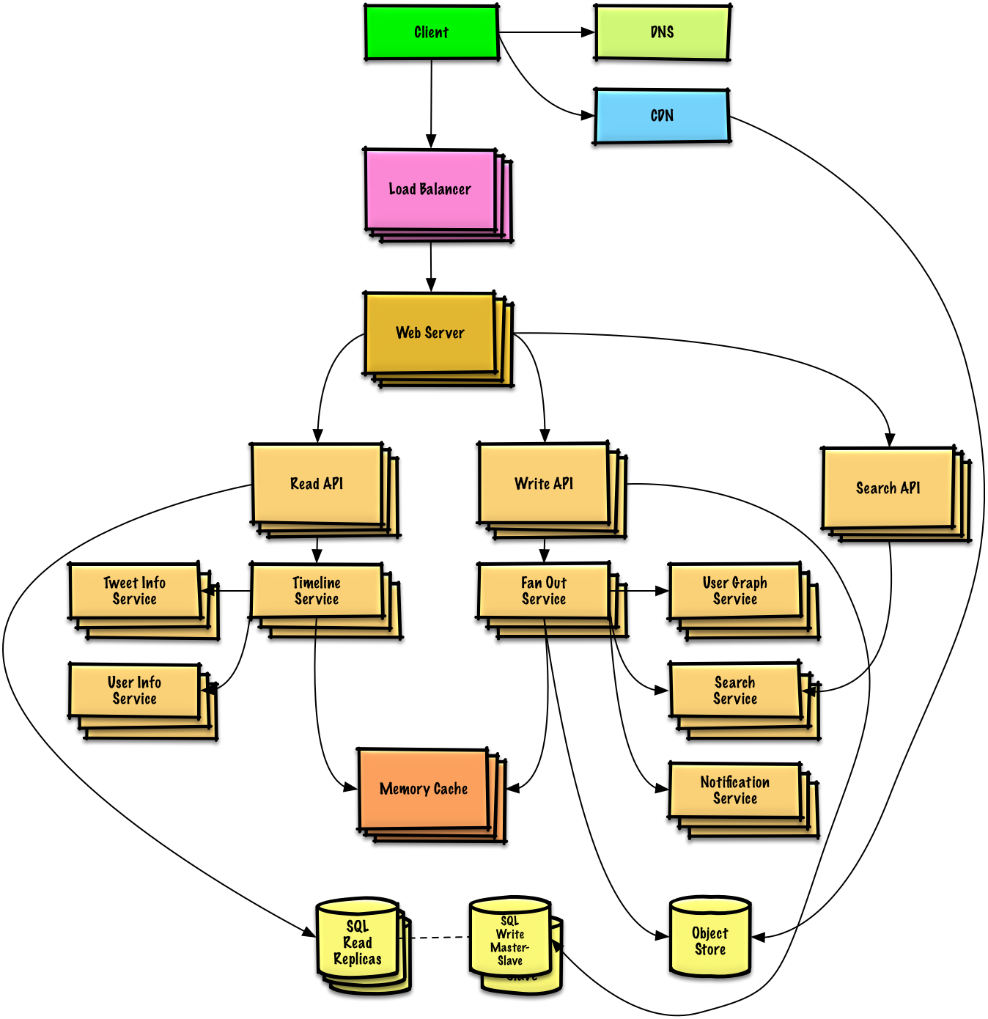

Design a web crawler:

<https://github.com/donnemartin/system-design-primer/blob/master/solutions/system_design/web_crawler/README.md>

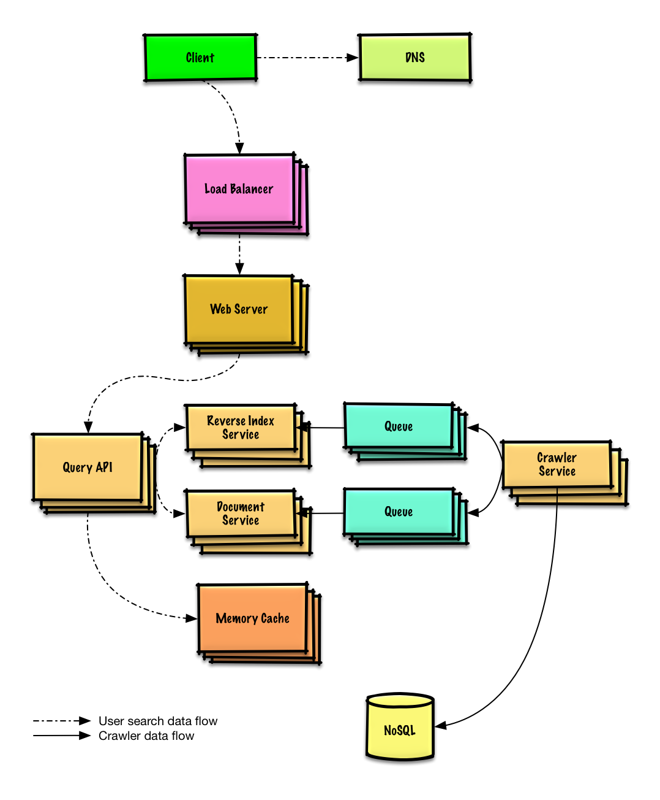

Design Mint.com

<https://github.com/donnemartin/system-design-primer/blob/master/solutions/system_design/mint/README.md>

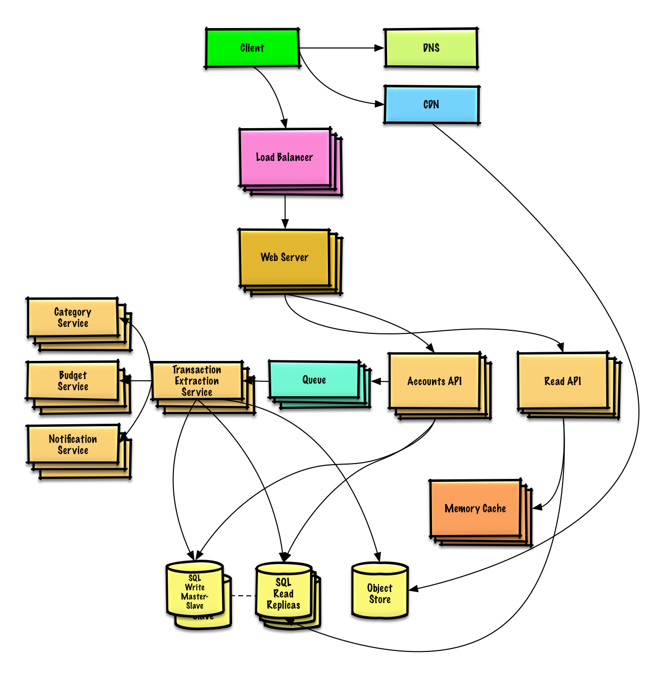

Design the data structures for a social network

<https://github.com/donnemartin/system-design-primer/blob/master/solutions/system_design/social_graph/README.md>

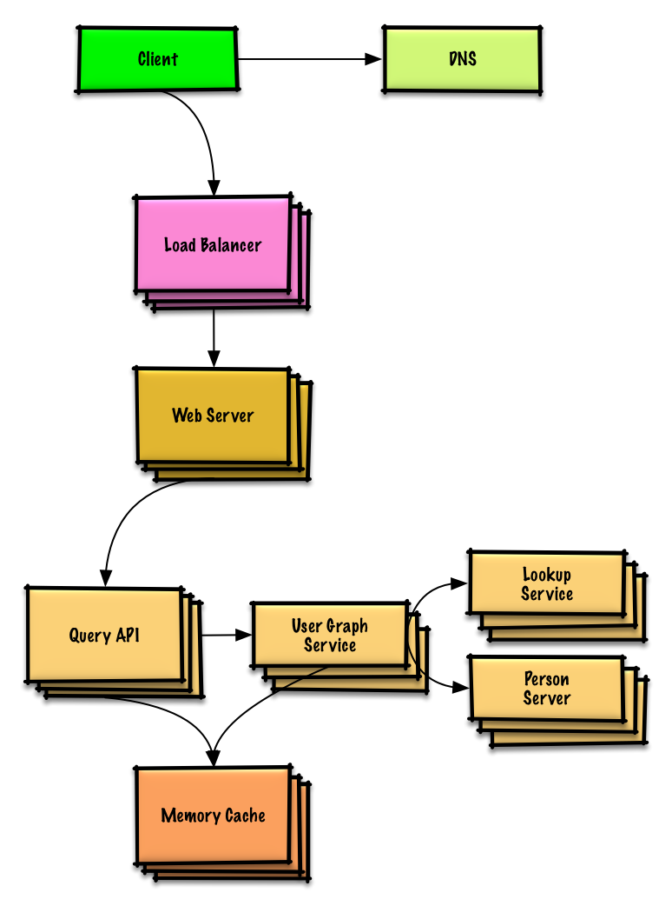

Design a key-value store for a search engine

<https://github.com/donnemartin/system-design-primer/blob/master/solutions/system_design/query_cache/README.md>

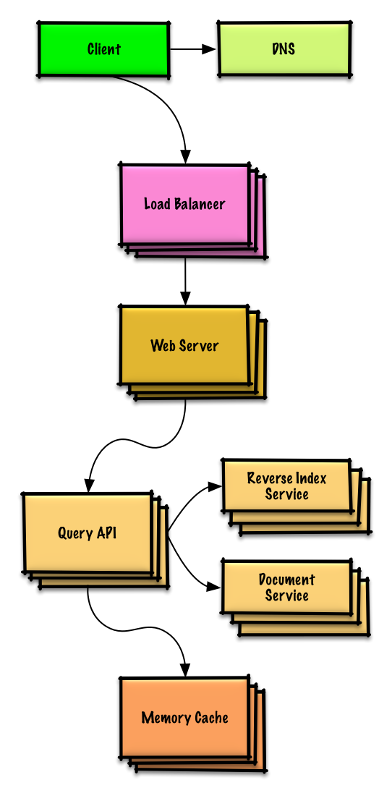

Design Amazon's sales ranking by category feature

<https://github.com/donnemartin/system-design-primer/blob/master/solutions/system_design/sales_rank/README.md>

