Project 1: MNIST Analysis
ENEE436 Foundation of Machine Learning
University of Maryland, College Park
Instructor: Joseph JaJa
Yuchen Zhou
11/09/20

Contents
Naïve Bayesian Classifier 2
Overall Accuracy 2
Label Accuracy 2
Kth Nearest Neighbor Classifier 4
Error Rate vs. Number of Neighbors 4
KNN Error Rate Table 4
Fisher’s Linear Discriminant Analysis 5
0 and 9 5
0 and 8 5
1 and 7 6
Error Rate Table 6
Principal component analysis 8
Number of principal component = 2 8
Number of principal component = 3 9
Naive Bayesian and KNN classification with PCA components = 5, 10, 20, 50,100 10

Naïve Bayesian Classifier

Overall Accuracy
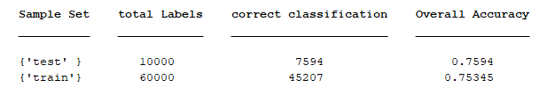

Label Accuracy
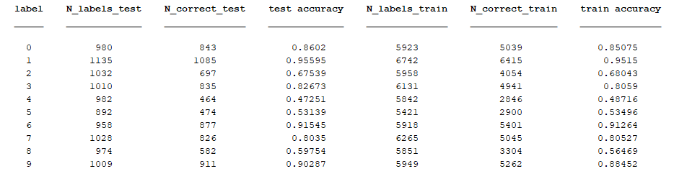
* Error Rate is 1 – accuracy
For the Naïve Bayesian Classifier, the label chosen is simply the one that yields the highest probability for that data:
$$c^{*}={argmax}_{c}P\left(c | x\right)={argmax}_{c}\frac{P(x|c)P\left(c\right)}{P(x)}$$
Since $P\left(x\right)$ is constant for all values for c in $P\left(c | x\right)$, we are only counting$P(x|c)P\left(c\right)$, which $P\left(x | c\right)$is the class conditional probability of given class label and $P\left(c\right)$ is the prior probability based on the training samples. For the Naïve Bayesian Classifier for MNIST, the class conditional probability of label c is the product of pixel $P(x_{i}|c)$ for $i=1…784$, or
$$P\left(x | c\right)=\prod_{i=1}^{784}{\frac{1}{\sqrt{{2πσ_{i}}^{2}}}e^{-\frac{{(x_{i}-μ_{i})}^{2}}{2{σ_{i}}^{2}}}}$$
We must compute the sample mean and sample variances of each pixels in each label in order to calculate the posterior probability $P\left(x | c\right)$. For a testing sample $x^{'}$, it will be classified as label c such that c maximizes $P(x'|c)P\left(c\right)$ or $ln⁡(P\left(x' | c\right))+ln⁡(P\left(c\right))$.
In the process of building the Naïve model, I ignored pixels that have 0 sample variance as they will cause undefined conditional probability. Therefore, the counted pixels were narrowed from 784 to 425.
From here, we have an approximately 25% overall error rate, with worst prediction rate in labels 4,5,8, and 9. we can observe that (5,8), (5,9), (4,8), (4,9) are some of the combinations where the classifier is confused in predicting the right label. Overall, the Naïve Bayesian Classifier

Kth Nearest Neighbor Classifier

Error Rate vs. Number of Neighbors

KNN Error Rate Table
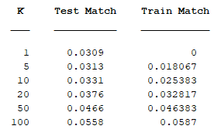
The Kth nearest neighbor classification method shows an outstanding performance on the MNIST data set as the error rate is less 1% for all K values I tested. This experiment also indicates that having a large K value doesn’t guarantee a better error rate than lower K values (the error rate grows as K increases), meaning the most optimal K value depends on the typical data set and it is the result from many tests. Sometimes considering more neighbors will cause more noises and interferences in the classification process, causing more incorrect predictions.

Fisher’s Linear Discriminant Analysis

0 and 9

0 and 8

1 and 7

Error Rate Table
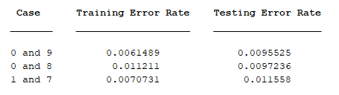

The first three plots show the projected samples in one dimensional space and their corresponding estimated Gaussian distribution plot. The vertical black line is the decision boundary for each two digits, which is the intersection between the two gaussian distribution. The Fisher linear discriminate analysis has efficiently separated the data by finding the optimal projection direction that divides the samples of classes as far as possible. The optimal direction for two classes is given by:
$$\vec{u}={S_{w}}^{-1}(\vec{μ_{1}}-\vec{μ_{2}})$$
$$\vec{μ_{i}}=\frac{1}{n_{i}}\sum_{\vec{x∈D_{i}}}{\vec{x}}=sample mean of samples of each classes$$
$$S_{w}=S_{1}+S_{2}=within-class scatter matrix$$
$$S_{i}=\sum_{x∈D_{i}}{(\vec{x}-\vec{μ_{i}}){(\vec{x}-\vec{μ_{i}})}^{t}}$$
Fisher LDA is an effective discriminate function for separating projected samples then classifying them based on the distribution. Having error rate less than 1% is the best evidence.

Principal component analysis

Number of principal component = 2

Number of principal component = 3
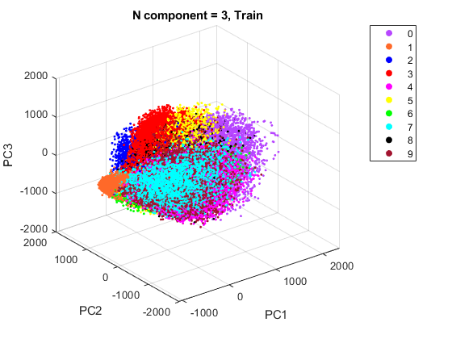
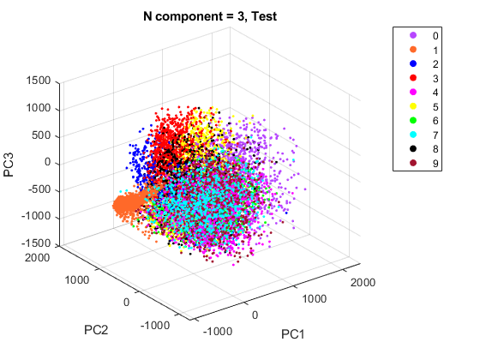

Naive Bayesian and KNN classification with PCA components = 5, 10, 20, 50,100
The principle component analysis reduces/projects the samples from higher dimension space into lower dimension space by capturing the important features that represent the sample. The Nth principal component projection vector is the Eigenvector of the Nth largest Eigenvalue of scatter matrix S
$$S=\sum_{k=1}^{n}{({\vec{x}}_{k}-\vec{μ}){({\vec{x}}_{k}-\vec{μ})}^{t}}$$
with $\vec{x}$ being the training samples and µ being the feature mean vector.
As we can observe from the error rate of classifier vs. number of PCA components plot, low number of PCA components is not decisive at classifying the samples, as the error rate of each classifier is approximately 20+% when we reduced the samples into 5-D. I believe the error rate would be grow higher if we reduce the number of PCA components to 1 and 2. Increasing the number of PCA components captures more decisive features of the samples, therefore the error rate improved significantly. However, there are optimal pivots where the error rate reaches the minimum, number of PCA components greater than that values result in higher error rate. To find this optimal value, it is important to perform multiple tests with various numbers of components, just like the Kth Nearest Neighbor Classifier.

