國立嘉義大學107學年度

資訊工程學系碩士班招生考試試題

科目：離散數學

1. Please determine whether each of the following functions from *Z* to *Z* is invertible (one-to-one and onto) function or not? (Note: *Z* means the set that contains all of the integers) (20%)



(a) (b)



1. 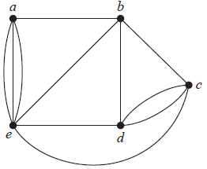Find an Eulerian circuit in the following graph if it exists. If it does not exist, please explain the reason. (10%)
2. Determine the number of possible integer solutions for , where
3. 
4. 
5. 
6. 

(20%)

1. Show that (10%)

(A∩B)∪(B∩C) 圖片2.jpg (A∪B).

1. Arranging all of the letters in MASSASAUGA. How many is the possible arrangements? If all four A’s are together? (10%)
2. Determine the number of nonnegative integer solutions to the equation. (10%)

*x*1 + *x*2 + *x*3 +*x*4 = 18 and *xi* ≤ 7 for all *i*.

1. Suppose that *S*={0, 1, 2, 3}. Let *R* be a relation containing (*a*, *b*) if *a* ≤ *b*,

where *a $∈$*  *S* and *b $∈$ S*. Is *R* reflexive, symmetric and antisymmetric? (10%)

1. Use logically equivalent statements without the direct use of truth tables, show that
2. *p*⇔***¬***(*p*∧*s*) → (***¬****s* ∧ *p*).
3. ***¬***(*p*↔*q* ) ⇔ (*p* ∧***¬****q*)∨(*q* ∧***¬****p*).

(10%)