**HW07 Report**

ECE497 Dr. Yoder

Yuchen Wang

The result shows the delay time and CPU usage for the three different modes.

|  |  |  |
| --- | --- | --- |
| **Mode** | **Delay** | **CPU** |
| interrupt | 130us | 2% |
| mmap | 590ns | 100% |
| kernel | 296us | 1.6% |

Below are the waveforms for the three different modes.

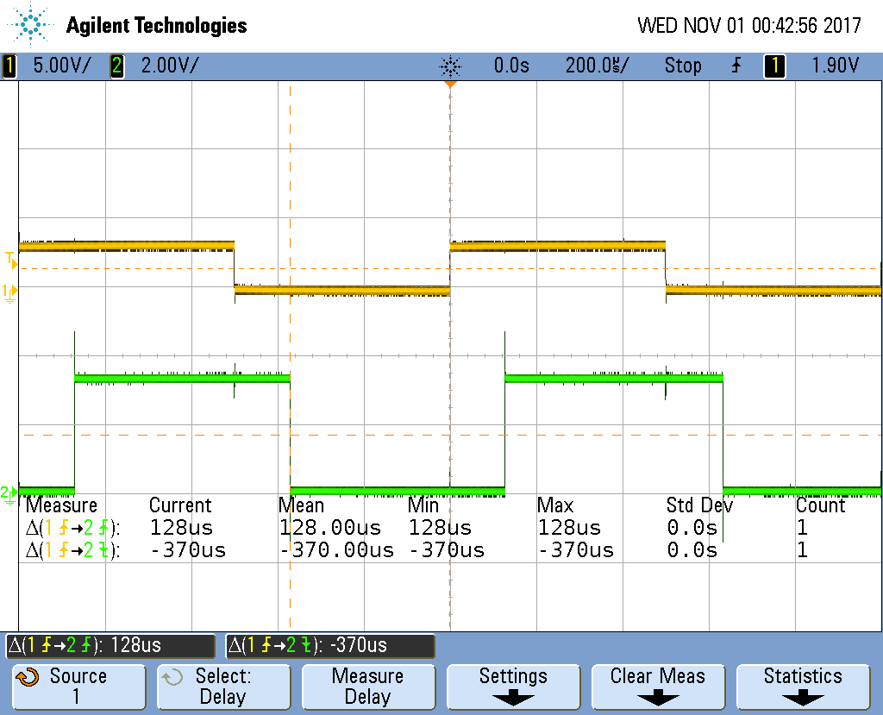

Figure1. Interrupted Mode

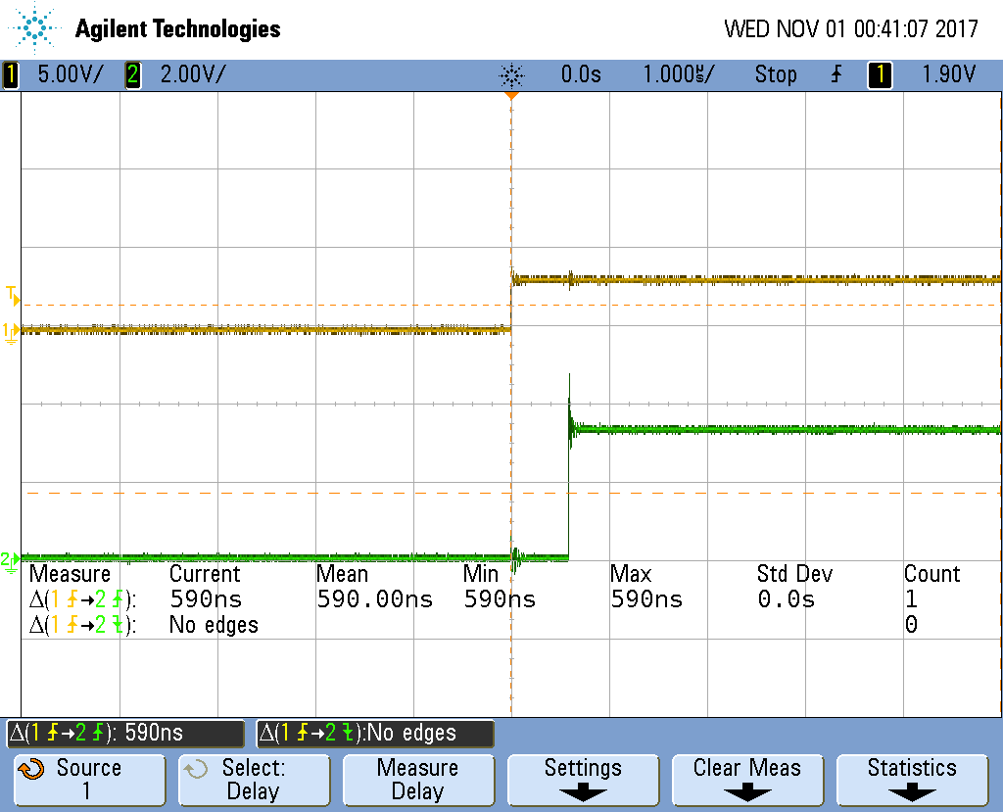

Figure2. mmap Mode

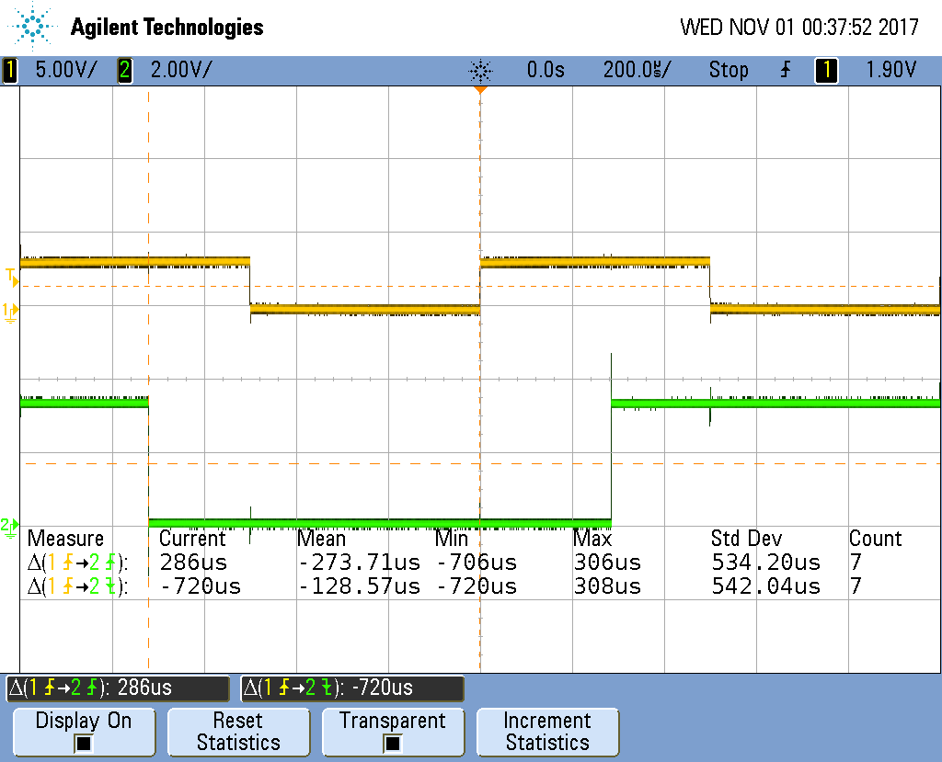

Figure3. Kernel Mode