# [Adaptive Histogram Equalization](https://stackoverflow.com/questions/28993831/adaptive-histogram-equalization-ahe-algorithm)

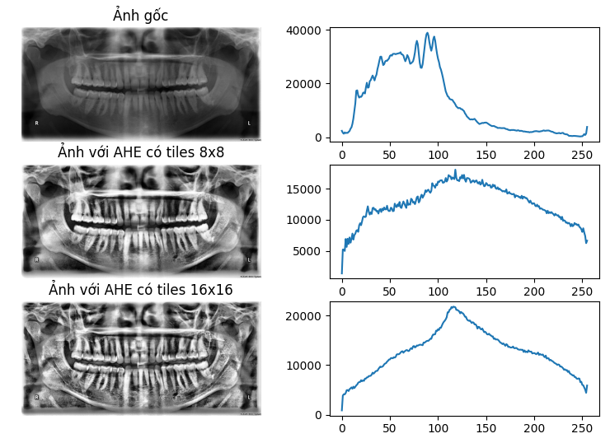

**Contrast Limited Contrast Limited**

