CMPT 275
Group 2
GoFit Apple
Requirement Document

Hartono (Tony) Salim [301233981]
Davidson Kao [301200386]
Yu-Chun (May) Lin [301168746]
Wei (Candy) Xiao [301187355]
Patrick McKnight [301244678]
Team Website: https://sites.google.com/site/sfu275group2/

Contents
Revision History 4
1. Introduction 5
2. Intended Audience List 6
3. Features 7
3.1. Authentication 7
3.2. Sign-up 7
3.3. Profiles 7
3.4. Facebook Connection 7
3.5. Calendar 7
3.6. Time Calculation & Movement Tracking 7
3.7. Game 7
3.8. Storing usage data 7
4. Functional Requirement 8
4.1. Authentication 8
4.2. Sign Up 8
4.3. Main screen 8
4.4. User Profile 8
4.5. User Activities 9
4.6. Game levels 9
4.7. Score 9
4.8. Exercise 9
5. Non-functional requirement 10
5.1. Performance 10
5.2. Space 10
5.3. Security 10
5.4. Usability 10
5.5. Reliability 11
5.6. Robustness 11
6. Tutorial example 12
6.1. Tutorial 1 12
6.2. Tutorial 2 13
6.3. Tutorial 3 16
6.4. Tutorial 4 17
7. Glossary 18
7.1. App 18
7.2. Authentication 18
7.3. IOS 18
7.4. Level 1 18
7.5. Level 2 18
7.6. Level 3 18
7.7. Arms 18
7.8. Core 18
7.9. Legs 19
7.10. Office worker 19
7.11. Fitness-lovers 19
7.12. Facebook 19
7.13. Pre-set score 19
7.14. Calendar 19
7.15. Gyroscope 19
7.16. Alpha Prototype 19
7.17. Beta Prototype 20
Reference 21

Revision History
Table 1: Revision History
Revision | Status | Publication/Revision Date | By
1.0 | Created | Oct 04, 2014 | Wei Xiao, Yu-Chun Lin
1.1 | Revised(Introduction, Intended Audience List, Features – Correct grammar and spelling) | Oct 05, 21, 2014 | Tony Lim
1.2 | Revised(Glossary – Add words) | Oct 05, 2014 | Wei Xiao
1.3 | Revised(Example Tutorials – Add diagrams) | Oct 06, 2014 | Yu-Chun Lin
1.4 | Revised(Glossary – Add more words) | Oct 06, 2014 | Yu-Chun Lin
2.0 | Final Version for assignment 1 (Add table content, cover page and page number) | Oct 06, 2014 | Wei Xiao, Yu-Chun Li，Tony Lim, Davison Kao, Patrick McKnight
2.1 | Revised(Edit score, user profile – Functional requirement) | Oct 23, 2014 | Wei Xiao
2.2 | Revised(Add “Accelerometer” - Glossary) | Oct 26, 2014 | Wei Xiao, Davison Kao
2.3 | Revised(Add new tutorial graphs – tutorial example) | Oct 26, 2014 | Wei Xiao
2.5 | Revised( Add reference – References) | Oct 26, 2014 | Wei Xiao
3.0 | Final Version for assignment 3 | Oct 26, 2014 | Davison  Kao, Patrick McKnight, Wei Xiao, Yu-Chun  Lin, Tony Lim
3.1 | Revised(make the correction according the TA’s feedback from HW2-revision history, introduction, features, functional and non-functional requirement, tutorial example) | Nov 6, 2014 | Wei Xiao
3.2 | Revised( change the document according to the implementation of version 2 | Nov 9, 2014 | Wei Xiao
4.0 | Final Version for assignment 4 | Nov 9, 2014 | Wei Xiao, Yu-Chun Li，Tony Lim, Davison Kao, Patrick McKnight
4.1 | Revised( modify the document – Introduction, Intended audience list, functional requirement | Nov 23, 2014 | Wei Xiao
4.2 | Revised( Add instruction - features | Nov 26, 2014 | Wei Xiao

Introduction

Welcome to Musclapp! Musclapp is a user input and muscle building game app that will be available on iOS platform devices and will be on the Apple App Store on December 2014.
The app is directed to teen and adults who desire to improve their muscles but do not have enough time to go to the gym. By using Musclapp, they can build muscle anywhere, even at home, without any fitness equipment. The app is recommended from mid to late high school level education when physical education has become an optional course, and older. The app is built towards building specific muscle through different exercises and user input data, which is used to calculate the score. Three levels of difficulty are involved in the app: level 1 (easy), level 2 (medium), level 3 (hard). In each level, the app have 3 different exercises that aim the training of specific muscle (arms (upper), core (abdominals, pectorals, etc.), and legs (calves, hamstring, etc.)). The app requires the user have the iPhone in close proximity – whether it is strapped, or placed nearby -- depending on the exercise to track their development. Lastly Musclapp is a personal use app only, that encourages limb strengthening along with decreasing stroke and/or heart attacks through cardiovascular activities.

Figure 1: Muscle

Intended Audience List

▪ Young teenagers who intend to build their muscle and become more fit but do not have much knowledge about muscle building.
▪ Office workers and students who are busy with their work do not have enough time to go to gym.
▪ Fitness lovers who desire to have fun during the exercise or want to challenge their friends.

Mid to late teenagers are one of the age group, where they are more body conscious than other age groups. They might want to start body building, but lack related knowledge and safety precautions; thus, they may easily get hurt during the exercises. Musclapp provides the scientific and systematic training plan which involves many sample exercises that can help them to build muscle in a healthy and safe way. By using Musclapp, users can follow the exercises in each level, and record their progress in calendar.

Office workers and students are busy with their works and always have a lot of peer-pressure from their co-workers and friends to “look good”. However, in their workplace, their fitness level can significantly decline due to sitting in front of computers every day and do not have enough time to go to gym. And this is where Musclapp comes along, to help them gain back their fitness level, without having the travelling time necessary to go to the gym. By using Musclapp, they exercise anywhere without using fitness equipment to help them motivate increasing their fitness level, without the hassle of going to the gym. The calendar system built in to Musclapp is also helps office workers tracking their fitness plan every day, their results, and provide them a scientific training plan.

Some fitness-lovers go to gyms every day and repeat similar exercise, so they tend to have more fun during their muscle-built process. Musclapp is a game that involves different difficulty levels. When fitness-lovers performing the exercise, Musclapp can calculate the number and the distance of the user’s movement that they have performed and then by that procedure, a score will be determined, and will be reported to the user. High score gives the user more sense of achievement.

Figure 2: Challenge

Features
  - Authentication
Users need a profile to access the feature of app.
  - Sign-up
A user can create a new profile with the sign-up feature or sign by their Facebook account.
  - Profiles
Profiles store users’ person information, such as name, weight, height, age and gender.
  - Calendar
This feature helps users to track their everyday exercises. Calendar records the information of exercises that the user has taken in the past.
  - Time Calculation & Movement Tracking
When the user is doing the exercise, the app will calculate the movement frequency and measure the distance for each move at the same time via the gyroscope implemented into the iOS system. Through the count of repetitions and the movement distance, the app will calculate a suitable score for the user.
  - Exercise
With respect to the exercise’s difficulty, the app has three levels. For each level there are three different exercises to perform which is aimed to train specific parts in our body (arms (upper), core (abdominals, pectorals, etc.), legs (calves, hamstring, etc.)). When the user selected the exercise, a gif animation and instruction will show how to perform the exercise.
  - Storing usage data
The app shall collect information about the app usage whenever the user finishing their exercises. Then, users can view them in calendar.

  - Instruction
List introduction and instruction for all exercises (total 9). The introduction and instruction help users to learn more about each exercise.

Functional Requirement

  - Authentication
▪The user shall create a new account using email address.
▪The user shall be able to sign up with username and password.
▪The user shall also be able to sign up through Facebook login page.
▪In case the user forgets his/her password; the system shall send an email with the link for resetting the password.

  - Sign Up
▪The username should be a valid email address in the format of XXX@XXX.XX.
▪The password should be no less than 6 characters but not more than 20 characters.
▪If the username or password has a wrong format; the app should show an error message and ask for retyping.
▪ If the username has be registered twice, the app should show an error message and ask for retyping.

  - Main screen
▪In the main screen, the user shall click one of the four buttons: “Profile”, “Exercise”, “My activities” and “Instruction”.
▪The user shall click the “Profile” button to access the “Profile” page.
▪The user shall click the “Exercise” button to access the “Exercise” page.
▪The user shall click the “My activities” button to access the “My activities” page.
▪The selected button should be highlighted and toggle to the corresponding page.

  - User Profile
▪This page shall show the user profile including personal information such as gender, age, height, weight.
▪The user shall be able to modify the profile by clicking the “save” button.
▪The app shall constrain the format of each item.
▪ Gender is either male or female.
▪ Age is an integer between 1 and 100.
▪ Height is an integer between 50 and 300 in the unit of centimeter.
▪ Weight is an integer between 20 and 200 in the unit of kilogram.
▪If the value that they entered is not in the range or wrong format, the app should show error message and ask for retyping.

  - User Activities
▪The workout history of the user shall be shown on a calendar with highlighted date.
▪The total time of the workout shall be display in the calendar screen.
▪The user shall switch between months by swiping left or right.
▪The daily workout page shall show the time.

  - Game levels
▪The app shall show a menu with four options: “Stretch”, “Level 1”, “Level 2”, and “Level3”.
▪The new user shall be able to click “Stretch”, “Level 1”, “Level 2”, and “Level 3”.
▪At each level, the app shall display an interactive image of human body, which contains three selectable major body parts: “Arms”, “Core”, and “Legs”. The user shall click one body part to start the corresponding workout.
▪The user shall be able to earn stars by doing workout. The total score earned from different workouts achieve the specified target.
  - Score
▪The score depends on the distance, the number of exercise and time used by the user.
▪The score is calculated as Score = gender modifier*(100 + exercise movement * reps). The score shall always be rounded to integer.
▪The gender modifier = 1 for male, 1.2 for female.
▪ reps = repetitions, the amount of times the user performs the exercises. If the user is doing legs or arms part exercises, which having to do the exercises once on both legs or arms to count as one repetition.
▪The score shall show in the “Exercise Level” and “My activities” screen. The score will also be shown once the exercise is completed in the “score” screen.

  - Exercise
▪The screen shall show instructions on how to position the body and place the device. User shall click the “Ready” button to terminate the instruction.
▪The screen shall display the “Start” button after closing the instruction.
▪The device shall display the number of repetitions during the exercise. The automatic counting shall be realized using the accelerometer sensor and gyroscope sensor by calculate the difference between the start angle and the end angle.
▪The user shall click the “Stop” button at the bottom of the screen to stop the workout, and the user shall see the final result for the exercise, which involved score, exercise time, number of repetitions and exercise distance.
▪The current finished workout shall be saved to “My activity” and scores shall be updated on the interactive body image.

- Non-functional requirement
  - Performance
▪The app must start within 3 seconds after clicking the icon of app.*
▪The app must take less than 1 second to switch between the pages.*
▪When the user forgot the password; the system must send an email in 60 seconds.*
▪Any users input to the screen must show up in 0.5 seconds.*
▪The counting number during the exercise must show up within 0.5 seconds.*
▪The system shall require less than 50 megabyte memory at run time.*
▪If the user presses the home button; the system shall toggle to the iPhone’s home screen.
▪If the user has not completed the exercise, and the data is not saved, the progress will be lost. A notification for lost data will be reminded.

*: These requirements are for user convenience. Numbers are defined by developer preference.
  - Space
▪The size of the app must less 30 MB.

  - Security
▪User must have valid username and password to the app, except viewing the log-in page.
▪When the user is inputting the password, the characters shall show up for 0.5 second and then is masked by “•”.
▪The personal information of user must be store in the database, which only be assess by authorized security administrator.

  - Usability
▪User should be able to understand the workout within 2 minutes.
▪User should be easily to count the number of exercise during the workout.
▪If the user cannot perform certain workout we specified, the app should make some alternative workouts (exercises that focuses on other body part) within the scope of our app.

  - Reliability
▪The app must check the inputs that valid with the system range. Refer to 5.4.3
▪The saved data should not be lost in any case.
▪During the normal use, the chance that the app crashes due to errors should be less than 5% of the time.

  - Robustness
▪After the system crash, the app must be able to restart within 10 seconds.
▪After the system crashed, the app shall create an error report and prompt to send it to the system manager.

- Tutorial example for version 1

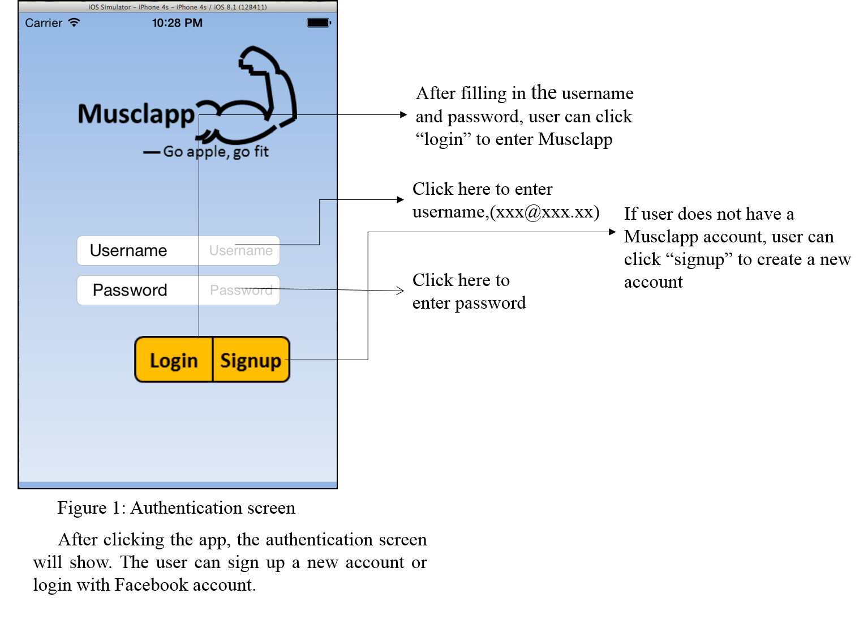
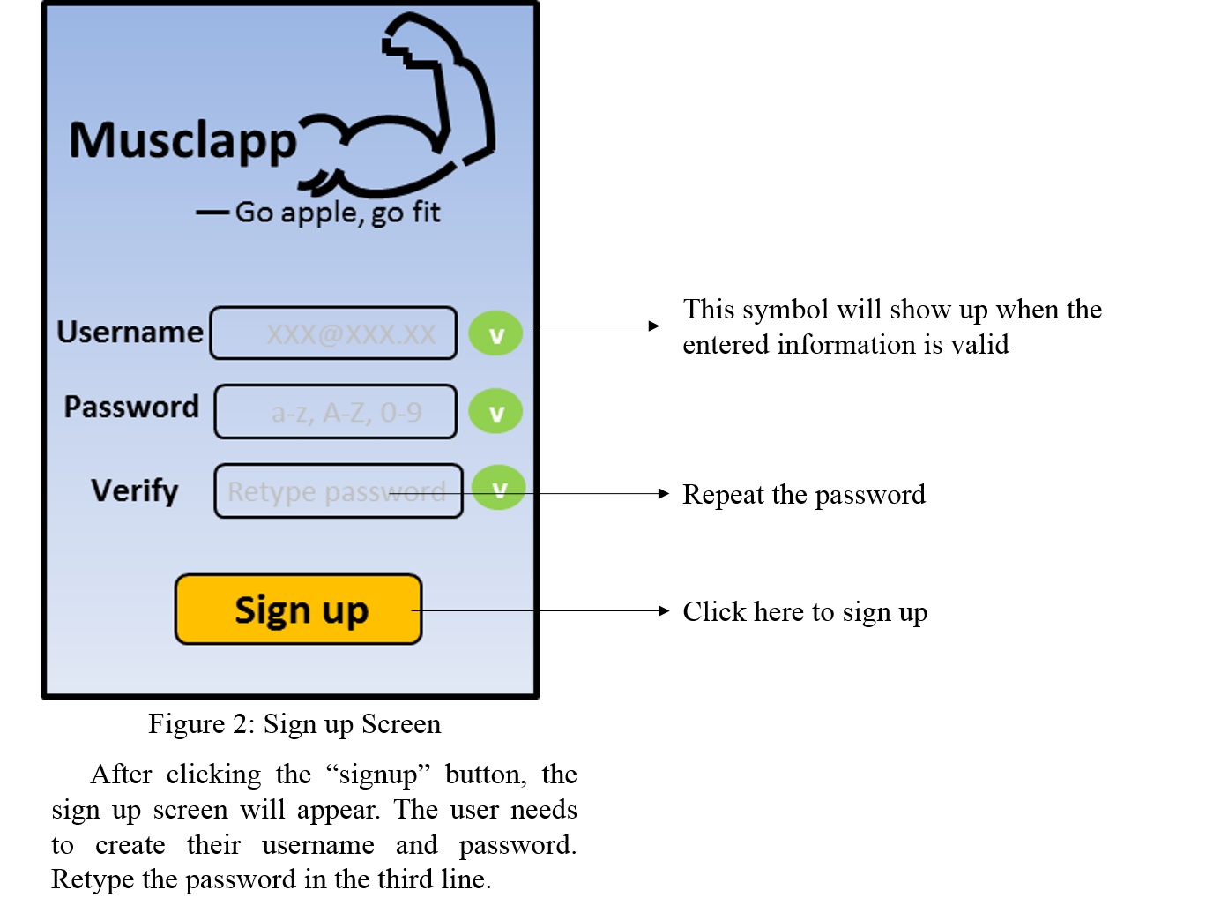

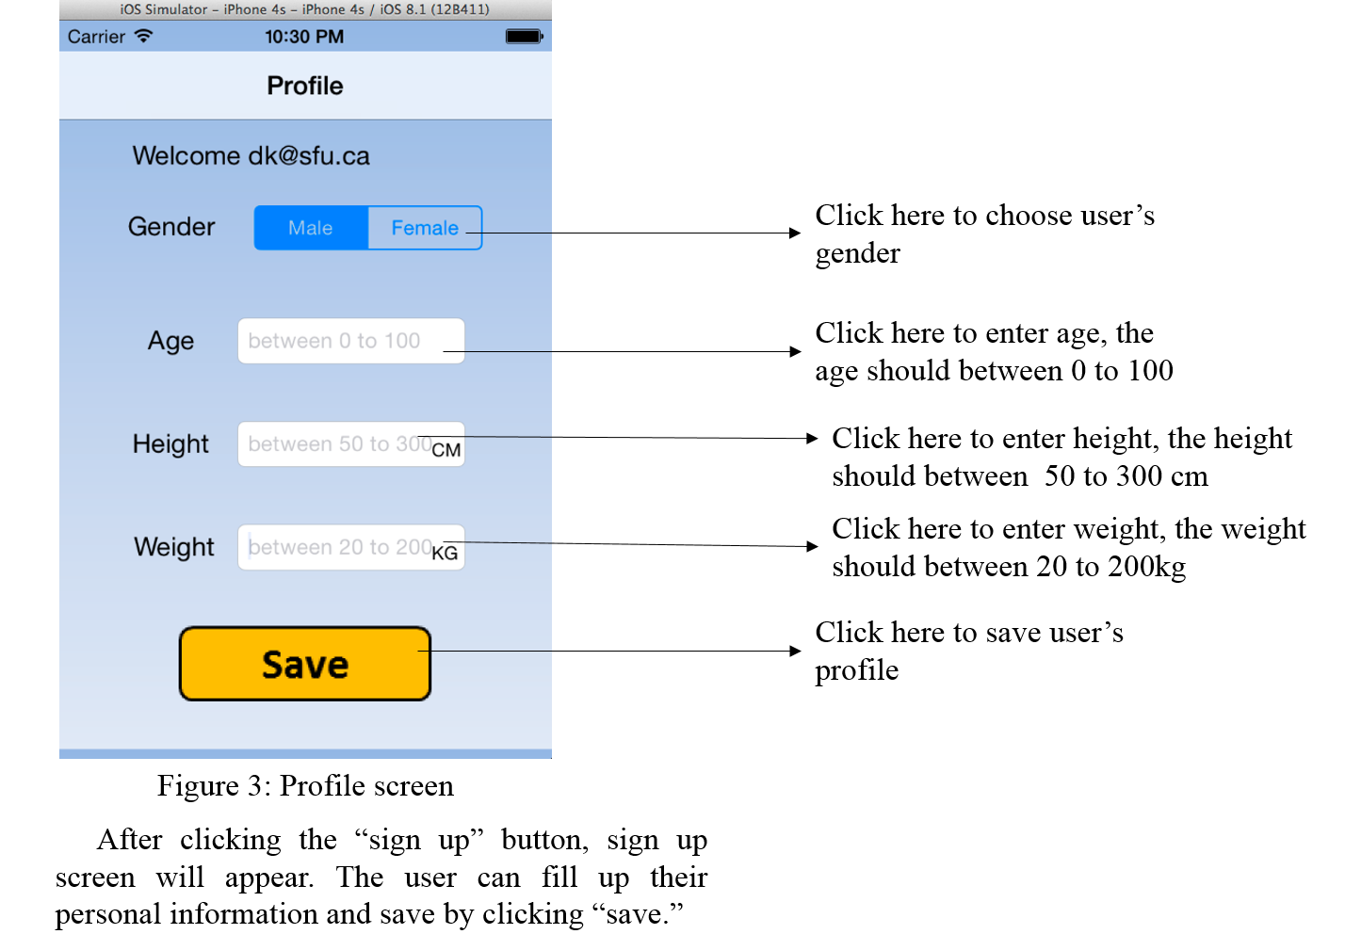

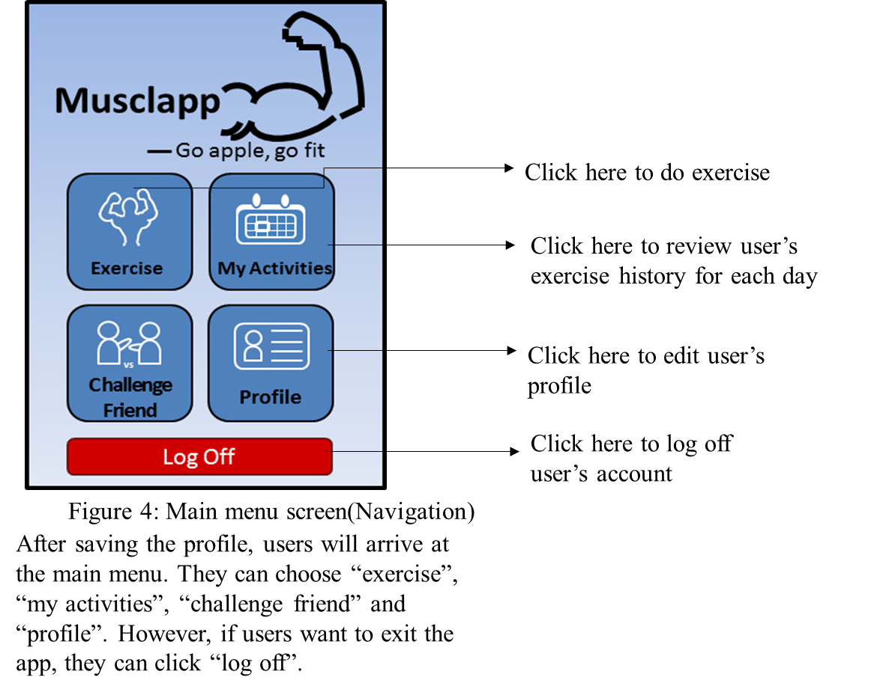

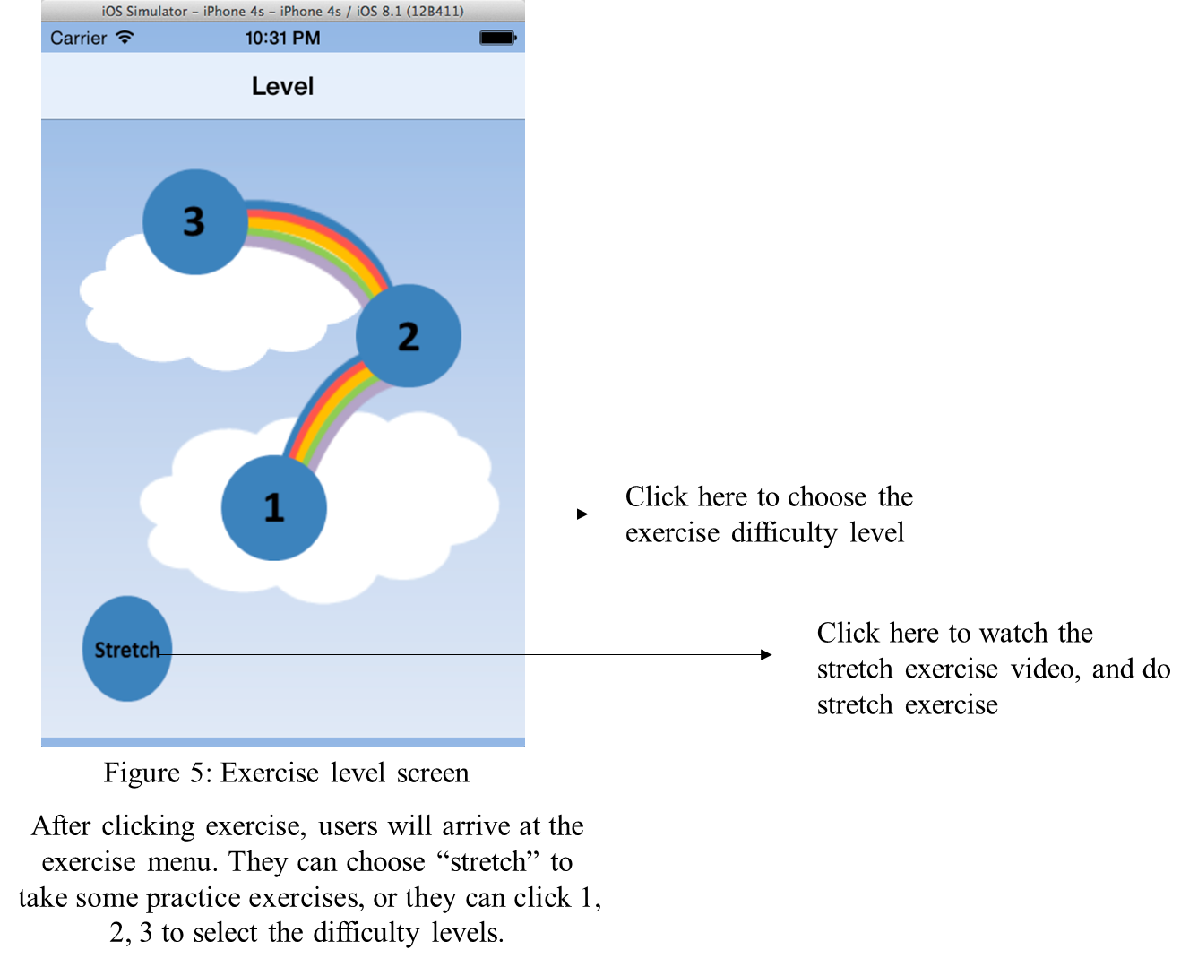
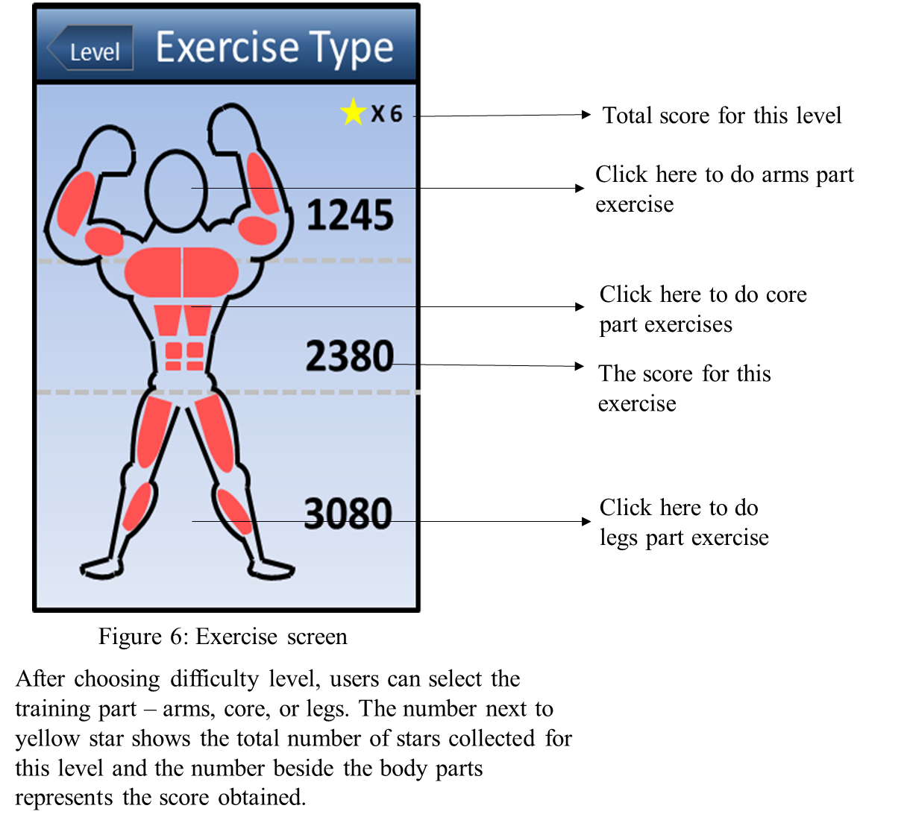
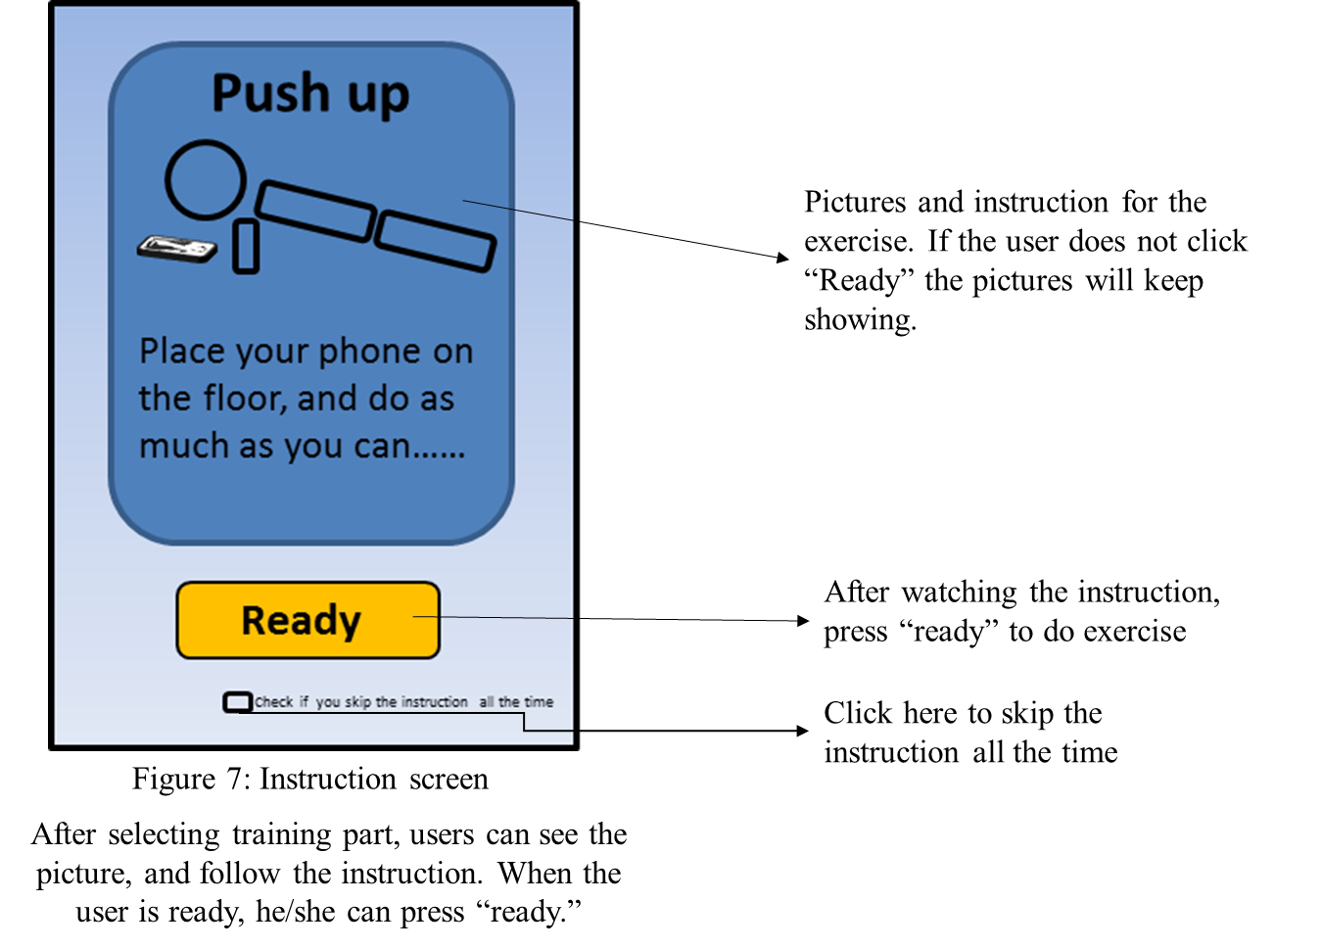

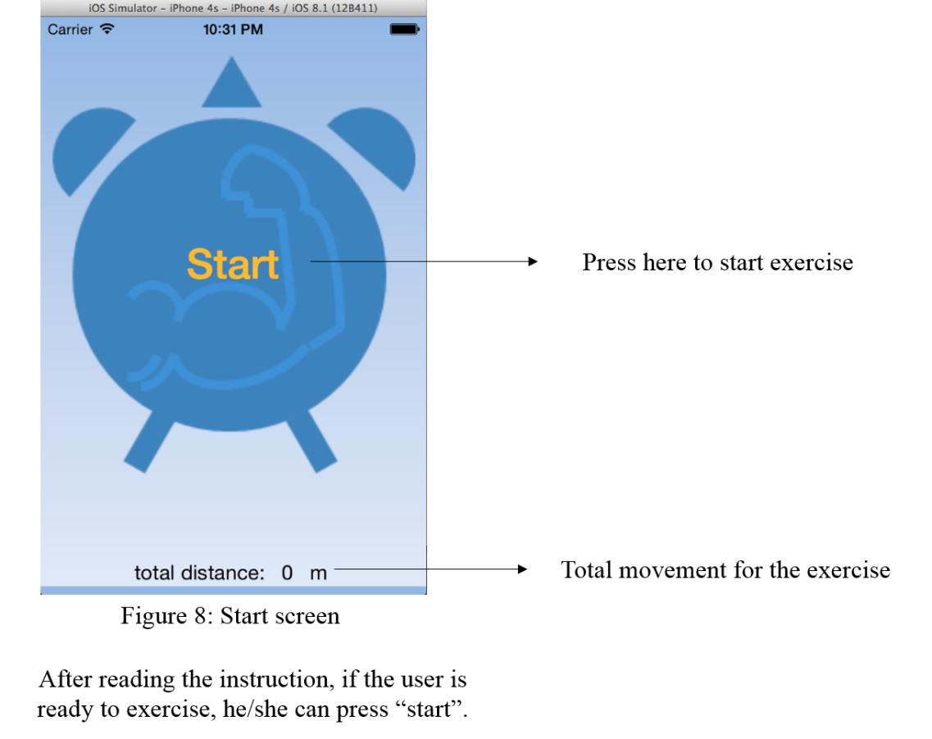

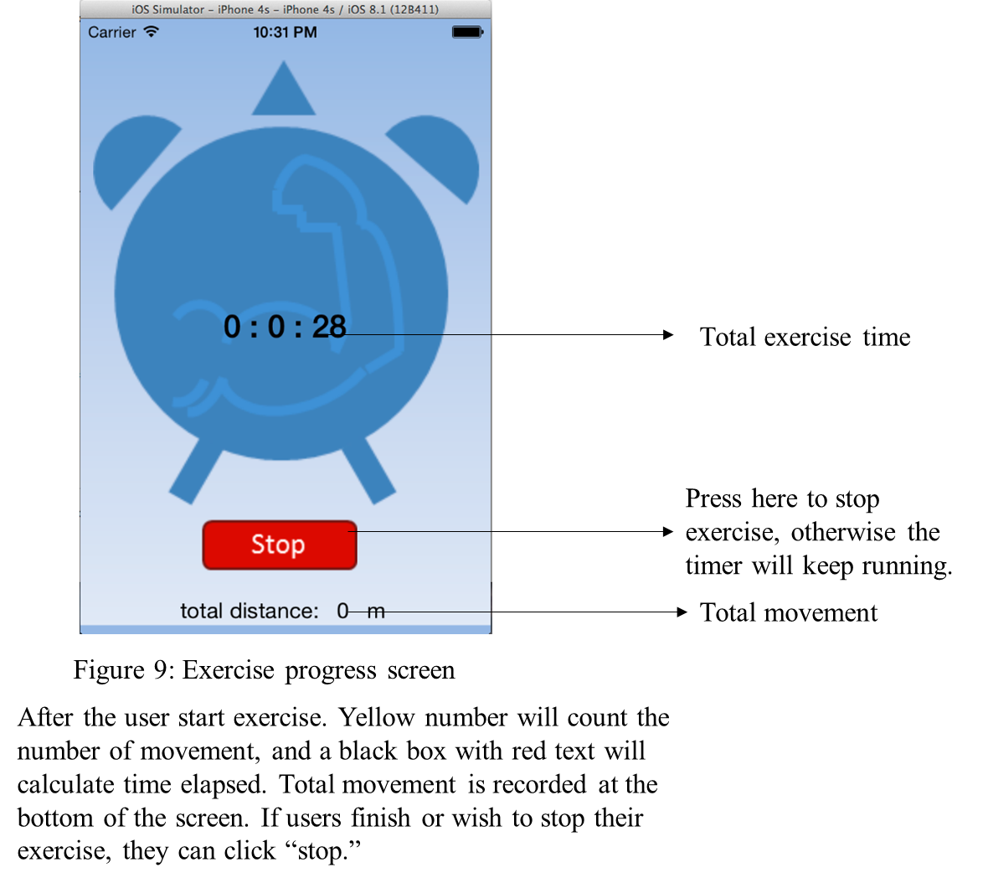
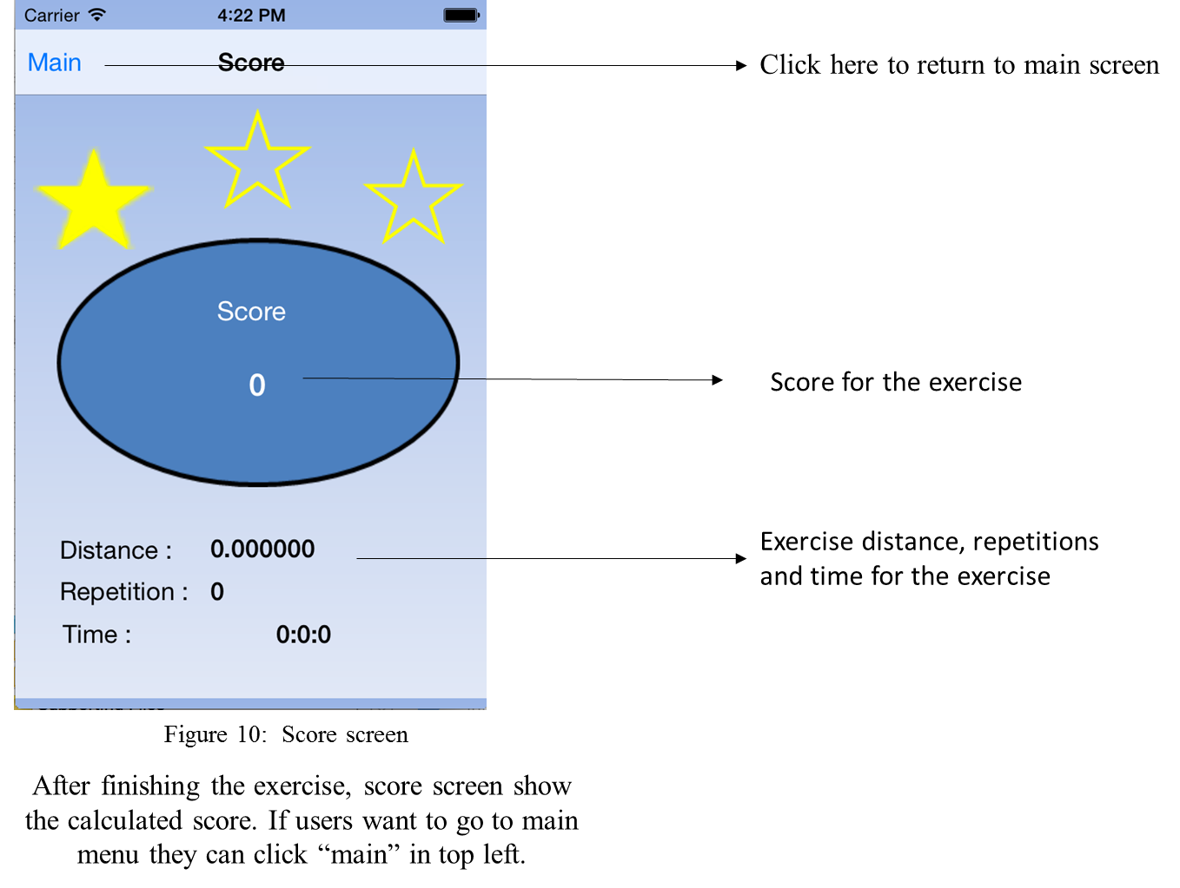

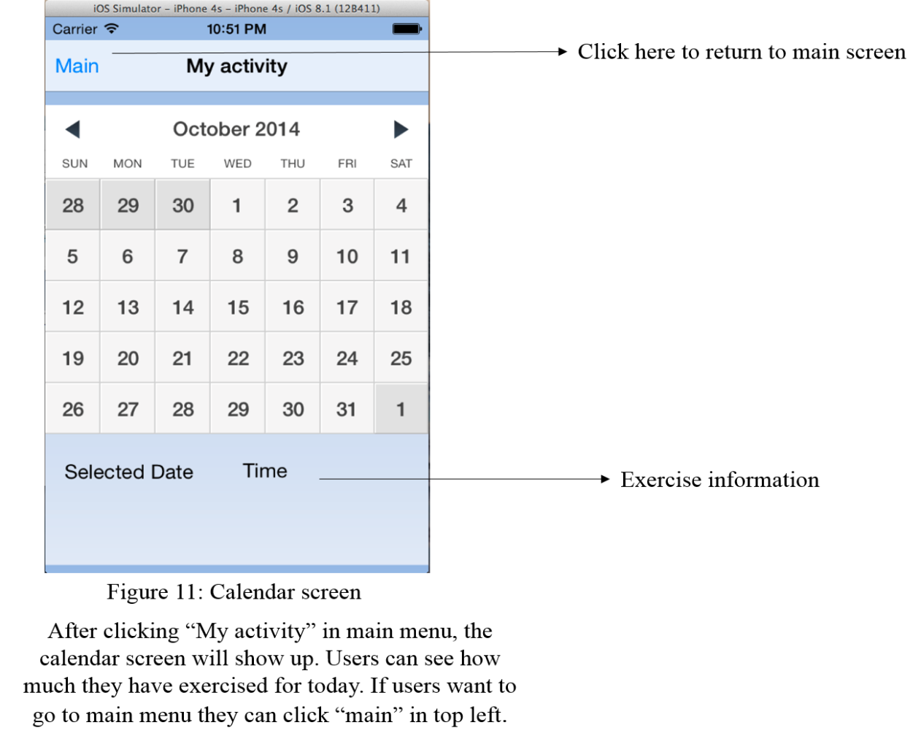

Glossary
  - App
An application, typically a small, specialized program downloaded on to mobile devices [1]

  - Authentication
Process of checking whether a username and password pair exists. If the pair exists, the user is given access; otherwise the user is denied access

  - IOS
Operation system for iPhone, iPod and iPad

  - Level 1
The lowest level in the app contains 3 different exercises with lowest degree of intensity

  - Level 2
The middle level in the app that contains 3 different exercises with degree of intensity in between level 1 and 3

  - Level 3
The highest level in the app contains 3 different exercises with degree of intensity higher than level 2
  - Core
Middle parts of human body that includes abdominals, pectorals, etc.

  - Legs
Lower part of human body that including calves, hamstring, etc.

  - Office worker
A person who performs his assigned tasks in an office or cubicle

  - Fitness-lovers
Fan of taking sport exercises, always go to gyms

  - Pre-set score
Minimum score that need to be achieved to unlock the next level

  - Calendar
A table or register with the days of each month and week in a year [2]. In this table the highest score, total score, total movement, total time, number of move will be recorded

  - Accelerometer
“An instrument for measuring acceleration,” of the device, through changes in acceleration of the device’s specified x, y, and z axis [3].

  - Alpha Prototype
The first version of “mock app,” designed for internal testing. The alpha prototype should show that the app is functional and is working

  - Beta Prototype
The second version of “mock app,” designed for use in the external testing phase. The beta prototype should represents as close as possible to the final product. During external testing, beta prototype of the app is the version of the app given to external testers

Reference
[1] Dictionary.com, "app," in The American Heritage® Abbreviations Dictionary, Third Edition. Source location: Houghton Mifflin Company, 2005.http://dictionary.reference.com/browse/app. Available: http://dictionary.reference.com. Accessed: October 06, 2014.
[2] Dictionary.com, "year," in Dictionary.com Unabridged. Source location: Random House, Inc. http://dictionary.reference.com/browse/year. Available: http://dictionary.reference.com. Accessed: October 06, 2014.
[3] Dictionary.com, "accelerometer," in Dictionary.com Unabridged. Source location: Random House, Inc. http://dictionary.reference.com/browse/accelerometer?s=t. Available: http://dictionary.reference.com. Accessed: October 26, 2014.
[4] I. Sommerville, “Requirements Engineering,” in Software Engineering, 9th ed. Boston, USA: Pearson Education Inc., 2009, ch. 4, pp. 082–117.

