CMPT 275
Group 2
GoFit Apple
Design Document

Hartono (Tony) Salim [301233981]
Davidson Kao [301200386]
Yu-Chun (May) Lin [301168746]
Wei (Candy) Xiao [301187355]
Patrick McKnight [301244678]
Team Website: https://sites.google.com/site/sfu275group2/

Contents
Revision History 3
Guidelines 4
Software development 4
Networking 4
Database 4
Graphic design 4
Documentation 5
Ethics and Legal issues 5
System Diagrams 6
Data input/output 12
User input 12
Data input 12
Data output 13
File format 13
Feature Priority 13
Version 1 13
Version 2 14
Version 3 14
Reference 16

Revision History
Table 1: Revision History
Revision | Status | Publication/  Revision  Date | By
1.0 | Created | Oct 6, 2014 | Davison  Kao, Patrick McKnight
1.1 | Revised (Guideline – add more points) | Oct 8, 2014 | Davison  Kao, Patrick McKnight
1.2 | Revised (System diagram – make third draft) | Oct 8, 2014 | Davison  Kao, Patrick McKnight
1.3 | Revised (features priority - create content) | Oct 10, 2014 | Yu-Chun  Lin
1.4 | Revised (System diagram – add sequence diagram) | Oct 10, 2014 | Wei Xiao
1.0 | Final Version for assignment 2 (Add table content, cover  page and page number) | Oct 10, 2014 | Davison  Kao, Patrick McKnight, Wei Xiao, Yu-Chun  Lin, Tony Lim
2.1 | Revised ( change diagram – Exercise system diagram) | Oct 24, 2014 | Wei Xiao, Davison  Kao
2.2 | Revised ( edit version 1,2,3 – features priority | Oct 26, 2014 | Wei Xiao, Davison  Kao
2.3 | Revised (add version 1 – features priority) | Oct 26, 2014 | Wei Xiao, Davison  Kao
2.4 | Revised (edit software development, database – guidelines) | Oct 26, 2014 | Wei Xiao, Davison  Kao
2.5 | Revised ( add reference – References) | Oct 26, 2014 | Yu-Chun lin
3.0 | Final Version for assignment 3 | Oct 26, 2014 | Davison Kao, Patrick McKnight, Wei Xiao, Yu-Chun Lin, Tony Lim
3.1 | Revised(make the correction according the TA’s feedback from HW2-revision history, guidelines) | Nov 6, 2014 | Wei Xiao
3.2 | Revised(Change class UML diagram - system diagrams) | Nov 9, 2014 | Patrick McKnight
3.3 | Revised( Add version 2 deliverable – Feature Priority | Nov 9, 2014 | Wei Xiao
4.0 | Final Version for assignment 4 | Nov 9, 2014 | Davison Kao, Patrick McKnight, Wei Xiao, Yu-Chun Lin, Tony Lim
4.1 | First revision for Assignment 5 (Replace “Friend Challenger” with “Instruction”, got rid of “Facebook Login”) | Nov 29, 2014 | Patrick McKnight

Guidelines

Software development
- The app’s software will be developed using Xcode platform
- The app’s software will be developed for iOS devices
- The app’s code will be written in/programmed using Objective-C Language
- The code will be written using Windows and iOS platform
- Code will be upload to Bitbucket

Networking
- The app will require internet connection for certain aspects of the app such as:
  - First Time login on the device
  - Updating the database data (includes uploading new user’s data)
  - Starting an event/ updating user’s score for the event
  - Transferring past year’s “My Activity” calendar
  - Accessing past “My Activity” calendar
- When there is no connection to the internet all information will be saved on the phone
- User with an device not connected to the internet, the user cannot login to it for the first time

Database
- MySQL (and possibly Game Center) will be the online database used to store user and event data
- The database includes the following data:
- id  - username  - password  - Stars collected level 1  - Arm score level 1  - Arm score level 3  - Core Score level 2  - Leg score level 1  - Leg score level 3  - Calendar data  - Last update date  - User gender  - User age | - Stars collected level 1  - Stars collected level 3  - Arm score level 2  - Core Score level 1  - Core Score level 3  - Leg score level 2  - Total score  - User weight  - User height  - Event data

Graphic design
- The graphics will be designed using Photoshop, Microsoft Visio, PowerPoint

Documentation
- Documents will be written using Google Docs and Microsoft Word
- Documents are saved as .docx and .pdf
- Reading documents can be using Google drive, Microsoft Word, and Adobe Reader
- Documentation will be saved on canvas and the group website

Ethics and Legal issues
- Gofit App is not responsible for any damage to Musclapp due to third party programs or user alterations
- Gofit App is not responsible for damage to the device due to improper handling
- Musclapp assumes the gender the user selects is the gender of your body structure. A transwoman would select ‘male’, so the exercises given is tailored to their body type
- Gofit App is not responsible for any injuries occurring during exercising and stretching
- Musclapp code’s copy write is to Gofit app and should not be reused without recognition
- Musclapp assures user profile data is confidential and will not be used for commercial uses
- Third party programs are assured to not distribute user information

System Diagrams
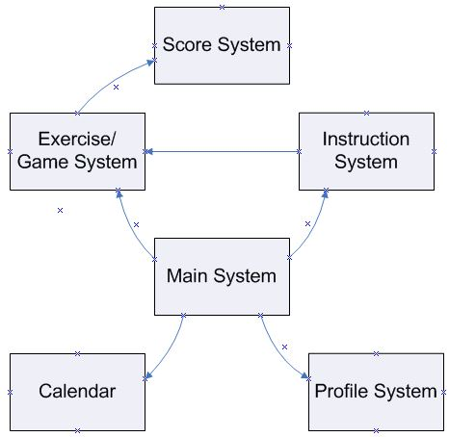
Figure 1: The system diagrams and how they interact. [1]

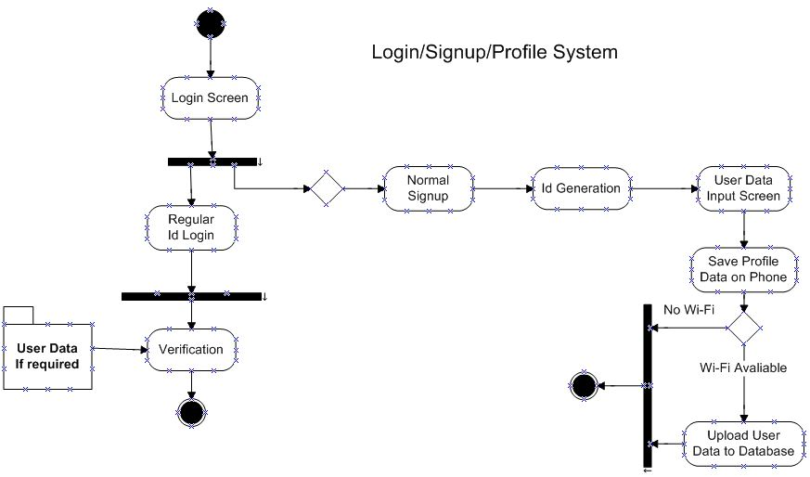
Figure 2: The process diagram for the signup/login/profile system not including the view/edit profile. [1]
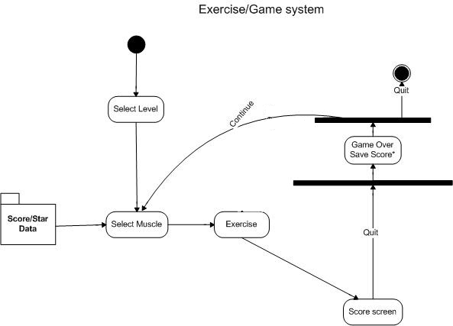
Figure 3: This is the Exercise path diagram of how the exercise/game system will work. [1]

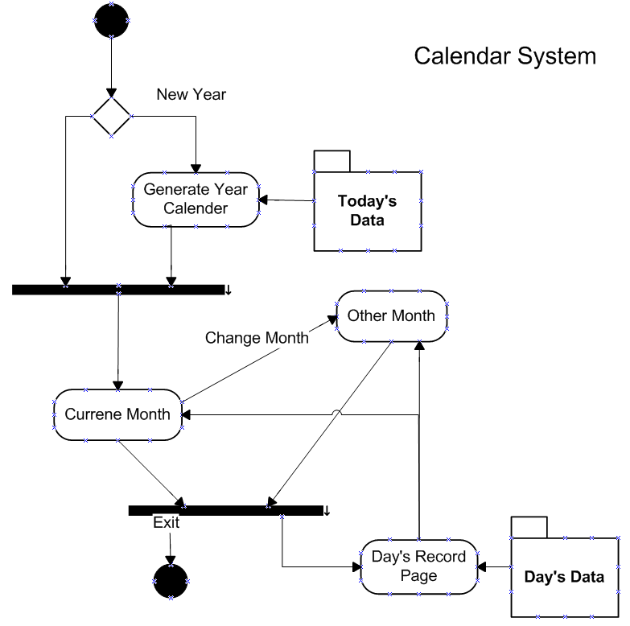
Figure 4: The process diagram of the calendar system. [1][2]
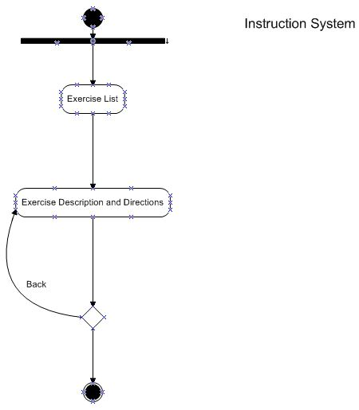
Figure 5: The process diagram of the Instruction system. Note that certain parts require internet connection. [1]

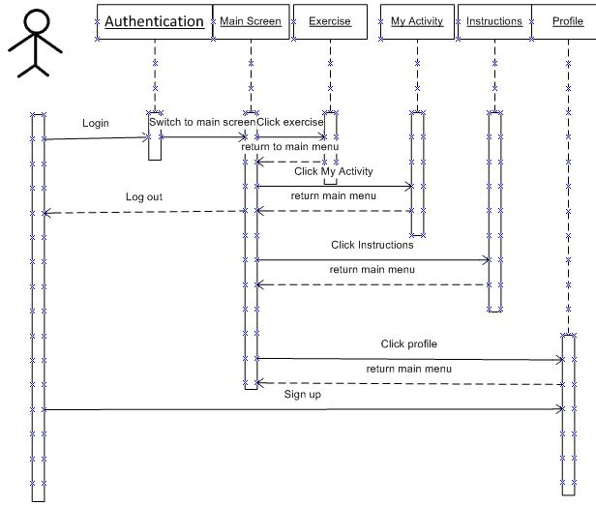
Figure 6: Overall user interface sequence diagram. [1]
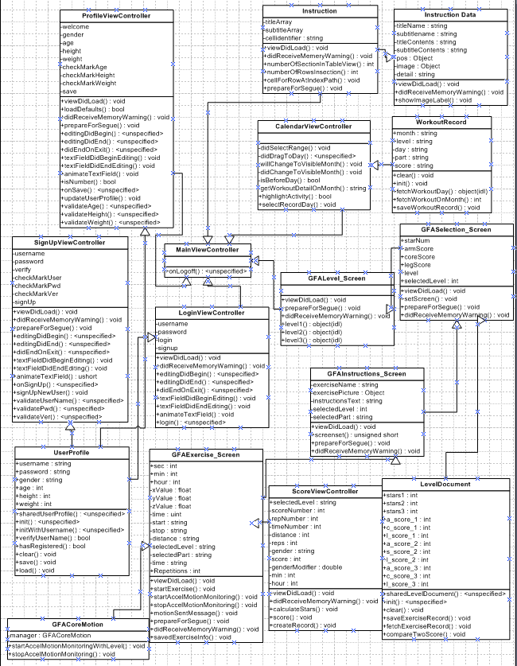
Figure 7: Class UML diagram. [1]
Table 1: Description of classes. [1]
Class | Description
MainViewController | The MainViewController class is closely related to the main screen where it would direct the user to the other parts of the app. Depending on the user’s selection it can advance to the profile, game/exercise, Instruction Screen, and calendar pages. Also in this class there would be all the functions needed for the other classes.
SignUpViewController | In this class the user can create an account by entering the username and password
ProfileViewController | In this class the user can fill out their personal information, such as name, weight, height, age and gender.
LoginViewController | In this class, the user can login via the valid username and password. If the user do not have a n account , they will go to SignUpViewController class
GFAExercise_Screen | This class includes the exercise parts, and exercises. After selecting the level and exercise part the user will advance to the exercise, refer to Figure 3 for exercise path.
CalendarViewController | This class will allow the user to view their progress through a calendar system. It will generate a new yearly calendar and save the data on the phone annually. Previous years data will be transferred and saved on the database when Wi-Fi is available Another feature is the ability to display the daily score and exercised parts for that day.
Instruction | The class includes the user creating an event. After creation of the event the user can select the level and exercise part for the event, before participating in the event. The class will save the data on the phone and when there is WI-FI the data will be uploaded onto the database.
ScoreViewController | Takes the information gathered from Exercise class to develop the score and save it on the user’s data file.
LevelDocument | This class contains the user score and star data for each level, and is used by the GFASelection_Screen to take the data and display it on the Selection screen.
GFAInstructions_Screen | This class will control which exercise instruction to display on the instruction screen. This is determined by the selected level and part the user selected.
UserProfile | Stores and receives user information such as gender, weight, height, name, age, and gender to and from the database.
GFACoreMotion | Implements gyroscope and accelerometer. Also using the data collected, it the class will calculate distance and repetitions, and returns distance and repetition values to GFAExercise_Screen.
GFASelection_Screen | Controls what is displayed on the part selection screen, making sure it displays the correct level and user score/star data for the level. Also makes sure that the part selected by the user will tell later views which part is selected.
GFALevel_Screen | Tells later views which level is selected by the user.
WorkoutRecord | Get workout data from database and pass to CalendarViewController.

Data input/output

User input
- User transition from one page to the next through touchscreen (buttons)
- User inputs profile data during signup or editing profile using the device’s default keyboard
- User inputs login info when logging in using the device’s default keyboard

Data input
- Data will be collected through the gyroscope and camera of the device to calculate distance and repetitions
- User data and collected data will be used to calculate the score
- Event and online user data will be received when there is Wi-Fi and will be interchanged from phone and database

Data output
- User information need to update score every time the user plays so new score data would be outputted and replace old score data
- Calendar data will be generated at annual rate
- Data will be uploaded from the phone to the database
- Sound output data will be implemented in version 3

File format
- User info file format will be in .ipa format
- Database format will be in MySQL format and PHP

Feature Priority

Version 1
Version 1 features must include basic features for Main screen, Exercise, and Profile.

Authentication
The user can login via the valid username and password.
The user can click sign up and go to the sign up screen.

Sign-up
The user can create a new account by giving a new valid username and password.

Profiles
The user can enter the personal information, such as Gender, Age, Height, and Weight.
When the user click the “Save” button, all the personal information will be stored in a file in the phone.

Main screen
The user can click the square buttons to the “Profile”, “My Activities”, and “Exercise” to toggle to the relative pages. Additionally, the user can click the “Log off” to log off the account and toggle to the authentication page.

My Activities
A calendar will show when you click “my activities”.

Exercise
Implement the level 1 with 3 exercises.

Score
After finishing the exercise, the score screen will show the “stars”, “score”, “time” and “movement”, along with “return to main” button.

Version 2
Version 1 features must include advances features for Main screen, Exercise, My Activities, and Profile.
Profiles
Add a text field animation to avoid keyboard covering problem.

Exercise
Implementing level 2 and 3 that consist of 3 exercises per level

Database Connection
A leading cloud service provider on Digital Ocean is created.
Application will connect to a server; the username and password are stored in database.
A PHP file is created to make a connection to the database server and encode the data into JSON format to be used in Xcode.
User profile’s data is now loaded according to the username that is logged in.

My Activities
Performed activities will be shown in calendar. The user can click the highlighted day to see the activities history such as “Total Time”.

Version 3

Error report
When the system crash and doesn’t work, the system must provide the error report to the user that can be sent back to the system manager.

Database System
The Log In, Sign up, Profile, Score, Exercise, and Calendar screens all use the database.
Instruction system
Display a table view of all the exercises and their level and parts. Selecting a cell on the table leads a new view containing the cells info as well as a picture of the exercise and the exercise’s information.

Exercise
The repetition increment function in the exercise system must be accurate. Also any previous known bugs must be fixed.

Version 1 deliverable
Implementation
- The systems that have been implemented in version 1 includes:
  - Profile system
  - Calendar system
  - Exercise system
  - Main system

Known bugs
- The timer for exercise only can run 4 minutes due to memory problem
- The score system can only save one time

Version 2 deliverable
Implementation
- The systems that have been implemented in version 2 includes:
  - Profile system
  - Calendar system
  - Exercise system
  - Main system
Known bugs
- Currently unable to filter acceleration due to gravity
- Repetition counter is inaccurate
- Unable to animate the instruction pictures
- Instruction pictures of type .gif is not animating (Probably requiring to do animation coding)
- Instructions for the exercise is too long to fit in test field (requiring scroll view)

Version 3 deliverable
Implementation
- The systems that have been implemented in version 2 includes:
  - Profile system
  - Calendar system
  - Exercise system
  - Main system
  - Instructions system
Known bugs
- Currently multi-threading in exercise system never terminates the core motion thread
  - Leads to an increase of rep and distance counting/incrementing rate
  - Quick fix is restarting the app after every exercise

Reference

[1] I. Sommerville, “Quality Management,” in Software Engineering, 9th ed. Boston, USA:
Pearson Education Inc., 2009, ch. 5-6, pp. 118-75.

[2] GitHub, "DSLCalendarView," in github.com. Source location: Github, Inc. http:// github.com/PeteC/DSLCalendarView Available: . http:// github.com/PeteC/DSLCalendarView Accessed: October 25, 2014.

