CEBU INSTITUTE OF TECHNOLOGY
UNIVERSITY

COLLEGE OF COMPUTER STUDIES

Software Design Description
for
WILDCAT WELFARE

Change History Signature

Date | Revision | Description
05/18/2026 | 1.0 | Initial Draft

Preface
The coexistence of students, faculty, and free-ranging campus animals has become a defining and beloved aspect of the Cebu Institute of Technology - University (CIT-U) culture. However, as the population of these "University Pets" grows, so does the complex responsibility of ensuring both animal welfare and public health. While initiatives like Task Force Bruno and the Catch, Neuter, Vaccinate, and Return (CNVR) framework have laid the groundwork for compassionate population control, the administrative execution has been hindered by fragmented, paper-based record-keeping and siloed communication.
The Wildcat Welfare Portal was conceptualized to bridge this gap. This capstone project introduces a centralized, web-based digital governance structure designed exclusively for the CIT-U premises. By transitioning manual logs into a unified digital ecosystem, the portal equips Task Force Bruno, the Medical-Dental Clinic (MDC), and student advocates with the tools they need to make proactive, data-driven decisions.
This document serves as the foundational blueprint for the Wildcat Welfare Portal. Its primary purpose is to align all stakeholders—including our Development Team, university administration, clinic personnel, and academic evaluators—under a shared, easily understood vision.
In the following pages, we detail the system's core architecture and its five primary functional pillars:
- Instant Identification: QR-coded profiles for real-time access to a pet’s health history.
- Clinical Governance: A secure MDC Dashboard for logging medical incidents and vaccination schedules.
- Campus Vigilance: A community newsfeed for crowdsourced reporting of sightings and welfare updates.
- Humane Rehoming: A digital adoption pipeline that tracks the end-to-end journey of rehoming pets.
- Resource Transparency: A live inventory tracker to ensure the sustainable distribution of essential supplies.
Importantly, this system is designed as a supplemental digital layer; it does not replace the critical physical operations and vetting processes managed by Task Force Bruno. Instead, it aims to eliminate administrative friction, replacing guesswork with measurable metrics.
Through this documentation, we establish the quantifiable performance factors necessary for a successful deployment, ensuring that CIT-U not only manages its campus animals effectively but sets a modern standard for what it means to be a truly pet-friendly institution.
Table of Contents

1. Introduction 6
1.1. Purpose 6
1.2. Scope 6
1.3. Definitions and Acronyms 6
1.4. References 6
2. Architectural Design 7
3. Detailed Design 8
Module 1 8
Module 2 9

Introduction

Purpose
The purpose of the Wildcat Welfare Portal is to digitally operate the current Animal Welfare Program needed at
Cebu Institute of Technology - University (CIT-U). This system is a web-based initiative to connect the program's
fragmented paper record keeping into one consolidated system under one governance structure.
The purpose of this document is to provide all stakeholders, (Development Team, Task Force Bruno,
Medical-Dental Clinic Personnel, Academic Evaluators) with an easily understood common goal in moving
forward with implementing the Wildcat Welfare Portal, outlining its key functionalities (i.e., QR coded pet profile,
medical incident reporting for pets, adoption pipeline for pets, resource utilization), and creating a framework of
quantifiable performance factors/metrics that will be used to determine successful implementation of the system.

Scope

The Wildcat Welfare Portal is a web-based platform created specifically to manage free-ranging dogs and cats
located within the grounds of CIT-U University. This system will be used by Task Force Bruno (i.e., MDC, PCO,
and SSD staff), potential adopters, student volunteers, and members of the surrounding university community.
The system consists of 5 primary functionalities:
- QR Coded Pet Profiles: Digitized identification system that allows for instant access to a campus pet’s vaccination record, health history, and behavior notes by scanning the QR code.
- MDC Medical Dashboard: Restricted to clinic staff who log, manage, and track the medical records of pet-related visits, vaccination reminders, and report cases of bites or scratches.
- Community Newsfeed and Reporting Hub: A “live” module for reporting animal sightings outside the campus, posting missing pet alerts, and posting updates on animal welfare.
- Digital Adoption Pipeline: An integrated adoption application system that allows end-to-end tracking of how to rehome pets from their profile page.
- Resource and Donation Tracker: “live” inventory tracking dashboard that has an optional online payment option that tracks and monitors the distribution of food and medical supplies.
Visitors may not bring their personal pets onto campus, nor will animals located outside CIT premises be
included in this system. The Task Force Bruno will continue to be responsible for the physical vetting of all
applicants to adopt animals from the MDC; this will not be a part of the MDC's clinical operations, but will serve
as a supplemental digital layer for documentation purposes only.

Definitions and Acronyms

Term/Acronym | Definition
CIT-U | Cebu Institute of Technology - University
Task Force Bruno | The CIT-U committee responsible for the welfare,monitoring, and management of campus animals
MDC | Medical-Dental Clinic; the CIT-U health facility responsible for logging and treating animal bite/scratch incidents
PCO | Property and Campus Operations office; involved incampus animal monitoring and relocation
SSD | Student Services Division; a stakeholder unit involved in campus pet welfare advocacy
CNVR | Catch, Neuter, Vaccinate, and Return; a humane stray animal population control framework adopted by Task Force Bruno
QR Code | Quick Response Code; a machine-readable matrix barcode used in this system for instant pet profile retrieval
PEP | Post-Exposure Prophylaxis; the medical protocol administered after potential rabies exposure from an animal bite or scratch
SRS | Software Requirements Specification; this document
MVP | Minimum Viable Product; the initial deployable version of the system containing core features
SUS | System Usability Scale; a standardized usability evaluation tool. A score of ≥ 80 is the target for this system
Lawganan | A Visayan/Cebuano term referring to a designated feeding area or feeding territory for campus animals
Agile Scrum | An iterative software development methodology used in this project, organized into two-week sprint cycles
University Pet | A campus animal that is recognized, registered, and cared for under the CIT-U community and Task Force Bruno
Stray | An unregistered animal that has entered the campus premises and has not yet been assessed by Task Force Bruno

References

● International Organization for Standardization. (2011). Systems and software engineering —
Systems and software Quality Requirements and Evaluation (SQuaRE) — System and software
quality models (ISO/IEC Standard No. 25010:2011). https://www.iso.org/standard/35733.html

● Macarulay, P. M. M., Lanticse, V. C. B., Ubas, R. M., Estillore, E. L. M., & Tiu, J. E. (2026).
The Wildcat Welfare Portal: Fostering a pet-friendly institution through digital governance and
community advocacy. Cebu Institute of Technology – University
.
● Medical-Dental Clinic. (2026). Proposal for policy/guideline on promoting a pet-friendly and
responsible institution. Cebu Institute of Technology – University.

● Task Force Bruno. (2026, February 27). Minutes of the meeting: Proceedings for the 2026 plans
for the campus Wildcats and Dogs. Cebu Institute of Technology – University.

Architectural Design

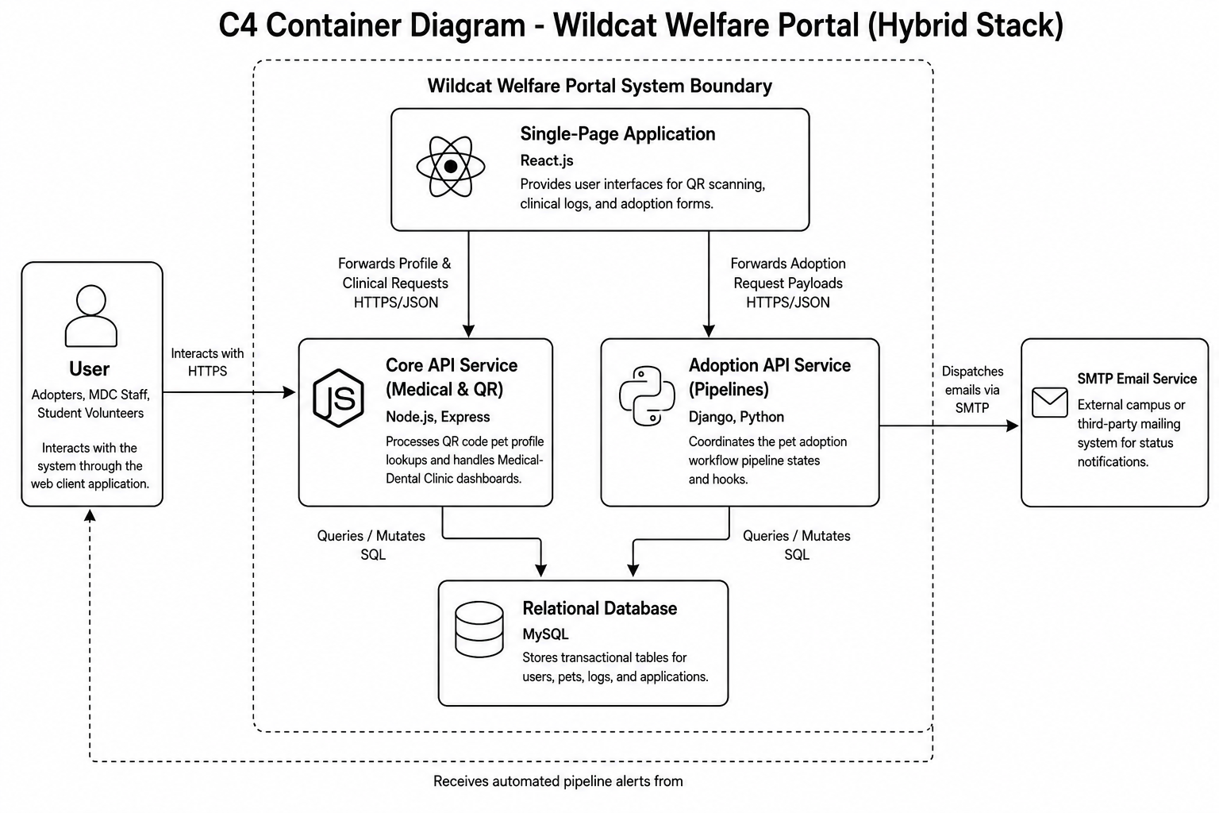

Detailed Design

Module 1

1.1 QR Profile Tracking
- User Interface Design
Scanner View:
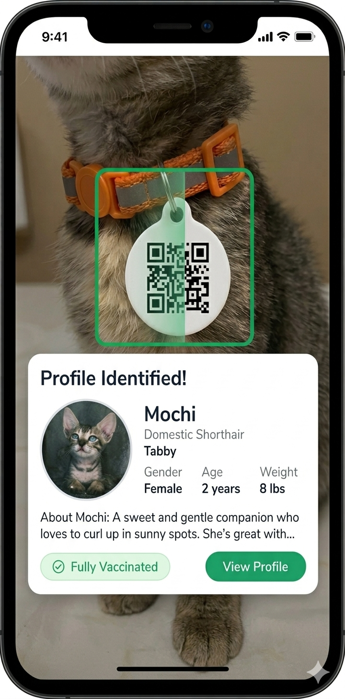
Pet Profile Page:
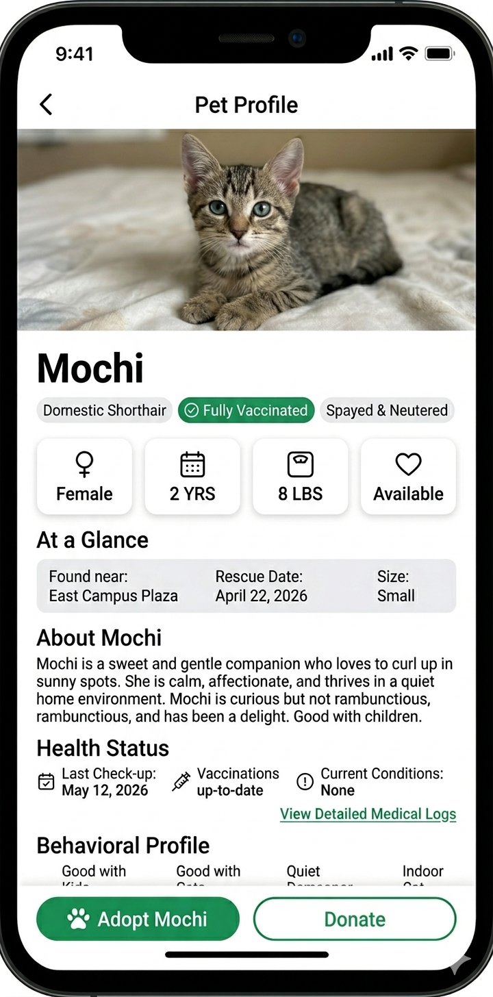
- Front-end component(s)
  - ProfileRouter
    - Parses the petID from the browser's URL path and identifies which pet to load.
    - React/JavaScript Logic
  - PetProfileView
    - Fetches and renders the pet’s data (name, status, bio) for the user to view.
    - React/UI Component
- Back-end component(s)
  - PetAPIController
    - Exposes an endpoint (e.g., /api/pets/:id) to serve pet data in JSON format.
    - Node.js / Express Controller
  - PetDataService
    - Queries the database to retrieve specific pet records based on the requested ID.
    - Service Layer (Business Logic)
- Object-Oriented Components
  - Class Diagram
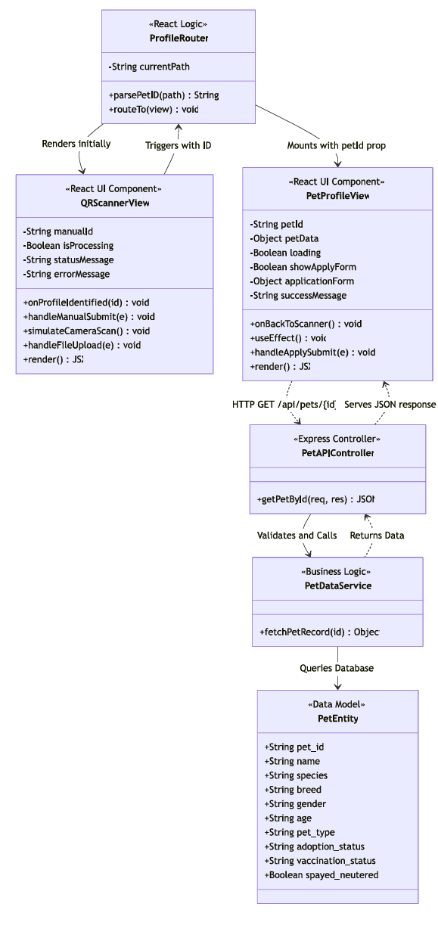
  - Sequence Diagram
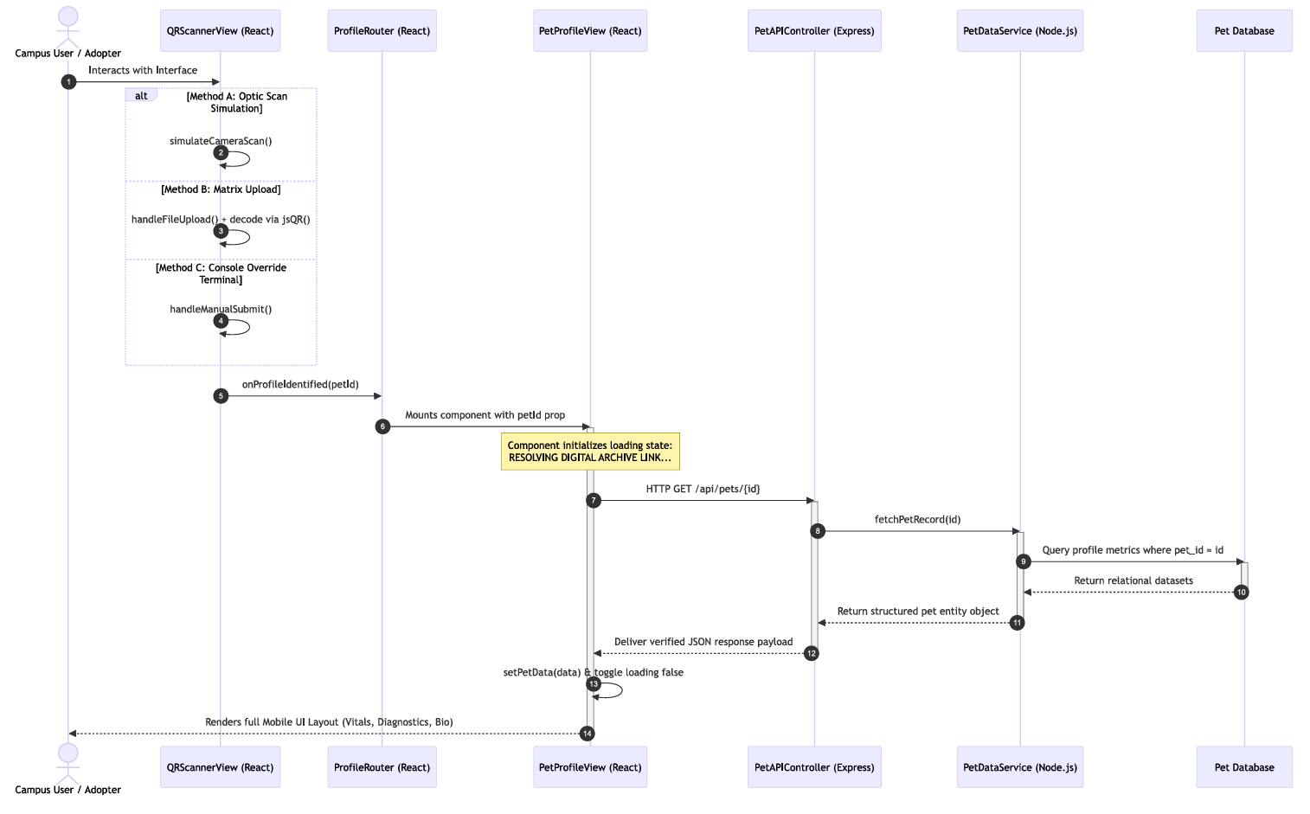
- Data Design
  - ERD or schema
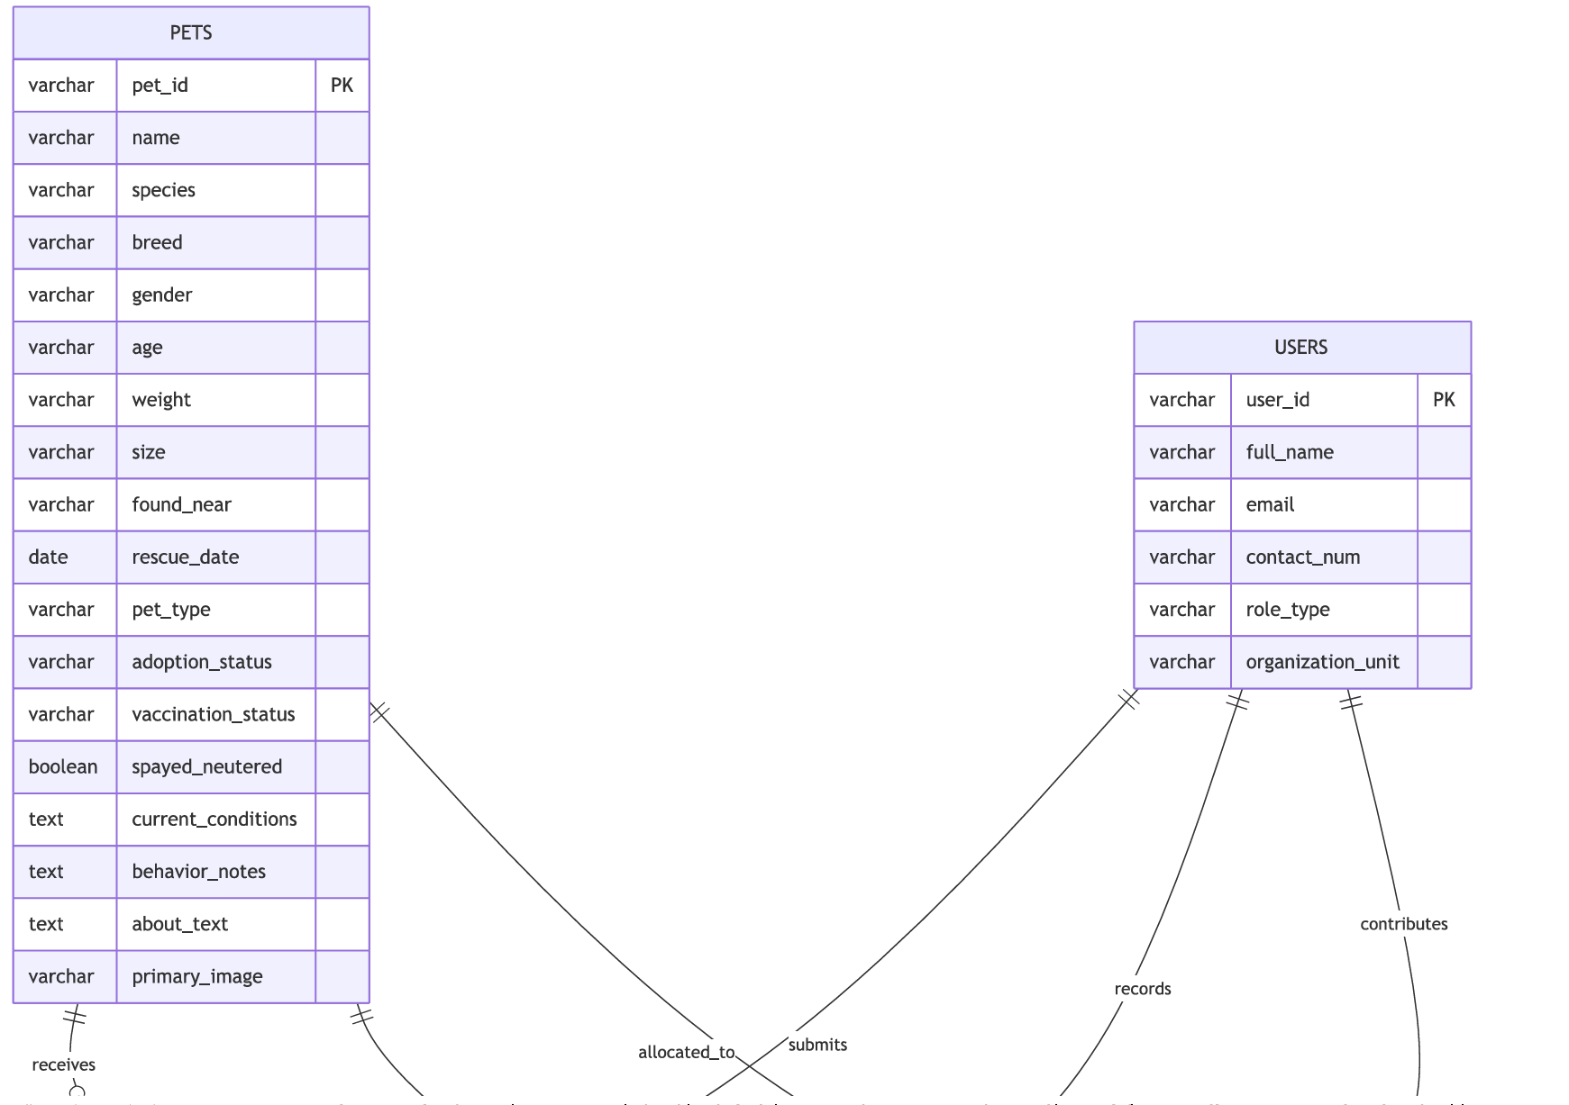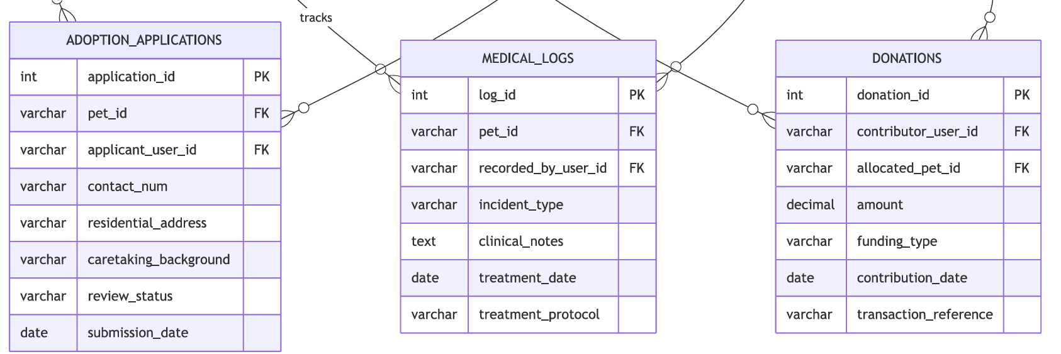

1.2 Medical Record Dashboard
- User Interface Design
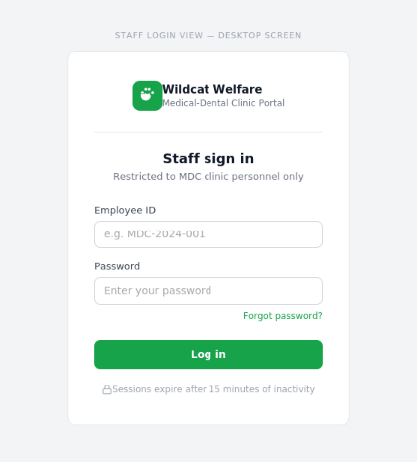
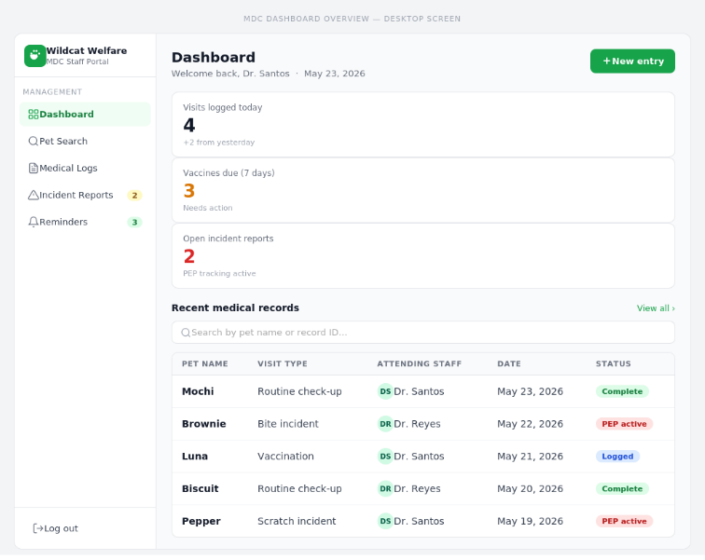
- Front-end component(s)
  - MDCAuthGate
    - A protected login form rendered exclusively for MDC clinic staff. It captures employee credentials (ID and password), submits them to the authentication endpoint, and redirects authorized users to the dashboard. Sessions expire automatically after 15 minutes of inactivity.
    - React Form Component
  - MDCDashboardView
    - The primary dashboard layout rendered after successful staff login. Displays summary counters (visits today, due vaccines, open incidents) and provides navigation to the pet search panel, reminders list, and historical log. Serves as the central hub for all MDC clinical operations within the system.
    - React Layout / Page Component
  - MedicalLogForm
    - A structured form component for logging routine medical visits. Fields include visit type, visit date, attending staff, weight (kg), clinical notes, and vaccination update. The “Save Record” button is disabled until all required fields are populated. A checkbox option auto-schedules the next vaccination reminder upon save.
    - React Form Component
  - IncidentReportForm
    - A specialized form for reporting bite or scratch incidents involving campus animals. Captures incident type (Bite—Human), incident date, location on campus, and person(s) involved. Mandatory fields are enforced with inline validation; the Save button remains disabled while required fields are blank. Submitted records trigger PEP protocol tracking in the backend.
    - React Form Component
- Back-end component(s)
  - MDCAuthController
    - Handles the /api/auth/mdc/login endpoint. Validates staff credentials against the MDC user table, issues a signed JWT on success, and returns an appropriate error response on failure. Enforces role-based access so only users with the MDC_STAFF role can reach protected dashboard routes.
    - Node.js / Express Controller
  - MedicalRecordAPIController
    - Exposes RESTful endpoints (e.g., POST /api/medical/log, POST /api/medical/incident) that receive form submissions from the frontend. Parses and validates the incoming payload, delegates persistence to the service layer, and returns success or error responses. Access is gated by JWT middleware to ensure only authenticated MDC staff can write records.
    - Node.js / Express Controller
  - MedicalRecordService
    - Encapsulates all business logic for medical record operations. Writes new visit logs and incident reports to the database, updates the linked pet’s vaccination status, and schedules future vaccination reminders when the auto-schedule flag is set. Also provides query methods for retrieving a pet’s full medical history for dashboard display.
    - Service Layer (Business Logic)
- Object-Oriented Components
  - Class Diagram
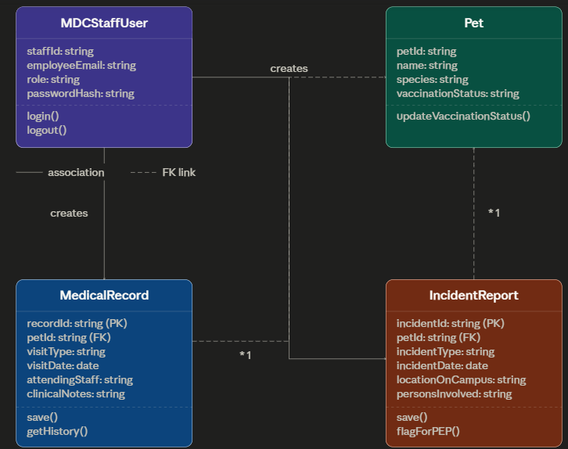

  - Sequence Diagram
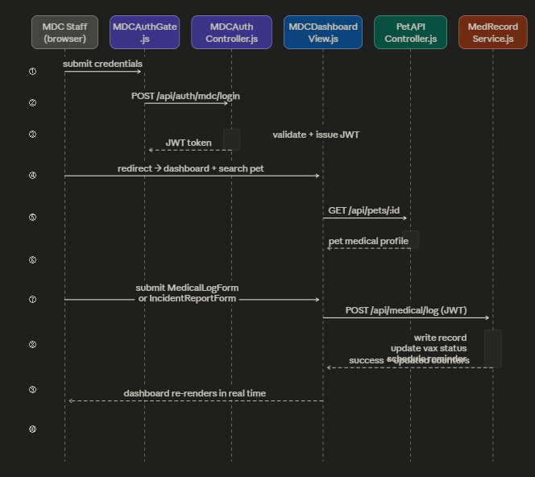

- Data Design
  - ERD or schema
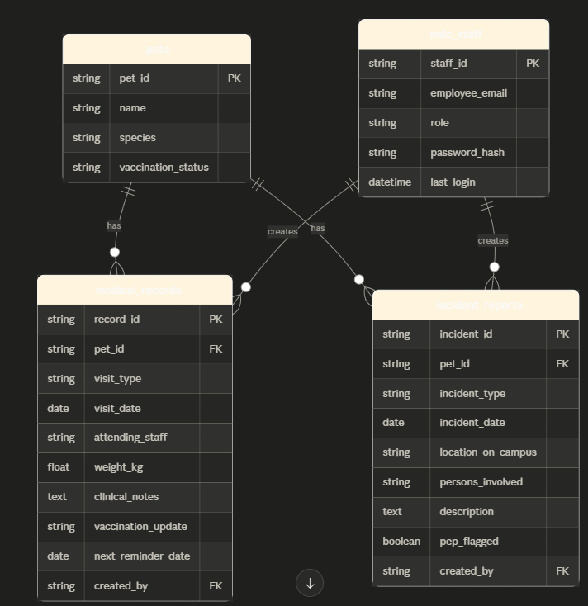

Module 2

2.1 Submit and Process Adoption Application
- User Interface Design
  - Adopter View (Mobile Screen)
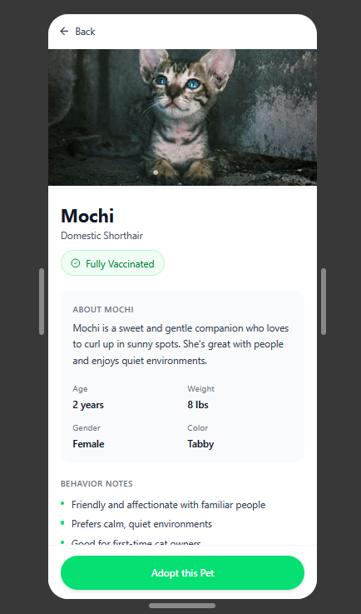

  - Staff View (Desktop Admin Dashboard)
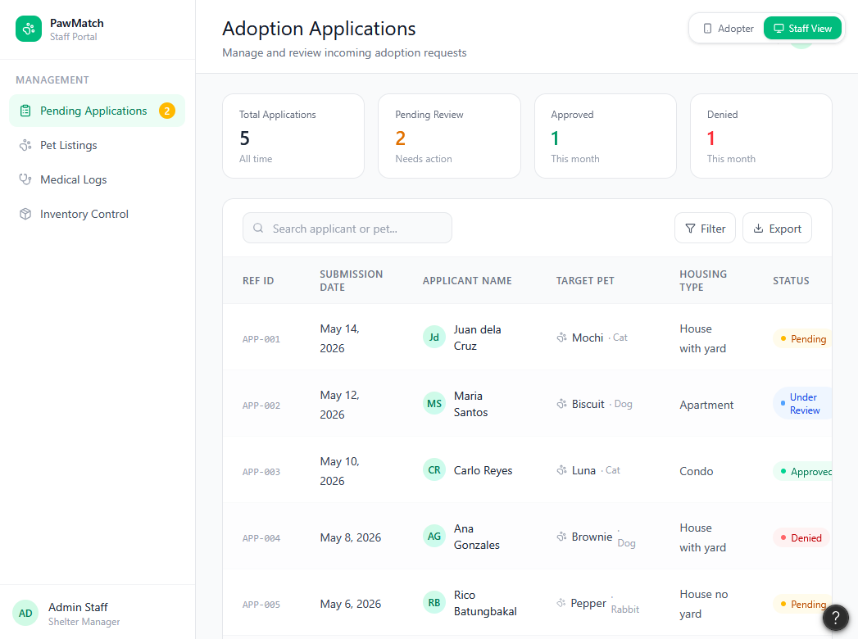

- Front-end component(s)
  - PetPicturesGallery
    - A dynamic image carousel integrated into the pet profile view that maps an array of structural image URLs into a swipeable layout, allowing prospective adopters to view multiple photos of the campus animal.
    - React Image Slider/Carousel UI Component.
  - AdoptionApplicationForm
    - A structured layout capturing essential applicant criteria. It includes form validation logic to ensure required fields, such as the applicant's name and living arrangement type, are filled before sending a POST request to the server.
    - React Form Component
  - ApplicationStatusTracker
    - A dedicated layout module for authenticated community users to view an ongoing list of their active adoption requests and monitor real-time pipeline status shifts.
    - React Card List Grid
  - ShelterAdminDashboard
    - A secure administrative tabular component displaying rows of pending applications, empowering staff to execute state mutations on incoming adoption records
    - React Data Table Grid Component

- Back-end component(s)
  - AdoptionRequestHandler
    - Exposes protected RESTful API endpoints (/api/applications/) configured to receive POST requests from the frontend application form, parsing inputs into standardized structural records and assigning a default status of "Pending".
    - Django REST Framework ViewSet / API Endpoint.
  - ApplicationReviewService
    - Coordinates transaction business rules. It modifies an application status record (Approved/Denied) based on administrative staff choices , executes related state alterations on the associated Pet registry record, and locks data histories for tracking.
    - Python Business Logic Service Module
  - AdoptionRequestHandler
    - Listens for pipeline status state modifications and triggers asynchronous hooks to the system's SMTP email service, automatically formatting and dispatching approval confirmations or rejection letters to the adopter.
    - Python Utility / Asynchronous Task Handler

- Object-Oriented Components
  - Class Diagram
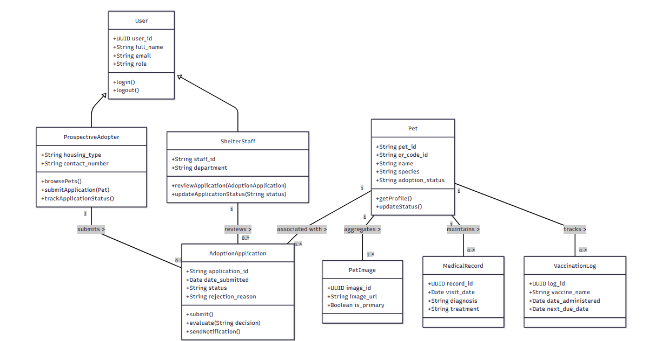
  - Sequence Diagram
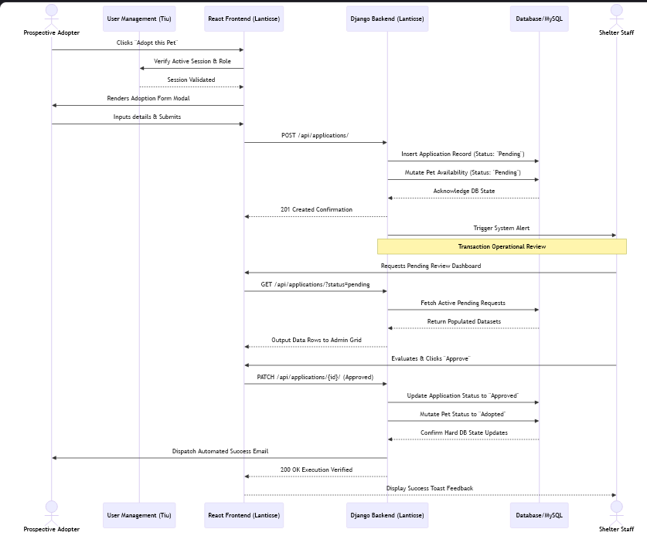

- Data Design
  - ERD or schema
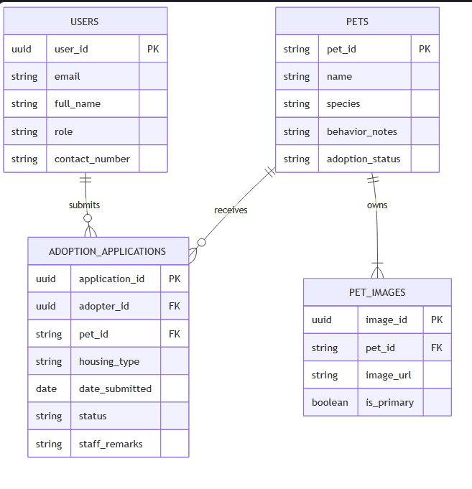

2.2 Donation
- User Interface Design
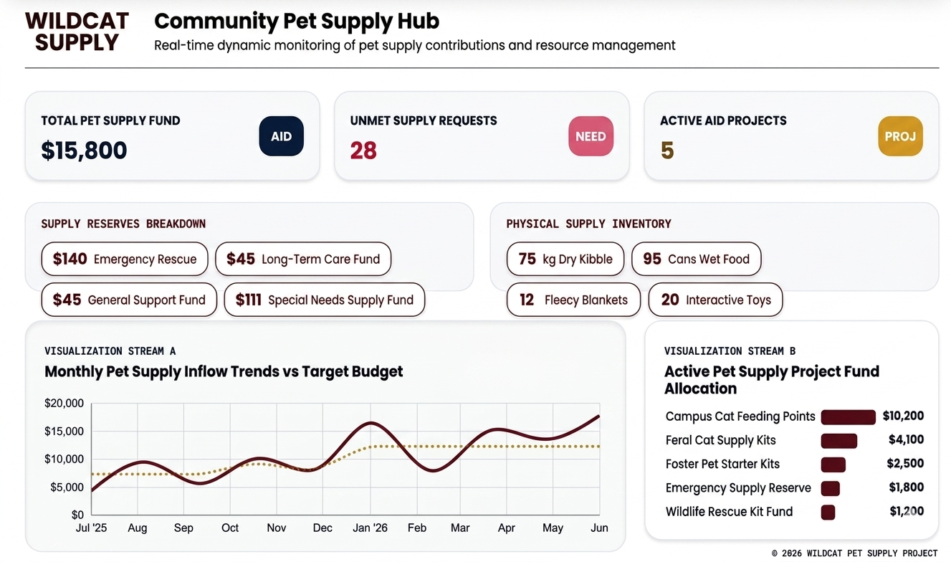
- Front-end component(s)
  - InventoryControl
    - The parent structural container for the logistics system. It receives historical ledger streams and active stock arrays as props, manages sub-tab context routing (stock-list, add-item, history), and hosts asynchronous state updates for asset creation and deletion workflows.
    - React Functional Component / Feature Module Container
  - Active Supply Stock Master
    - A horizontal-scrolling tabular interface that lists current items with real-time descriptions, quantities, and expirations. It serves as the interaction hub where users can either kick off structural item removals (DELETE) or drill down into targeted modifications.
    - Inline React UI Block / Dynamic Data Table
  - Transaction Ledger History
    - An unalterable chronological audit rail displaying past transactions. It reads tracking properties to visually badge actions as INFLOW or OUTFLOW adjustments, ensuring any modification can be immediately contextualized with historical reason codes.
    - Inline React UI Block / Audit Trail View

- Back-end component(s)
  - InventoryController
    - The API endpoint and routing interface. It catches incoming HTTP client requests generated by your forms: tracking new assets (POST /api/inventory/), injecting adjustments (POST /api/inventory/transactions/), and managing hard removals (DELETE /api/inventory/:id/).
    - Node.js / Express Route Controller
  - InventoryService
    - The database business logic engine. It handles critical type-casting tasks implied by your code, such as parsing payload numeric values into strict base-10 integers (parseInt) and enforcing type boundaries to prevent infrastructure type matching rejections.
    - Service Layer (Business Logic)
  - InventorySchema
    - The structural data definition for the main supply entries. It defines core item fields modeled in your table, including string variables (item_name, category, unit, supplier_donor), numerical entries (quantity, min_threshold), and date matrices (expiration_date).
    - Relational Database Model / Schema

- Object-Oriented Components
  - Class Diagram
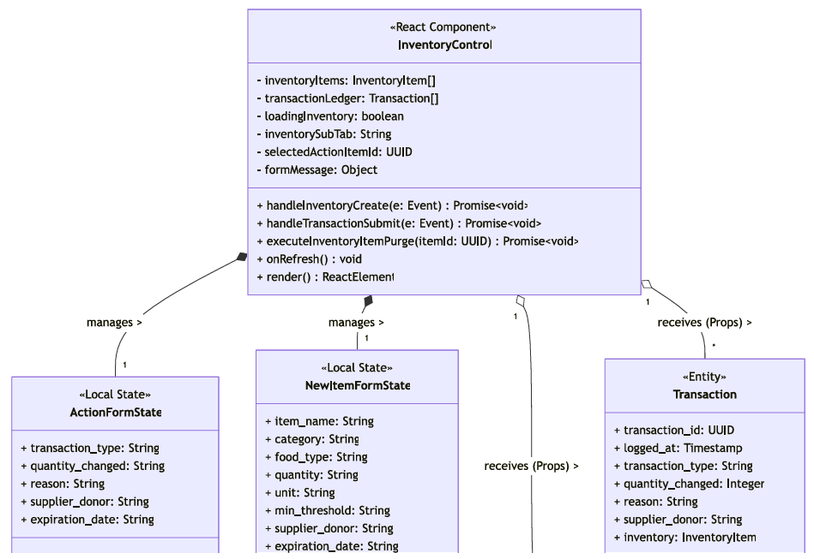
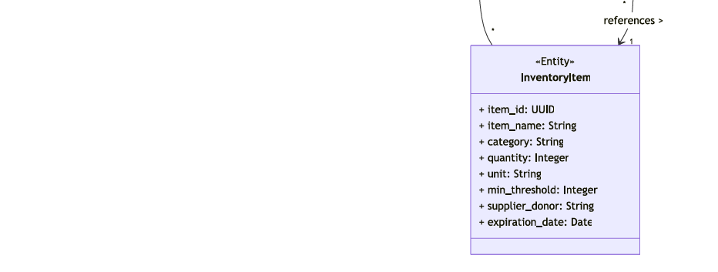

  - Sequence Diagram
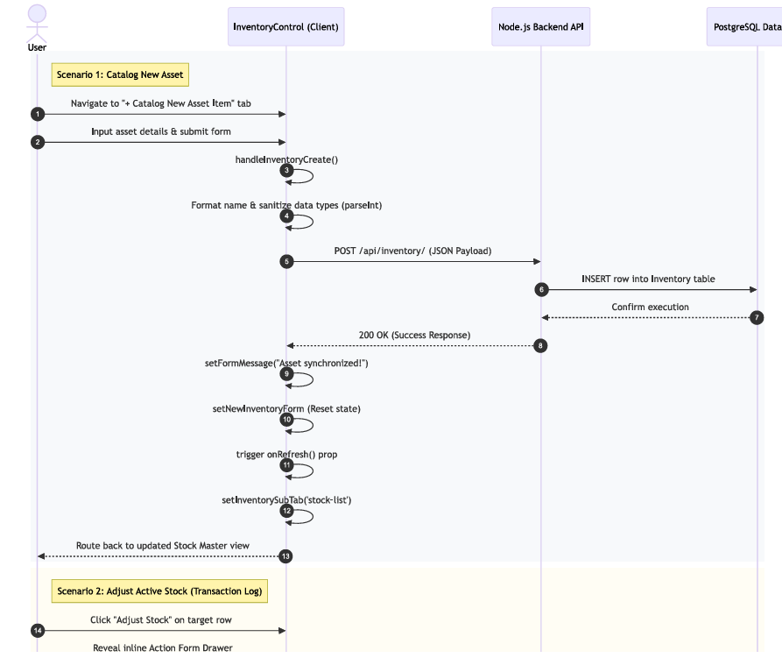
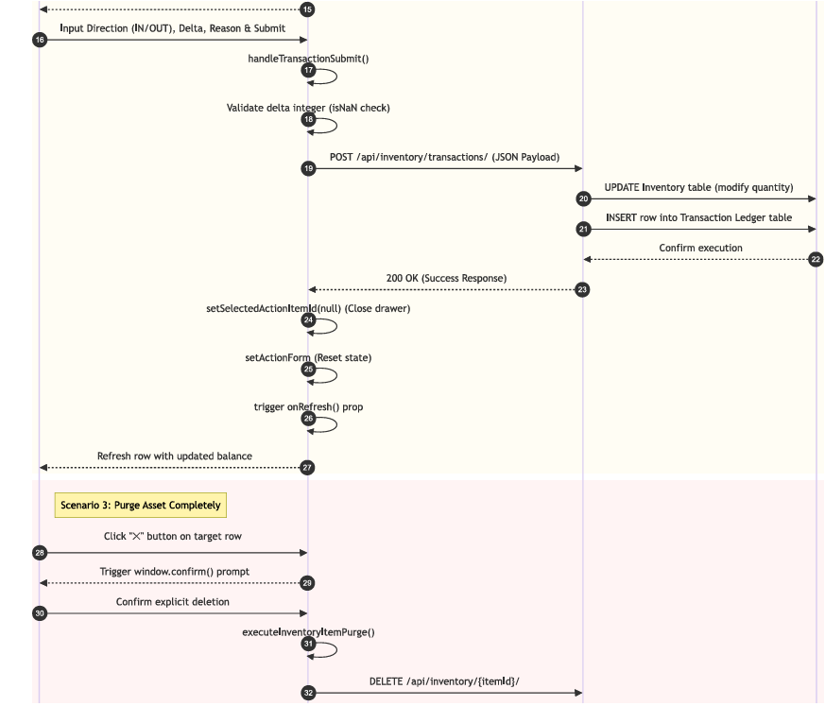
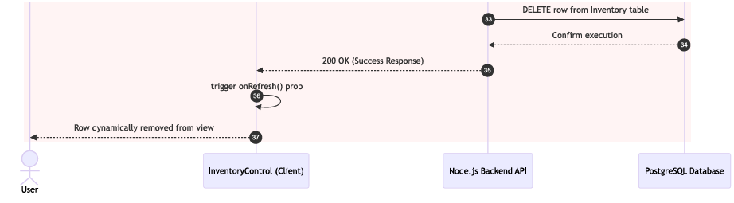

- Data Design
  - ERD or schema
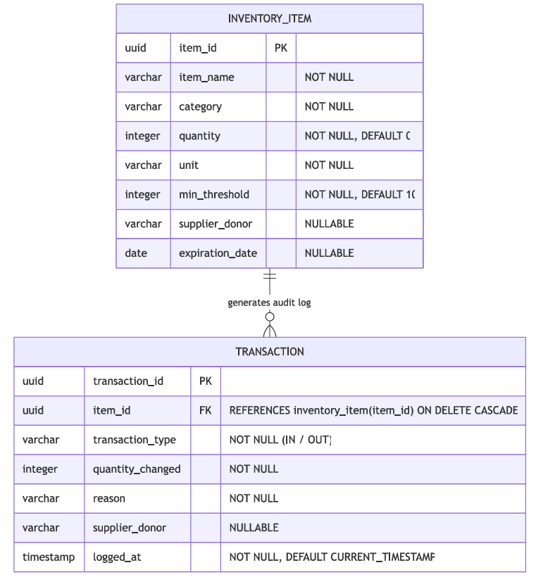

Module 3

3.1 Homepage/Newsfeed
- User Interface Design
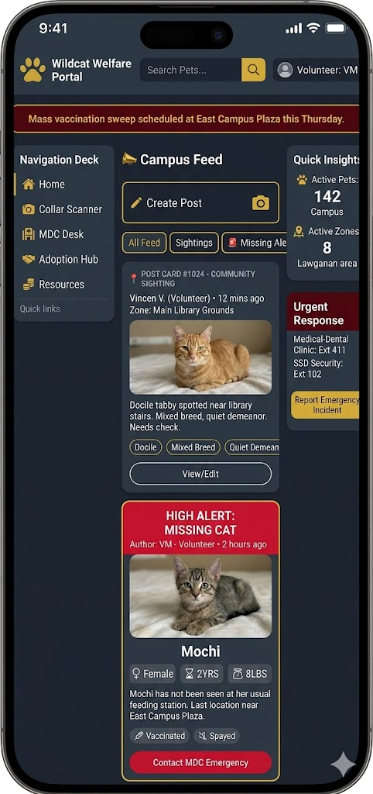

- Front-end component(s)
  - NewsfeedView
    - The primary social timeline container. It renders the main interactive feed, allowing users to track community posts, filter data via search capsules, and paginate through records. It actively calculates and displays quantitative metrics, such as total matched feeds and active sighting volumes.
    - React Functional Component / View
- Back-end component(s)
  - NewsfeedController
    - The routing layer that manages incoming HTTP requests for the feed (GET /api/newsfeed/), likes (POST /api/newsfeed/like/), comments (POST /api/newsfeed/comment/), and post moderation (PUT, DELETE). It authenticates users based on their institutional email domain.
    - Node.js / Express Controller
  - NewsfeedService
    - The business logic layer. It processes the raw quantitative data (like incrementing/decrementing like counts) and synchronizes community interactions, ensuring comments and likes are securely mapped to the correct user emails and feed_ids.
    - Service Layer (Business Logic)
  - NewsfeedSchema
    - Defines the strict data shape for the NEWSFEED, COMMENTS, and LIKES database tables. It guarantees every post has measurable attributes like likes_count, timestamp matrices, and relational mapping to the author_tag.
    - Relational Database Schema / Model

- Object-Oriented Components
  - Class Diagram
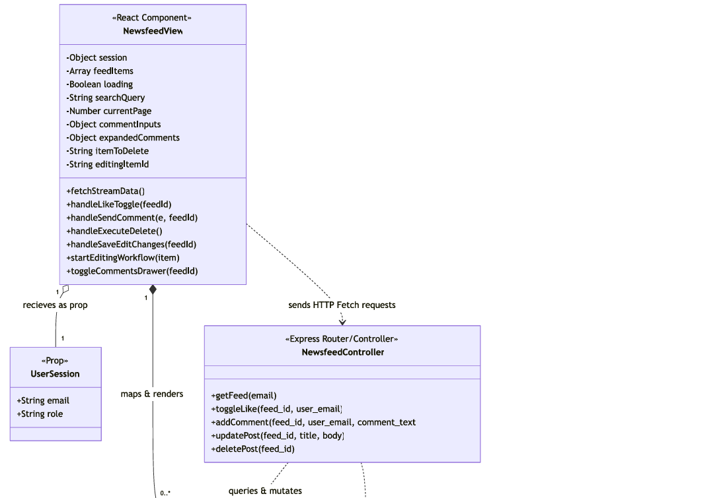
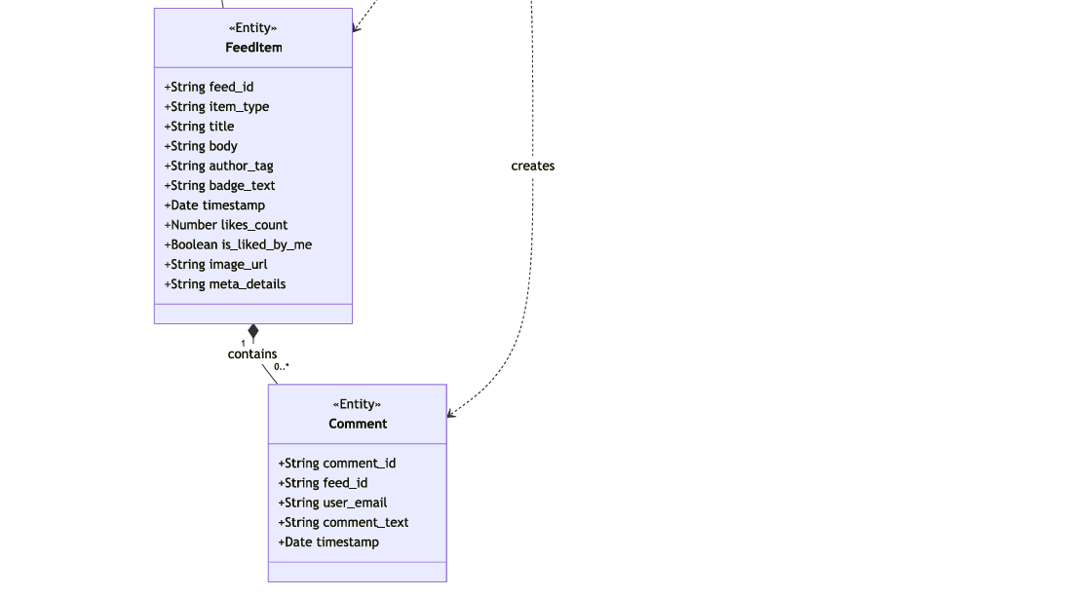

  - Sequence Diagram
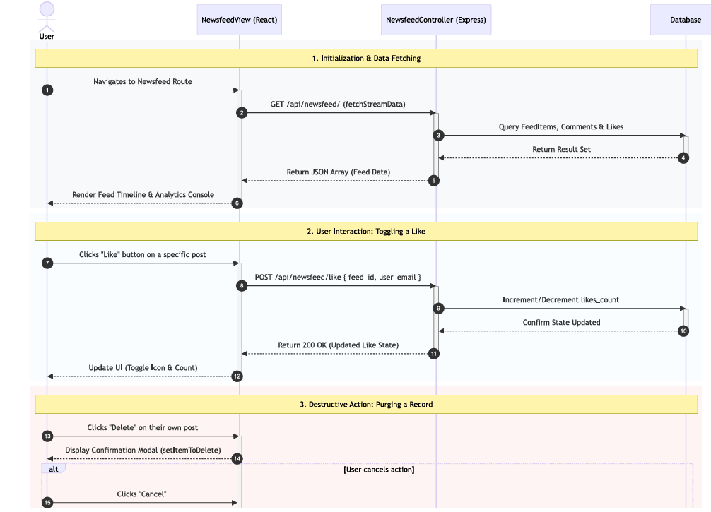
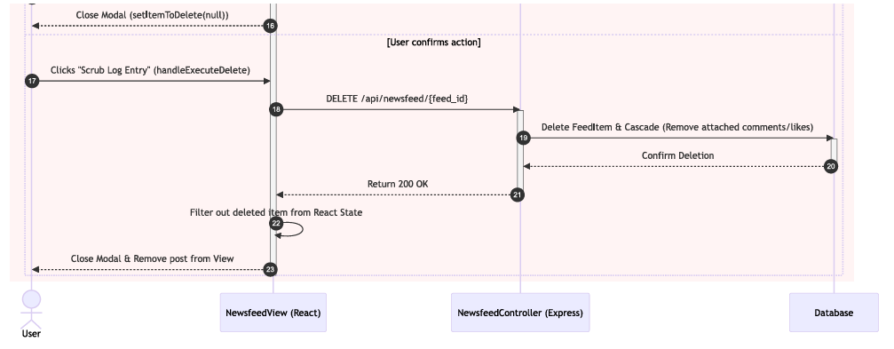

- Data Design
  - ERD or schema
