CEBU INSTITUTE OF TECHNOLOGY
UNIVERSITY

COLLEGE OF COMPUTER STUDIES

Software Design Description
for
WILDCAT WELFARE

Change History Signature
Version | Date | Author | Summary of Changes / Refactoring Description
1.0 | February 2026 | Wildcat Welfare Team | Initial Software Design Description Draft & Scope Definition.
2.0 | May 2026 | Development Team | Detailed Component Decomposition, Class Diagrams, and Sequence Flows.
3.0 | August 2026 | Development Team | Pre-Validation Baseline Architecture & Database Relational Schemas.
3.1 | September 19, 2026 | Task Force Bruno Team | Post-MVP Validation Refactoring: Incorporated empirical findings from N=34 campus evaluation. Added Public Emergency Pet Passport (unauthenticated QR access), 14-day bite/scratch quarantine telemetry (RA 9482), 1-click sighting intake handoff, printable collar QR generator, dimensional supply logistics (kg/cans/vials), and interactive user onboarding. Harmonized architectural terminology across all detailed design modules to strictly reflect Django REST Framework (Class-Based APIViews, Python biosecurity pipelines, and Supabase client data access), eliminating legacy Node.js/Express and Spring controller references.
3.2 | September 19, 2026 | Task Force Bruno Team | Comprehensive System Feature Alignment & Modular Expansion: Completely refactored detailed design to 100% reflect Django REST Framework Class-Based APIViews and Supabase cloud persistence. Added dedicated detailed design sections for Animal Intake & Registry (Module 1.3), Landmark-Assisted Sighting Telemetry & 1-Click Intake (Module 3.2), and Interactive Onboarding & Role Governance (Module 4). Preserved all 58+ diagram artifact anchors for manual student visual replacements.

Date | Revision | Description
05/18/2026 | 1.0 | Initial Draft

Preface
The coexistence of students, faculty, and free-ranging campus animals has become a defining and beloved aspect of the Cebu Institute of Technology - University (CIT-U) culture. However, as the population of these "University Pets" grows, so does the complex responsibility of ensuring both animal welfare and public health. While initiatives like Task Force Bruno and the Catch, Neuter, Vaccinate, and Return (CNVR) framework have laid the groundwork for compassionate population control, the administrative execution has been hindered by fragmented, paper-based record-keeping and siloed communication.
The Wildcat Welfare Portal was conceptualized to bridge this gap. This capstone project introduces a centralized, web-based digital governance structure designed exclusively for the CIT-U premises. By transitioning manual logs into a unified digital ecosystem, the portal equips Task Force Bruno, the Medical-Dental Clinic (MDC), and student advocates with the tools they need to make proactive, data-driven decisions.
This document serves as the foundational blueprint for the Wildcat Welfare Portal. Its primary purpose is to align all stakeholders—including our Development Team, university administration, clinic personnel, and academic evaluators—under a shared, easily understood vision.
In the following pages, we detail the system's core architecture and its five primary functional pillars:
- Instant Identification & Public Pet Passport: QR-coded profiles for real-time access to companion health history, featuring an unauthenticated emergency public passport view for immediate safety and rabies verification without mandatory login.
- Clinical Governance & Biosecurity Telemetry: A secure MDC Dashboard for logging medical incidents, vaccination schedules, and active 14-day observation quarantine tracking for bite/scratch incidents in compliance with RA 9482.
- Campus Vigilance & 1-Click Sighting Intake: A community reporting hub with CIT-U landmark localization and an administrative 1-click handoff directly admitting stray sightings into pet registration.
- Humane Rehoming: A digital adoption pipeline tracking the end-to-end journey of rehoming pets with living environment validation and clear recovery/adoptability badges.
- Resource & Supply Logistics: A live inventory tracker monitoring medical and nutritional supplies by genuine physical units (kilograms, cans, vials, pieces) and generating printable collar QR tags.
Importantly, this system is designed as a supplemental digital layer; it does not replace the critical physical operations and vetting processes managed by Task Force Bruno. Instead, it aims to eliminate administrative friction, replacing guesswork with measurable metrics.
Through this documentation, we establish the quantifiable performance factors necessary for a successful deployment, ensuring that CIT-U not only manages its campus animals effectively but sets a modern standard for what it means to be a truly pet-friendly institution.
Table of Contents

1. Introduction 6
1.1. Purpose 6
1.2. Scope 6
1.3. Definitions and Acronyms 6
1.4. References 6
2. Architectural Design 7
3. Detailed Design 8
Module 1 8
Module 2 9

Introduction

Purpose
The purpose of the Wildcat Welfare Portal is to digitally operate the current Animal Welfare Program needed at
Cebu Institute of Technology - University (CIT-U). This system is a web-based initiative to connect the program's
fragmented paper record keeping into one consolidated system under one governance structure.
The purpose of this document is to provide all stakeholders, (Development Team, Task Force Bruno,
Medical-Dental Clinic Personnel, Academic Evaluators) with an easily understood common goal in moving
forward with implementing the Wildcat Welfare Portal, outlining its key functionalities (i.e., QR coded pet profile,
medical incident reporting for pets, adoption pipeline for pets, resource utilization), and creating a framework of
quantifiable performance factors/metrics that will be used to determine successful implementation of the system.

Scope

The Wildcat Welfare Portal is a web-based platform created specifically to manage free-ranging dogs and cats
located within the grounds of CIT-U University. This system will be used by Task Force Bruno (i.e., MDC, PCO,
and SSD staff), potential adopters, student volunteers, and members of the surrounding university community.
The system consists of 5 primary functionalities:
- QR Coded Pet Profiles & Public Emergency Passport: Digitized identification system providing instant access to companion vaccination records, health history, and emergency clinic/security contacts via camera QR scanning without requiring an institutional login.
- MDC Medical Dashboard & Biosecurity Surveillance: Restricted to clinic staff to log, manage, and track clinical visits, automated vaccination reminders, and active 14-day observation quarantine alerts for animal bite or scratch incidents under Republic Act No. 9482.
- Community Newsfeed & Sighting Triage Hub: A live module for crowdsourced reporting of stray sightings with CIT-U landmark localization, missing pet alerts, and administrative 1-click admission into pet registration.
- Digital Adoption Pipeline: An integrated adoption application system that enables end-to-end vetting, living condition verification, and transition to Adopted Alumni status.
- Resource & Supply Logistics Tracker: Live inventory dashboard monitoring medical and nutritional supplies by genuine physical units (kg, cans, vials, assets) with printable collar QR tag generation.
Visitors may not bring their personal pets onto campus, nor will animals located outside CIT premises be
included in this system. The Task Force Bruno will continue to be responsible for the physical vetting of all
applicants to adopt animals from the MDC; this will not be a part of the MDC's clinical operations, but will serve
as a supplemental digital layer for documentation purposes only.

Definitions and Acronyms

Term/Acronym | Definition
CIT-U | Cebu Institute of Technology - University
Task Force Bruno | The CIT-U committee responsible for the welfare,monitoring, and management of campus animals
MDC | Medical-Dental Clinic; the CIT-U health facility responsible for logging and treating animal bite/scratch incidents
PCO | Property and Campus Operations office; involved incampus animal monitoring and relocation
SSD | Student Services Division; a stakeholder unit involved in campus pet welfare advocacy
CNVR | Catch, Neuter, Vaccinate, and Return; a humane stray animal population control framework adopted by Task Force Bruno
QR Code | Quick Response Code; a machine-readable matrix barcode used in this system for instant pet profile retrieval
PEP | Post-Exposure Prophylaxis; the medical protocol administered after potential rabies exposure from an animal bite or scratch
SRS | Software Requirements Specification; this document
MVP | Minimum Viable Product; the initial deployable version of the system containing core features
SUS | System Usability Scale; a standardized usability evaluation tool. A score of ≥ 80 is the target for this system
Lawganan | A Visayan/Cebuano term referring to a designated feeding area or feeding territory for campus animals
Agile Scrum | An iterative software development methodology used in this project, organized into two-week sprint cycles
University Pet | A campus animal that is recognized, registered, and cared for under the CIT-U community and Task Force Bruno
Stray | An unregistered animal that has entered the campus premises and has not yet been assessed by Task Force Bruno

References

● International Organization for Standardization. (2011). Systems and software engineering —
Systems and software Quality Requirements and Evaluation (SQuaRE) — System and software
quality models (ISO/IEC Standard No. 25010:2011). https://www.iso.org/standard/35733.html

● Macarulay, P. M. M., Lanticse, V. C. B., Ubas, R. M., Estillore, E. L. M., & Tiu, J. E. (2026).
The Wildcat Welfare Portal: Fostering a pet-friendly institution through digital governance and
community advocacy. Cebu Institute of Technology – University
.
● Medical-Dental Clinic. (2026). Proposal for policy/guideline on promoting a pet-friendly and
responsible institution. Cebu Institute of Technology – University.

● Task Force Bruno. (2026, February 27). Minutes of the meeting: Proceedings for the 2026 plans
for the campus Wildcats and Dogs. Cebu Institute of Technology – University.

Architectural Design

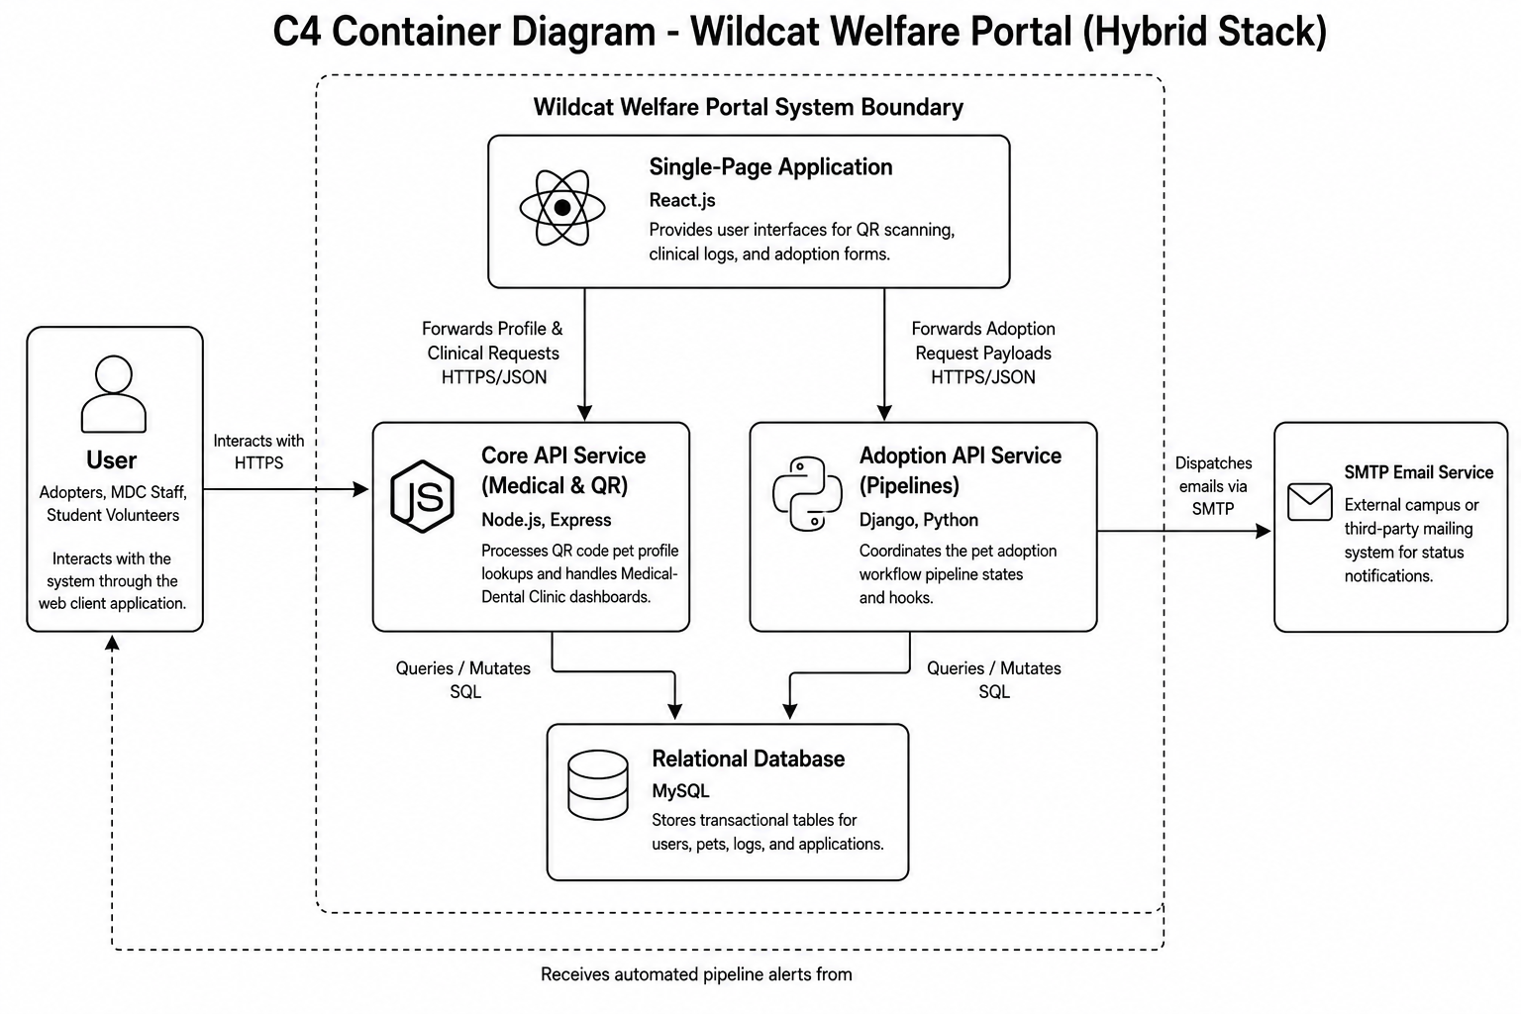

Detailed Design

Module 1

1.1 QR Profile Tracking
- User Interface Design
Scanner View:
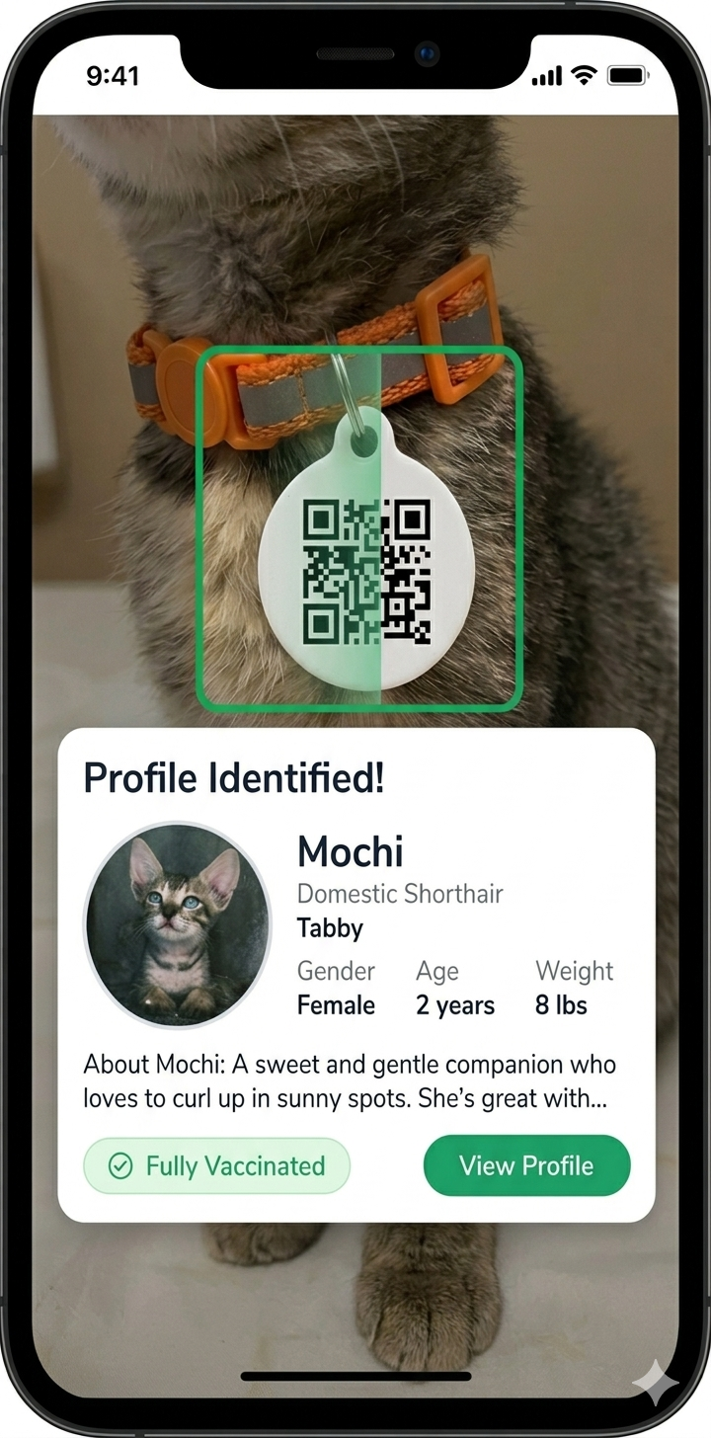
Pet Profile Page:
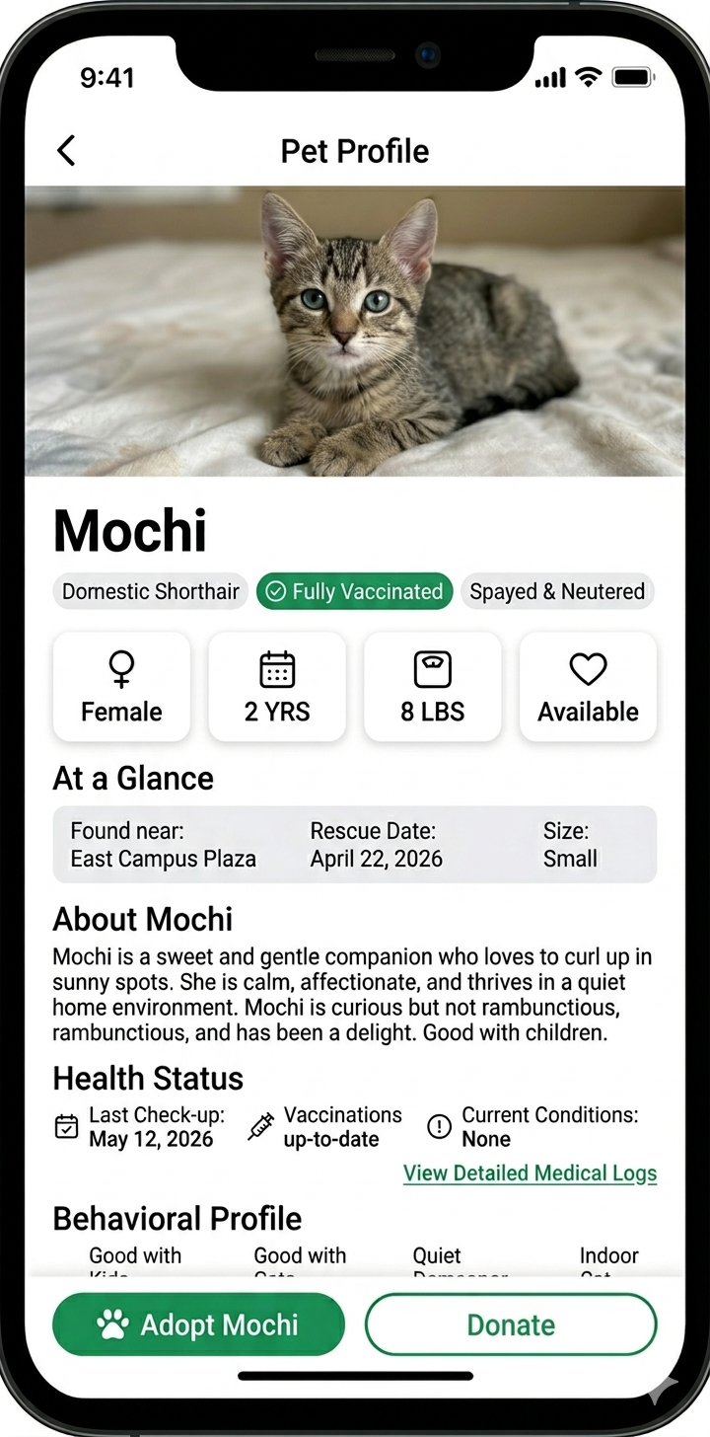
- Front-end component(s)
  - ProfileRouter
    - Parses the petID from the browser's URL path and identifies which pet to load.
    - React/JavaScript Logic
  - PetProfileView
    - Fetches and renders the pet’s data (name, status, bio) for the user to view.
    - React/UI Component
PetPassportView
A public-facing, unauthenticated emergency passport interface rendered when campus community members or visitors scan an animal's collar QR tag. It displays verified rabies immunization badges, emergency medical alerts, and direct campus clinic/security hotlines without requiring an initial institutional login.
React / Public Emergency UI Component
QRScannerView (Hardware Camera & File Upload Fallback)
The optical scanning interface utilizing jsQR. Includes environmental rear-camera constraints and an automated gallery file-upload fallback when hardware camera permissions are restricted or denied on mobile devices.
React / Optical Decoder Component
- Back-end component(s)
  - PetDetailAPIView & PetListAPIView
    - Exposes RESTful endpoints (GET /api/pets/, GET /api/pets/<str:pet_id>/) that query the database to retrieve and serve sanitized companion profiles (name, species, sex, collar tag ID, rescue status, care notes) in JSON format.
    - Django REST Framework APIView (Class-Based View)
  - PetProfileQueryHandler
    - Executes structured queries against the Supabase pets table via the Supabase Python client. Enforces data sanitization, resolves image storage bucket URLs, and formats response payloads for client-side rendering.
    - Python / Supabase Data Access Handler
PublicPassportAPIView
Exposes a public read-only endpoint (GET /api/pets/<str:pet_id>/) that delivers sanitized public safety metadata (name, vaccination tier, rabies status, clinic hotline) while strictly filtering out internal clinic notes and restricted administrative audit logs.
Django REST Framework Public APIView
- Object-Oriented Components
  - Class Diagram
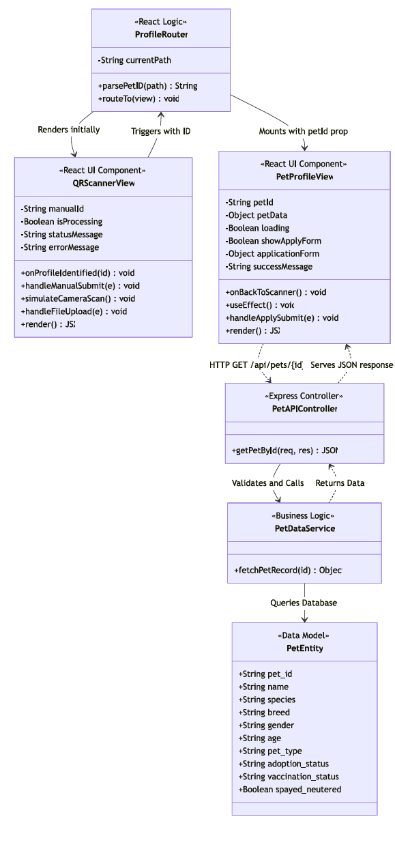
  - Sequence Diagram
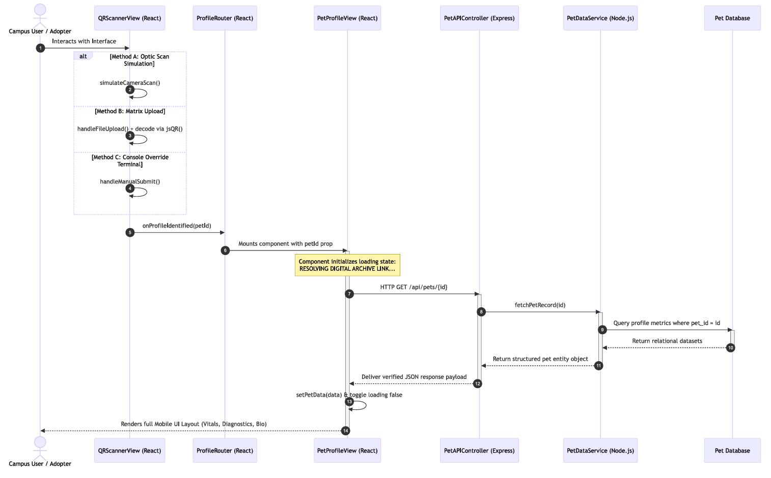
- Data Design
  - ERD or schema
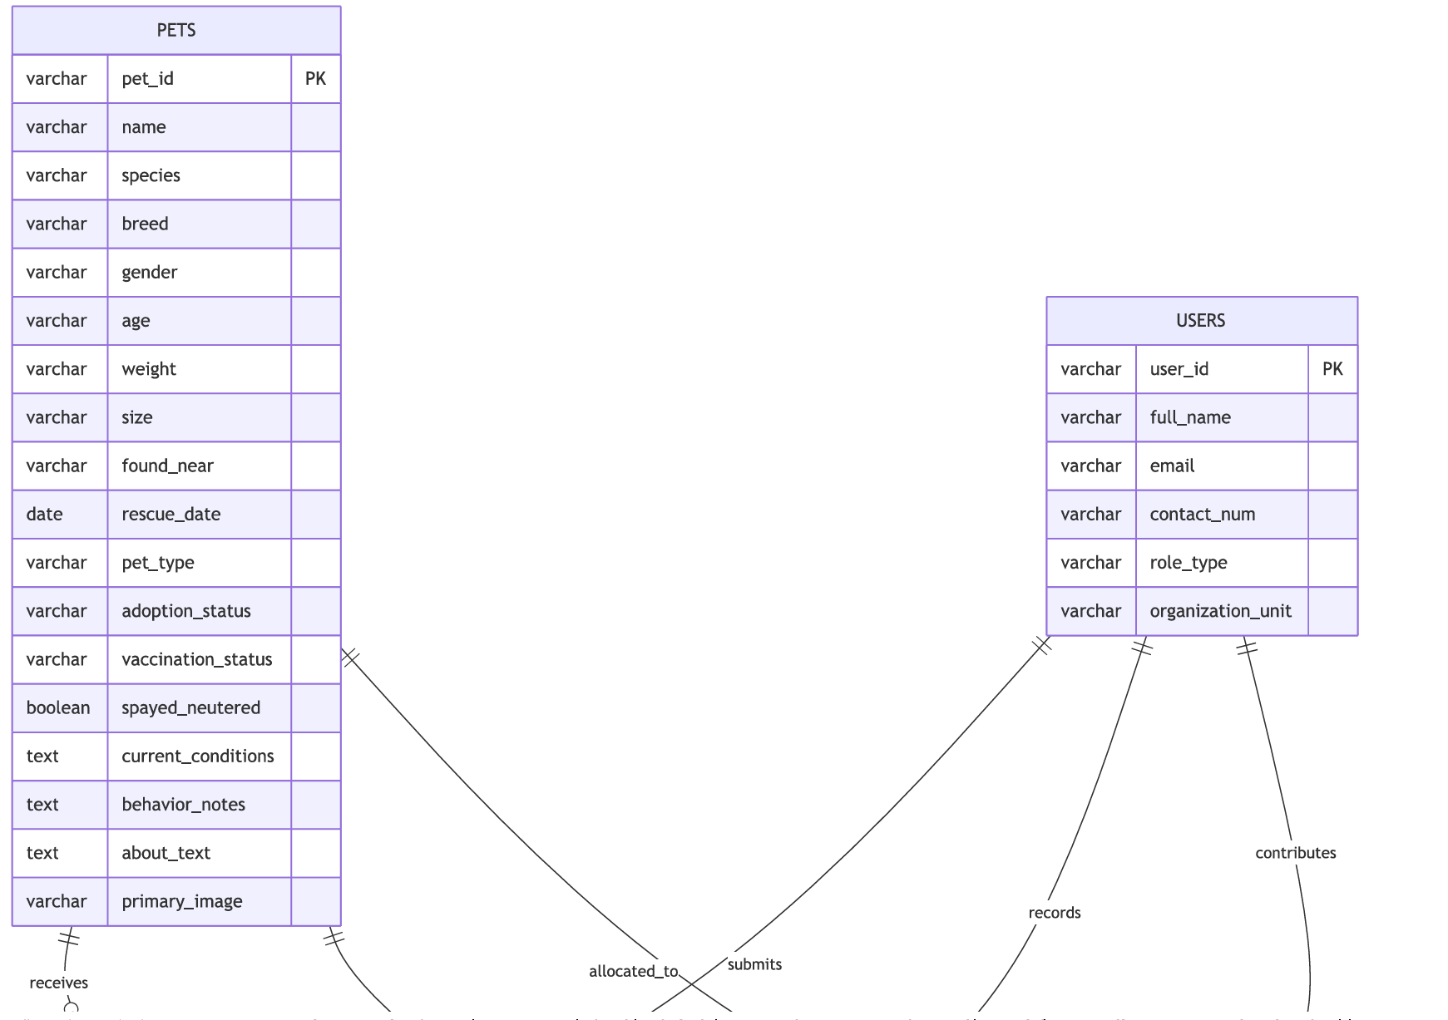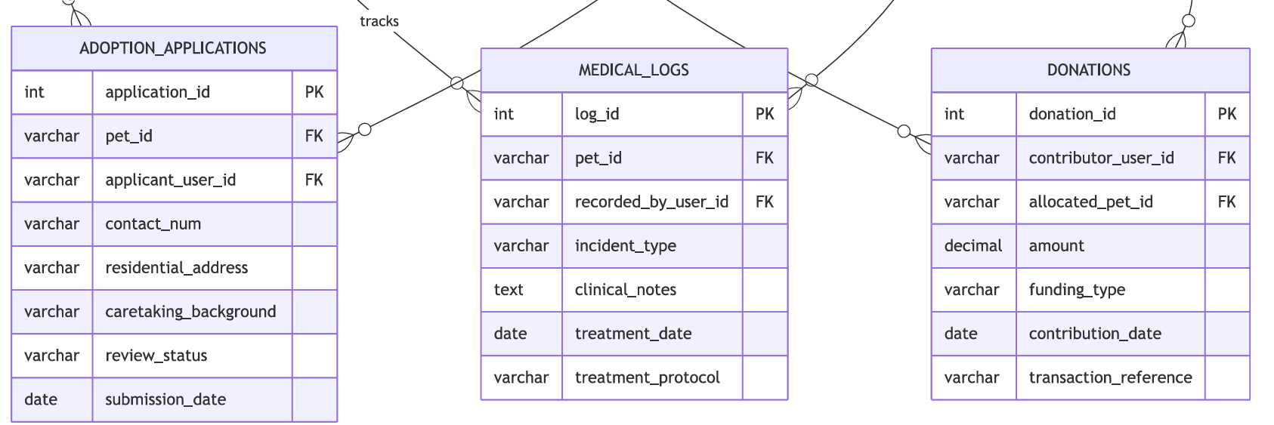

1.2 Medical Record Dashboard
- User Interface Design
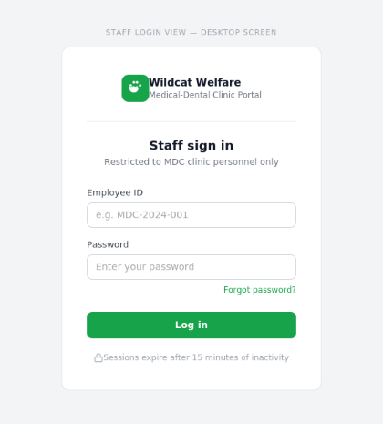
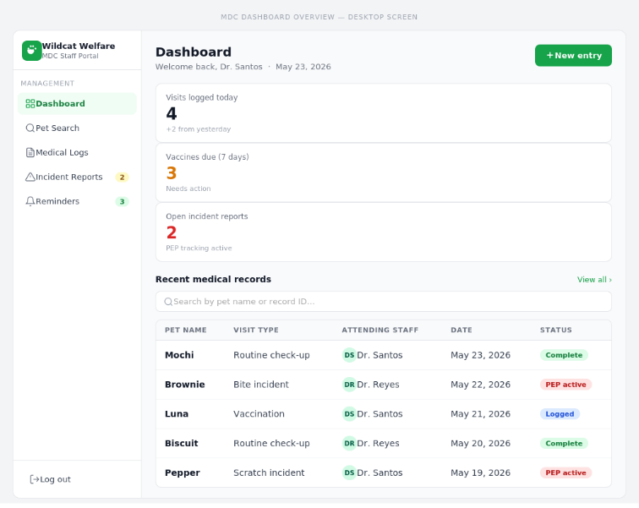
- Front-end component(s)
  - MDCAuthGate
    - A protected login form rendered exclusively for MDC clinic staff. It captures employee credentials (ID and password), submits them to the authentication endpoint, and redirects authorized users to the dashboard. Sessions expire automatically after 15 minutes of inactivity.
    - React Form Component
  - MDCDashboardView
    - The primary dashboard layout rendered after successful staff login. Displays summary counters (visits today, due vaccines, open incidents) and provides navigation to the pet search panel, reminders list, and historical log. Serves as the central hub for all MDC clinical operations within the system.
    - React Layout / Page Component
  - MedicalLogForm
    - A structured form component for logging routine medical visits. Fields include visit type, visit date, attending staff, weight (kg), clinical notes, and vaccination update. The “Save Record” button is disabled until all required fields are populated. A checkbox option auto-schedules the next vaccination reminder upon save.
    - React Form Component
  - IncidentReportForm
    - A specialized form for reporting bite or scratch incidents involving campus animals. Captures incident type (Bite/Scratch—Human), incident date, campus landmark location, victim details, and automatically initializes an active 14-day observation quarantine status in compliance with Republic Act No. 9482. Submitted records trigger emergency clinical follow-ups and Post-Exposure Prophylaxis (PEP) tracking.
    - React Form Component
QuarantineTrackerComponent
A biosecurity monitoring widget integrated into the MDC Dashboard. Automatically calculates and displays active 14-day observation countdowns for campus animals involved in reported human bite or scratch incidents, enforcing strict regulatory adherence to Republic Act No. 9482 (Anti-Rabies Act of 2007).
React Biosecurity Telemetry Component
- Back-end component(s)
  - LoginView (MDC Authentication Gate)
    - Handles the /api/login/ endpoint. Validates staff credentials and institutional email formats (@cit.edu) against the Supabase users table, verifies role permissions (role = 'MDC_STAFF'), and returns authenticated session tokens to guard clinical management routes.
    - Django REST Framework APIView (Authentication Gate)
  - MedicalRecordsAPIView & VaccinationLogsAPIView
    - Exposes RESTful clinical endpoints (GET/POST /api/medical/<str:pet_id>/, GET/POST /api/vaccinations/<str:pet_id>/) configured to intake and validate routine visit notes, vaccination administration batches, and incident reports from the frontend. Access is gated by authentication permissions to ensure only authorized MDC personnel can mutate clinical records.
    - Django REST Framework APIView (Clinical & Biosecurity Handlers)
  - ClinicalBiosecurityService
    - Encapsulates business logic for animal health records and biosecurity protocols. Writes new clinical visit logs and vaccination entries to Supabase, updates immunization timestamps, and automatically initializes 14-day bite/scratch observation quarantine tracking records in compliance with Republic Act No. 9482 (Anti-Rabies Act of 2007).
    - Python Business Logic & Biosecurity Module
- Object-Oriented Components
  - Class Diagram
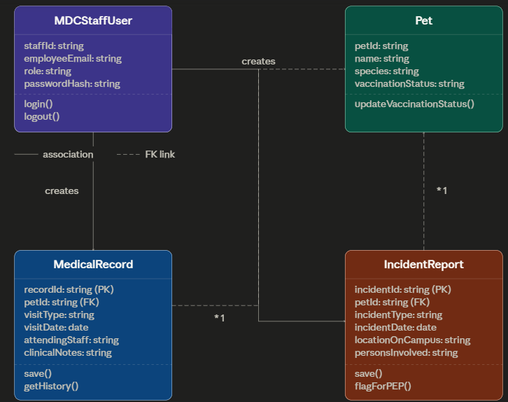

  - Sequence Diagram
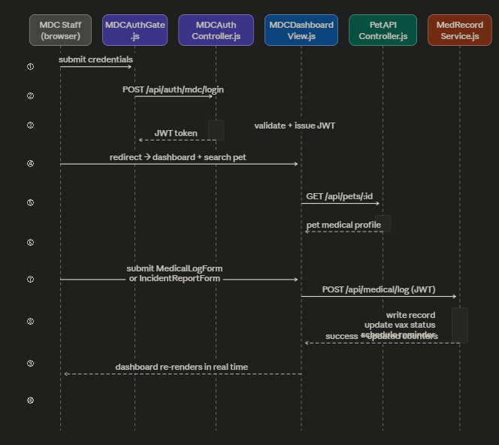

- Data Design
  - ERD or schema
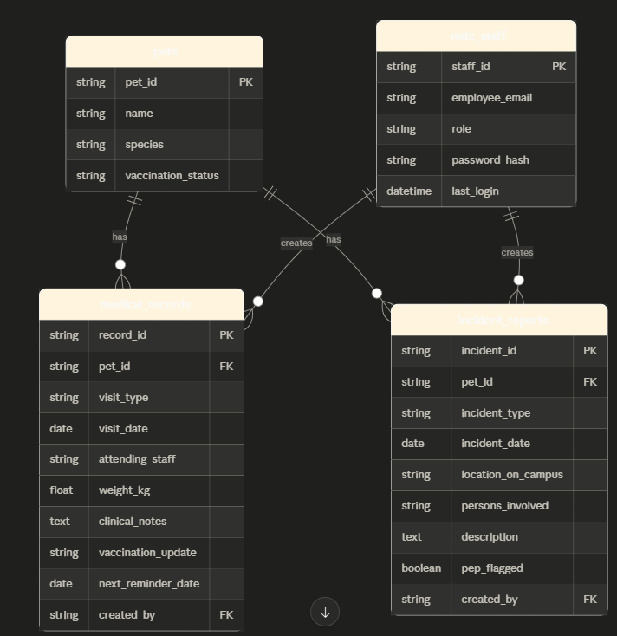

Module 2

2.1 Submit and Process Adoption Application
- User Interface Design
  - Adopter View (Mobile Screen)
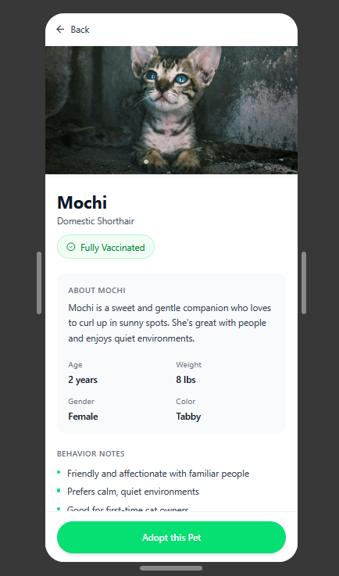

  - Staff View (Desktop Admin Dashboard)
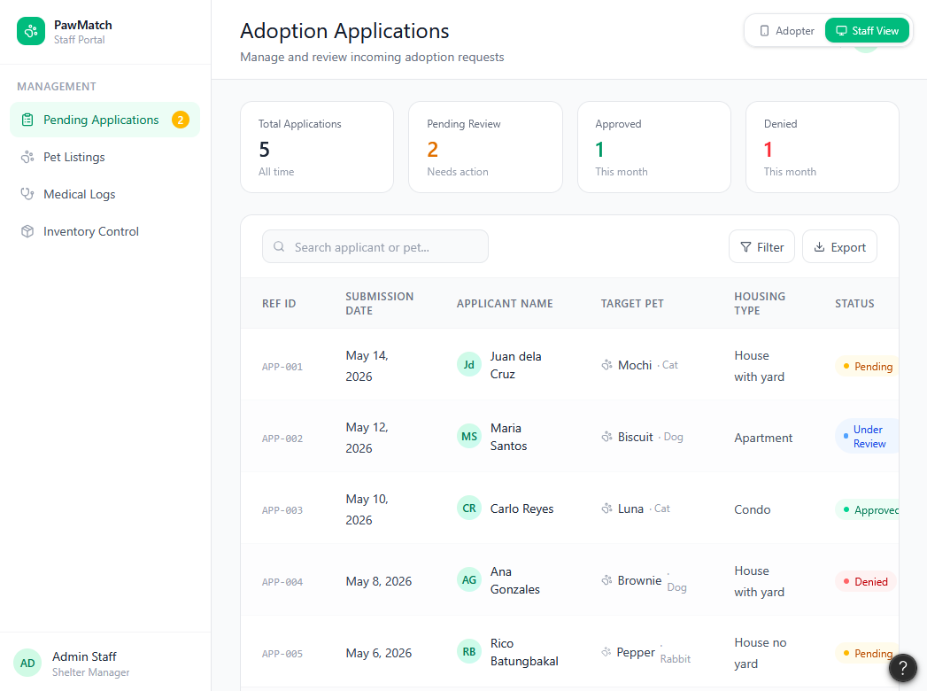

- Front-end component(s)
  - PetPicturesGallery
    - A dynamic image carousel integrated into the pet profile view that maps an array of structural image URLs into a swipeable layout, allowing prospective adopters to view multiple photos of the campus animal.
    - React Image Slider/Carousel UI Component.
  - AdoptionApplicationForm
    - A structured layout capturing essential applicant criteria. It includes form validation logic to ensure required fields, such as the applicant's name and living arrangement type, are filled before sending a POST request to the server.
    - React Form Component
  - ApplicationStatusTracker
    - A dedicated layout module for authenticated community users to view an ongoing list of their active adoption requests and monitor real-time pipeline status shifts.
    - React Card List Grid
  - ShelterAdminDashboard
    - A secure administrative tabular component displaying rows of pending applications, empowering staff to execute state mutations on incoming adoption records
    - React Data Table Grid Component

- Back-end component(s)
  - AdoptionApplicationAPIView
    - Exposes RESTful API endpoints (POST /api/pets/applications/, GET /api/pets/applications/) configured to receive multi-stage adoption questionnaire payloads from the frontend, parsing inputs into standardized structural records and assigning a default status of "Pending".
    - Django REST Framework APIView (Pipeline Submission View)
  - AdoptionApplicationDetailAPIView
    - Handles administrative triage and state transitions (PATCH /api/pets/applications/<int:application_id>/). Modifies application status records (Approved/Denied) based on staff reviews, executes related state alterations on linked pet registry records, and locks historical audit trails.
    - Django REST Framework APIView (Triage & State Mutation View)
  - AdoptionNotificationMailer
    - Listens for pipeline status state modifications and triggers asynchronous hooks to the system's SMTP email service, automatically formatting and dispatching approval confirmations or rejection advisories to the adopter's institutional email address.
    - Django Core Mail / SMTP Asynchronous Task Handler

- Object-Oriented Components
  - Class Diagram
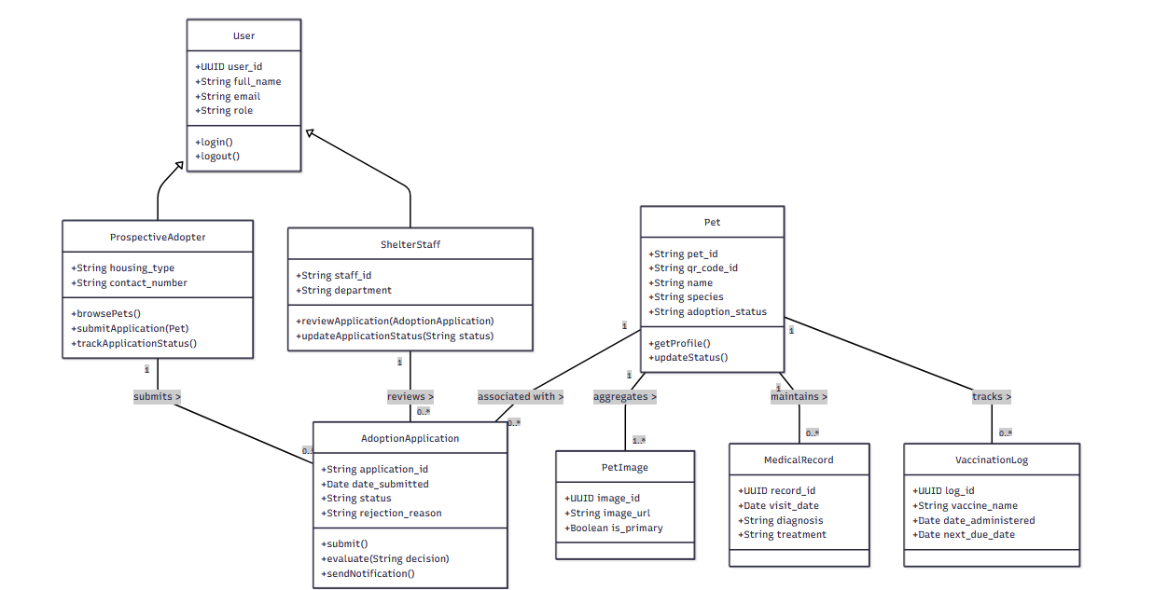
  - Sequence Diagram
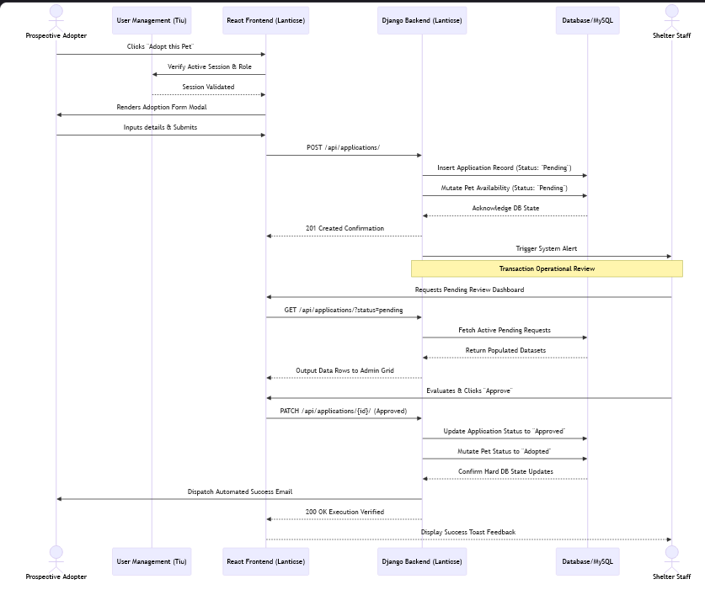

- Data Design
  - ERD or schema
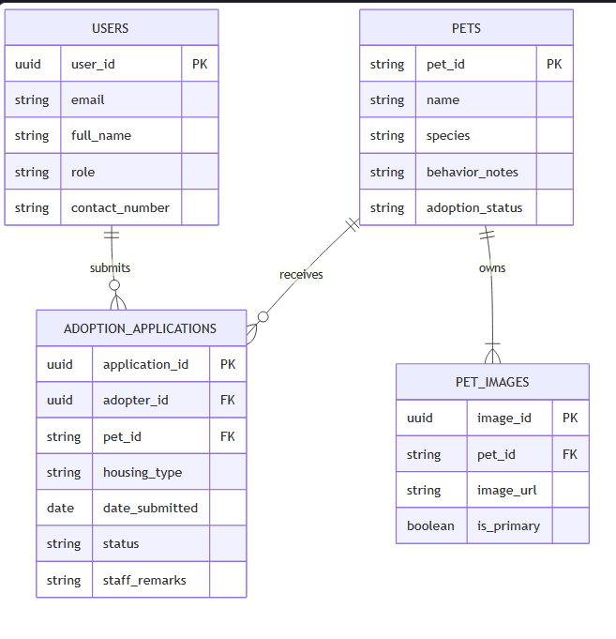

2.2 Supply Logistics & Inventory Control
- User Interface Design
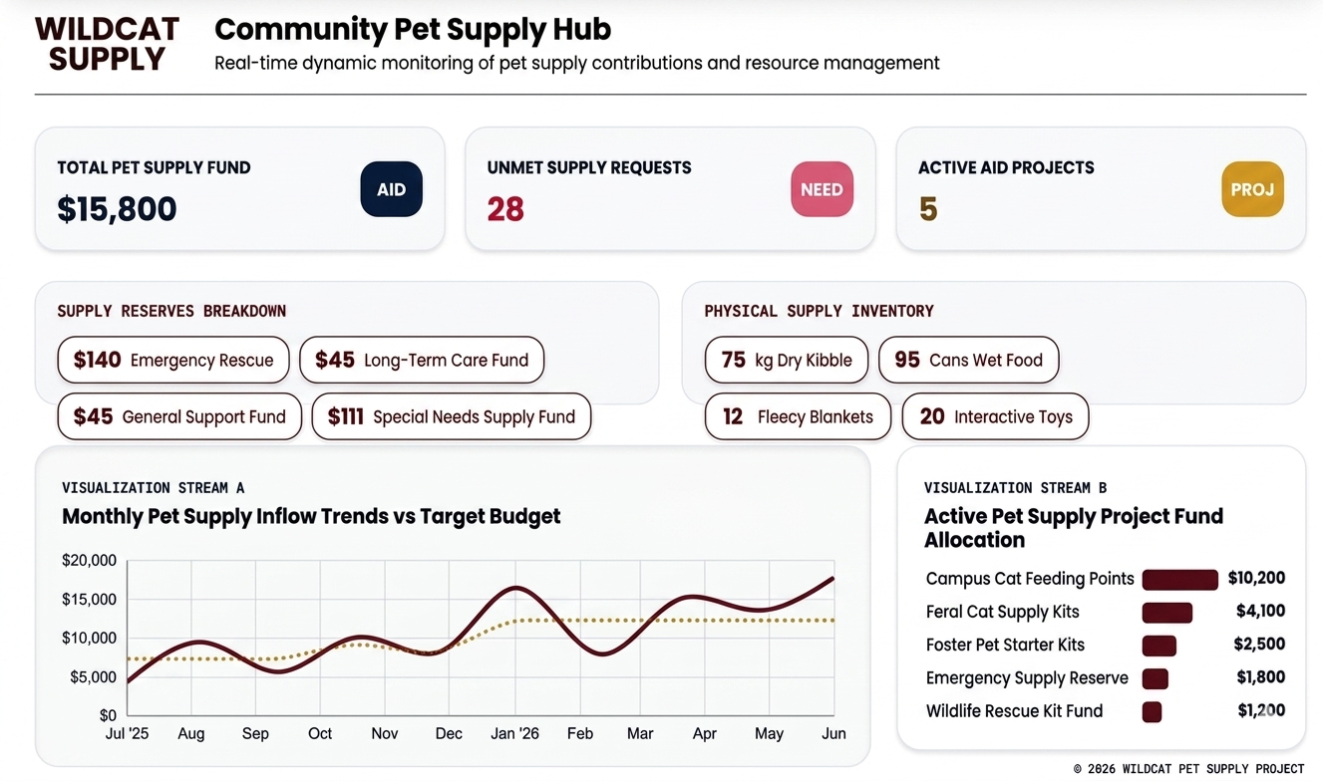
- Front-end component(s)
  - InventoryControl
    - The parent structural container for the logistics system. It receives historical ledger streams and active stock arrays as props, manages sub-tab context routing (stock-list, add-item, history), and hosts asynchronous state updates for asset creation and deletion workflows.
    - React Functional Component / Feature Module Container
  - Active Supply Stock Master
    - A dynamic tabular interface that lists current items segmented by standardized physical operational units (kilograms for kibble, cans for wet food, vials for vaccines/medications, and pieces for collar/hardware assets). Enforces discrete numerical step increments to prevent inventory data entry errors.
    - Inline React UI Block / Dynamic Data Table
  - Transaction Ledger History
    - An unalterable chronological audit rail displaying past transactions. It reads tracking properties to visually badge actions as INFLOW or OUTFLOW adjustments, ensuring any modification can be immediately contextualized with historical reason codes.
    - Inline React UI Block / Audit Trail View
CollarTagGenerator
An integrated administrative utility that compiles pet identification codes and URLs into high-resolution, printable collar QR tags formatted for standard waterproof collar tag matrices.
React / HTML5 Canvas Tag Export Utility

- Back-end component(s)
  - InventoryAPIView & InventoryDetailAPIView
    - Exposes RESTful API endpoints (GET/POST /api/inventory/, PUT/DELETE /api/inventory/<int:item_id>/) to handle supply catalog queries, new asset intake, threshold configurations, and record deletions.
    - Django REST Framework APIView (Supply Endpoints)
  - InventoryTransactionHandler
    - Processes operational supply mutations (POST /api/inventory/transactions/). Enforces strict numeric type validation (quantities, minimum alert thresholds), categorizes adjustments into discrete physical unit types (kilograms, cans, vials, pieces), and writes immutable audit entries to the inventory_transactions ledger for inflow and outflow tracking.
    - Python Supply Ledger & Validation Module
  - InventorySchema
    - The structural relational data definition for supply entries. Models operational fields including item_name, category, physical unit_type (kilograms, cans, vials, pieces), quantity, min_threshold, donor_attribution, and expiration_date.
    - Supabase / Relational PostgreSQL Table Schema

- Object-Oriented Components
  - Class Diagram
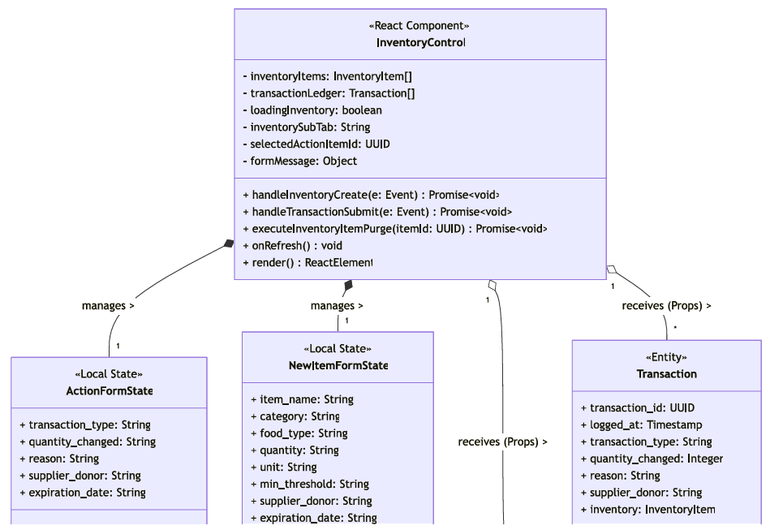
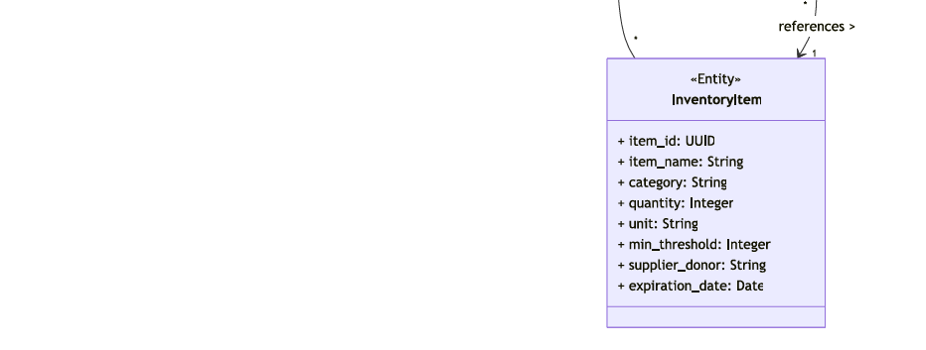

  - Sequence Diagram
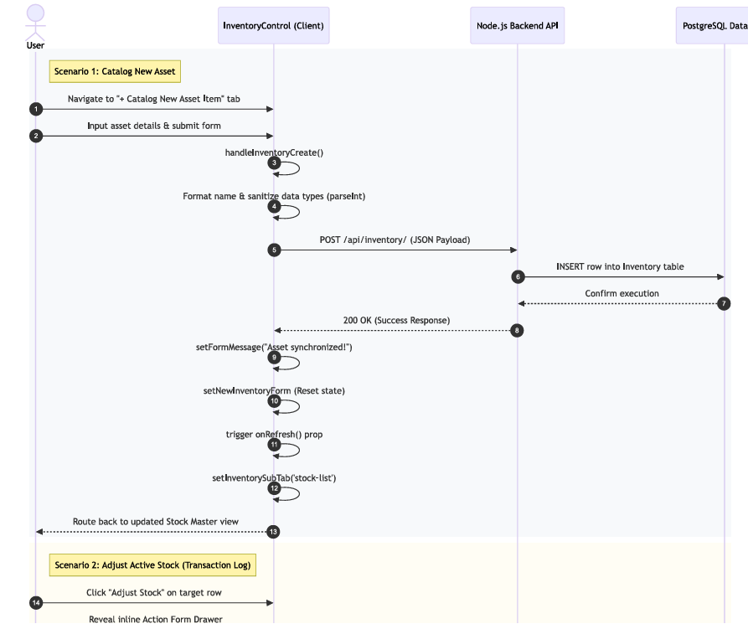
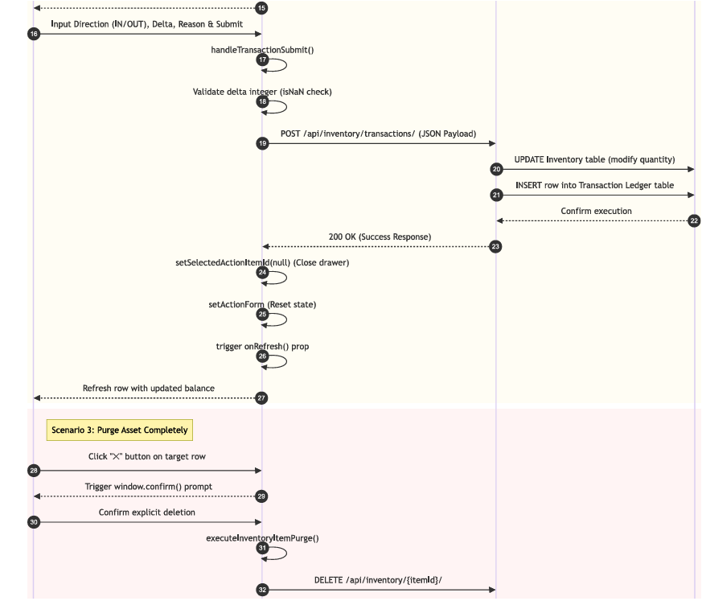
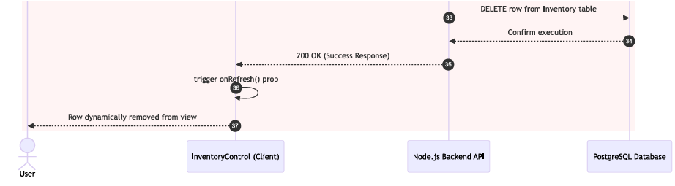

- Data Design
  - ERD or schema
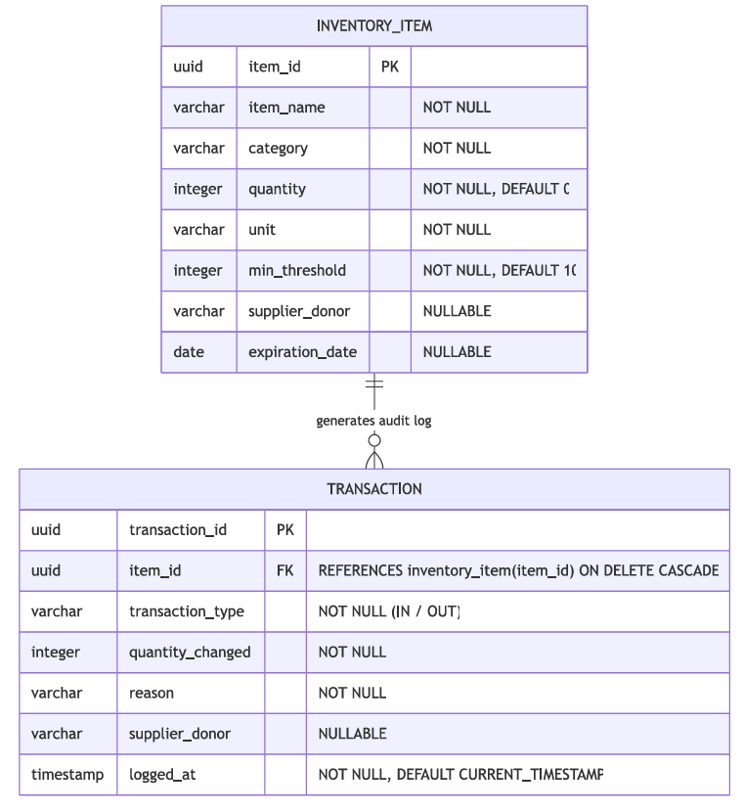

Module 3

3.1 Homepage/Newsfeed
- User Interface Design
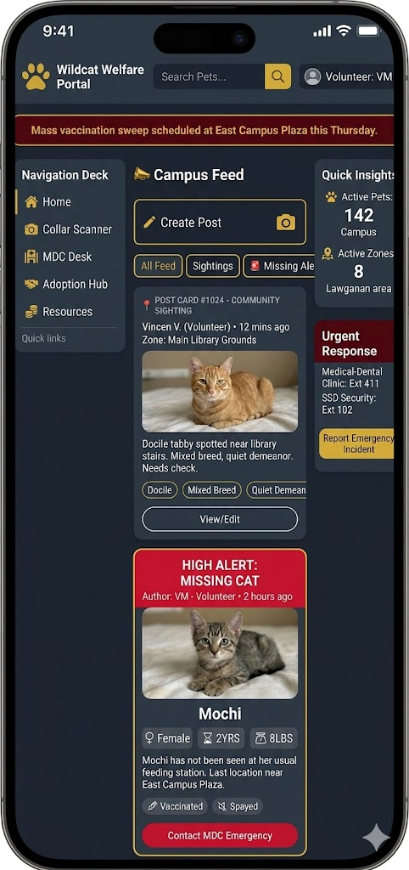

- Front-end component(s)
  - NewsfeedView
    - The primary social timeline container. It renders the main interactive feed, allowing users to track community posts, filter data via search capsules, and paginate through records. It actively calculates and displays quantitative metrics, such as total matched feeds and active sighting volumes.
    - React Functional Component / View
SightingTriageView
A specialized administrative triage queue allowing campus clinic staff and welfare officers to review incoming community sighting reports, inspect uploaded photos and location landmarks, and execute a 1-click 'Admit & Intake Stray' workflow that auto-populates the new pet registration form without duplicate data entry.
React Administrative Triage Grid Component
UserGuideModal (UserGuideModal.jsx)
An interactive onboarding modal designed in response to MVP validation user feedback. Provides first-time students, faculty, and administrative users with step-by-step guidance on QR scanning, sighting submissions, and pet passport navigation.
React Interactive Modal / Walkthrough Component
ReportSightingView (with CIT-U Campus Landmark Selector)
The community sighting submission interface. Features structured dropdown selection for standardized CIT-U campus buildings and zones (NGE Building, Main Canteen, Academic Complex, Gymnasium, Grounds) alongside photo attachment and condition tags, eliminating ambiguous location descriptions.
React Form / Sighting Submission Component
- Back-end component(s)
  - UnifiedNewsfeedAPIView
    - The centralized routing view that manages incoming HTTP requests for the campus activity stream (GET /api/newsfeed/), integrating announcements, sighting reports, and community posts. Enforces domain authentication (@cit.edu) and handles moderation endpoints (DELETE /api/newsfeed/action/).
    - Django REST Framework APIView (Stream & Moderation Endpoint)
  - NewsfeedInteractionHandler
    - Encapsulates social business logic for community interaction endpoints (ToggleLikeAPIView, AddCommentAPIView, CommentActionAPIView). Manages atomic increment/decrement operations for like counters, formats hierarchical comment trees, and sanitizes user-submitted strings before persisting to Supabase.
    - Python / Django Interaction Logic Module
  - NewsfeedSchema
    - Defines the relational data structure for announcements, animal_sightings, comments, and likes tables, ensuring relational integrity between post content, user attribution IDs, and media attachments.
    - Supabase / Relational PostgreSQL Table Schema

- Object-Oriented Components
  - Class Diagram
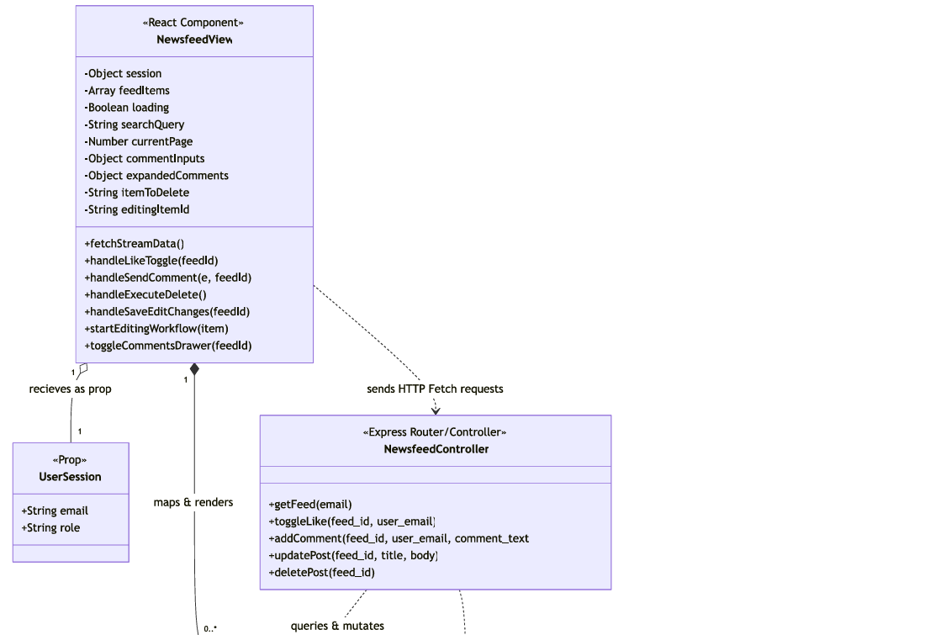
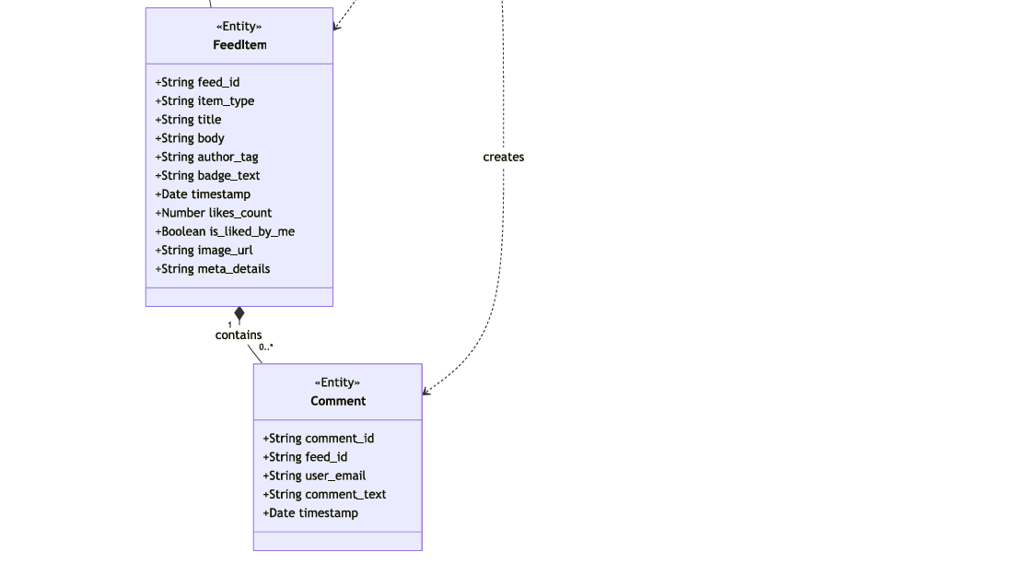

  - Sequence Diagram
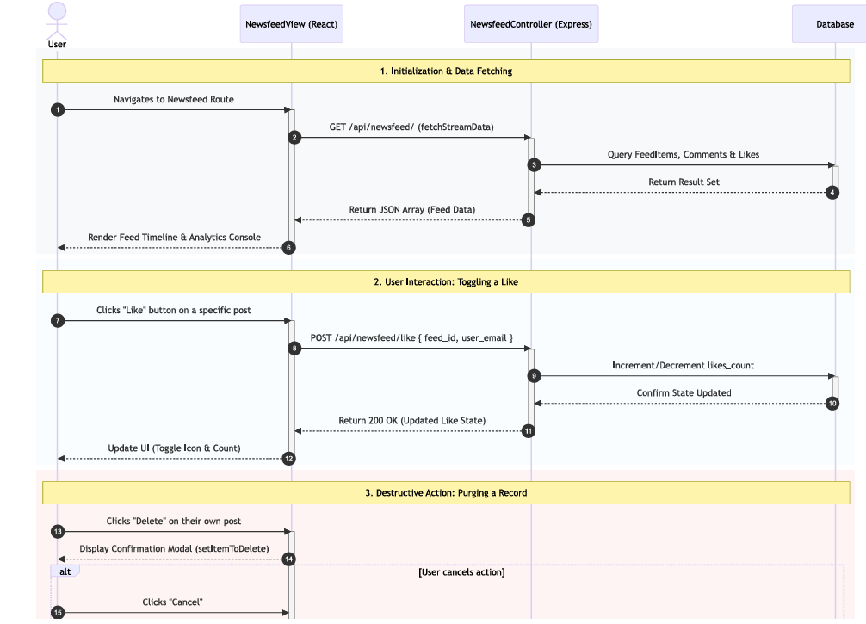
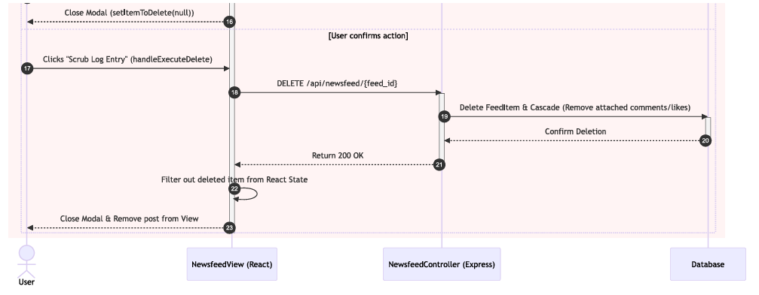

- Data Design
  - ERD or schema
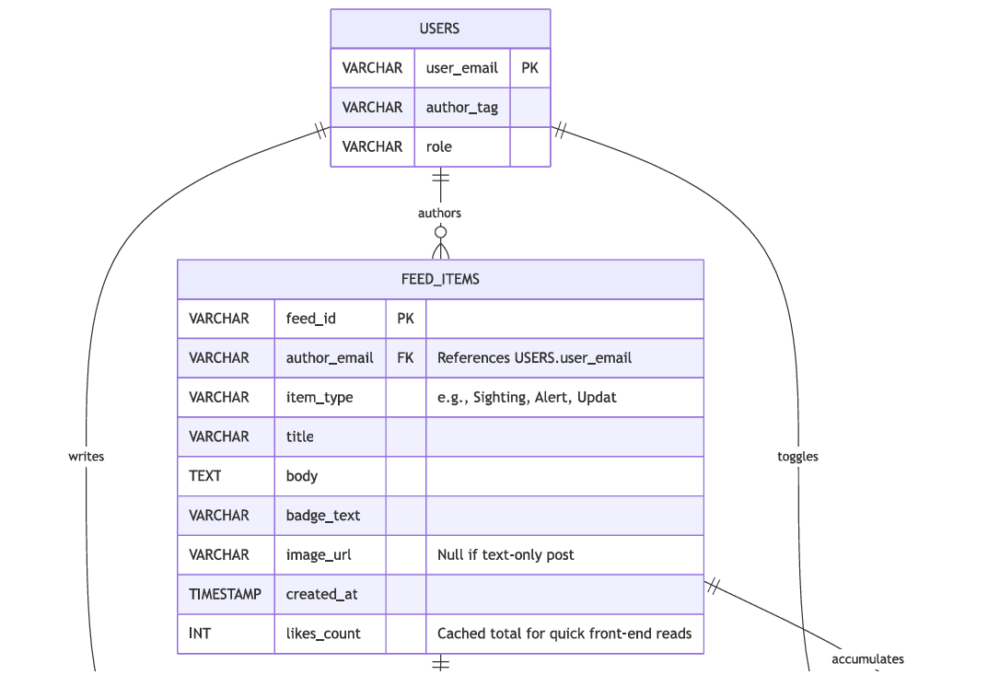
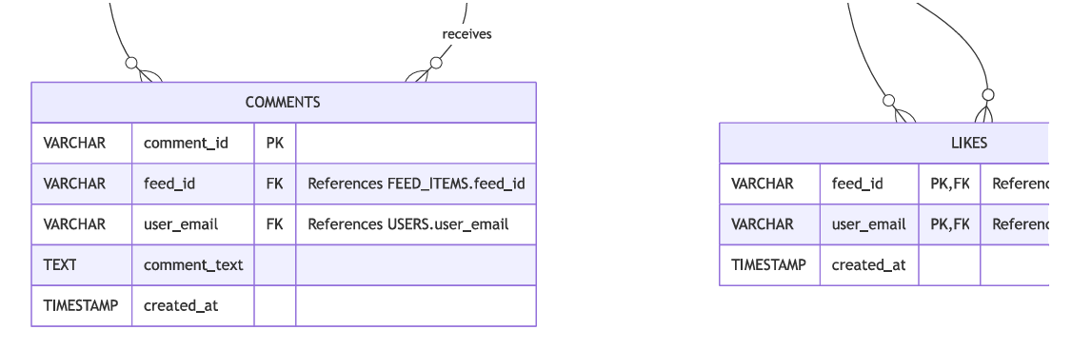

1.3 Animal Intake, Registry & Tag Generation
This module governs the administrative lifecycle of campus animal admissions into the official Wildcat Welfare Registry. It provides clinic personnel and shelter administrators with unified workflows to register rescued campus strays, record initial biometric baselines, upload authenticated companion pictures to Supabase Storage, and automatically generate print-ready waterproof collar QR matrices for physical tagging.
User Interface Design
The user interface consists of the AddNewPet modal/screen and the PetListings master directory grid, enabling instant search, filter by adoption status (Available, Adopted, Under Quarantine), and collar tag badge printing.
Front-end component(s)
AddNewPet (AddNewPet.jsx)
A multi-field administrative intake form allowing clinic staff to register newly admitted campus animals. Captures species, name, estimated age, gender, coat pattern, initial health diagnosis, spayed/neutered boolean, and primary picture upload with real-time browser preview. Automatically triggers unique collar tag generation upon successful admission.
React Administrative Intake Form Component
PetListings (PetListings.jsx)
The central administrative companion management directory. Renders searchable, filterable data cards displaying current health statuses, rabies vaccination indicators, microchip IDs, and quick-action buttons to view profiles, edit vitals, or trigger collar QR generation.
React Master Directory Grid Component
CollarTagGenerator
A client-side utility integrated into PetListings and AddNewPet. Synthesizes the animal's unique identifier and portal URL into high-resolution, waterproof QR tag matrices ready for direct thermal or color printing, ensuring physical campus animals carry immediate optical passport links.
React / HTML5 Canvas Optical Tag Generator
Back-end component(s)
PetListAPIView
Exposes POST /api/pets/ and GET /api/pets/. Parses multipart form payloads, validates compulsory biological fields, writes new companion rows into the Supabase pets table, and coordinates secure image asset uploads into the 'petpictures' storage bucket.
Django REST Framework APIView (Intake Endpoint)
PetAISearchAPIView
Exposes GET /api/pets/ai-search/. Provides semantic natural-language search across registered animal traits, behaviors, and descriptions, allowing adopters and clinic staff to discover companions via conceptual queries (e.g., 'calm ginger cat near library').
Django REST Framework APIView (AI Semantic Search)
PetIntakeStorageHandler
A Python storage utility interacting with Supabase Cloud Storage. Generates sanitized unique filenames, sets appropriate MIME types, streams binary image payloads into bucket partitions, and returns CDN-backed public image URLs for relational linking.
Python / Supabase Cloud Storage Handler
[Diagram Placeholder: Module 1.3 Animal Intake Architecture & Class Flow]
3.2 Landmark-Assisted Sighting Telemetry & 1-Click Intake
This module operationalizes community-driven animal welfare surveillance across the Cebu Institute of Technology – University campus. Community members can rapidly report wandering or distressed animals using standardized CIT-U building landmarks, while MDC and shelter personnel monitor an incoming triage queue. Crucially, verified sightings can be converted directly into registered companion profiles via a seamless 1-Click Sighting-to-Intake handoff.
Front-end component(s)
ReportSightingView (ReportSightingView.jsx)
The public reporting interface accessible on mobile and desktop. Features structured dropdown selection for standardized CIT-U campus buildings and zones (NGE Building, Main Canteen, Academic Complex, Gymnasium, Quadrangle, Grounds), photo capture attachment, animal condition tags (Injured, Aggressive, Healthy), and optional reporter contact information.
React Community Sighting Form Component
SightingTriage (SightingTriage.jsx)
An administrative command interface for clinic and security teams. Displays real-time telemetry cards of reported strays, allows status updates (Open, Under Review, Dispatched, Resolved), and provides the 'Convert to Intake' button for 1-click rescue onboarding.
React Administrative Triage Queue Component
Back-end component(s)
AnimalSightingAPIView
Exposes GET /api/sightings/ and POST /api/sightings/. Validates incoming sighting payloads, handles image file uploads into the 'sightings' Supabase storage bucket, and writes new telemetry entries with an initial status of 'Open'.
Django REST Framework APIView (Sighting Endpoint)
AnimalSightingDetailAPIView (1-Click Intake Gate)
Exposes PATCH /api/sightings/<int:sighting_id>/. Manages triage status state transitions and executes the 1-click sighting-to-intake handoff: extracts sighting photos and physical condition tags to automatically generate a pre-populated draft in the pets table while updating sighting status to 'Resolved (Intake Completed)'.
Django REST Framework APIView (Triage & Intake Gate)
AnimalSightingSchema
The relational database schema for animal sightings. Defines fields: sighting_id (bigint PK), landmark_location, building_zone, animal_description, condition_tags, photo_url, reporter_id (FK profiles.id), reporter_contact, status, and created_at.
Supabase / Relational PostgreSQL Table Schema
[Diagram Placeholder: Module 3.2 Sighting Triage & 1-Click Intake Flow]
Module 4: Security, Access Governance & User Onboarding
4.1 Interactive User Onboarding Walkthrough
Front-end component(s)
UserGuideModal (UserGuideModal.jsx)
A responsive multi-step onboarding modal developed in direct response to the N=34 MVP validation findings (System Usability Scale benchmark of 62.32). Provides visual walkthroughs, animated icons, and quick-start instructions for first-time students, faculty, and clinic staff across QR collar scanning, sighting reporting, public pet passport access, and adoption submissions.
React Interactive Walkthrough Modal Component
SupportAndVolunteers (SupportAndVolunteers.jsx)
A public guidance and civic engagement hub. Displays institutional animal welfare protocols, guidelines for interacting with free-ranging Wildcats, donation drop-off locations, and volunteer orientation materials.
React Community Advocacy & FAQ Component
4.2 Role-Based Access Control & Institutional Authentication
Front-end component(s)
Login (Login.jsx) & Register (Register.jsx)
Client authentication portals. Register enforces strict client-side validation for institutional @cit.edu email domains and standard CIT-U student/employee ID matrices (format: XX-XXXX-XXX). Login authenticates against Supabase Auth, caches session JWTs in secure browser storage, and directs users to role-specific dashboard views.
React Authentication & Security Gate Components
Back-end component(s)
RegisterUserView & LoginView
Exposes POST /api/register/ and POST /api/login/. Enforces institutional email format regex (^[a-zA-Z0-9._%+-]+@cit\.edu$) and Student ID format regex (^\d{2}-\d{4}-\d{3}$). Authenticates against Supabase auth.users, synchronizes role attributes (STUDENT, FACULTY, MDC_STAFF, ADMIN) into public.profiles, and issues signed session tokens.
Django REST Framework APIView (Authentication Gates)
HealthCheckAPIView
Exposes GET /api/health/. An automated keep-alive and telemetry endpoint continuously monitored by infrastructure watchdogs to prevent cold-start latency on cloud container hosts (Render) and verify active Supabase PostgreSQL connection pools.
Django REST Framework APIView (Infrastructure Health Telemetry)
[Diagram Placeholder: Module 4 Security Architecture & Role Authorization Flow]

