“Room Escape” Write-up

Yvette Wang

A room allows a player to explore. The player can only see the indoor scene. The room design is based on the painting of Vincent van Gogh’s room (see Figure 1). I have simplified some details from the original painting.

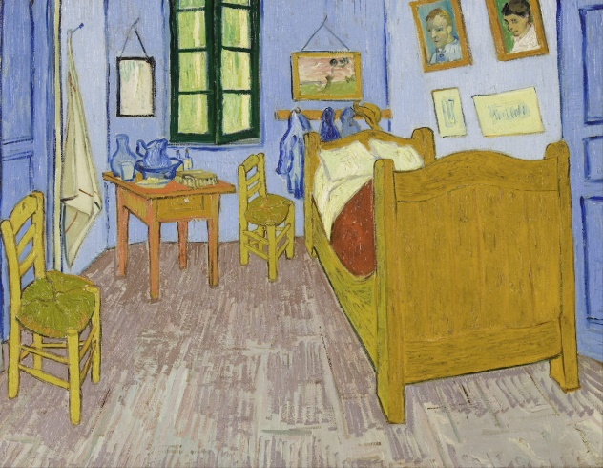

Figure 1. Vincent van Gogh, Bedroom in Arles.

The player can change the view inside the room: she/he can turn around, walk around, as well as moving up and down. The player can click on the furniture in the room. Different events may occur depends on the click actions. The important descriptions of the events will show up at the bottom of the webpage.

The game is to escape from the room through the door. In order to unlock the door, the player should solve the designed puzzle based on the information the room gives. The solution to the game will be at the end of the write-up.

The game can be easily accessed at <http://ee.cooper.edu/~wang2/final/roomEscape.html>. Google chrome should be able to display the whole project.

Hint for the game: Check the status log at the bottom of the page frequently!

Implementation notes: The game uses third-party OBJ. models from online. The models are parsed into the WebGL with an open sourced obj loader (<https://github.com/aircloud/WebGL-obj-loader>). The WebGL functions and basic matrix calculations are depended on the initialShaders.js, webgl-utils.js, and MV.js from the textbook.

The solution:

1. The way to unlock the door is to click on the 9 buttons to form a pattern, and then confirm your answer by pressing the long button below.

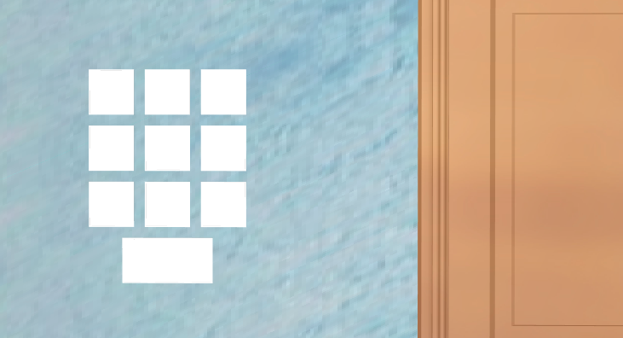

Figure 2. The 9 buttons and the confirm button.

1. Click the self-portrait and the status log will ask you to find van Gogh’s ear.
2. Find the ear beneath the bed, and click on it. The pad in front of the bed will have some content show up. It is a grid with numbers representing each grid in Figure 2.
3. Click the frame of the sunflower painting. The painting should be removed, and a piece of paper will appear. Get the answer of the question on the paper (which is 15).
4. Check the back of the easel. Click the white board if you can’t read the words straightly from the easel.
5. Get the answer of step 5 by clicking the bed and the easel, which is 37.
6. Press 1537 on the buttons in Figure 2, and confirm.