|  |
| --- |
|  |
| Jboss安裝 |
|  |
| [鍵入文件副標題] |

**[鍵入公司名稱]**

[挑選日期]

撰寫人: tommy

Jboss安裝

[鍵入文件副標題]

再bin目錄下面執行

To install the service run:

**%JBOSS_HOME%**\bin\service.bat install

上面全部才不會出 jboss NET HELPMSG 3534。

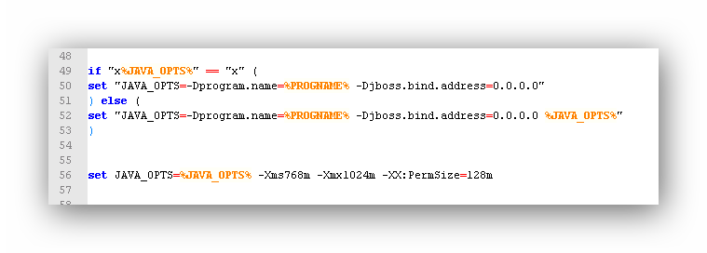

Run.bat

|  |
| --- |
| if "x%JAVA_OPTS%" == "x" (  set "JAVA_OPTS=-Dprogram.name=%PROGNAME% -Djboss.bind.address=0.0.0.0"  ) else (  set "JAVA_OPTS=-Dprogram.name=%PROGNAME% -Djboss.bind.address=0.0.0.0 %JAVA_OPTS%"  )  set JAVA_OPTS=%JAVA_OPTS% -Xms768m -Xmx1024m -XX:PermSize=128m |