Install jenkins

Jenkins 帳號/密碼 jenkins / jenkins

Configure jenkins service linux (Running as a Linux Service)

create linux-user jenkins/jenkins

$ vim /etc/systemd/system/jenkins.service

# Systemd unit file for tomcat
[Unit]
Description=Apache Tomcat Web Application Container
After=syslog.target network.target

[Service]
Type=forking

Environment=JAVA_HOME=/opt/jdk1.8.0_111
Environment=ANT_HOME=/opt/apache-ant-1.10.0
Environment=M2_HOME=/opt//opt/apache-maven-3.3.9
Environment=JENKINS_HOME=/home/jenkins/workspace

Environment=CATALINA_PID=/home/tomcat8/apache-tomcat-8.5.9/temp/tomcat.pid
Environment=CATALINA_HOME=/home/tomcat8/apache-tomcat-8.5.9/
Environment=CATALINA_BASE=/home/tomcat8/apache-tomcat-8.5.9/
Environment='CATALINA_OPTS=-Xms512M -Xmx1024M -server -XX:+UseParallelGC'
Environment='JAVA_OPTS=-Djava.awt.headless=true -Djava.security.egd=file:/dev/./urandom'

ExecStart=/home/tomcat8/apache-tomcat-8.5.9/bin/startup.sh
ExecStop=/bin/kill -15 $MAINPID

User=root
Group=root

[Install]
WantedBy=multi-user.target

Now reload Systemd to load the jenkins unit file:
systemctl daemon-reload

Now you can start the jenkins service with this systemctl command:
systemctl start jenkins

Now you can stop the jenkins service with this systemctl command:
systemctl stop jenkins

If you want to enable the jenkins service, so it starts on server boot, run this command:
systemctl enable jenkins

http://http://192.168.0.8:18080/

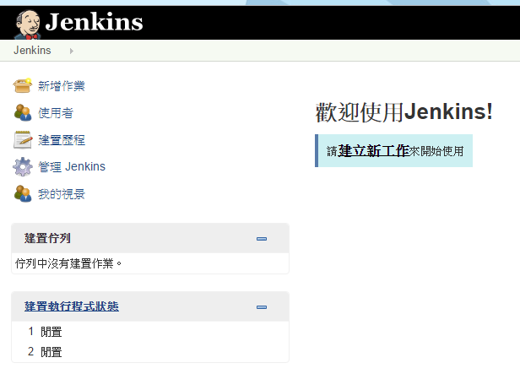

http://192.168.0.8:18080/jenkins/
login => 帳號/密碼 jenkins / jenkins
svn => 帳號/密碼 zonvan/zonvan

