sudo apt-get update

sudo apt-get install goaccess

sudo apt-get install geoip-database

===========================================================

test apache2 httpd log

apt-get install apache2

apache2 access log location

curl locahost

wget localhost

===========================================================

cat /etc/goaccess.conf GoAccess配置文件

goaccess -f /var/log/apache2/access.log

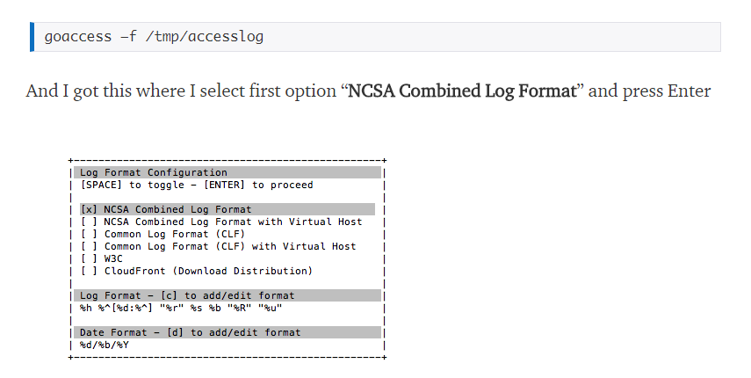

===========================================================

%h %l %u %t &quot;%r&quot; %s %b <= 标准格式

goaccess -f /var/log/apache2/access.log > /var/www/html/reports.html

<http://192.168.0.216/reports.html>

===========================================================

apt-get install cron

使用以下命令列出当前用户计划的cron作业。 crontab –l

编辑Cron作业 crontab -e

vim /etc/crontab

===========================================================

如何设定realtime

goaccess /var/log/apache2/access.log -o /var/www/html/realtime.html

goaccess -f /var/log/apache2/access.log -a -o /var/www/html/realtime.html --real-time-html --ws-url=192.168.0.216

＃＃＃＃＃＃＃＃＃＃ goaccess -f /var/log/nginx/site1-access.log -a -o /var/www/goaccess.mydomain.com/site.html.html --real-time-html --ws-url=goaccess.mydomain.com

goaccess --fifo-in=/var/log/apache2/access.log --fifo-out=/var/www/html/realtime.html -

tail -f -n +0 /var/log/apache2/access.log | goaccess -o /var/www/html/realtime.html --real-time-html -

goaccess: unrecognized option '--real-time-html'