Services for Network File System 概觀

<https://technet.microsoft.com/zh-tw/library/cc732369(v=ws.11).aspx>

windows server from NFS

install NFS Server see windows.2008r2.gif

===========================================================

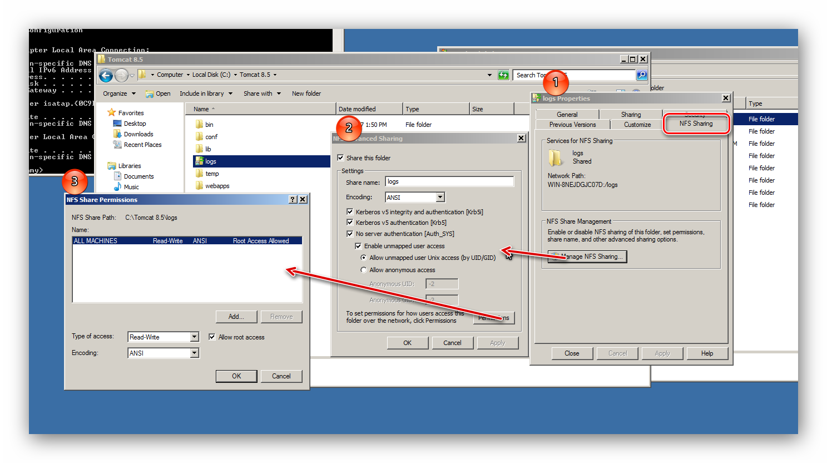

===========================================================

linux

apt-get install nfs-kernel-server

apt-get install nfs-common

===========================================================

mount -t nfs 192.168.0.133:/share /mnt/nfs/var/win7

umount /mnt/nfs/var/win7

mount -t nfs 192.168.0.123:/logs /mnt/nfs/var/rd2

umount /mnt/nfs/var/rd2/

mount -t nfs 192.168.0.126:/logs /mnt/nfs/var/rd3/

umount /mnt/nfs/var/rd3/

mount -t nfs 192.168.0.126:/logs /mnt/nfs/var/rd3/

umount /mnt/nfs/var/rd3/

===========================================================