apt-get install nodejs

apt-get install npm

apt-get install git

===========================================================

install head 需要nodejs

<https://github.com/mobz/elasticsearch-head>

===========================================================

Running with docker

for Elasticsearch 5.x: # docker run -d -p 9100:9100 mobz/elasticsearch-head:5

apt install docker.io

add http.cors.enabled: true

you must also set http.cors.allow-origin because no origin allowed by default. http.cors.allow-origin: "\*" is valid value, however it’s considered as a security risk as your cluster is open to cross origin from anywhere.

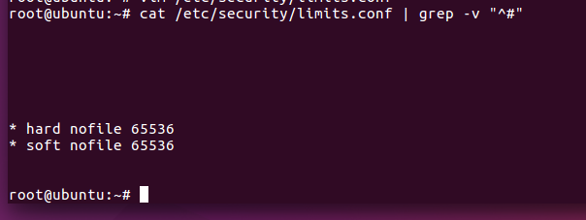

apt-get install nfs-kernel-server

apt-get install nfs-common

===========================================================

$ /opt/elasticsearch/bin/elasticsearch > /dev/null &

netstat -tlanp | grep 9200

