Lab5
1. Environment Setup (Docker Desktop / WSL Installation)
On Windows, the typical setup for Docker experiments is installing Docker Desktop and enabling WSL2 integration.
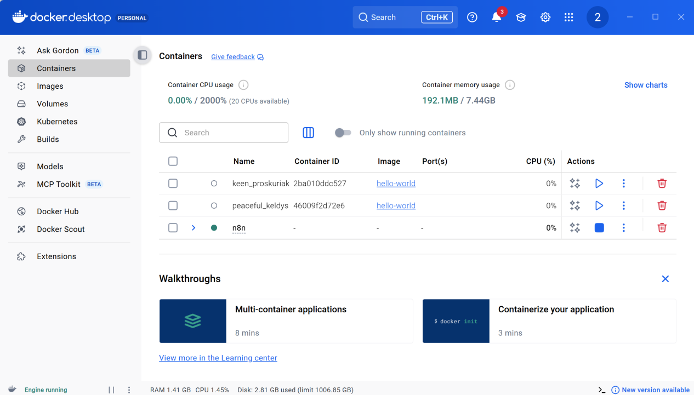
2. What is a Container
- A container is a running instance of an image.
- It has its own isolated filesystem, network interfaces, and process space.
- A container adds a writable layer on top of an image — you can only write to this layer, while all others remain read-only.
“docker run hello-world”
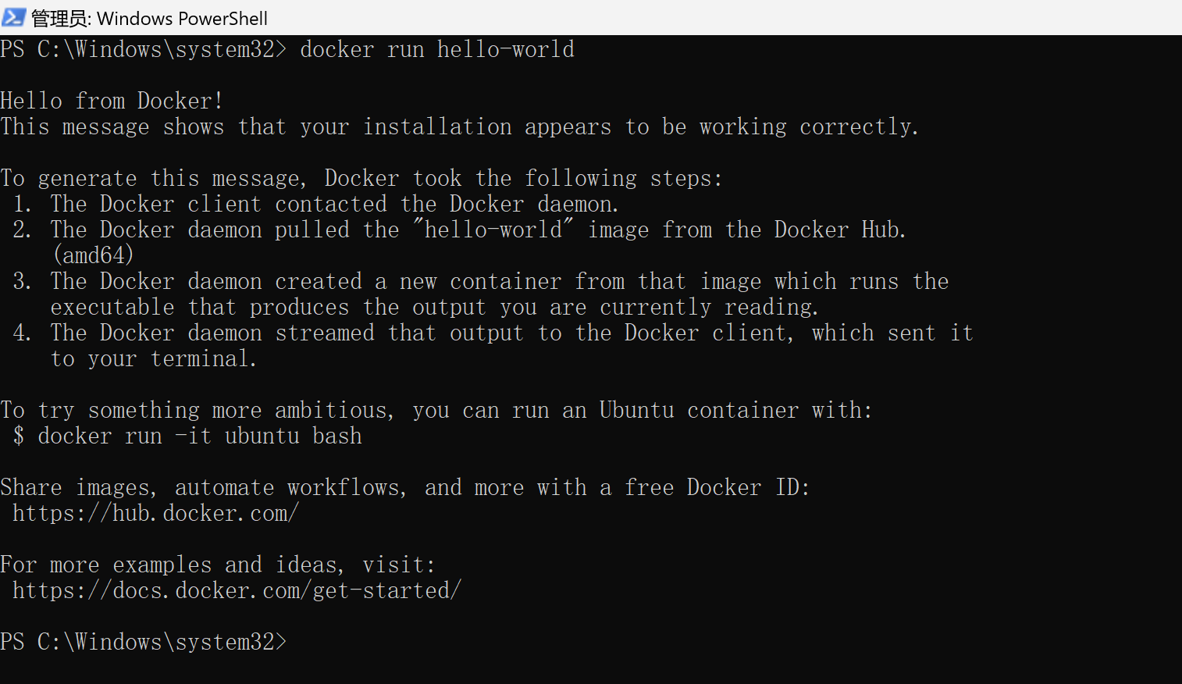
This command does the following:
- Pulls the hello-world image from Docker Hub if not found locally.
- Creates and runs a container from that image, prints “Hello from Docker!”, and exits.
you can check its state with:
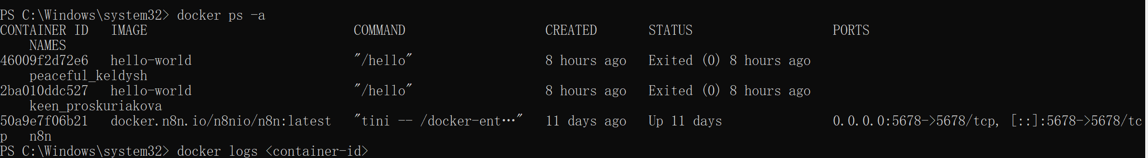
3. What is an Image
An image is a read-only template used to create containers.
Each image is composed of multiple layers.
Each RUN, COPY, or ADD command in a Dockerfile adds a new layer.
Images are immutable—changes made inside containers don’t modify the image itself.
- docker images # List all local images
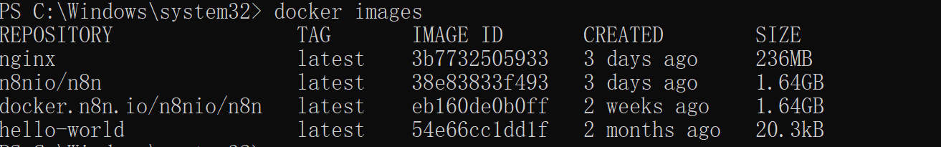
- docker inspect <image> # Show metadata, layers, and config
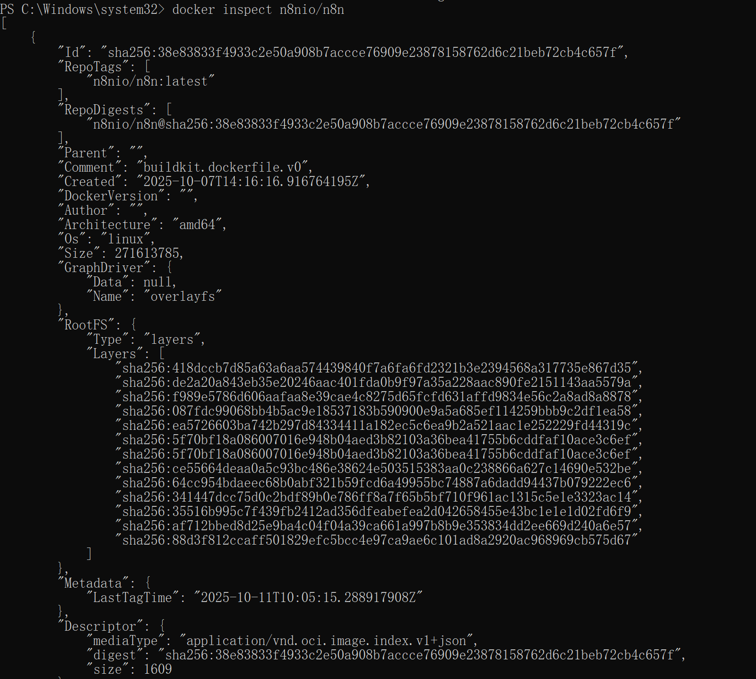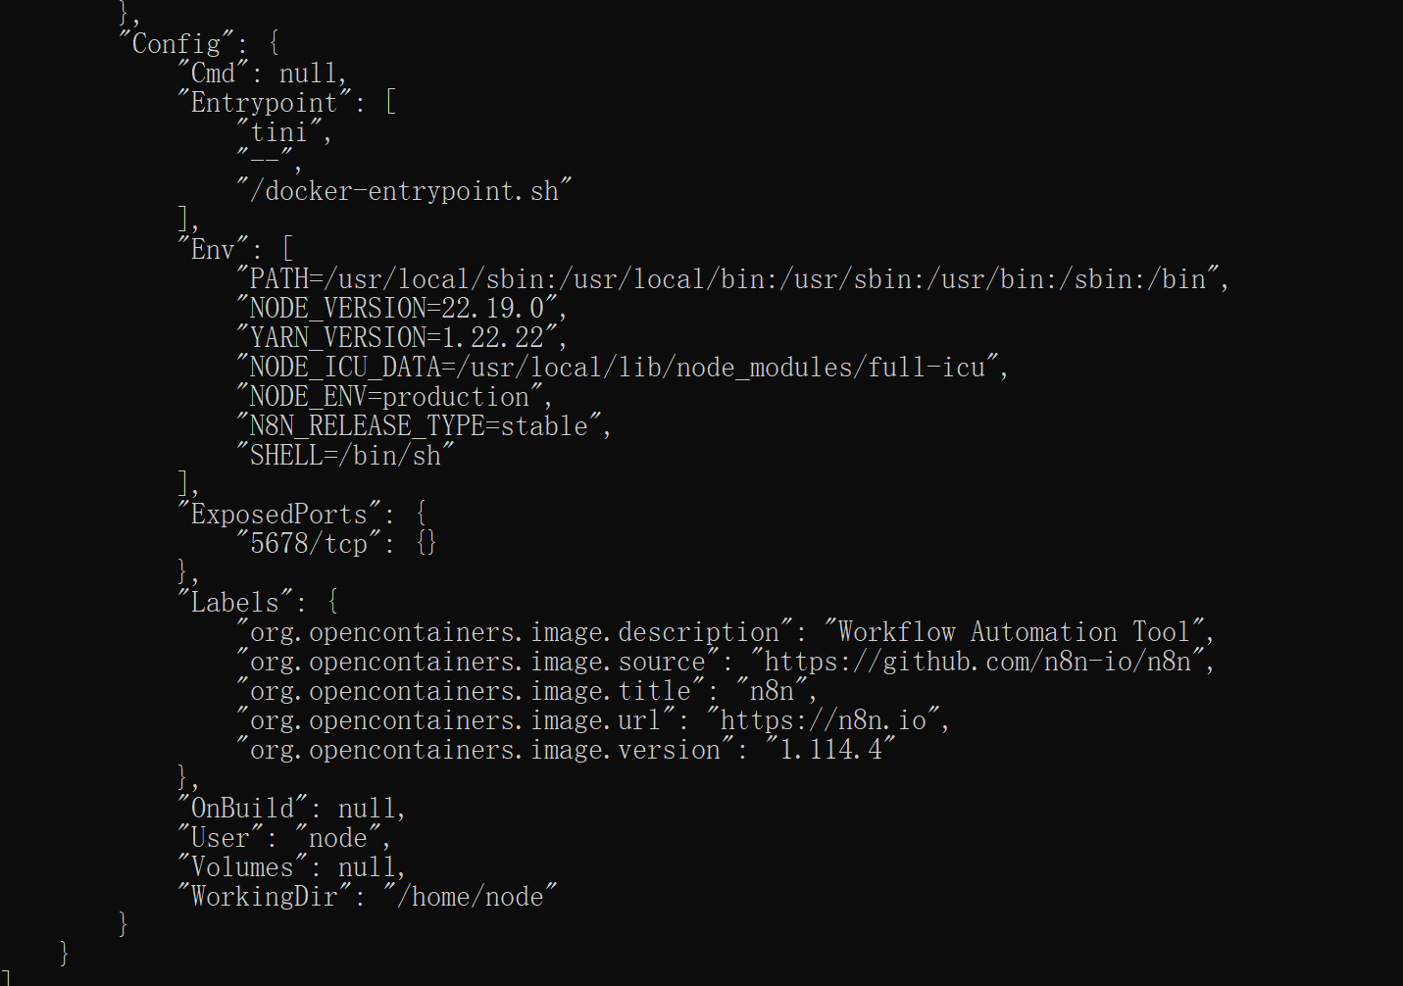
- docker rmi <image> # Remove an image (if unused)
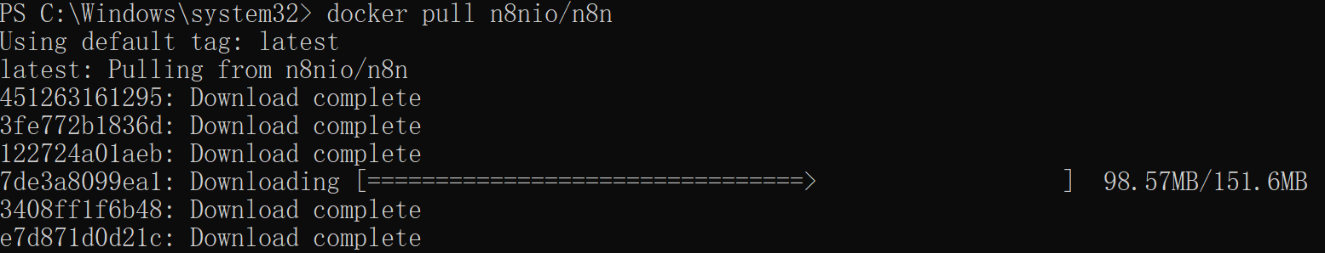
You can also visualize image layers and size using Docker Desktop’s GUI.
4. Docker Compose
Docker Compose defines and runs multi-container applications using a single configuration file (docker-compose.yml).
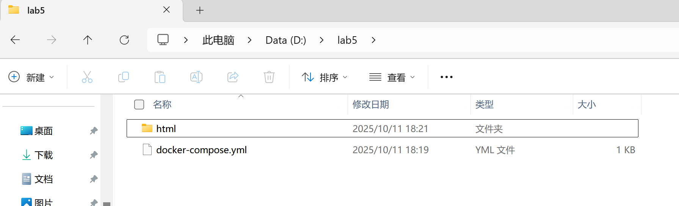
docker-compose up
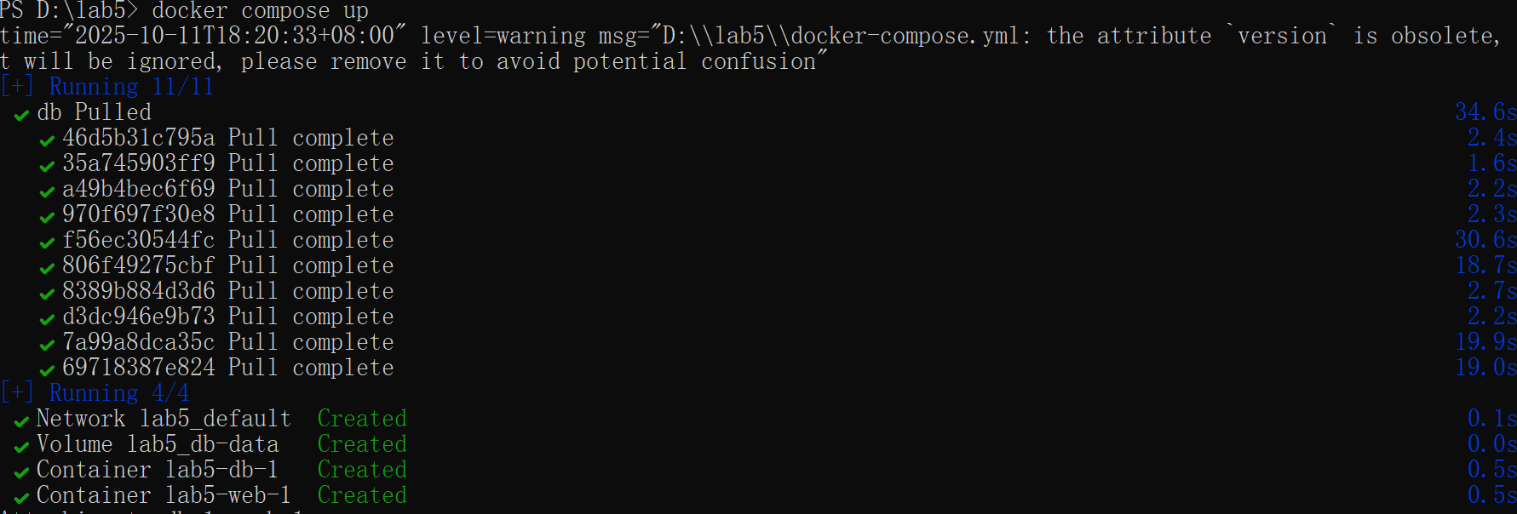
This launches both web and db containers, managing their networking and storage automatically.

5. Publishing Ports
When a containerized service (e.g., a web server) listens on an internal port (like 80), you must publish that port to make it accessible externally.
This maps port 8080 on the host to port 80 in the container, so you can access it at http://localhost:8080.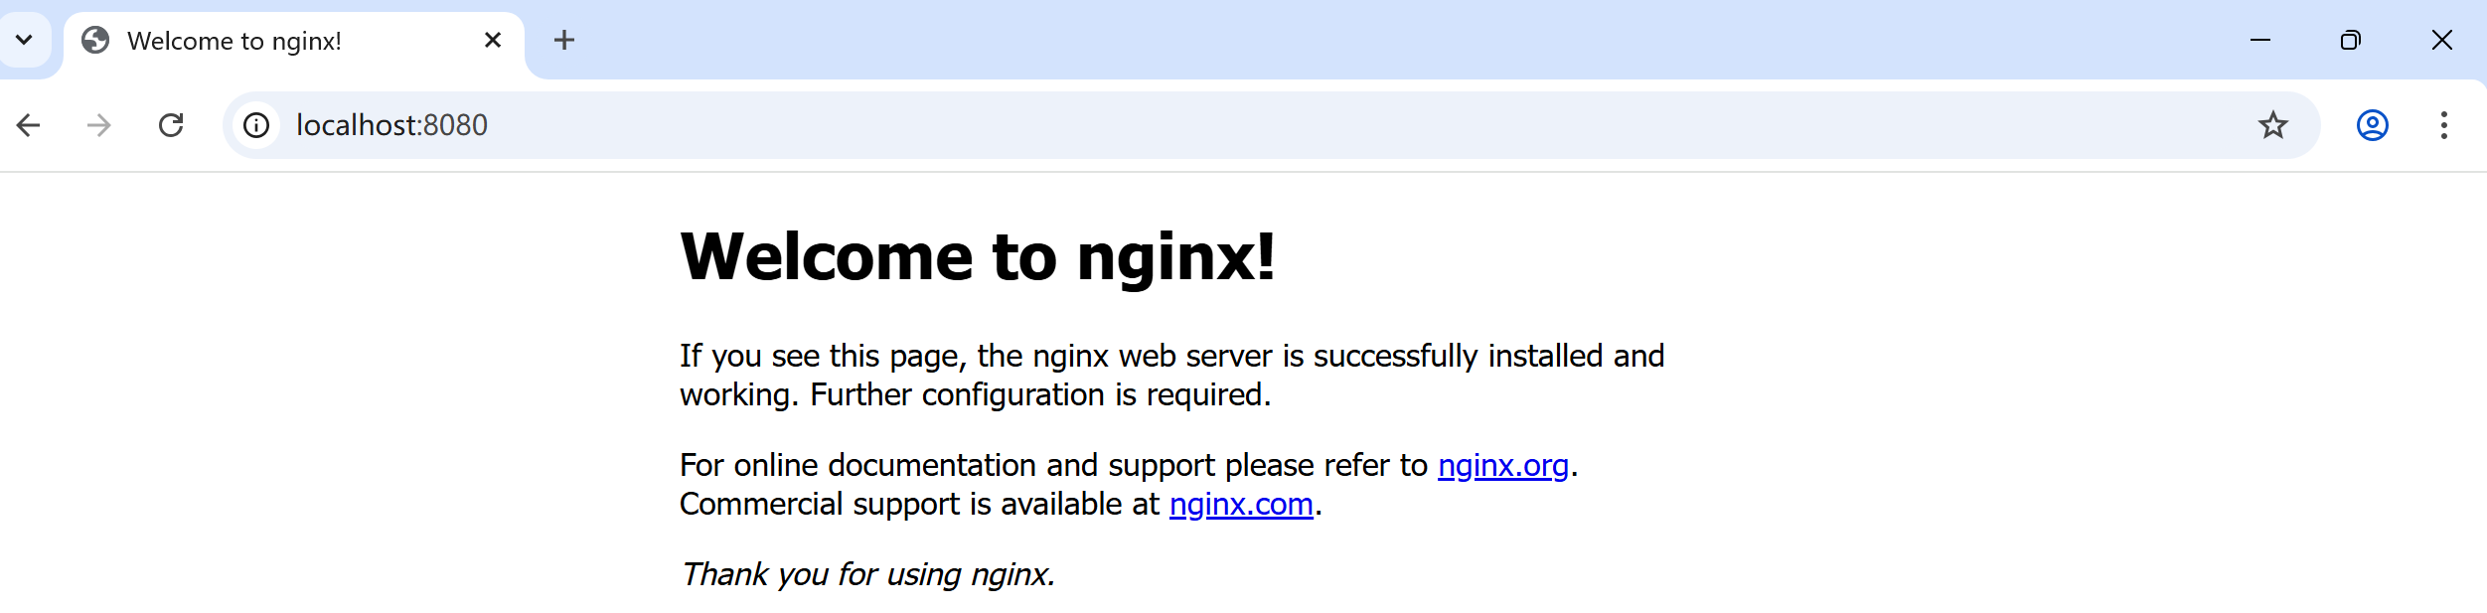
6. Overriding Container Defaults
Images define default startup commands or environment variables using CMD and ENTRYPOINT.
You can override them when running the container.
1.Create a file in D:/lab5
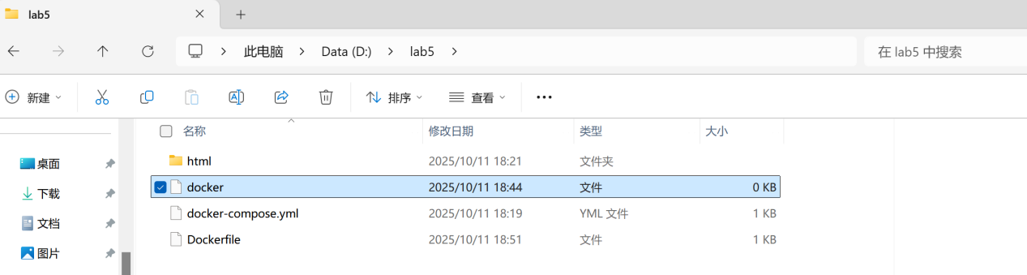
- Build and run
Command:docker run my-ubuntu-echo
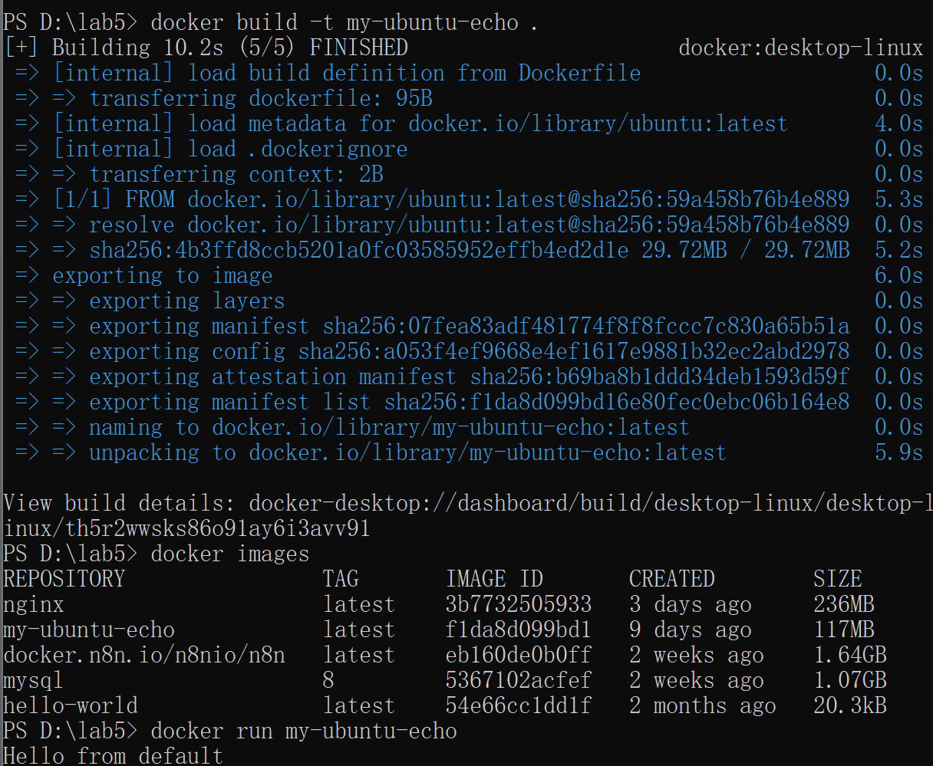
The result:Hello from default
Override it:
This replaces the default command with your own.
7. Persisting Container Data
Containers are ephemeral—data inside disappears when the container is deleted.
To persist data (e.g., databases, logs), use volumes or bind mounts.
Common methods:
- Bind Mounts: mount a host directory
-v /host/path:/container/path
- Docker Volumes: managed persistent storage
-v myvolume:/container/path
- Named Volumes: reusable, managed by Docker
command:
docker run -d -v mydata:/var/lib/mysql mysql:8
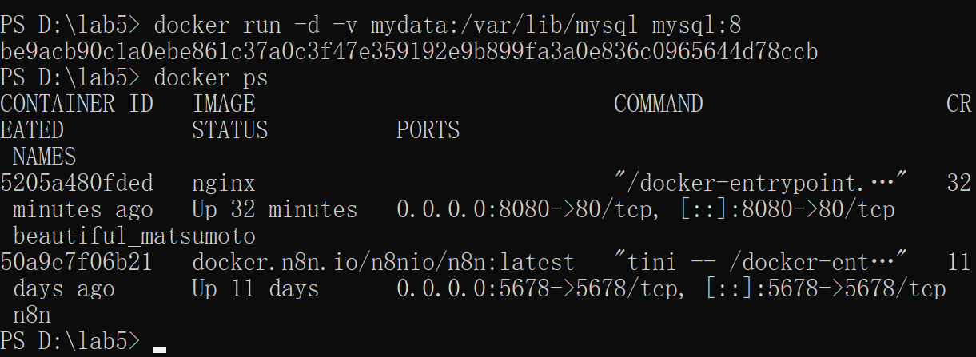
8. Sharing Local Files
To share files (e.g., source code, configs, static content) between your host and container:
- Create a local folder for your website:
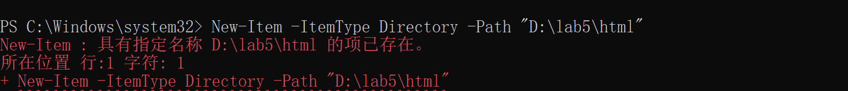
- Add a simple HTML page:
- Run Nginx with the local folder mounted:
- Open in your browser:
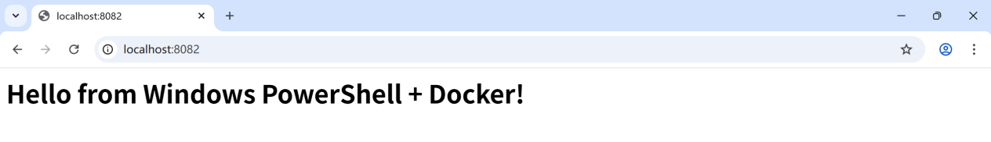
9.Multi-Container Applications (Docker Compose)
1.Create a docker-compose.yml file:
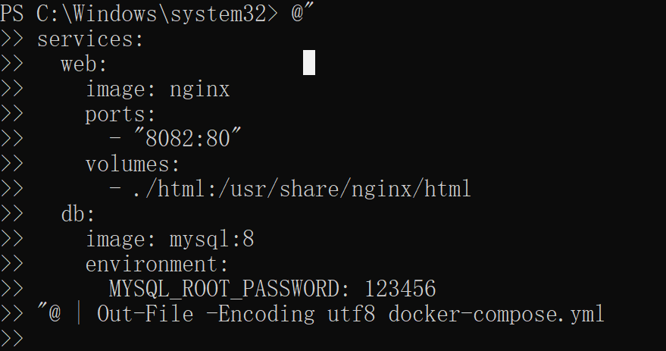
2.Start your multi-container app:
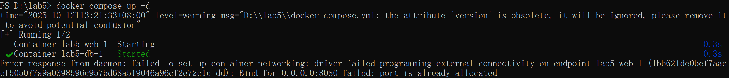
3.Check running containers:
- stop and clean up
Optional: Clean Up All Lab Resources
