lab6
This manual provides a complete, interactive guide to repeat the Hello Minikube experiment. Each step includes explanations, commands, and checkboxes for progress tracking.

1. Preparation
✅ Ensure Docker Desktop is running.
✅ Verify WSL2 integration in Docker Desktop Settings → Resources → WSL Integration.
✅ Confirm the following tools are installed and accessible:
Docker Engine、kubectl 、Minikube

2.Environment Verification
Run `docker version` and confirm both Client and Server sections display correctly.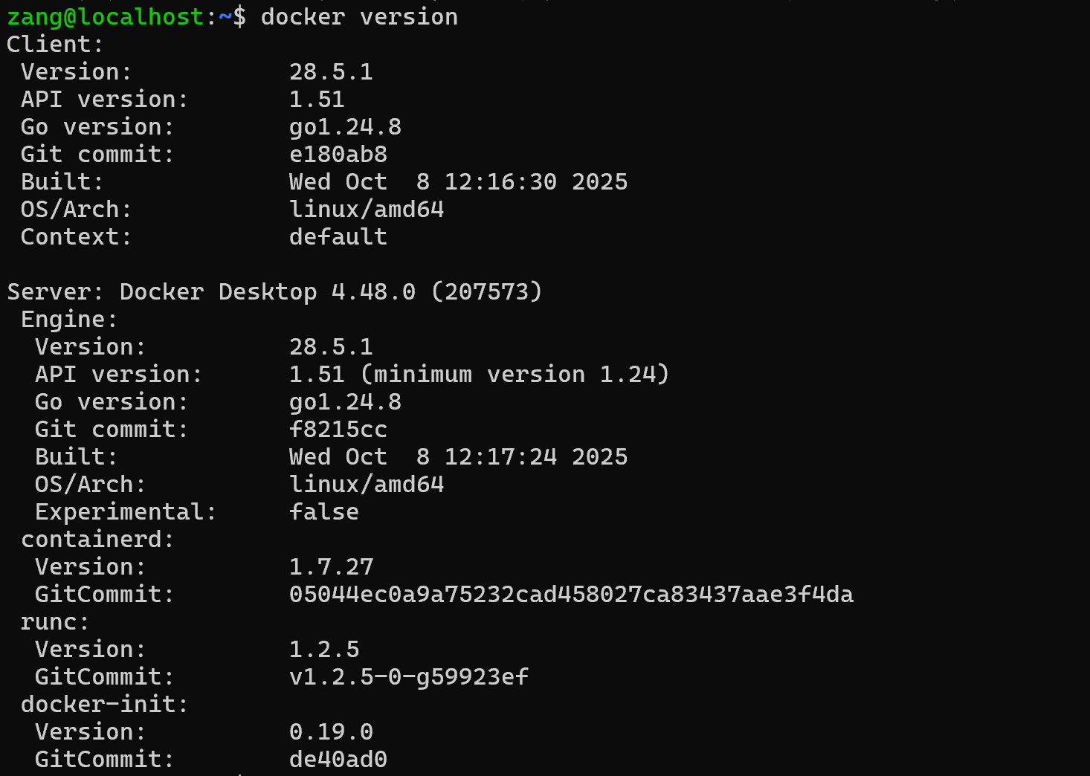
Run `kubectl version --client` to confirm kubectl is installed.
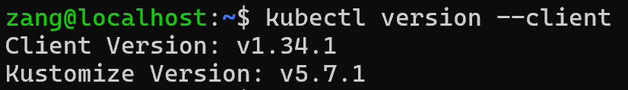
Run `minikube version` to check Minikube installation.
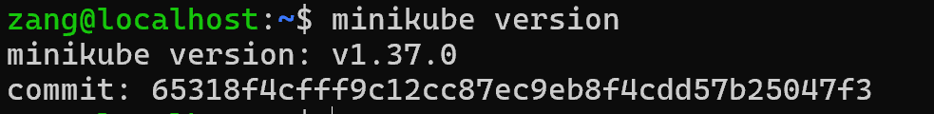

✅ Verification
If all commands print version information (no “command not found” errors), setup is correct.
! Common Issues
Docker Desktop not running → start it first.
WSL2 not integrated with Docker → enable Ubuntu under Docker Desktop → Settings → Resources → WSL Integration.

3.Start Minikube Cluster
Execute `minikube start --driver=docker`.
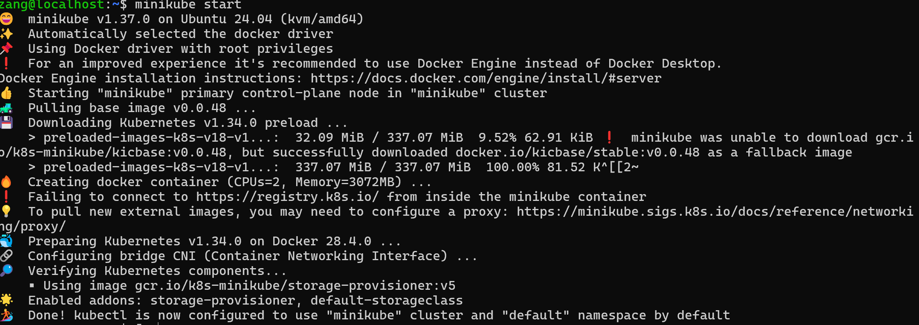
Wait until you see: ' Done! kubectl is now configured to use "minikube" cluster.'
Explanation
--driver=docker forces Minikube to use Docker as its VM driver.
Minikube creates a local single-node Kubernetes cluster.

4. Verify Node Status
Run `kubectl get nodes` and verify that the node 'minikube' is Ready.
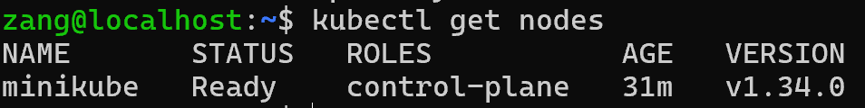
Shows that the single Minikube node is Ready.

5. Deploy the Application
Run `kubectl create deployment hello-minikube --image=registry.cn-hangzhou.aliyuncs.com/google_containers/echoserver:1.10`.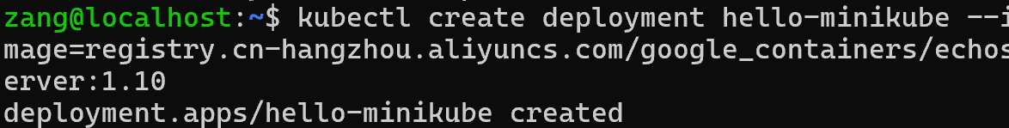
Wait for the Pod to reach Running status.
Verification：
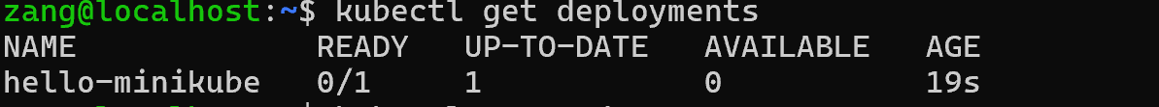
Pods in Running state → successful.
Explanation
Creates a Deployment named hello-minikube.
Runs an Echo Server container that returns the request info.

6. Expose the Deployment
Run `kubectl expose deployment hello-minikube --type=NodePort --port=8080`.
Check the service using `kubectl get services`.
Note the NodePort number in the output
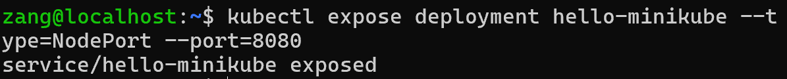
Explanation
--type=NodePort: exposes the app to the host machine.
--port=8080: sets the service port.
Kubernetes assigns a random external NodePort (30 000 – 32 767).
Verification：
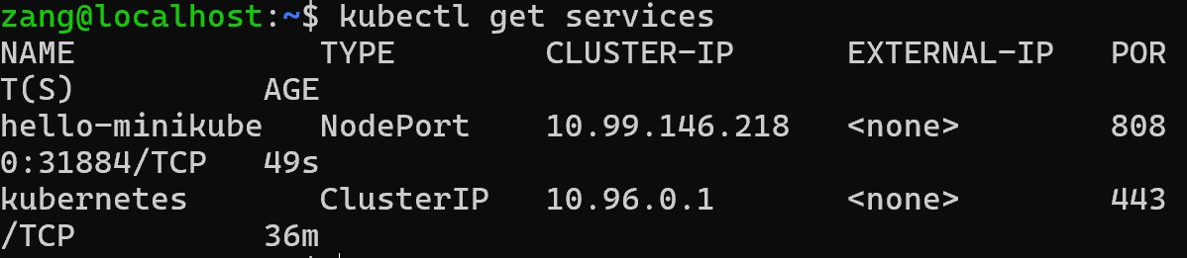

7.Access the Application
Run `minikube service hello-minikube --url`.
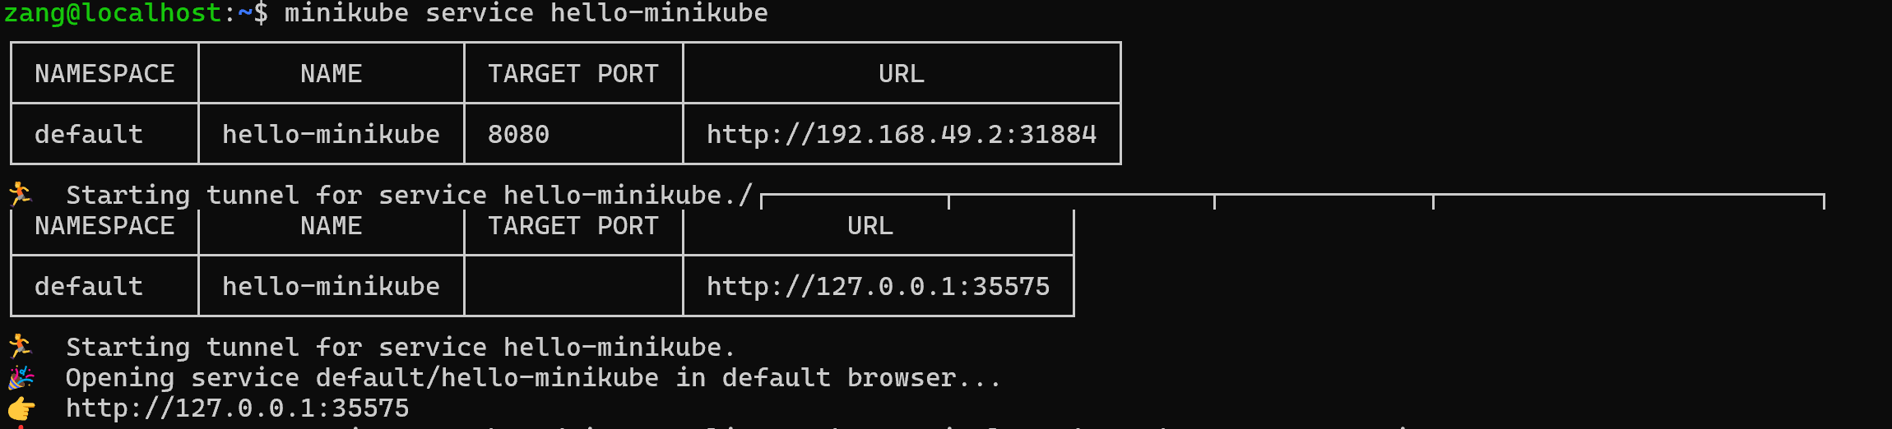
Copy the printed URL and open it in your Windows browser.
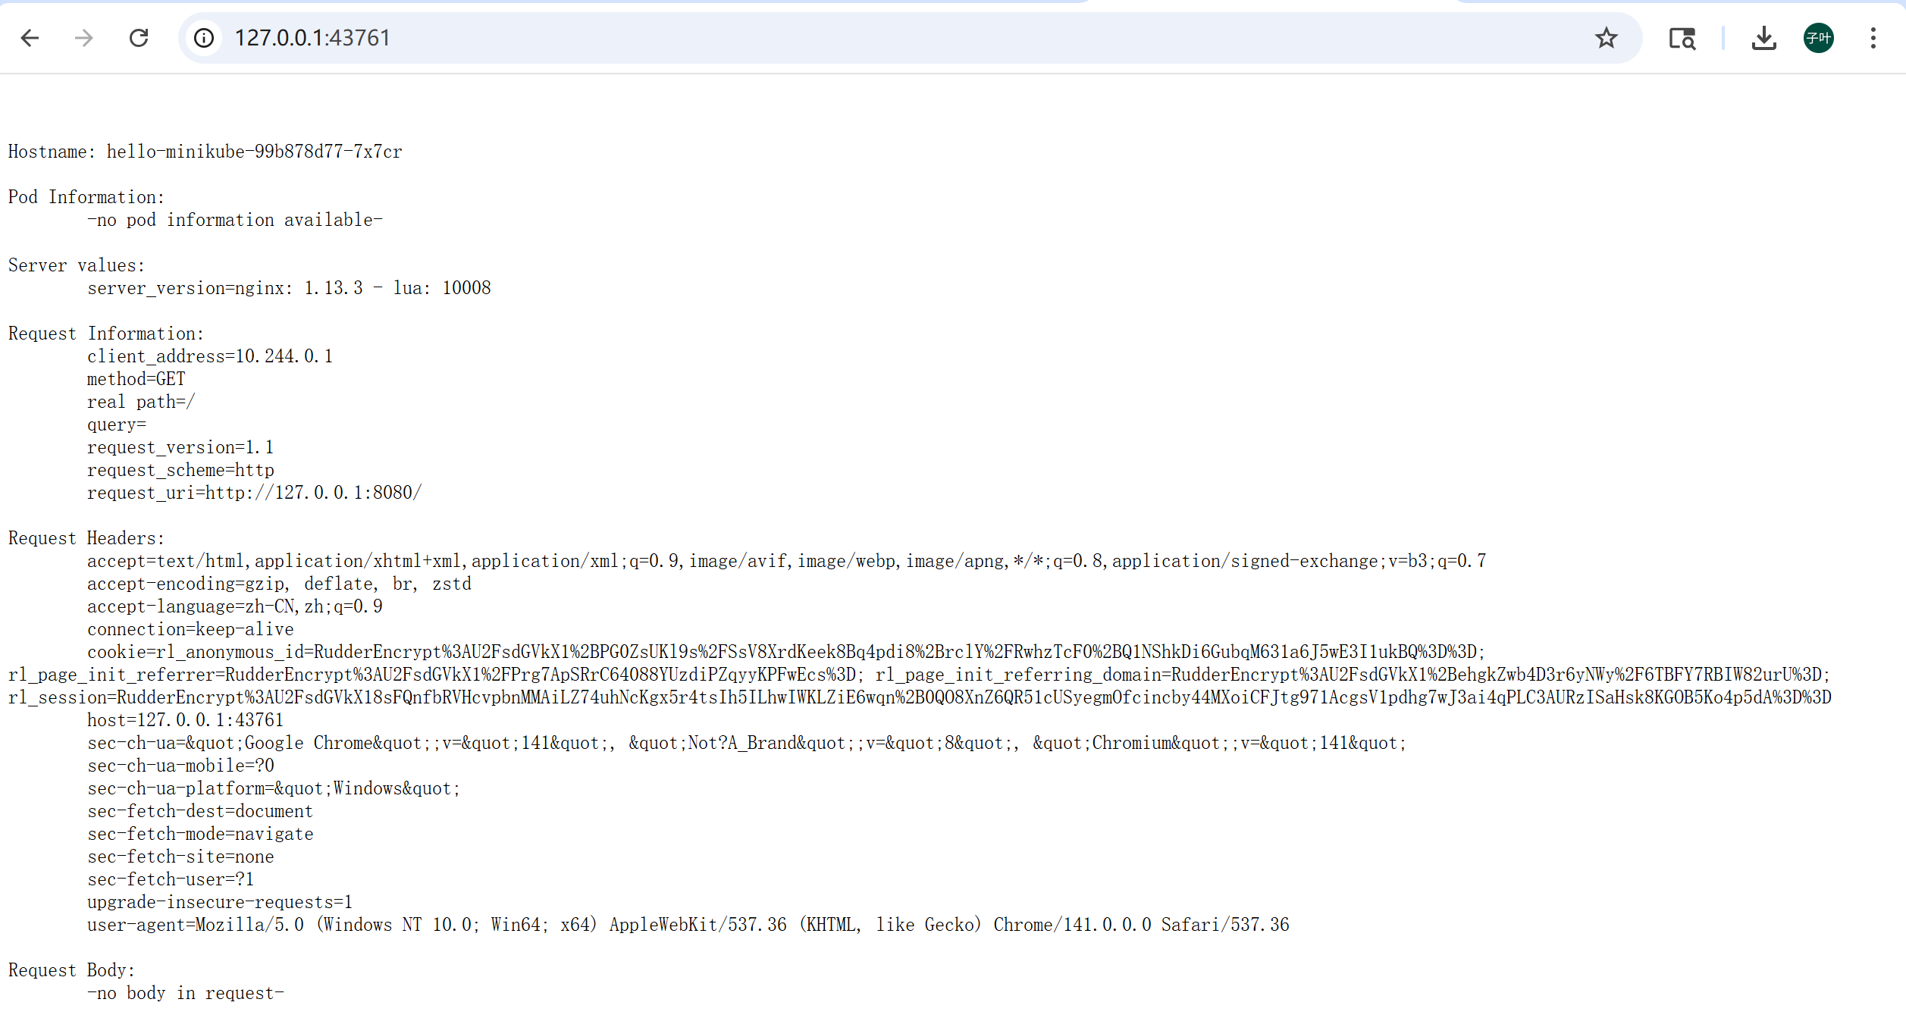
Verify the echoserver response message in the browser.

8.Advanced Steps
1.View dashboard: `minikube dashboard --url`.
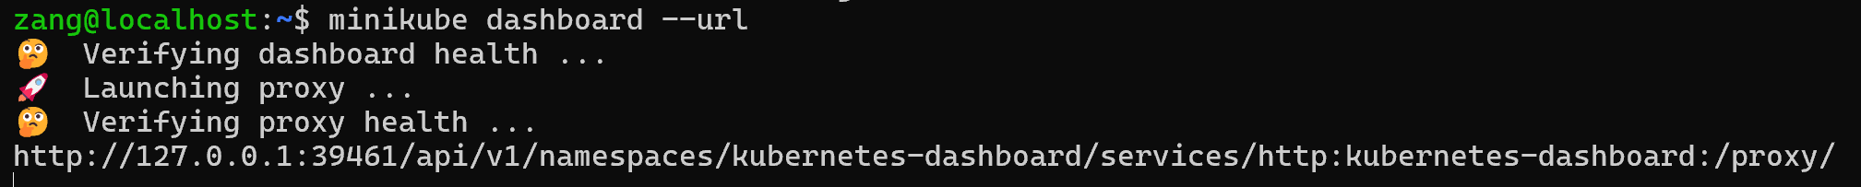
then copy the url to the brower and you will get the page like this
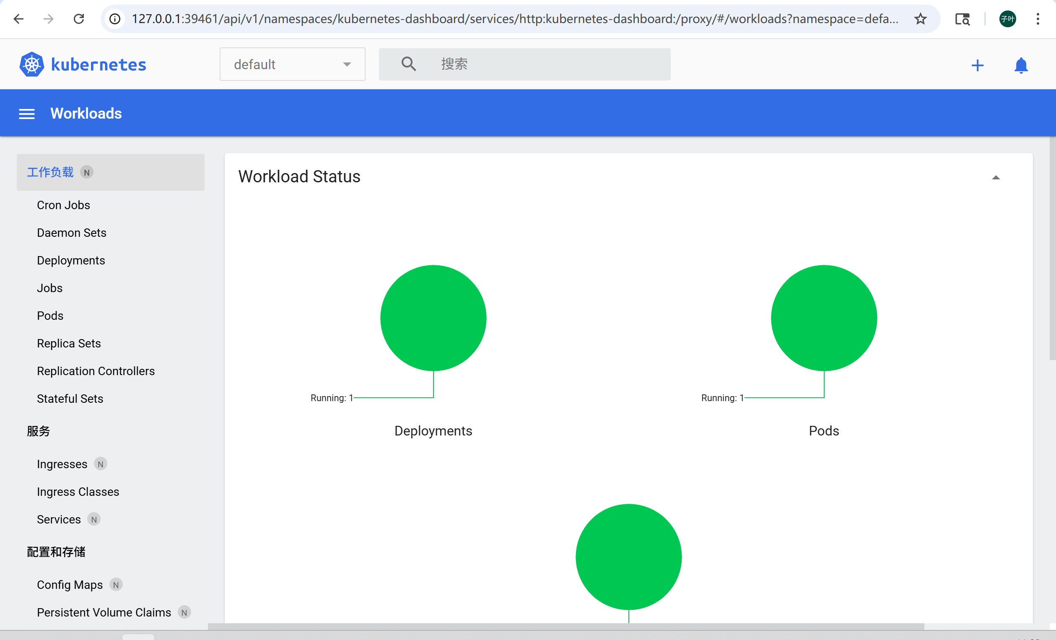
- Scale the deployment: `kubectl scale deployment hello-minikube --replicas=3`.
- Update image: `kubectl set image deployment/hello-minikube hello-minikube=echoserver:1.11`.
Rollback: `kubectl rollout undo deployment/hello-minikube`.
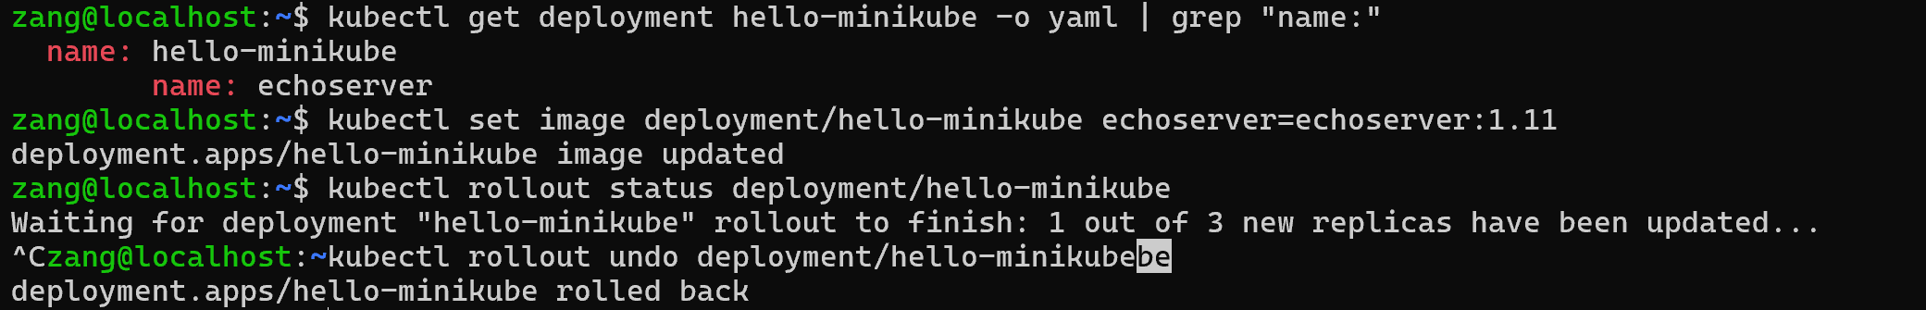
This sequence covers deployment, scaling, updating, and rollback — the entire Kubernetes application lifecycle.

3. Summary of the Workflow (Core Logic)
Phase | Purpose | Key Command
Setup | Ensure tools are installed | docker version, minikube version
Cluster Start | Create local cluster | minikube start --driver=docker
Verify | Confirm Kubernetes node | kubectl get nodes
Deploy | Run containerized app | kubectl create deployment ...
Expose | Make app accessible | kubectl expose deployment ...
Test | Access via browser | minikube service hello-minikube

