Lab7— Istio Getting Started

1. Experiment Environment
Item | Description
Operating System | Windows 11 + WSL2 (Ubuntu 24.04)
Container Runtime | Docker Desktop (WSL2 backend)
Kubernetes Cluster | Minikube v1.37.0 (Docker driver)
Service Mesh Platform | Istio v1.28.1
Sample Application | Bookinfo microservices demo

2. Environment Preparation

2.1 WSL2, Docker, and Minikube Setup
- Enabled Windows Subsystem for Linux (WSL) and Virtual Machine Platform, and configured WSL default version as WSL2.
- Installed Docker Desktop and enabled WSL integration for Ubuntu.
- Downloaded and installed Minikube manually in the WSL environment.
- Preloaded the kicbase image into Docker to avoid network issues during Minikube startup.
- Started Minikube using the Docker driver.
Verification:
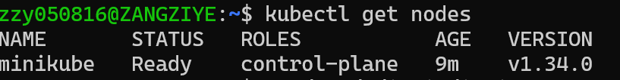
This confirms that the local Kubernetes cluster was created successfully.

3. Downloading and Installing Istio

3.1 Download Istio
Downloaded Istio Linux distribution (istio-1.28.1-linux-amd64.tar.gz) from the official Istio website.
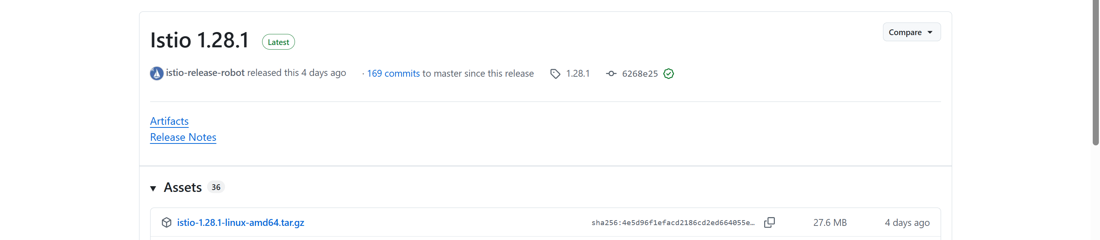
Extracted the package to the D: drive on Windows and accessed it through WSL.
Verification:
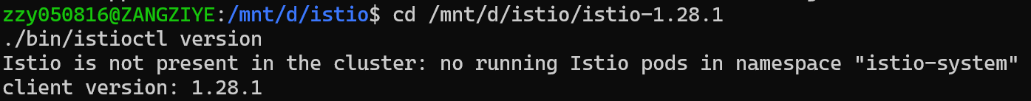
This indicates that istioctl was installed correctly.

4. Installing Istio Control Plane
Istio was installed using the demo profile, which is recommended by the official Getting Started guide.
Successful installation output：
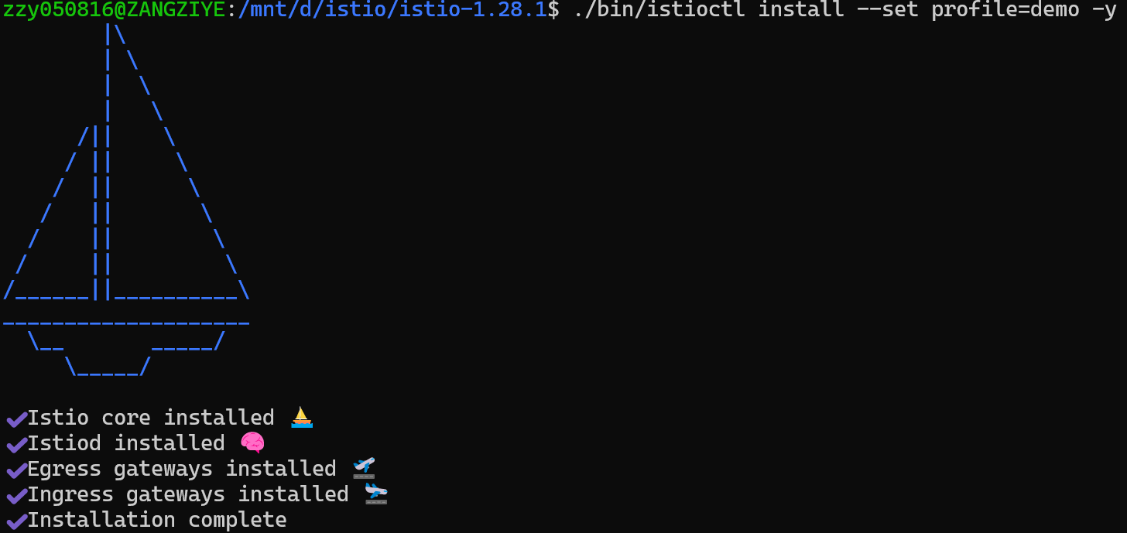
The control plane status was verified by:
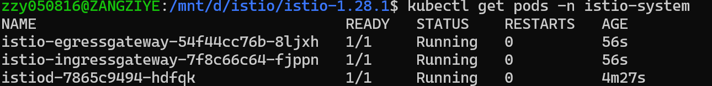
Both istiod and istio-ingressgateway were in the Running state.

5. Deploying the Bookinfo Application

5.1 Enable Sidecar Injection
To allow automatic Envoy sidecar injection, the default namespace was labeled:

5.2 Deploy Bookinfo Services
The Bookinfo sample application was deployed using the official Kubernetes manifests.
Due to network restrictions affecting access to docker.io, the image URLs for the reviews service were modified to use a domestic mirror repository. This ensured reliable image pulling without requiring Docker Hub authentication.
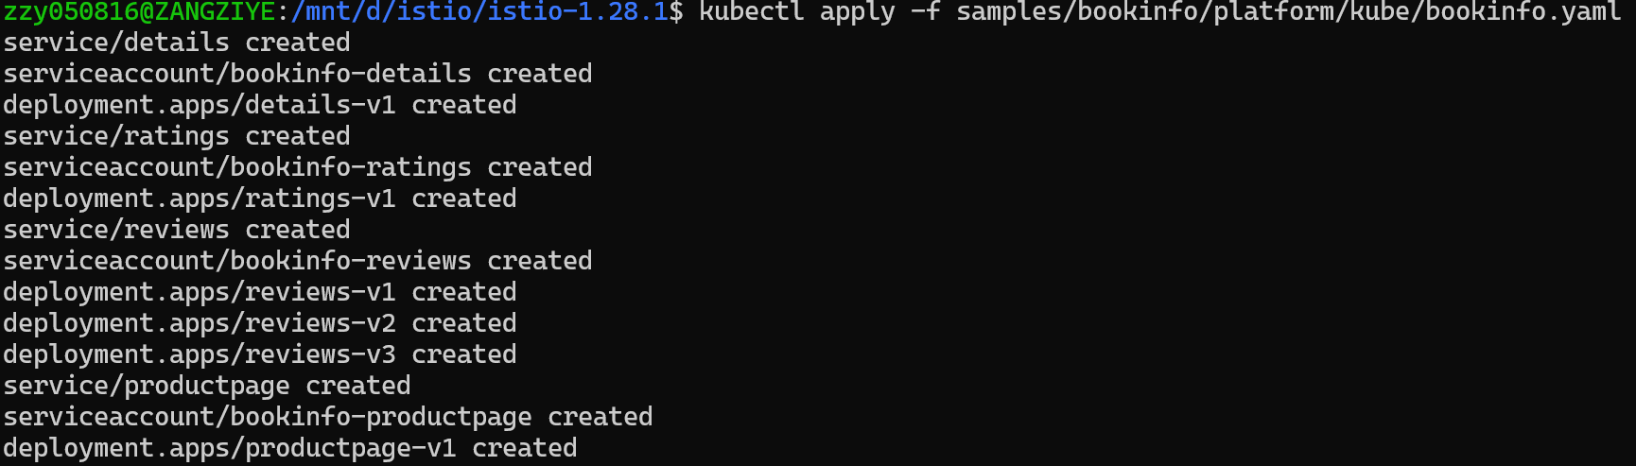
After redeploying the application and restarting failed Pods, all Bookinfo services reached the desired state:
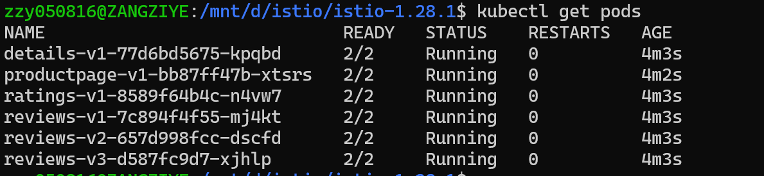
This confirms that all services were successfully injected with Istio sidecars.

6. Exposing the Application via Istio Gateway
The classic Istio Gateway configuration was applied (as recommended for the Getting Started guide).
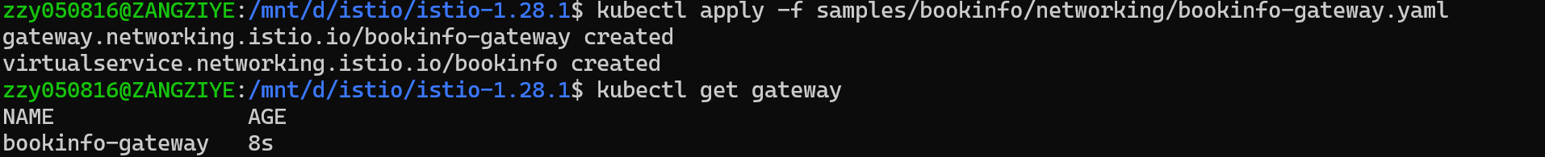
To access the application locally, port forwarding：
The Bookinfo application was then accessed via a web browser:
http://localhost:8080/productpage
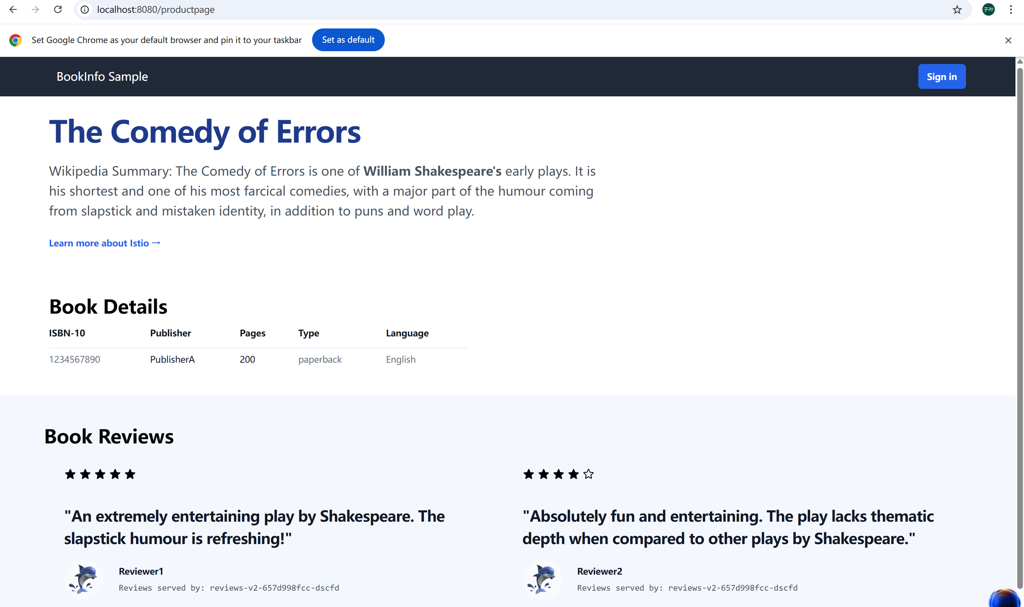
The web page loaded successfully, confirming that Istio ingress traffic routing was functioning correctly.

7. Results and Verification Checklist
The following results confirm successful completion of the Istio Getting Started experiment:
✅ Minikube Kubernetes cluster running correctly
✅ Istio control plane installed and operational
✅ Envoy sidecars injected into all Bookinfo services
✅ Istio Gateway configured and exposed
✅ Bookinfo product page accessible via browser

8. Issues Encountered and Solutions
Issue | Cause | Solution
ImagePullBackOff / ErrImagePull | Docker Hub access restricted in domestic network | Replaced image URLs with domestic mirror repositories
Minikube startup delays | Large image downloads | Preloaded base images into Docker
Gateway API errors | Gateway API CRDs not installed | Used classic Istio Gateway configuration

9. Conclusion
In this experiment, an Istio service mesh environment was successfully deployed using Minikube on Windows with WSL2.
Despite network-related challenges in accessing external container registries, the issues were resolved by using domestic mirror repositories and local image caching.
The experiment successfully completed all steps outlined in the official Istio Getting Started documentation, including installing Istio, deploying the Bookinfo application, enabling sidecar injection, and exposing the application through an Istio Gateway.
This experiment demonstrates that Istio can be reliably deployed in a local development environment, even under constrained network conditions.

