Lab8 Istio Traffic Management Lab Report

1. Introduction
This lab provides hands-on experience with Istio traffic management features in a Kubernetes environment.
Using the official Bookinfo and httpbin sample applications, the experiment demonstrates how Istio can control and manage service-to-service communication in a microservices architecture.
The lab focuses on the following four core traffic management capabilities:
Request Routing
Traffic Shifting
Fault Injection
Circuit Breaking
These features are widely used in modern cloud-native systems to support canary releases, resilience testing, and system stability.

2. Experimental Environment
Operating System: Linux (WSL2)
Kubernetes: Minikube (Docker driver)
Service Mesh: Istio 1.28.1
Namespace: default
Sidecar Injection: Enabled
Access Method: kubectl port-forward

3. Environment Setup

3.1 Enable Sidecar Injection
Istio sidecar automatic injection was enabled for the default namespace:
Pods created in this namespace automatically include the istio-proxy sidecar.
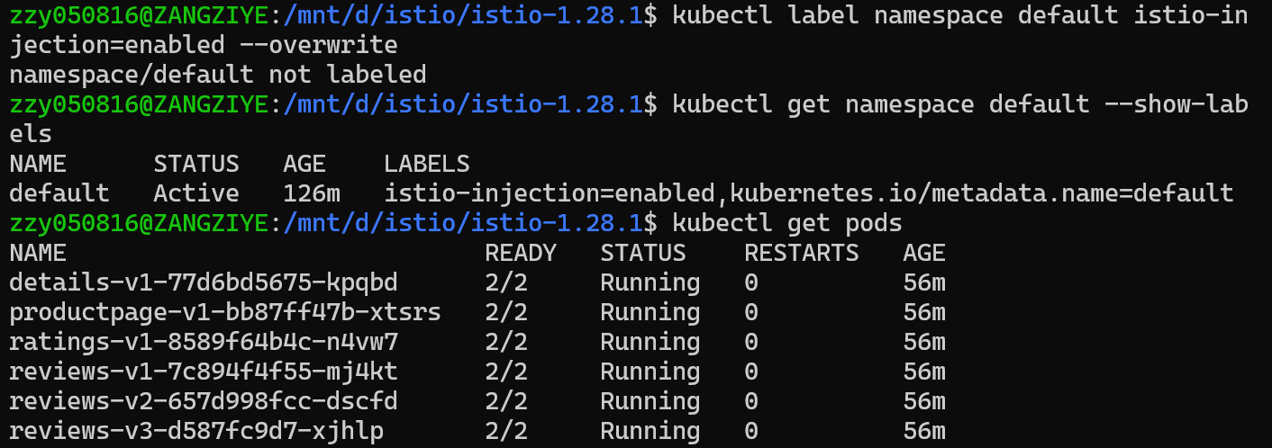

3.2 Deploy the Bookinfo Sample Application
The Bookinfo application was deployed using the official Istio sample configuration:
All application pods (productpage, reviews, ratings, details) reached the Running state with two containers per pod, confirming successful sidecar injection.
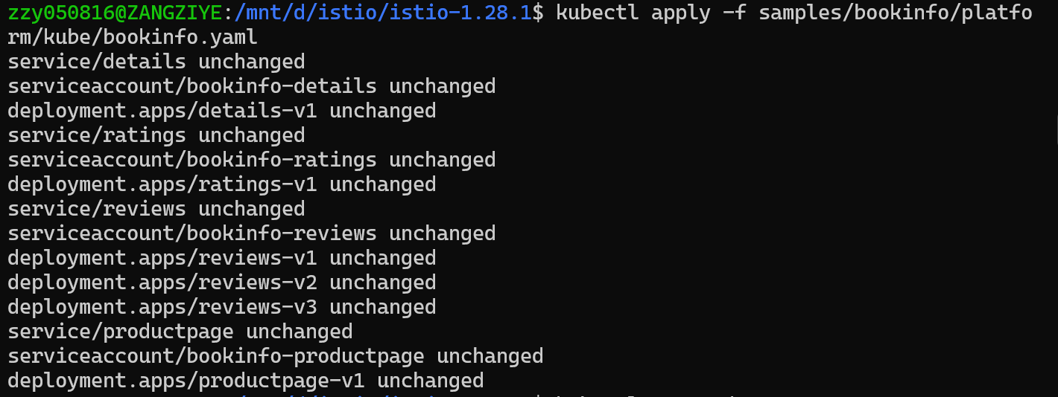

3.3 Apply Default Destination Rules
Destination rules defining service subsets (v1, v2, v3) were applied:
These rules allow Istio to route traffic to specific service versions.
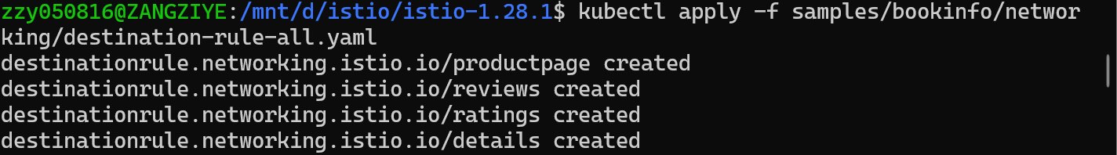

3.4 Configure Ingress Gateway Access
The Bookinfo gateway configuration was applied:
Because Minikube with Docker driver does not provide an external load balancer IP, the ingress gateway was exposed using port forwarding:
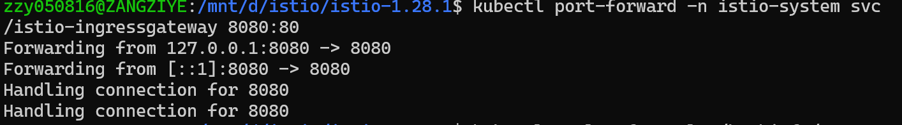The application was accessed through:
http://localhost:8080/productpage

4. Experiment 1: Request Routing

4.1 Objective
Demonstrate Istio’s ability to route requests based on service versions and HTTP request headers.

4.2 Route All Traffic to Version v1
All traffic was routed to version v1 of each service using the following configuration:
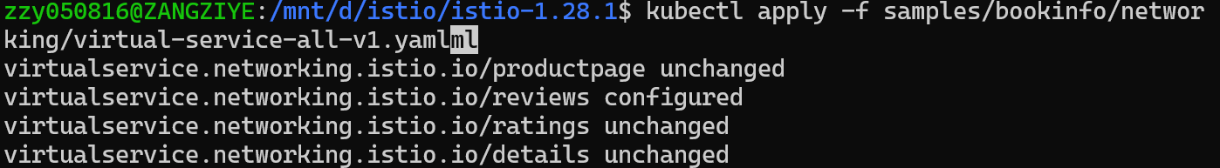
Observation:
After applying the rule, the Bookinfo page consistently displayed no rating stars, indicating that all requests were routed to reviews:v1.
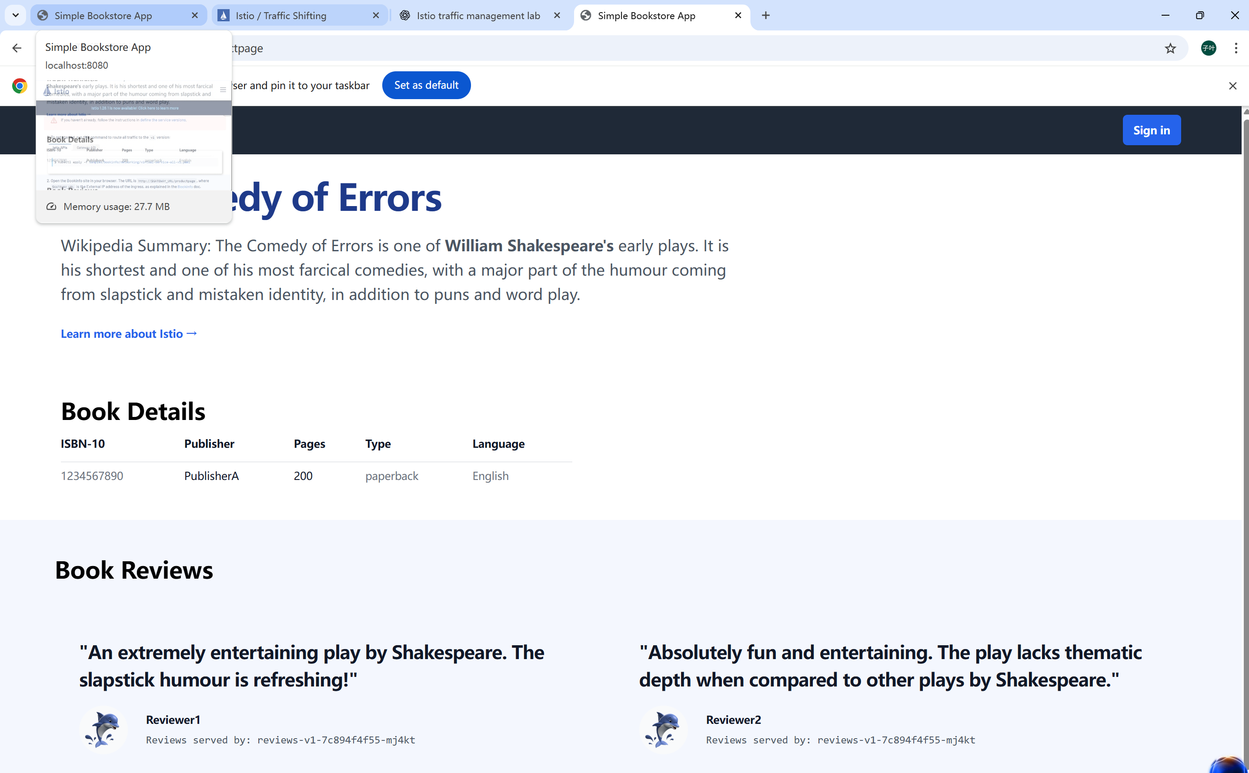

4.3 User-Based Routing (Header Matching)
Traffic for user jason was routed to reviews:v2, while other users continued using reviews:v1:
Observation:
When logged in as jason, rating stars appeared on the page.
When logged in as other users, no stars were displayed.
This confirms that Istio successfully performed request routing based on the HTTP header end-user.
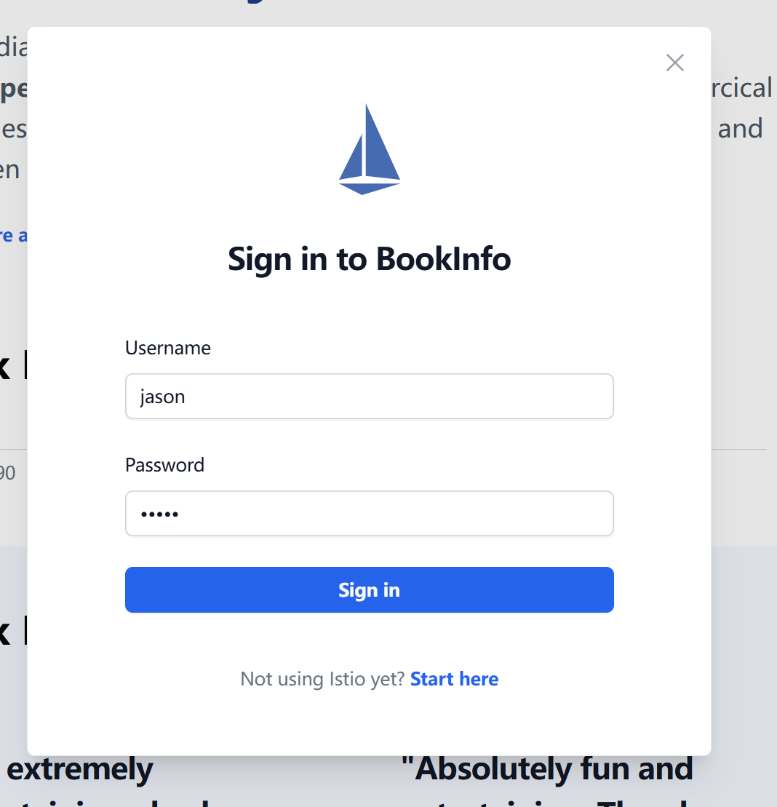
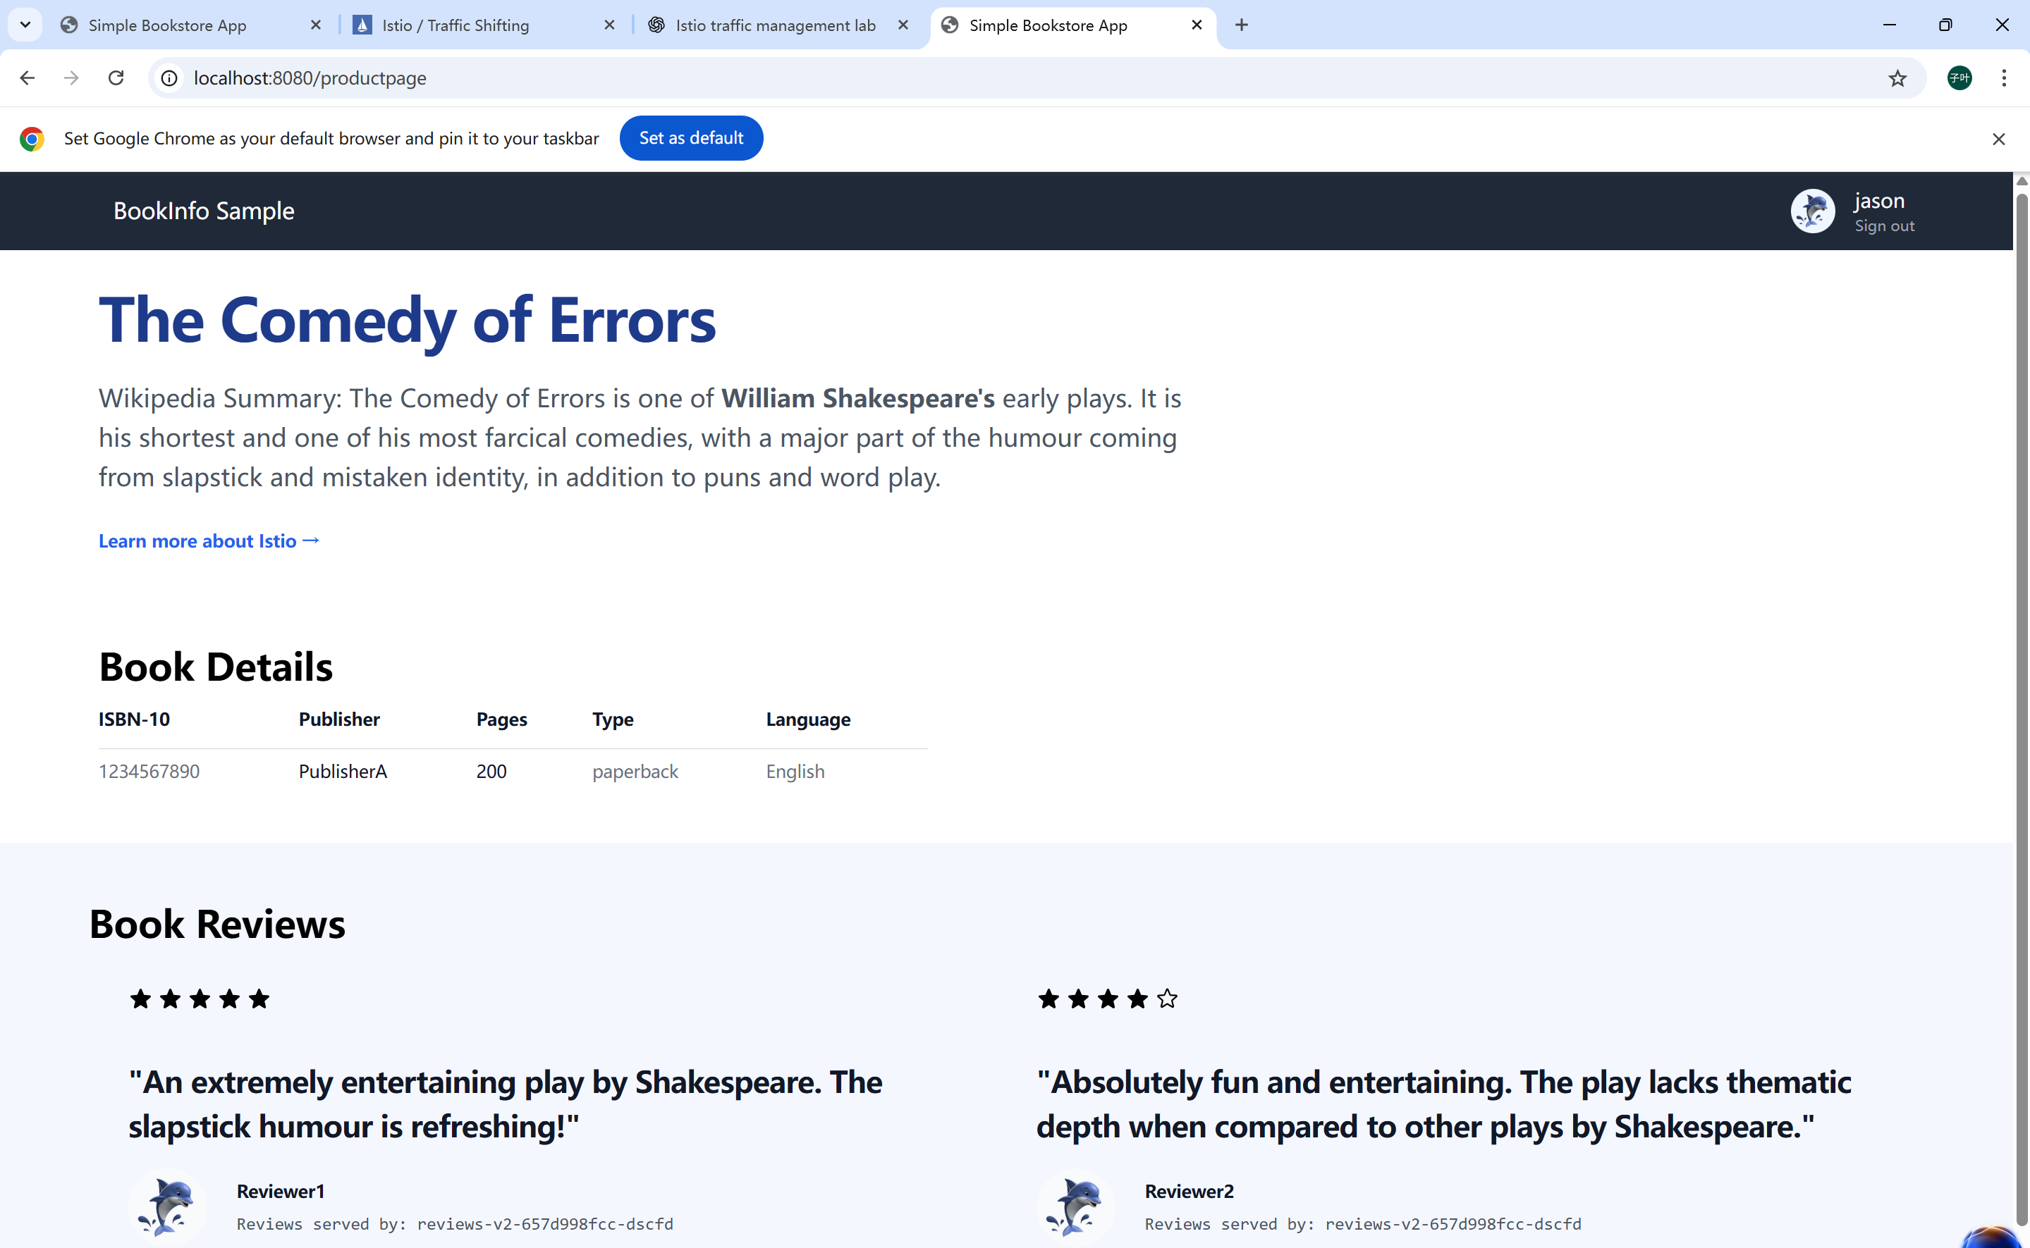
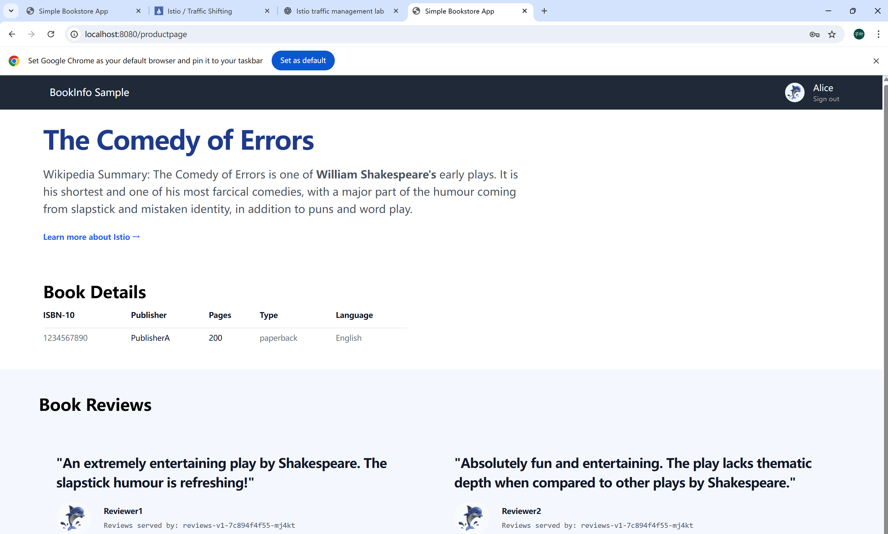

5. Experiment 2: Traffic Shifting

5.1 Objective
Demonstrate gradual traffic migration between service versions, a key technique used in canary deployments.

5.2 50% Traffic Route to v1 and v3
Traffic was split equally between reviews:v1 and reviews:v3:
Observation:
Upon refreshing the page multiple times:
Some requests showed no stars (v1)
Some requests showed red stars (v3)
This behavior confirms a successful 50/50 traffic split.


5.3 100% Traffic Route to v3
Traffic was fully migrated to reviews:v3:
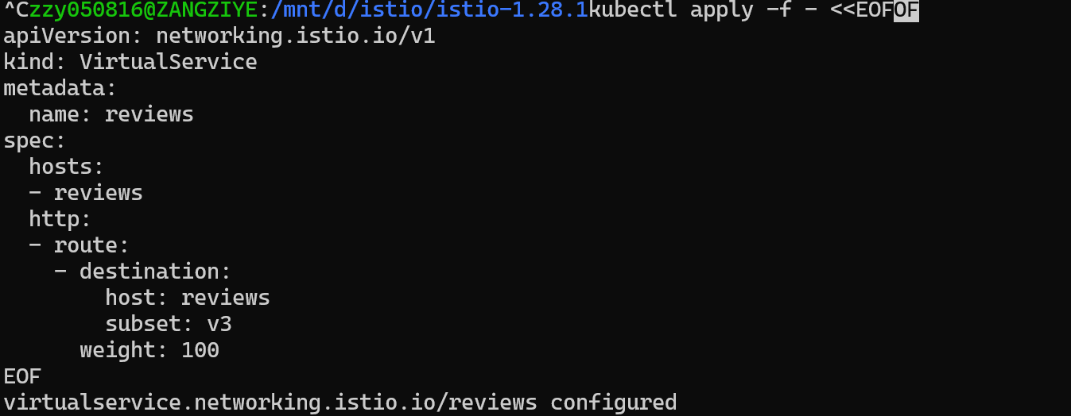
Observation:
All page refreshes consistently displayed red rating stars, indicating full traffic migration.

6. Experiment 3: Fault Injection

6.1 Objective
Evaluate system resilience by injecting artificial latency and failures.

6.2 Inject Network Delay
A 7-second delay was injected into the ratings service for user jason:
Observation:
User jason experienced slow page loading and error messages.
Other users were not affected.

6.3 Inject HTTP Abort (500 Error)
An HTTP 500 error was injected:
Observation:
The page immediately displayed an error message for user jason, demonstrating fault injection at the application level.

7. Experiment 4: Circuit Breaking

7.1 Objective
Use Istio circuit breaking to prevent cascading failures under high load.

7.2 Deploy httpbin Service

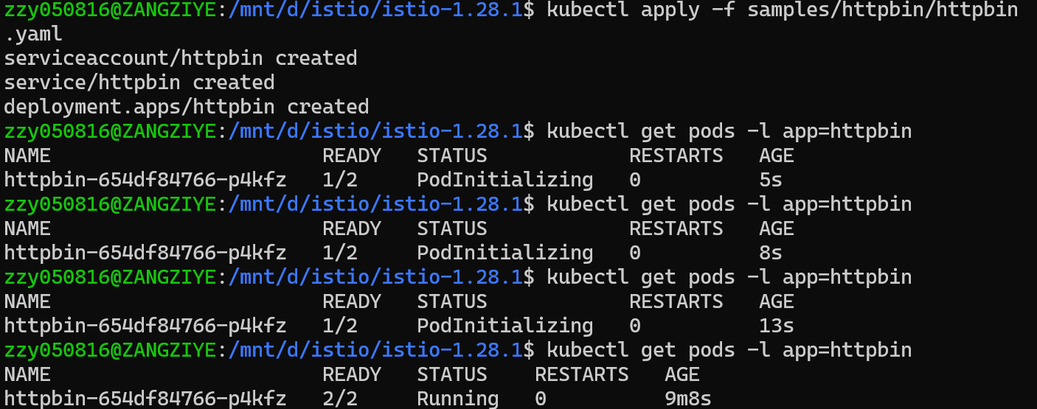7.3 Apply Circuit Breaking Rules
A destination rule limiting connections and requests was applied:
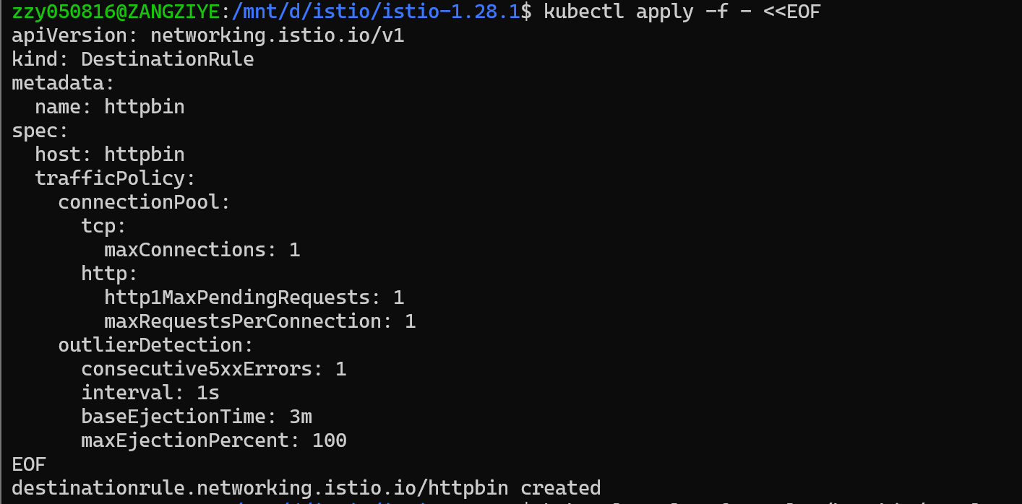

7.4 Generate Load with Fortio
The fortio client was used to generate concurrent requests:
Observation:
The output showed HTTP 503 errors, indicating that the circuit breaker was triggered successfully.
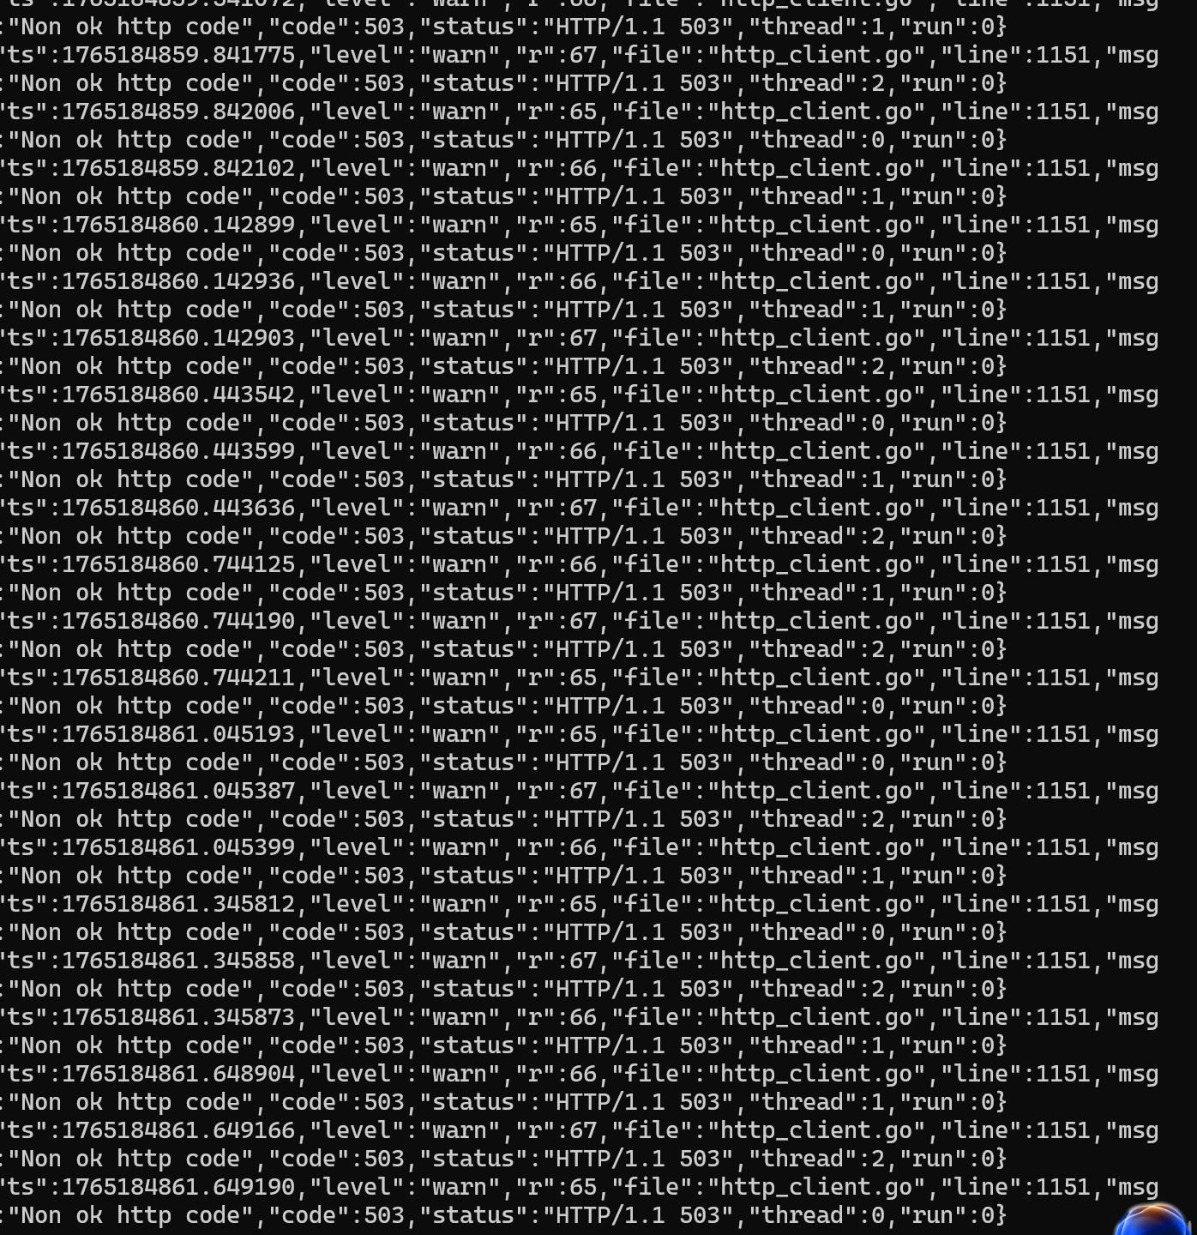

8. Conclusion
This lab successfully demonstrated Istio’s traffic management capabilities:
Request Routing enabled version-based and header-based routing.
Traffic Shifting allowed controlled and gradual service upgrades.
Fault Injection simulated network latency and service failures.
Circuit Breaking protected services from overload and cascading failures.
These features illustrate how Istio can significantly enhance reliability, observability, and safety in microservices-based systems.

