Lab9 Knative Lab Report
Building, Deploying and Managing Serverless Applications with Knative
- Introduction
This lab provides hands-on experience with Knative for building, deploying,
and managing serverless cloud-native applications on Kubernetes.

The experiment covers the installation of Knative Serving and Eventing,
local development using Knative Functions, deployment of a Knative Service,
and event-driven communication using Knative Eventing.
- Experimental Environment
The experiment was conducted in the following environment:
- Operating System: Windows + WSL (Linux)
- Kubernetes: Minikube
- Container Runtime: Docker
- Knative CLI: kn
- Knative Functions CLI: func v0.47.0
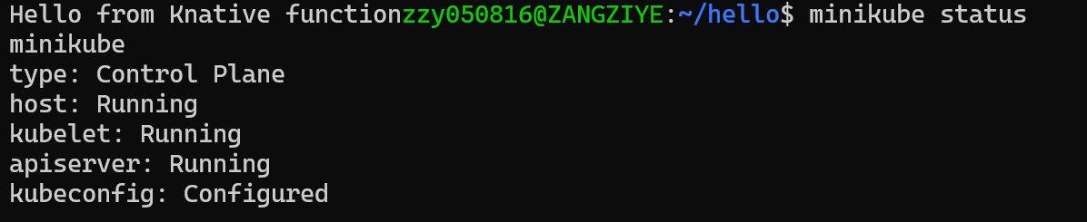
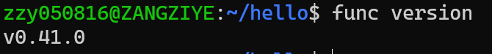
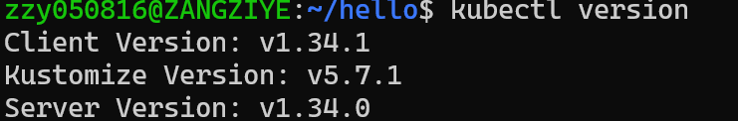

3. Installing Knative Serving and Eventing

3.1 Knative Serving Installation
Knative Serving was installed using the official YAML manifests.
The Serving CRDs and core components were applied successfully.
Istio was used as the networking layer for Knative Serving.
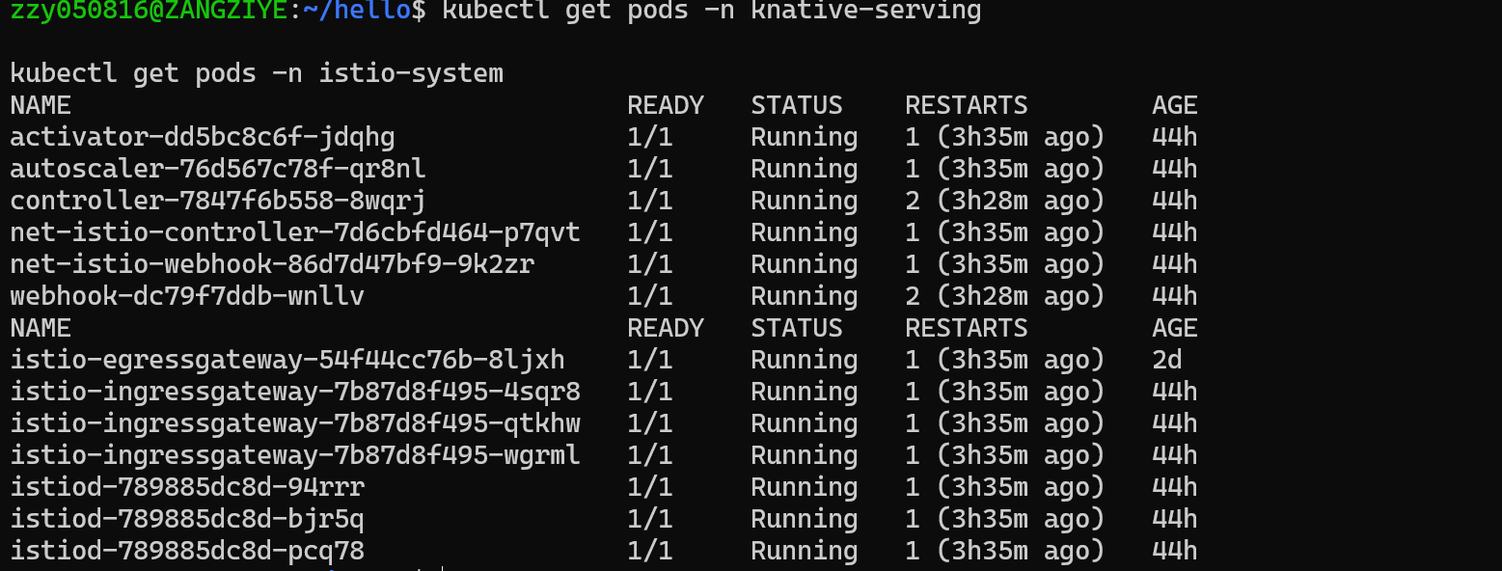
3.2 Knative Eventing Installation
Knative Eventing was installed using the official YAML manifests.
All Eventing components were successfully deployed and running.
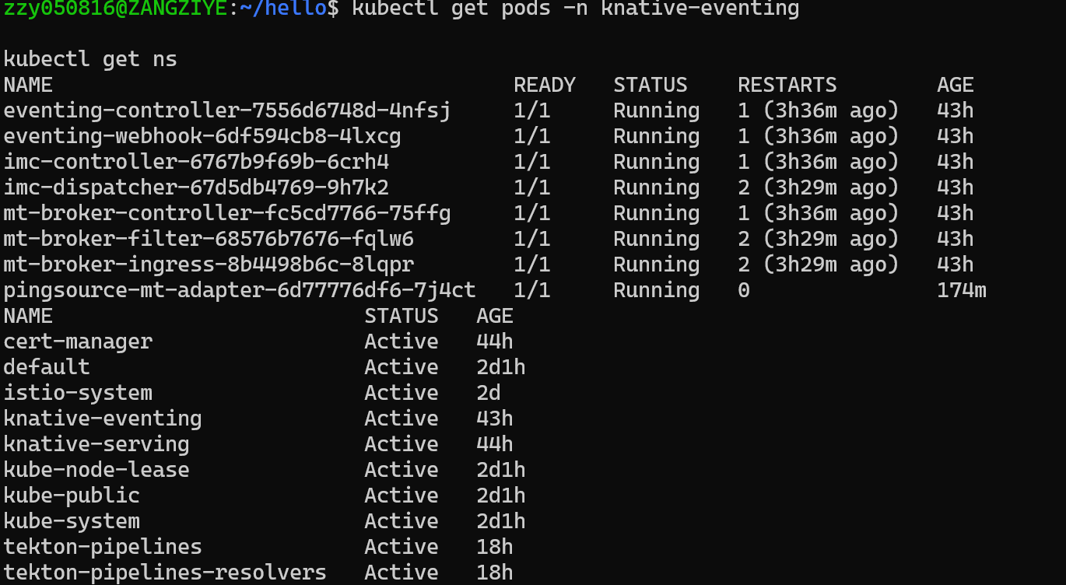4.Knative Functions
A Go-based Knative Function was created using the func CLI.
The function image was built and pushed to a local container registry
(localhost:5001) using the following command:
func run --registry localhost:5001
After the build completed, the function was started locally and
successfully invoked using `func invoke`, returning the expected response.
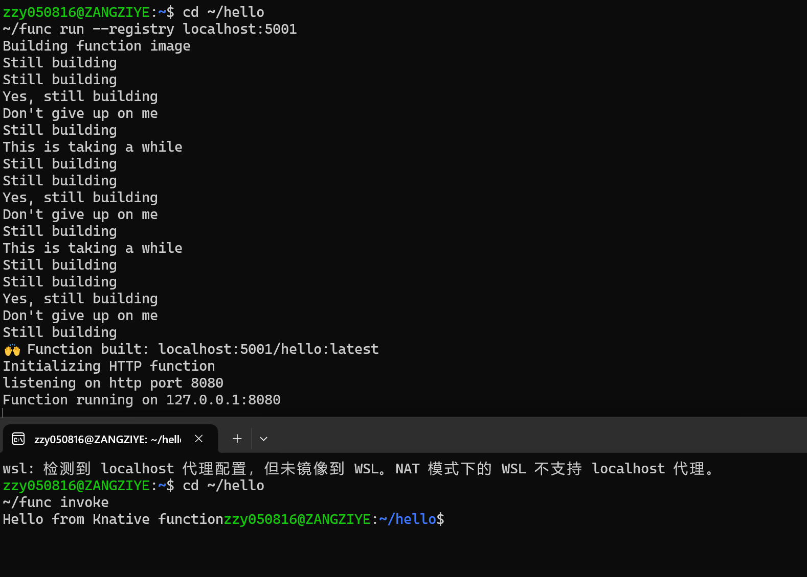
- Knative Serving: First Service
A Knative Service named `hello-serving` was created using the kn CLI.
The service was successfully deployed and reached the Ready state.
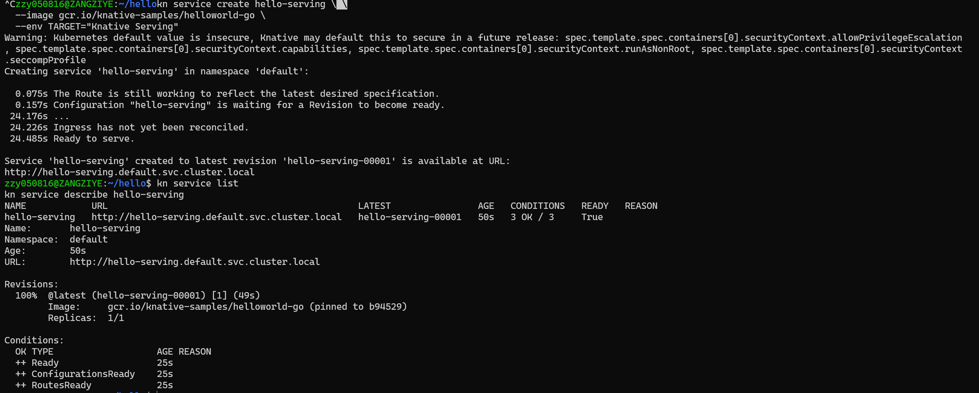

Autoscaling

List your Knative Service
View a list of Knative Services by running the command:

Access your Knative Service
Access your Knative Service by opening the previous URL in your browser or by running the command:
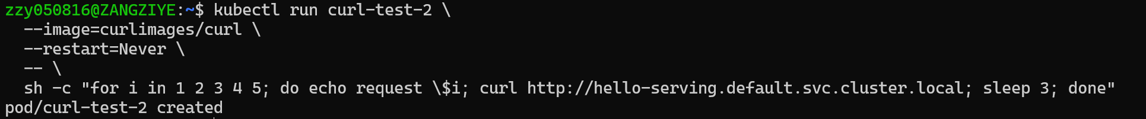

Observe autoscaling
Watch the pods and see how they scale to zero after traffic stops going to the URL:
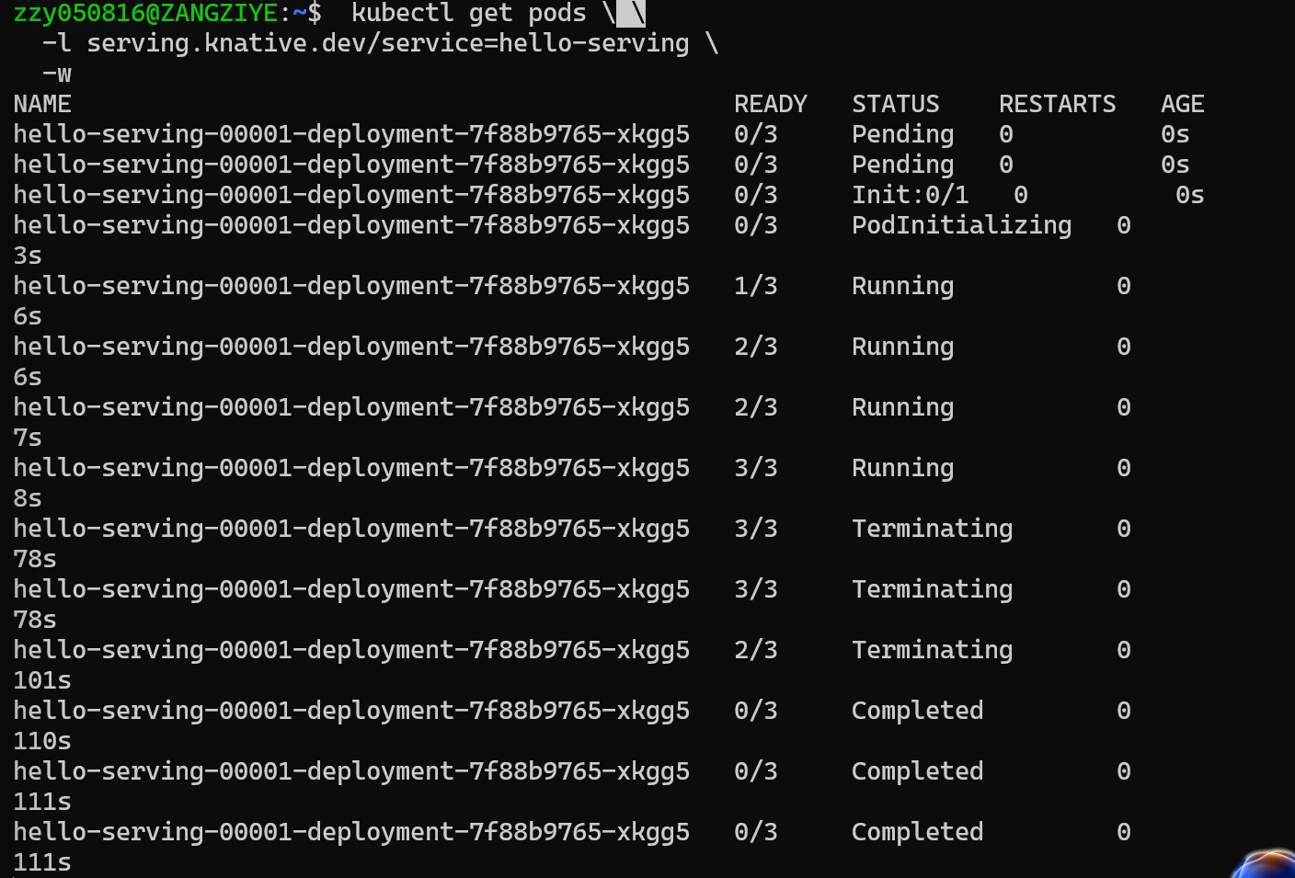

Trafiiic splitting

Creating a new Revision
Instead of TARGET=World, update the environment variable TARGET on your Knative Service to greet "Knative" instead.
Deploy the updated version of your Knative Service by running the command:
As before, kn prints out some helpful information to the CLI.
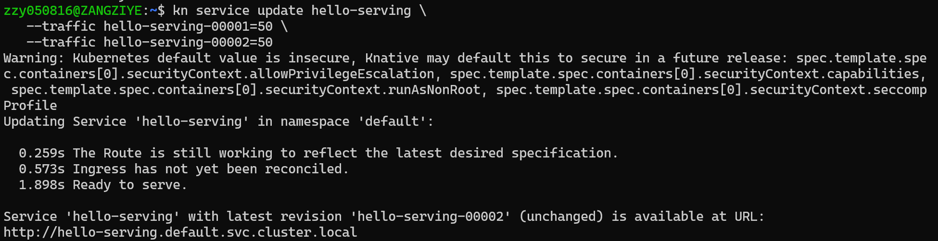
Because you are updating an existing Knative Service, the URL won't change, but the new Revision has the new name hello-00002.

View existing Revisions
You can view a list of existing Revisions by using the Knative (kn) or kubectl CLI:
When running the kn command, the relevant column is TRAFFIC. You can see that 100% of traffic is going to the latest Revision, hello-00002, which is on the row with the highest GENERATION. 0% of traffic is going to the Revision hello-00001.
When you create a new Revision of a Knative Service, Knative defaults to directing 100% of traffic to this latest Revision. You can change this default behavior by specifying how much traffic you want each Revision to receive.

Splitting traffic between Revisions
Split the traffic between the two Revisions:
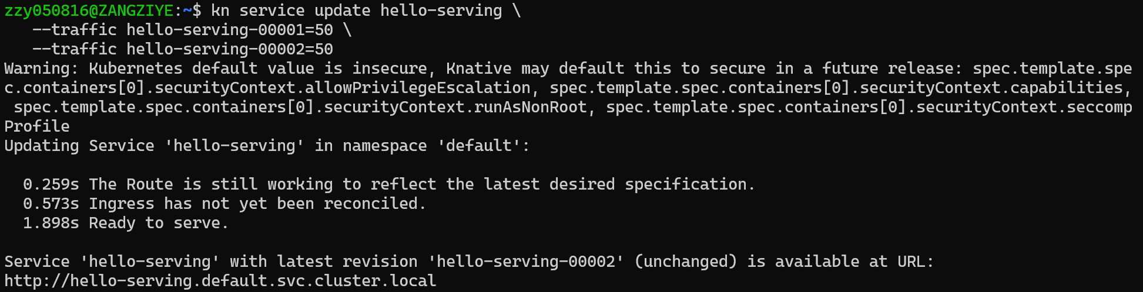

Verify the traffic split
To verify that the traffic split has configured correctly, list the Revisions again by running the command:

6. Knative Eventing: Event-driven Architecture

6.1 Event Display Service
An event-display Knative Service was deployed to receive and
display incoming CloudEvents.
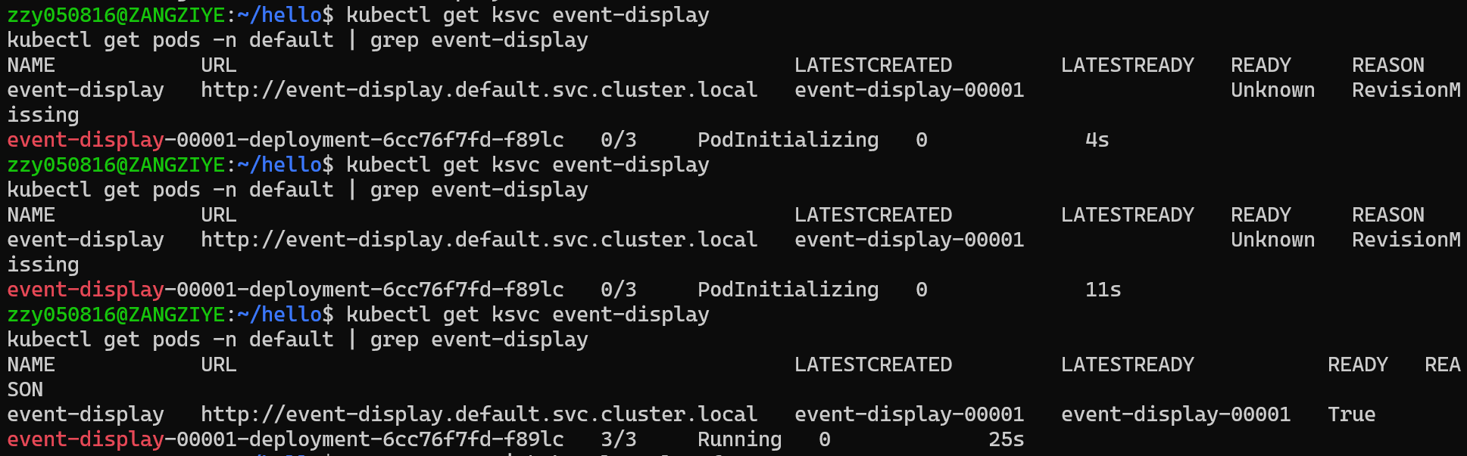
6.2 PingSource Creation
A PingSource was created to generate periodic events and send them
to the event-display service.
6.3 Event Verification
The event flow was verified by checking the logs of the event-display pod.
CloudEvents generated by the PingSource were successfully received.
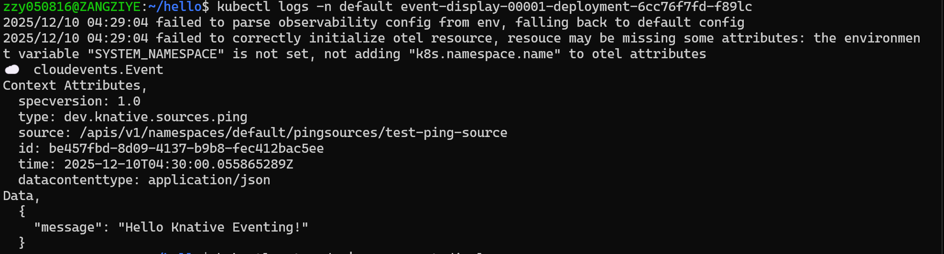
7. Results and Analysis
All components of Knative Serving, Functions, and Eventing were successfully
deployed and verified. The experiment demonstrates how Knative enables
serverless and event-driven workloads on Kubernetes.
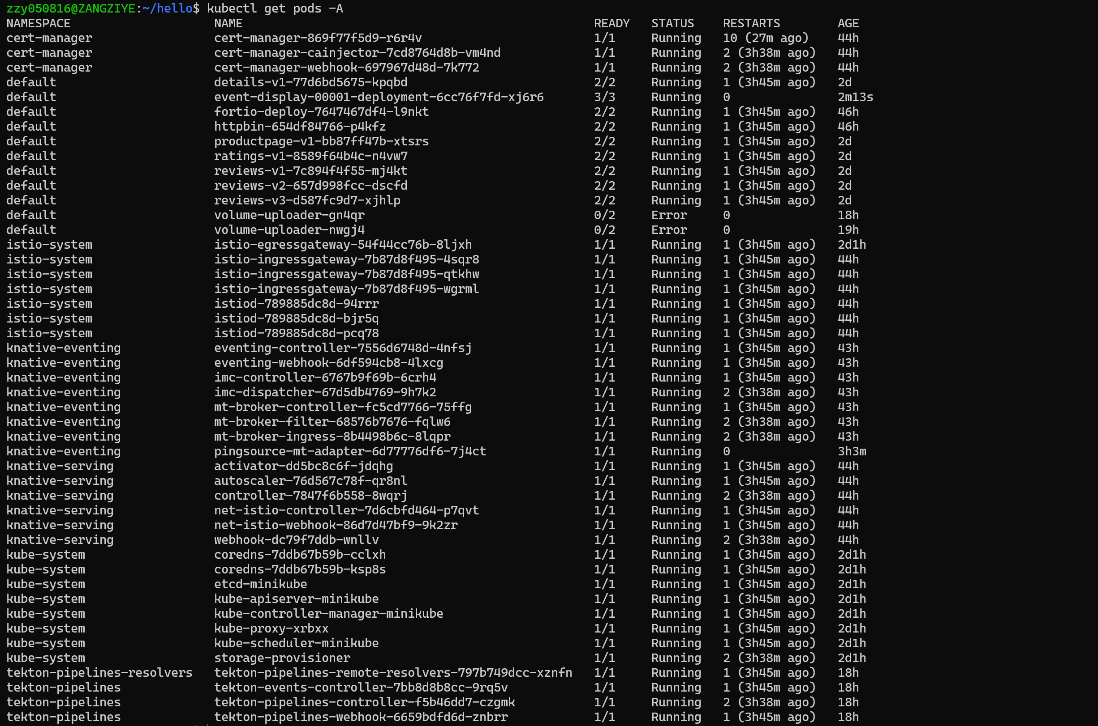
- Conclusion
Through this lab, a complete Knative environment was built and validated.
The experiment deepened understanding of serverless computing,
event-driven architecture, and cloud-native application deployment.

