1. 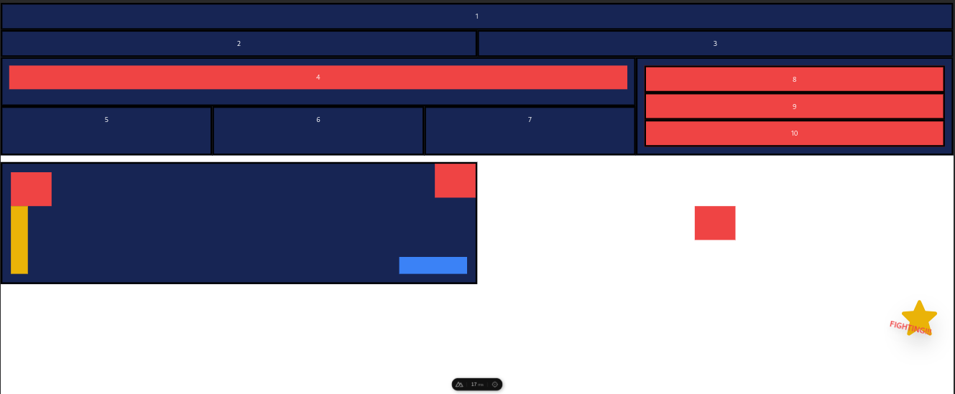  
     
   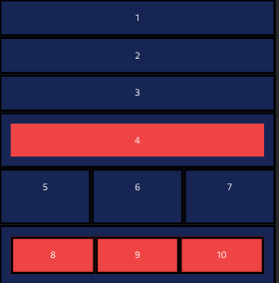

<template>

<div>

<div class="grid grid-cols-3 gap-2 m-4">

<button class="text-white p-4 rounded bg-indigo-500 shadow-md flex items-center justify-center">

<svg xmlns="http://www.w3.org/2000/svg" class="h-6 w-6 mr-2" fill="none" viewBox="0 0 24 24"

stroke="currentColor">

<path stroke-linecap="round" stroke-linejoin="round" stroke-width="2"

d="M3 12l2-2m0 0l7-7 7 7M5 10v10a1 1 0 001 1h3m10-11l2 2m-2-2v10a1 1 0 01-1 1h-3m-6 0a1 1 0 001-1v-4a1 1 0 011-1h2a1 1 0 011 1v4a1 1 0 001 1m-6 0h6" />

</svg>

Marketing

</button>

<button class="p-4 rounded bg-white text-indigo-500 shadow-md flex items-center justify-center">

<svg xmlns="http://www.w3.org/2000/svg" class="h-6 w-6 mr-2" fill="none" viewBox="0 0 24 24"

stroke="currentColor">

<path stroke-linecap="round" stroke-linejoin="round" stroke-width="2"

d="M5.121 17.804A13.937 13.937 0 0112 16c2.5 0 4.847.655 6.879 1.804M15 10a3 3 0 11-6 0 3 3 0 016 0zm6 2a9 9 0 11-18 0 9 9 0 0118 0z" />

</svg>

IT

</button>

<button class="p-4 rounded bg-white text-indigo-500 shadow-md flex items-center justify-center">

<svg xmlns="http://www.w3.org/2000/svg" class="h-6 w-6 mr-2" fill="none" viewBox="0 0 24 24"

stroke="currentColor">

<path stroke-linecap="round" stroke-linejoin="round" stroke-width="2"

d="M17 8h2a2 2 0 012 2v6a2 2 0 01-2 2h-2v4l-4-4H9a1.994 1.994 0 01-1.414-.586m0 0L11 14h4a2 2 0 002-2V6a2 2 0 00-2-2H5a2 2 0 00-2 2v6a2 2 0 002 2h2v4l.586-.586z" />

</svg>

Design

</button>

</div>

<div class="shadow-xl border border-gray-100 font-light p-8 rounded text-gray-500 bg-white mt-6 mx-4">

<h1 class="text-green-500">{{ jobPost.title }}</h1>

<p><strong>Description:</strong></p>

<div v-html="jobPost.description.txt"></div>

<h5><strong>Skill :</strong></h5>

<ul>

<li v-for="skill in jobPost.ptJobSkills" :key="skill.id">

{{ skill.name }}

</li>

</ul>

</div>

<div class="shadow-xl border border-gray-100 font-light p-8 rounded text-gray-500 bg-white mt-6 mx-4">

<div class="grid grid-cols-2 gap-2 my-2 mx-4">

<div class="mb-4">

<label class="block text-gray-700 text-sm font-bold mb-2" for="displayName">

Yourname

</label>

<input v-model="displayName"

class="shadow appearance-none border rounded w-full py-2 px-3 text-gray-700 leading-tight focus:outline-none focus:shadow-outline"

id="displayName" type="text" placeholder="Username" />

</div>

<div class="mb-4">

<label class="block text-gray-700 text-sm font-bold mb-2" for="phone">

Mobile number

</label>

<input v-model="phone"

class="shadow appearance-none border rounded w-full py-2 px-3 text-gray-700 leading-tight focus:outline-none focus:shadow-outline"

id="phone" type="text" placeholder="Mobile number" />

</div>

</div>

<div class="grid grid-cols-2 gap-2 my-2 mx-4">

<div class="mb-4">

<label class="block text-gray-700 text-sm font-bold mb-2" for="email">

Email

</label>

<input v-model="email"

class="shadow appearance-none border rounded w-full py-2 px-3 text-gray-700 leading-tight focus:outline-none focus:shadow-outline"

id="email" type="text" placeholder="Email" />

</div>

<div class="mb-4">

<label class="block text-gray-700 text-sm font-bold mb-2" for="message">

Message

</label>

<input v-model="message"

class="shadow appearance-none border rounded w-full py-2 px-3 text-gray-700 leading-tight focus:outline-none focus:shadow-outline"

id="message" type="text" placeholder="Message" />

</div>

</div>

<div class="container ">

<div id="images-container"></div>

<div class="flex my-4">

<div id="multi-upload-button"

class="inline-flex items-center px-4 py-2 bg-gray-600 border border-gray-600 rounded-l font-semibold cursor-pointer text-sm text-white tracking-widest hover:bg-gray-500 active:bg-gray-900 focus:outline-none focus:border-gray-900 focus:ring focus:ring-gray-300 disabled:opacity-25 transition ">

Click to browse

</div>

<div class="w-4/12 lg:w-3/12 border border-gray-300 rounded-r-md flex items-center justify-between">

<span id="multi-upload-text" class="p-2"></span>

<button id="multi-upload-delete" class="hidden" @click="removeMultiUpload">

<svg xmlns="http://www.w3.org/2000/svg" class="fill-current text-red-700 w-3 h-3"

viewBox="0 0 320 512">

<path

d="M310.6 361.4c12.5 12.5 12.5 32.75 0 45.25C304.4 412.9 296.2 416 288 416s-16.38-3.125-22.62-9.375L160 301.3L54.63 406.6C48.38 412.9 40.19 416 32 416S15.63 412.9 9.375 406.6c-12.5-12.5-12.5-32.75 0-45.25l105.4-105.4L9.375 150.6c-12.5-12.5-12.5-32.75 0-45.25s32.75-12.5 45.25 0L160 210.8l105.4-105.4c12.5-12.5 32.75-12.5 45.25 0s12.5 32.75 0 45.25l-105.4 105.4L310.6 361.4z" />

</svg>

</button>

</div>

</div>

<input type="file" id="multi-upload-input" class="hidden" ref="fileInput" @change="handleFileChange" />

</div>

<button class="text-white bg-blue-500 p-2 rounded-md" @click="submitForm">Send Message</button>

</div>

</div>

</template>

<script>

import axios from 'axios';

export default {

data() {

return {

displayName: '',

email: '',

phone: '',

message: '',

files: null,

jobPost: {

title: "Marketing Planner",

description: {

txt: "<h5><strong>Job Description :</strong></h5><ul><li>Monitor competition to identify new industry trends and opportunities for innovation</li><li>Develop marketing strategies based on customer preferences, business objectives, and available resources</li><li>Conduct market research to identify potential customers and assess their needs, interests, and preferences</li><li>Work with design teams to develop marketing materials such as brochures, ads, and presentations</li><li>Create an advertising budget that reflects the company’s priorities while remaining within the parameters set by upper management</li><li>Develop an effective communications strategy for each campaign using several different channels, including social media, email, push notification, print ads</li><li>Create a detailed timeline of all marketing activities, including production schedules, deadlines for materials delivery, and event dates and locations</li><li>Provide feedback to superiors regarding the effectiveness of new campaigns and recommend adjustments</li></ul>",

},

ptJobSkills: [

{ id: 1101, name: "Minimum bachelor degree in Marketing Management" },

{ id: 1102, name: "Minimum 3-5 years experience as Marketing Manager/Director in any marketplace industry" },

{ id: 1103, name: "Good time management and project management skill" },

{ id: 1104, name: "Creative communication skill in both verbal and design" },

{ id: 1105, name: "Multi-language abilities in verbal and non-verbal" },

],

},

};

},

methods: {

async submitForm() {

try {

const formData = new FormData();

formData.append('displayName', this.displayName);

formData.append('subject', 'Marketing Planner');

formData.append('email', this.email);

formData.append('phone', this.phone);

formData.append('message', this.message);

formData.append('ptJobApplyType', 'APPLICATION');

formData.append('isActive', false);

if (this.file) {

formData.append('file', this.file);

}

const response = await axios.post(

'https://bti.id/services/btiportalcorems/api/pt-job-posts/no-auth',

formData,

{

headers: {

'Content-Type': 'multipart/form-data',

},

}

);

console.log('Form submitted successfully:', response.data);

} catch (error) {

console.error('Error submitting form:', error);

}

},

removeMultiUpload() {

},

handleFileChange(event) {

this.file = event.target.files[0];

},

},

};

</script>

C.

-- Result 1

SELECT DISTINCT item

FROM asset;

-- Result 2

SELECT

user_id,

GROUP_CONCAT(item ORDER BY item) AS asset

FROM asset

GROUP BY user_id;

D.

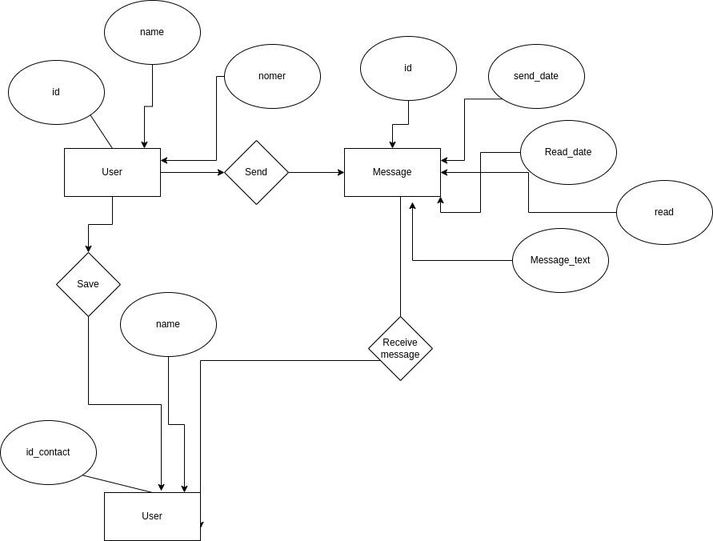  
  
E.

1.

function generatePattern(n) {

let result = '';

for (let i = 1; i <= n; i++) {

for (let j = 1; j <= n; j++) {

if (j <= i) {

result += j;

} else {

result += '*';

}

}

result += '\n';

}

return result;

}

console.log(generatePattern(5));

console.log(generatePattern(4));

2.

function findMaxDifference(arr) {

let maxDifference = 0;

let currentMin = arr[0];

for (let i = 1; i < arr.length; i++) {

const currentNumber = arr[i];

const currentDifference = currentNumber - currentMin;

maxDifference = Math.max(maxDifference, currentDifference);

currentMin = Math.min(currentMin, currentNumber);

}

return maxDifference;

}

// Contoh penggunaan

const harga = [10, 7, 5, 8, 11, 9, 1];

console.log(findMaxDifference(harga)); // Output: 6

F.

Cypress:

Alat pengujian end-to-end (E2E) untuk pengujian otomatis aplikasi web.

Kubernet:

Platform sumber terbuka untuk mengotomatisasi, menskalakan, dan mengelola penerapan aplikasi kontainer.

ORM (Pemetaan Relasional Objek):

Suatu teknik pemrograman untuk mengkonversi data antara sistem database terstruktur dan format yang dapat digunakan dalam bahasa pemrograman berorientasi objek.

Ada banyak contoh mirip Prism di Node js

class:

Dalam pemrograman berorientasi objek, Anda membuat cetak biru suatu objek, yang mendefinisikan properti dan perilakunya.

function:

Sebuah blok kode yang dapat dipanggil dan dieksekusi untuk melakukan tugas tertentu.

DevOps:

Praktik pengembangan perangkat lunak yang menyatukan pengembangan (Dev) dan operasi (Ops) untuk meningkatkan kolaborasi dan penyampaian perangkat lunak yang efisien.

docker:

Sebuah platform untuk mengembangkan, mengirimkan, dan menjalankan aplikasi dalam container.

G.

Microservices Architecture:

Teknologi terbaik: Kubernetes untuk orkestrasi, Spring Boot untuk backend, React atau Angular untuk frontend.

alasan:

Pembangunan sangat terukur dan fleksibel, sehingga sangat mendukung pembangunan di masa depan

Menjadikannya aplikasi failover yang sangat baik sehingga jika salah satu layanan gagal, layanan lainnya tidak berdampak dan tetap dapat berjalan

Serverless Architecture:

Contoh: AWS Lambda, Azure Functions, Google Cloud Functions untuk fungsi tanpa server, dan React atau Angular untuk front-end.

alasan:

Biayanya murah, jika tidak digunakan, bahkan gratis tergantung pemakaian

Ekspansi otomatis, dapat ditingkatkan skalanya sesuai kebutuhan kapasitas

Event-Driven Architecture:a:

Teknologi terbaik: Apache Kafka untuk streaming acara, Node.js atau Spring Cloud Streams untuk layanan pemrosesan acara.

alasan:

pemrosesan data realtime

Skalabilitas data sangat mudah dikelola