SIMATS ENGINEERING
Saveetha Institute of Medical and Technical Sciences
A PYTHON PROGRAMMING PROJECT REPORT
FOOD ORDER AND ANALYSIS MANAGEMENT SYSTEM
CSA0801 – Python Programming
Submitted by
YUDHISHT RAM D.A.
Register Number: 1921260052
Academic Year: 2026
September 2026

BONAFIDE CERTIFICATE
This is to certify that the project entitled “Food Order and Analysis Management System” has been carried out by Yudhisht Ram D.A. (1921260052) as part of the requirements for the course CSA0801 – Python Programming at SIMATS Engineering, Saveetha Institute of Medical and Technical Sciences, Chennai.
The report documents the problem definition, objectives, system design, modular implementation, testing, output evidence, analysis and conclusion of the Python-based application.

Role | Signature | Name
Course Coordinator | __________________ | Dr. S. Loganayaki
Project Guide | __________________ | Dr. U. Samson Ebenezer
Student | __________________ | Yudhisht Ram D.A.

Place: Chennai
Date: September 2026

DECLARATION
I, Yudhisht Ram D.A. (1921260052), hereby declare that the project work entitled “Food Order and Analysis Management System” is the academic work completed for CSA0801 – Python Programming. The report has been prepared from the supplied assignment implementation, pseudocode, testing evidence and execution outputs.
The report presents the system as an educational Python prototype. The results and calculations described are based on the supplied implementation and observed execution evidence.
Place: Chennai
Date: September 2026

Signature of the Student: __________________________
Yudhisht Ram D.A. (1921260052)

INDIVIDUAL CONTRIBUTION STATEMENT
The supplied assignment identifies the submitted work as being completed for the project. The contribution below records the work represented by the source code, pseudocode, testing, output evidence, analysis and report preparation.
Student | Register No. | Contribution
Yudhisht Ram D.A. | 1921260052 | Python program, module design, pseudocode, testing, output screenshots, analysis and report preparation.

ABSTRACT
The Food Order and Analysis Management System is a menu-driven Python application developed to manage customers, restaurants, food items and orders in a single workflow. The system reduces repetitive manual entry by allowing records to be added, searched, displayed and reused. It also supports order creation, bill calculation, order-status updates, customer spending analysis, order comparison, report generation and CSV-based data persistence.
The implementation follows a modular structure. The main controller coordinates customer, restaurant, food, order, analysis, report and file-handling modules. Dictionaries are used for customer, restaurant and food records; a list stores orders; tuples represent customer addresses; and a set stores cuisine categories. CSV files provide persistent storage after the application is closed.
The order module calculates subtotal, discount, delivery charge and final amount. The supplied implementation applies a 10% discount for a subtotal of at least Rs.1000 and a 5% discount for a subtotal of at least Rs.500, followed by a fixed delivery charge of Rs.40. The analysis module calculates customer order value and compares two orders, while the report module summarizes sales, order status and restaurant-wise sales.
Testing evidence in the supplied assignment shows successful customer and restaurant operations, food-item creation, order creation, status changes, analysis, report generation and data saving. The final evidence records 1 customer, 1 restaurant, 1 food item and 2 orders with total sales of Rs.680.00, including one Delivered order and one Pending order. The project therefore demonstrates core Python programming concepts through a practical application.
Keywords: Python, food order management, customer management, restaurant management, order processing, CSV, data structures, modular programming, analysis and reporting.

TABLE OF CONTENTS
Chapter 1: Introduction and Engineering Problem
1.1 Background
1.2 Need for the Project
1.3 Problem Statement
1.4 Aim
1.5 Objectives
1.6 Scope
1.7 Stakeholders and Expected Benefits
1.8 Expected Engineering Outcome
1.9 Organisation of the Report
Chapter 2: System Study and Existing Approach
2.1 Study Method
2.2 Manual Food-Order Management
2.3 Proposed Python-Based Approach
2.4 Technology and Data-Structure Choices
2.5 Functional Comparison
2.6 Engineering Gap
2.7 Proposed Contribution
Chapter 3: System Design, Architecture and Logic
3.1 Functional Requirements
3.2 Non-Functional Requirements
3.3 Modular Architecture
3.4 Data Model
3.5 Module Descriptions
3.6 Order-Billing Logic
3.7 Validation and Exception Handling
3.8 CSV Persistence
3.9 Flowchart and Processing Sequence
3.10 Sustainability and Responsible Use
3.11 Risks and Controls
Chapter 4: Implementation, Testing and Results
4.1 Development Approach
4.2 Resources and Tools
4.3 Module Implementation
4.4 Integrated Processing Flow
4.5 Test Plan
4.6 Test Results
4.7 Output Evidence
4.8 Analysis and Discussion
4.9 Strengths and Limitations
Chapter 5: Conclusion, Future Work and Reflection
5.1 Conclusion
5.2 Future Work
5.3 Professional Learning
5.4 Individual Reflection
References
Appendices

LIST OF FIGURES
Figure No. | Figure Name
Figure 3.1 | Modular architecture of the Food Order and Analysis Management System
Figure 3.2 | Processing flow of the menu-driven application
Figure 4.1 | Flowchart and execution evidence from the supplied assignment
Figure 4.2 | Customer and restaurant operations output
Figure 4.3 | Food and order operations output
Figure 4.4 | Analysis and report generation output
Figure 4.5 | Data-saving and program-closing output

LIST OF TABLES
Table No. | Table Name
Table 1 | Functional requirements
Table 2 | Data structures used
Table 3 | Module responsibilities
Table 4 | Test cases and results
Table 5 | Strengths and limitations

LIST OF ABBREVIATIONS / SYMBOLS
Term | Description
CSV | Comma-Separated Values
UI | User Interface
ID | Identifier
Rs. | Indian Rupees
CRUD | Create, Read, Update and Delete style record operations
Python | Programming language used for implementation

CHAPTER 1: INTRODUCTION AND ENGINEERING PROBLEM

1.1 Background
Food-order information can become difficult to manage when customer details, restaurant details, food items and order records are handled separately. Manual handling can lead to repeated entry, difficulty in finding records and errors while calculating order amounts. A small information-management application can combine these tasks into one consistent workflow.
The project develops a Python-based Food Order and Analysis Management System. The supplied assignment states that the program keeps customer, restaurant, food-item and order details in one place and allows the user to add records, search information, create orders, change order status, compare orders and prepare reports.

1.2 Need for the Project
The need for the system comes from the requirement to manage several related types of information and perform calculations consistently. A menu-driven application gives the user a predictable sequence of operations and reduces the need to repeat calculations manually.

1.3 Problem Statement
To design and implement a modular Python application that manages customer, restaurant, food and order information; calculates order amounts with discounts and delivery charges; supports order-status management and analysis; generates useful summaries; and preserves records using CSV files.

1.4 Aim
To develop a simple, reliable and modular Food Order and Analysis Management System using Python programming concepts, data structures, functions, modules, exception handling and file handling.

1.5 Objectives
- Maintain customer information and support customer search.
- Maintain restaurant information and support restaurant search and listing.
- Maintain food items and associate them with restaurants and cuisine categories.
- Create orders using valid customer, restaurant and food references.
- Calculate subtotal, discount, delivery charge and final order amount.
- Update and display order status.
- Calculate total order value for a selected customer.
- Compare the totals of two orders.
- Generate an overall order and sales report.
- Save and reload application data using CSV files.

1.6 Scope
The scope includes customer, restaurant, food and order management, bill calculation, order-status updates, analysis, reporting and CSV persistence. The current implementation is a console-based educational prototype. A graphical interface, online payment gateway and real delivery service are outside the supplied implementation.

1.7 Stakeholders and Expected Benefits
Stakeholder | Need | Expected Benefit
Customer | Order-related information | Consistent customer and order records
Restaurant | Food and order information | Food items can be linked to a restaurant
System User | Fast record operations | Menu-driven access to common functions
Project Evaluator | Evidence of Python concepts | Clear demonstration of modular programming and testing

1.8 Expected Engineering Outcome
The expected outcome is a functional console application in which related data can be entered, retrieved and processed through separate modules. The application should produce understandable output, handle common input errors and preserve records for later use.

1.9 Organisation of the Report
Chapter 1 introduces the problem, aim, objectives and scope. Chapter 2 discusses the system study and the proposed approach. Chapter 3 presents requirements, architecture, data structures, modules, billing logic, validation and persistence. Chapter 4 records implementation, testing, output evidence and analysis. Chapter 5 concludes the work and identifies future improvements.

CHAPTER 2: SYSTEM STUDY AND EXISTING APPROACH

2.1 Study Method
The system study is based on the supplied assignment implementation, its revised pseudocode, test cases and execution-output evidence. The design is interpreted according to the functionality actually described in those materials.

2.2 Manual Food-Order Management
A manual process may require separate records for customers, restaurants, menus and orders. Calculations such as discounts and delivery charges may have to be repeated for every order. Searching and summarising records can also require additional effort. The project addresses these issues by keeping related information in memory and by providing dedicated functions for common operations.

2.3 Proposed Python-Based Approach
The proposed solution uses a menu-driven console interface with command dispatch. The main module loads stored records, displays the menu, receives a command, calls the associated operation and continues until the user chooses the exit option. Separate modules handle customer, restaurant, food, order, analysis, report and file operations.

2.4 Technology and Data-Structure Choices
Technology / Structure | Purpose
Python | Core programming language
Dictionary | Customer, restaurant and food records
List | Collection of orders
Tuple | Customer address as location and city
Set | Cuisine categories
CSV | Persistent storage
Functions | Reusable operations
Modules | Separation of responsibilities
Exception handling | Controlled response to invalid input

2.5 Functional Comparison
Approach | Advantages | Limitations | Relevance
Manual records | Simple to start | Slow search and calculation | Problem context
Spreadsheet-style records | Flexible | Repeated formulas and manual updates | Possible baseline
Dedicated Python prototype | Modular, reusable and easy to test | Console-based and small-scale | Selected approach
Full online food-order platform | Could provide payment and delivery | Much larger implementation scope | Future direction

2.6 Engineering Gap
The key gap addressed by the project is the absence of a small integrated workflow connecting customer, restaurant, food and order records with analysis and reporting. The system goes beyond a simple calculator by associating an amount with a particular customer, food item, restaurant and order record.

2.7 Proposed Contribution
The project contributes a modular educational application that demonstrates how Python data structures, functions, control statements, string operations, custom exceptions and file handling can work together in a realistic management problem.

CHAPTER 3: SYSTEM DESIGN, ARCHITECTURE AND LOGIC

3.1 Functional Requirements
ID | Requirement | Acceptance Evidence
FR-01 | Add and search customers | Customer record is stored and matching names can be displayed
FR-02 | Add, search and list restaurants | Restaurant records are stored and displayed
FR-03 | Add and list food items | Food is linked to a valid restaurant and cuisine set
FR-04 | Create an order | Valid customer, food and quantity produce an order
FR-05 | Calculate bill | Subtotal, discount, delivery and total are displayed
FR-06 | Update order status | Status changes to an accepted state
FR-07 | Analyse orders | Customer value and order comparison are produced
FR-08 | Generate report | Sales, status counts, restaurant sales and cuisines are shown
FR-09 | Persist records | CSV files are written and can be loaded later

3.2 Non-Functional Requirements
- Usability: menu options and messages should be understandable.
- Maintainability: operations are separated into modules.
- Reliability: invalid identifiers and numeric input should be checked.
- Persistence: saved records should remain available after program closure.
- Readability: monetary values and report summaries should be clearly formatted.

3.3 Modular Architecture
The application is divided into eight logical modules. The main controller coordinates the application. Customer operations manage customer records. Restaurant operations manage restaurant records. Food operations manage food items and cuisine categories. Order operations create orders and calculate bills. Analysis provides customer spending and order comparison. Report generation prepares summaries. File handling saves and loads CSV data.
Figure 3.1 can be represented as the following logical structure:
- main.py → controls menu and dispatches operations
- customer.py → add_customer(), find_customer()
- restaurant.py → add_restaurant(), find_restaurant(), list_restaurants()
- food.py → add_food(), list_food()
- order.py → calculate_bill(), place_order(), list_orders(), update_status()
- analysis.py → total_for_customer(), customer_spending(), compare_order_totals()
- report.py → build_report()
- file_handler.py → save_all(), load_all()

3.4 Data Model
The customer collection is a dictionary keyed by a customer identifier. Each address is represented by a two-value tuple containing location and city. Restaurant and food collections are also dictionaries. Orders are maintained as a list because multiple orders can exist for the same customer or food item. Cuisine categories are maintained as a set to avoid duplicate category entries.

3.5 Module Descriptions
Module | Main Responsibility
Application Controller | Load data, show menu, dispatch commands and handle exceptions
Customer Operations | Add and search customers
Restaurant Operations | Add, search and list restaurants
Food Operations | Add food items and maintain cuisine categories
Order Operations | Validate references, calculate bills, create/list/update orders
Analysis | Customer spending and order comparison
Report Generation | Record counts, total sales, status counts, restaurant sales and cuisines
CSV Persistence | Save and reload four CSV datasets

3.6 Order-Billing Logic
The supplied implementation uses the following calculation sequence:
- subtotal = price × quantity
- If subtotal ≥ Rs.1000, discount rate = 10%.
- Else if subtotal ≥ Rs.500, discount rate = 5%.
- Otherwise discount rate = 0%.
- discount = subtotal × selected rate.
- delivery charge = Rs.40.
- total = subtotal − discount + delivery charge.
The order is initially assigned the status Pending. Accepted status values are Pending, Confirmed, Preparing, Delivered and Cancelled.

3.7 Validation and Exception Handling
The system rejects blank or duplicate customer identifiers, duplicate restaurant identifiers, duplicate food codes and invalid food references. Quantity is converted to an integer and must be greater than zero. The application defines a custom OrderError and also handles common input and key errors. This keeps incorrect operations from silently producing invalid order records.

3.8 CSV Persistence
The file-handling module writes customers, restaurants, food items and orders to CSV files using UTF-8 encoding and appropriate newline handling. On loading, stored strings are converted back into the required data types, including floats for prices and monetary values and integers for quantities. Missing CSV files are ignored so that a first-time user can begin with empty collections.

3.9 Flowchart and Processing Sequence
The supplied flowchart shows a repeating sequence: load saved data → display menu → receive selection → perform selected task → return to menu → save and exit when the exit option is selected. This loop allows several operations to be performed during a single program session.

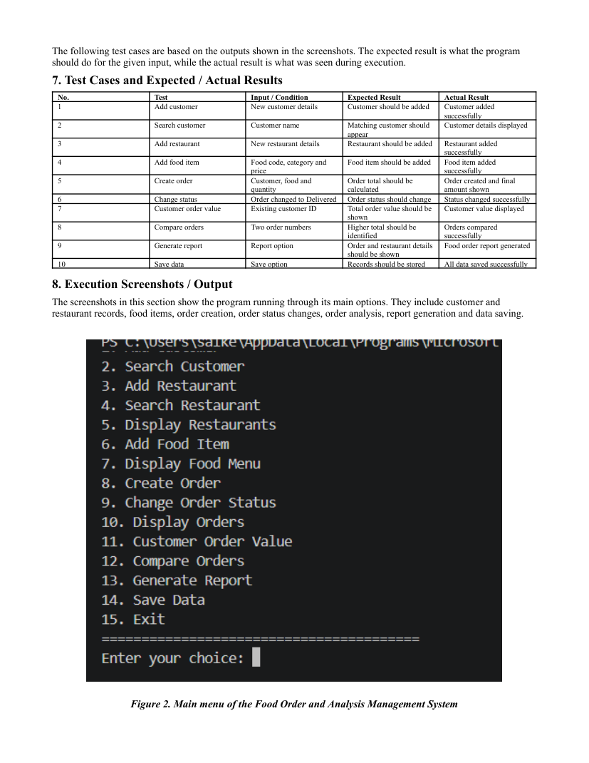
Figure 3.2. Flowchart / execution-page evidence from the supplied assignment.

3.10 Sustainability and Responsible Use
The console and CSV design requires only ordinary computing resources and avoids unnecessary physical paperwork. For a small educational system, this is a lightweight approach. Responsible use also requires preserving the correctness of stored data and preventing accidental overwriting of records.

3.11 Risks and Controls
Risk | Impact | Control
Invalid input | Incorrect records or program errors | Input validation and exception handling
Duplicate identifiers | Ambiguous records | Duplicate checks before insertion
Invalid food/restaurant reference | Broken order association | Reference validation
Incorrect quantity | Wrong bill | Positive-integer validation
Data loss after closure | Records unavailable | CSV persistence
Unexpected exception | Interrupted operation | General exception handling and recovery message

CHAPTER 4: IMPLEMENTATION, TESTING AND RESULTS

4.1 Development Approach
The implementation follows an incremental modular approach. Data structures and individual operations are separated first, then the order workflow connects the records. Analysis and reporting are built over the stored order collection, and file handling provides persistence. The supplied assignment includes revised pseudocode for each module before the source-code and output sections.

4.2 Resources and Tools
Resource / Tool | Purpose
Python | Program development and execution
Console / terminal | User interaction and testing
CSV files | Persistent storage
Text/code editor | Source-code preparation
Word processor | Project documentation

4.3 Module Implementation
The main controller loads five collections: customers, restaurants, foods, orders and cuisines. A command dictionary maps menu selections to functions. Customer and restaurant modules perform record creation and searching. The food module validates the restaurant reference and price. The order module validates identifiers and quantity, calculates the bill and appends a Pending order. Analysis and report modules then operate on the resulting order data.

4.4 Integrated Processing Flow
The integrated flow begins with data loading. The user selects an operation from the menu. For an order, the system verifies the customer and food references, resolves the associated restaurant, validates quantity, calculates the amount and stores the order. The user can subsequently list orders, update status, analyse customer spending, compare orders, generate a report and save all data.

4.5 Test Plan
The test cases below follow the test evidence provided in the supplied assignment. Expected results describe the intended behaviour and actual results record the observed execution outcome.
No. | Test Input / Condition | Expected Result | Actual Result
1 | Add customer with new details | Customer should be added | Customer added successfully
2 | Search customer by name | Matching customer should appear | Customer details displayed
3 | Add restaurant with new details | Restaurant should be added | Restaurant added successfully
4 | Add food item with code, category and price | Food item should be added | Food item added successfully
5 | Create order with customer, food and quantity | Order total should be calculated | Order created and final amount shown
6 | Change order status to Delivered | Order status should change | Status changed successfully
7 | Calculate customer order value | Total order value should be shown | Customer value displayed
8 | Compare two order numbers | Higher total should be identified | Orders compared successfully
9 | Generate report | Order and restaurant details should be shown | Food order report generated
10 | Save data | Records should be stored | All data saved successfully

4.6 Test Results
The supplied execution evidence indicates that the major functions worked together as planned. Customer and restaurant details were created and searched. Food items were linked to restaurants and displayed. Orders were created with quantity, discount and delivery charge included. Status was changed successfully, analysis functions returned values, reports were generated and the data-saving operation completed.
The final report output in the supplied assignment records 1 customer, 1 restaurant, 1 food item and 2 orders with total sales of Rs.680.00. The displayed status counts include Delivered = 1 and Pending = 1. The assignment also confirms successful data saving and program closure.

4.7 Output Evidence
The following pages reproduce the execution-output evidence supplied with the assignment. They are included as supporting evidence rather than as newly generated test results.
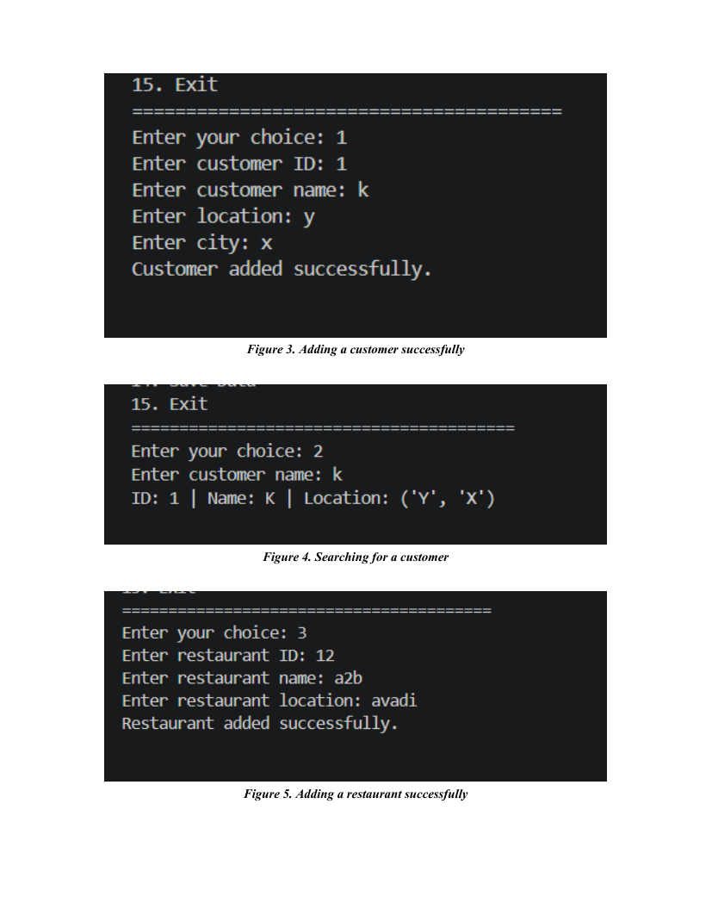
Figure 4.2. Execution output evidence from the supplied assignment.

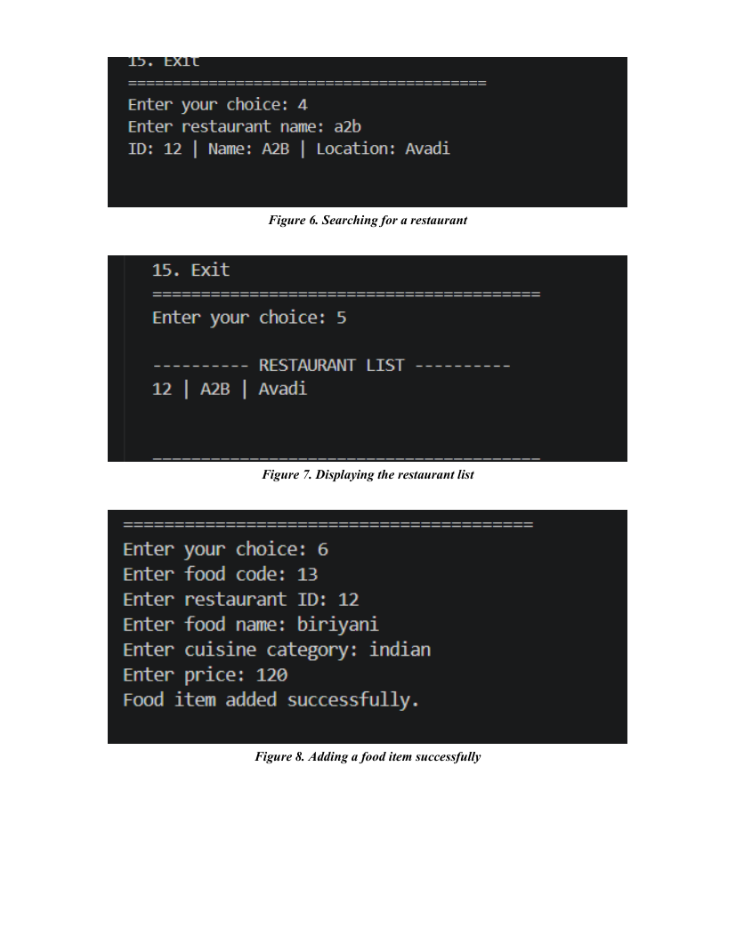
Figure 4.3. Execution output evidence from the supplied assignment.

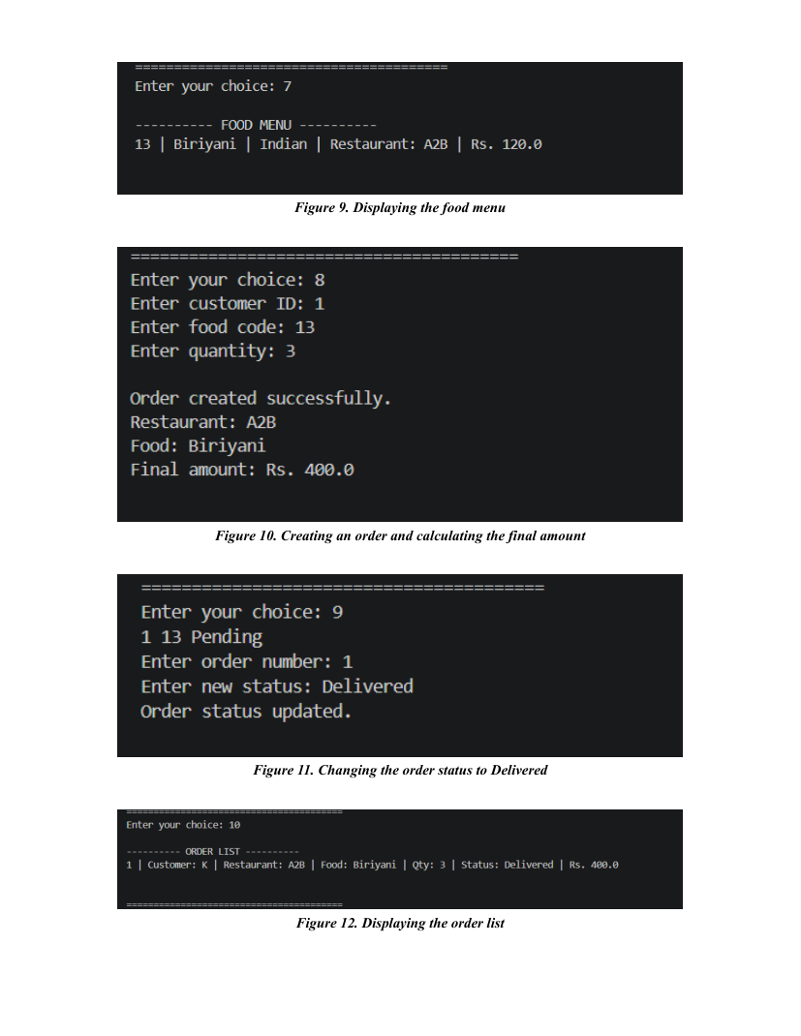
Figure 4.4. Execution output evidence from the supplied assignment.

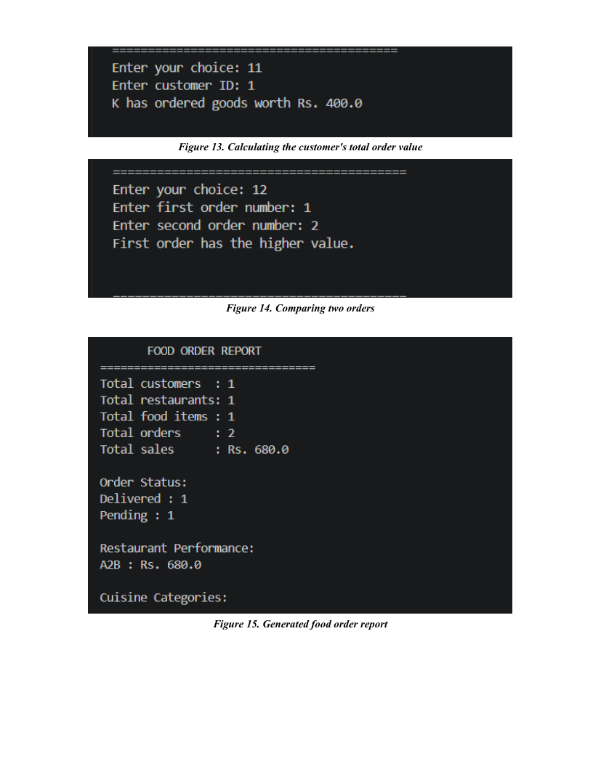
Figure 4.5. Execution output evidence from the supplied assignment.

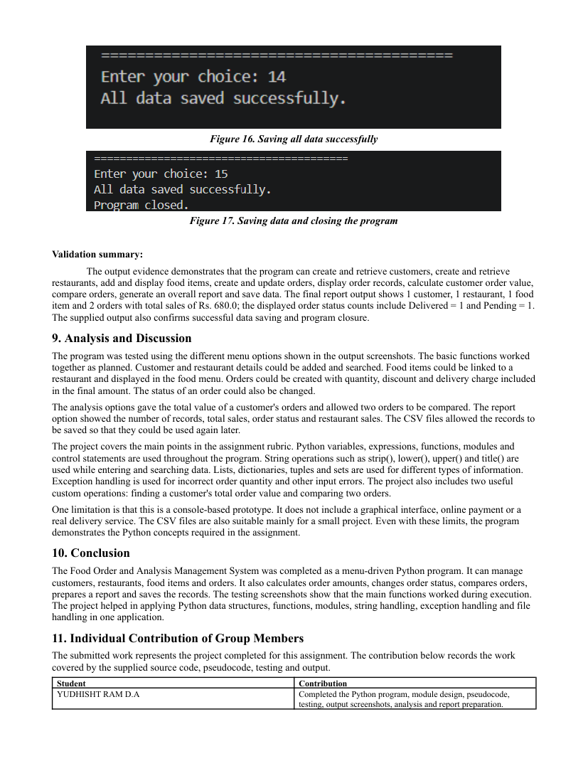
Figure 4.6. Execution output evidence from the supplied assignment.

4.8 Analysis and Discussion
The implementation demonstrates a complete small-scale workflow rather than isolated code examples. The same customer, restaurant, food and order collections are passed between modules, allowing the output of one operation to become the input of another. This provides a clear demonstration of modular programming and data-structure usage.
The project uses Python variables, expressions, functions, modules and control statements throughout the program. String methods such as strip(), lower(), upper() and title() support input normalization and searching. Lists, dictionaries, tuples and sets are used for different categories of information. Exception handling is used for incorrect order quantity and other input errors.
The report and analysis functions provide useful derived information instead of only storing raw records. Customer order value is calculated by summing order totals for a customer, while order comparison identifies which of two orders has the greater total. The report aggregates total sales, status counts, restaurant sales and cuisine categories.

4.9 Strengths and Limitations
Strengths | Limitations
Clear modular decomposition | Console-only interface
Uses multiple Python data structures appropriately | No online payment integration
Includes validation and custom exception handling | No real delivery-service integration
Supports analysis and reporting | CSV storage is mainly suitable for small-scale use
Persists records across program sessions | No graphical user interface
Easy to demonstrate and test | Limited scalability compared with a database-backed platform

CHAPTER 5: CONCLUSION, FUTURE WORK AND REFLECTION

5.1 Conclusion
The Food Order and Analysis Management System was completed as a menu-driven Python application. It manages customers, restaurants, food items and orders and combines these records into a practical workflow. The application calculates order amounts, changes order status, compares orders, calculates customer order value, generates a report and saves records to CSV files.
The testing evidence shows that the principal operations were executed successfully. The project also demonstrates important Python concepts including variables, expressions, functions, modular programming, strings, lists, dictionaries, tuples, sets, exception handling and file handling.
The final implementation is appropriately viewed as an educational prototype. It provides the core functionality required by the assignment but does not attempt to provide a complete commercial food-ordering platform.

5.2 Future Work
- Develop a graphical or web-based user interface.
- Replace CSV persistence with a relational database for larger datasets.
- Add user authentication and role-based access.
- Add edit and delete operations with stronger record-management controls.
- Support multiple food items within a single order.
- Add order history and more detailed sales analytics.
- Introduce online payment integration in a future web version.
- Add delivery tracking and restaurant availability features.
- Provide automated unit and integration tests for edge cases.
- Add export options such as PDF or spreadsheet reports.

5.3 Professional Learning
The project provided practical experience in decomposing a problem into modules, selecting appropriate data structures, designing reusable functions and connecting multiple operations through a controller. It also reinforced the importance of validation, exception handling and persistent storage in a real application.

5.4 Individual Reflection
Working on the project helped connect Python programming concepts with a practical management problem. Designing separate modules made the code easier to understand and test. The testing and report-generation stages highlighted the importance of checking not only whether a program runs, but also whether the data flows correctly between functions and whether the final output is meaningful.

5.5 Outcome Mapping
Learning / Project Outcome | Evidence in Project
Problem analysis | Problem statement, objectives and scope
Python programming | Functions, control statements and modules
Data structures | Lists, dictionaries, tuples and sets
Input processing | String normalization and validation
Error handling | Custom OrderError and exception handling
File handling | CSV save/load operations
Testing | Ten test cases with expected and actual results
Reporting | Sales, status and restaurant summaries

REFERENCES
- CSA0801 – Python Programming Assignment Question and Assessment Rubrics, Department of Computer Science and Engineering.
- Python standard library documentation for basic Python programming and CSV file handling concepts.
- Project source code, pseudocode and execution outputs prepared for the Food Order and Analysis Management System.

APPENDICES

Appendix A – Revised Module Pseudocode Summary
The revised pseudocode in the supplied assignment defines eight modules: application controller, customer operations, restaurant operations, food operations, order operations, analysis, report generation and CSV persistence. The controller loads records, dispatches menu commands and saves on exit. Customer and restaurant modules perform record operations. Food validates restaurant references and prices. Order operations calculate bills and manage statuses. Analysis provides customer totals and order comparison. Report generation aggregates sales and statuses. File handling reconstructs the required in-memory structures from CSV data.

Appendix B – Core Bill Calculation
For a food price P and quantity Q:
Subtotal = P × Q
Discount = Subtotal × applicable discount rate
Delivery Charge = Rs.40
Final Total = Subtotal − Discount + Delivery Charge
Discount rate used by the supplied prototype: 10% for subtotal ≥ Rs.1000; 5% for subtotal ≥ Rs.500; otherwise 0%.

Appendix C – Module/File Summary
File | Functions / Purpose
main.py | Application menu, command dispatch, exception handling
customer.py | add_customer(), find_customer()
restaurant.py | add_restaurant(), find_restaurant(), list_restaurants()
food.py | add_food(), list_food()
order.py | OrderError, calculate_bill(), place_order(), list_orders(), update_status()
analysis.py | total_for_customer(), customer_spending(), compare_order_totals()
report.py | build_report()
file_handler.py | save_all(), load_all()

Appendix D – Validation Summary
The output evidence demonstrates creation and retrieval of customers, creation and retrieval of restaurants, food-item management, order creation and update, customer-value analysis, order comparison, report generation, data saving and program closure. The final report output records total sales of Rs.680.00 across two orders.

Appendix E – Evidence Note
The execution images embedded in Chapter 4 are reproductions of the corresponding pages from the supplied assignment PDF. No additional execution claims have been introduced beyond the evidence contained in that assignment.

