1. Source Codes

view-latihan2.php > application/views

Model1.php > application/model

Latihan1.php > application/controllers

Latihan2.php > application/controllers

1. URL

[http://localhost/pustakabooking/index.php/Latihan1/penjumlahan/10/10](http://localhost/pustakabooking-5c-fariq/index.php/Latihan1/penjumlahan/10/10)

http://localhost/pustakabooking/index.php/Latihan2/penjumlahan/10/10

1. Screenshot

* 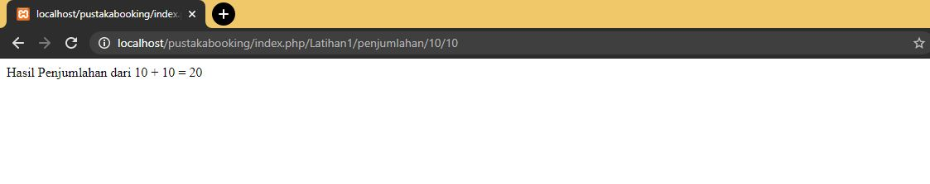Latihan 1
* Latihan 2

