Mechanical Overview

Year: ___2017___ Semester: __Spring______ Team: __8___ Project:__________Barbot___________________

Creation Date: _____2/8/2017_________________ Last Modified: February 3,2017

Author: _______Siyi Cai__________________________ Email: ________cai71@purdue.edu_____________________

Assignment Evaluation:

|  |  |  |  |  |
| --- | --- | --- | --- | --- |
| **Item** | **Score (0-5)** | **Weight** | **Points** | **Notes** |
| **Assignment-Specific Items** | | | | |
| **Commercial Packaging Analysis 1** | 4 | x2 | 8 |  |
| **Commercial Packaging Analysis 2** | 4 | x2 | 8 |  |
| **CAD Model Illustrations** | 5 | x4 | 20 |  |
| **Project Packaging Specifications** | 5 | x2 | 10 |  |
| **PCB Footprint Layout** | 5 | x2 | 10 |  |
| **Writing-Specific Items** | | | | |
| **Spelling and Grammar** | 4 | x2 | 8 |  |
| **Formatting and Citations** | 4 | x1 | 4 |  |
| **Figures and Graphs** | 4.5 | x2 | 9 |  |
| **Technical Writing Style** | 4 | x3 | 12 |  |
| **Total Score** | 89 | | |  |

5: Excellent 4: Good 3: Acceptable 2: Poor 1: Very Poor 0: Not attempted

Comments:

1. Commercial Product Packaging

We analyzed two automatic bartender in the market, similar to our Bartender. The first one is “Bartendro 15” [1] and the second is “Somabar” [2].

* 1. Product #1

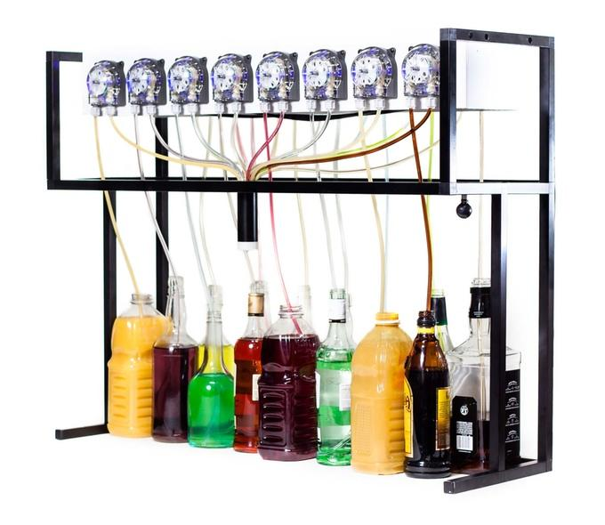

Figure 1: Packaging for Product #1

“Bartendro 15” is packaged within an iron frame package. The top part of frame is a shelf that holds electronic 8 pumps, which can dispense drinks. One end of each pump is placed in 8 different drinks, and another end will come together to a tube that dispenses final mixed drinks.

The iron frame allows the “Bartendro 15” to have a cuboid shape that is stable standing on a surface. The structure of the frame is not complex and allow user to move it easily. However, there is nothing to stabilize those bottles, which is easily spill by an accidental collision.

Our project will also have a similar iron frame. We choose valves that can connect to the drinks’ bottles instead of pumps of “Bartendro 15”, and we will install those bottles with valves face down on the shelf.

* 1. Product #2

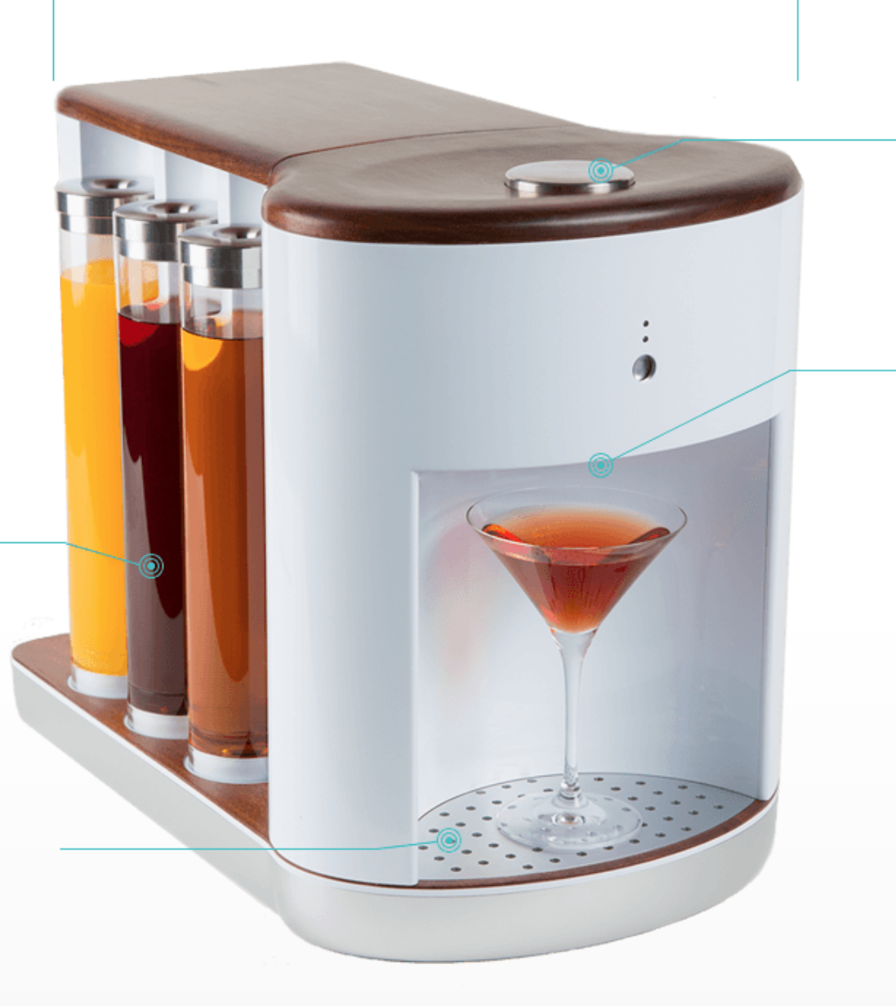

Figure 1: Packaging for Product #2

The “Somabar” is packaged within a plastic packaging with curved edges. Within the top button to is the switch to control the machine. There are 6 containers to store 6 different drinks. Three containers on each side. In the middle of the machine, there is a platform to hold the cup.

The use of plastic as a packaging material reduces weight of the machine. This combined with the compact arrangement of drinks’ containers, makes “Somabar” more portable. The one disadvantage to this is that it takes time for user pour drinks to the containers patiently, and it is difficult to clean up.

This project is good for mixing drinks of small amount , and there is also requirement for the size of the cup. It is not efficient for party and large demand of drinks. Our design doesn’t need user to refill drinks every time when it runs out. User can just change a new bottle drink, and don’t need to worry the liquids spill everywhere. User can change the drink anytime as they want.

3.0 Sources Cited

[1] “Bartendro 15,” *Party Robotics Store*. [Online]. Available: http://partyrobotics.com/collections/products/products/bartendro-15. [Accessed: 09-Feb-2017].

[2]“Somabar,” *Somabar Home Comments*. [Online]. Available: http://somabar.com./. [Accessed: 09-Feb-2017].

Appendix 1: CAD Model Illustrations

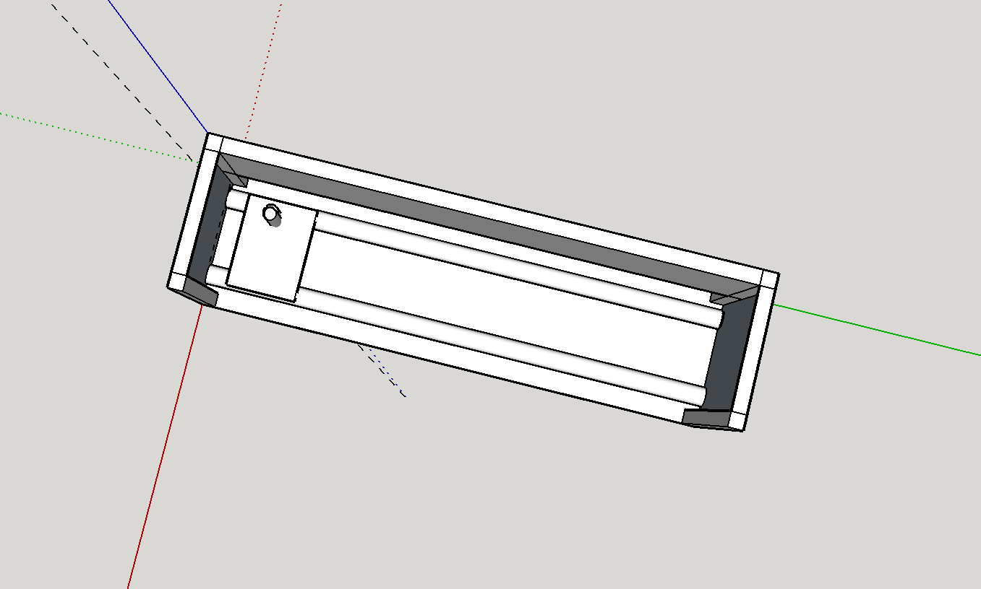

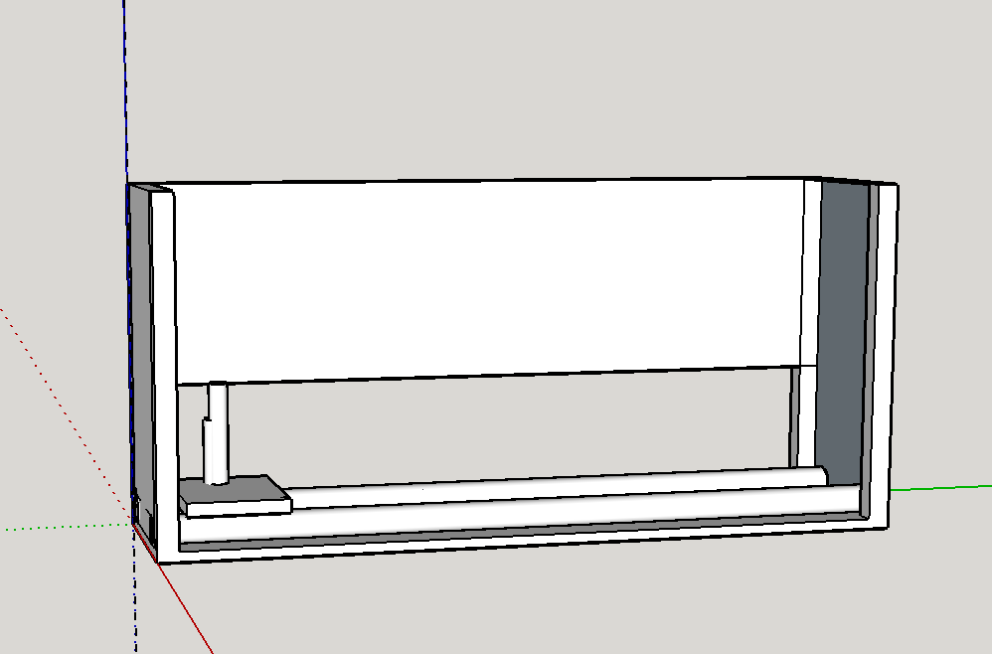

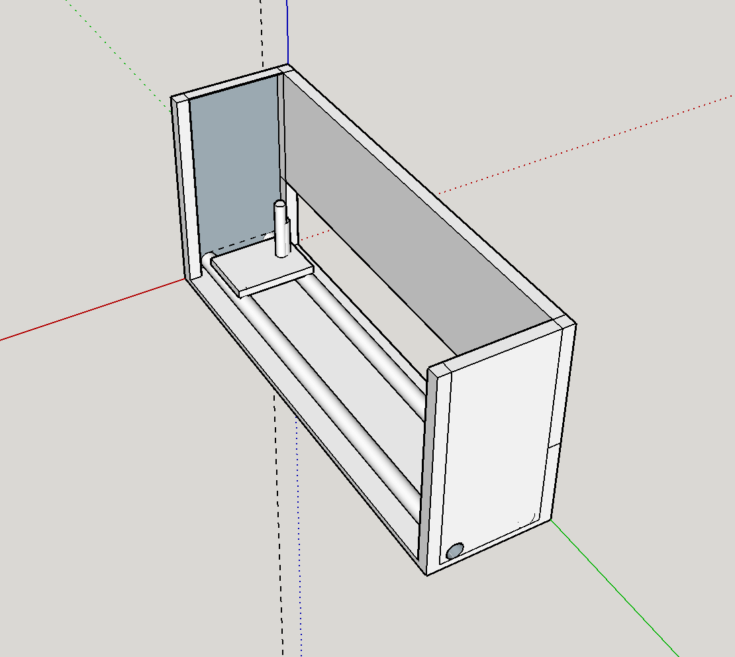

Appendix 2: Project Packaging Specifications

|  |  |  |  |
| --- | --- | --- | --- |
| Material | Tooling Requirement | Weight | Estimate Cost |
| Aluminum Frame | Welding, Saw, Drill | 11.83kg (0.0154lbs/cm) | $150 |
| Wood | Saw, Drill | 2kg | $15 |
| Screws | Screwdrill | 0.2kg | $2 |
| Bolts | Wrench | 0.2kg | $2 |
| Nuts | N/A | 0.2kg | $1 |

Appendix 3: PCB Footprint Layout

