Reliability and Safety Analysis

Year: __2017____ Semester: _Spring_______ Team: __8___ Project:______Barbot_______________________

Creation Date: _______3/29/2017_______________ Last Modified: March 29, 2017

Author: ________Menshi Feng_________________________ Email: ___feng96@purdue.edu__________________________

Assignment Evaluation:

|  |  |  |  |  |
| --- | --- | --- | --- | --- |
| **Item** | **Score (0-5)** | **Weight** | **Points** | **Notes** |
| **Assignment-Specific Items** | | | | |
| **Reliability Analysis** | 4 | x2 | 8 |  |
| **MTTF Tables** | 5 | x3 | 15 |  |
| **FMECA Analysis** | 4 | x2 | 8 |  |
| **Schematic of Functional Blocks (Appendix A)** | 5 | x2 | 10 |  |
| **FMECA Worksheet (Appendix B)** | 5 | x3 | 15 |  |
| **Writing-Specific Items** | | | | |
| **Spelling and Grammar** | 5 | x2 | 10 |  |
| **Formatting and Citations** | 5 | x1 | 5 |  |
| **Figures and Graphs** | 5 | x2 | 10 |  |
| **Technical Writing Style** | 5 | x3 | 15 |  |
| **Total Score** | 96-40=56 | | |  |

5: Excellent 4: Good 3: Acceptable 2: Poor 1: Very Poor 0: Not attempted

Comments: Good work! A penalty of 10% will be deducted for each day.

1. Reliability Analysis

### PIC24FJ128GA010[2]

The PIC24FJ128GA010 is used to control stepper motor and linear actuator, and communicate with Bluetooth module in our Project. Based on its complexity and importance, it was chosen for the reliability analysis. From the formula stated in MIL-HDBK-217F [1], the failure per 10^6 hours (λp) is calculated based on the formula, λp=(C1πT+ C2πE) πQ πL, and mean time to failure (MTTF) was calculated from parameter λp. After all the estimation, the MTTF and λp is in the acceptable range

|  |  |  |  |
| --- | --- | --- | --- |
| Parameter name | Description | Value | *Comments regarding choice of parameter value, especially if you had to make assumptions.* |
| C1 | Die Complexity Failure Rate | .28 | MIL-HDBK-217F [1] section 5.1  16 bit MOS Microprocessor |
| πT | Temperature coefficients | .1 | Assumed to be a digital MOS device |
| C2 | Package Failure Rate | .41 | Hermetically sealed SMT with 100 pins |
| πE | Environment Factor | 2 | $G_{F}(Ground,Fixed)$ MIL-HDBK-217F [1] section 3.0 |
| πQ | Quality Factor | 10 | Commercial Component |
| πL | Learning Factor | 1 | Component has been in production for over 2 years. |
| Entire Design: | | | |
| $$λ_{p}$$ | Failures rate per million hours | 8.48 | Using the equation found in the MIL-HDBK-217F [1] section 5.1 |
| MTTF | Mean Time to Failure | 117924hrs. | Approximately 13 years. |

LD1117[3]

LD1117 is used to regulate the voltage input for microcontroller (PIC24FJ128GA010) and the Bluetooth module (RN4020).  If LD117 can’t operate normally, the power supplied to microcontroller or Bluetooth module may be excess or insufficient. Both situation will cause unexpected operation of microcontroller and Bluetooth. There will also be some danger for user using our project.  From the formula,  λp=(C1πT+ C2πE) πQ πL, and gather all the parameters’ value from MIL-HDBK-217F [1], we get the failures rate per million hours (λp) is around 1.1748, andMTTF is about 97 years, which fulfills our expectation.

|  |  |  |  |
| --- | --- | --- | --- |
| Parameter name | Description | Value | *Comments regarding choice of parameter value, especially if you had to make assumptions.* |
| C1 | Die Complexity Failure Rate | .02 | MIL-HDBK-217F [1] for device with 100 to 300 transistors. |
| πT | Temperature coefficients | 5.8 | Assumed the worst junction temperature for regulator, 125C. |
| C2 | Package Failure Rate | .00092 | SMT with 3 pins from MIL-Hnbk-217f page 5-14 [1] |
| πE | Environment Factor | 2 | $G_{F}(Ground,Fixed)$ MIL-HDBK [1] section 3.0 |
| πQ | Quality Factor | 10 | Commercial Component |
| πL | Learning Factor | 1 | Component has been in production for over 2 years. |
| Entire Design: | | | |
| $$λ_{p}$$ | Failures rate per million hours | 1.1748 | Using the equation found in the MIL-HDBK [1] section 5.1 |
| MTTF | Mean Time to Failure | 848608 hrs. | Approximately 97 years. |

RN4020

Android application communicate with microcontroller through RN4020. Based on its complication, it was chosen for reliability analysis. If RN4020 can’t work normally, microcontroller can’t work as well, because microcontroller get the order information from the Android application through RN4020. After all the data collected from its data sheet and military handbook. Calculated failures rate per million hours ($λ_{p}$) and MTTF are in an acceptable range, which means RN4020 is a reliable and safe electronic part.

|  |  |  |  |
| --- | --- | --- | --- |
| v | Description | Value | *Comments regarding choice of parameter value, especially if you had to make assumptions.* |
| C1 | Die Complexity Failure Rate | .02 | MIL-HDBK-217F [1]  with 100 to 300 transistors. |
| πT | Temperature coefficients | 9.8 | Assumed the worst junction temperature for regulator, 85C. |
| C2 | Package Failure Rate | .00079 | SMT with 22 pins from MIL-Hnbk-217f page 5-14 [1] |
| πE | Environment Factor | 2 | $G_{F}(Ground,Fixed)$ MIL-HDBK [1] section 3.0 |
| πQ | Quality Factor | 10 | Commercial Component |
| πL | Learning Factor | 1 | Component has been in production for over 2 years. |
| Entire Design: | | | |
| $$λ_{p}$$ | Failures rate per million hours | 3.9515 | Using the equation found in the MIL-HDBK [1] section 5.1 |
| MTTF | Mean Time to Failure | 253062 hrs. | Approximately 28 years. |

SUMMARY

The MTTF of all four components all can work long enough for Barbot. All reliability is determined in the worst case of operating temperature. All four components could work longer under usual operating temperature of the environment. There is also one way to improve the reliability of Barbot is to use less complex microcontroller and ICs, which could make Barbot working for even more longer time.

1. Failure Mode, Effects, and Criticality Analysis (FMECA)

There are three criticality levels for this project, low, medium and high. Low refers criticality failures that won't threat users’ safety and won’t break the whole system. The Barbot didn’t make the correct drink, or wrong message sent between microcontroller and Android application. Low criticality failures are aimed to have a failure rate of 10-6 or less.

Medium criticality failures stand for Barbot may not hurt users, but this failure may potentially damage the entire system. Power system failure could potentially damage the entire board. Medium criticality failures rate should be equal or less than 10-7 . High criticality failures will cause injury to user, such as voltage regulator catching on fire or due to lack of water resistance, microcontroller catching on fire. High criticality failures shouldn't have a failure rate over 10-9.

1. Sources Cited:

[1] Reliability Prediction of Electronic Equipment, 1st ed. Department Of Defense, 2017, pp. 0-205.

[2]"PIC24FJ128GA010 - Microcontrollers and Processors", Microchip.com, 2017. [Online]. Available: http://www.microchip.com/wwwproducts/en/PIC24FJ128GA010. [Accessed: 17- Mar- 2017].

[3] "LD1117 - Adjustable and fixed low drop positive voltage regulator - STMicroelectronics", St.com, 2017. [Online]. Available: http://www.st.com/en/power-management/ld1117.html. [Accessed: 18- Mar- 2017].

[4] F. Semiconductor, "KA7805A Fairchild Semiconductor | Mouser Europe", Mouser Electronics, 2017. [Online]. Available: http://www.mouser.com/ProductDetail/Fairchild-Semiconductor/KA7805A/?qs=EFgRTyqNuDPaqjAn%252bLuRwg%3D%3D. [Accessed: 18- Mar- 2017].

[5]"RN4020 Bluetooth Low Energy Module - Microchip | Mouser Europe", Mouser.com, 2017. [Online]. Available: http://www.mouser.com/new/microchip/microchip-rn4020-module/?gclid=CjwKEAjwkq7GBRDun9iu2JjyhmsSJADHCD_HqioS7spo9sYaiDypnAR560sDlhvI7Yfg_apPvF2_lhoCwwTw_wcB. [Accessed: 18- Mar- 2017].

Appendix A: Schematic Functional Blocks

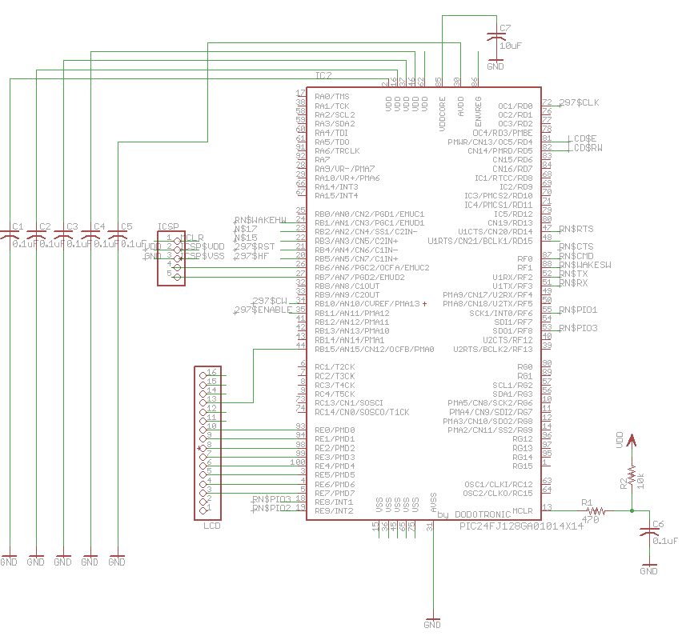

Figure 1 Microcontroller circuit block

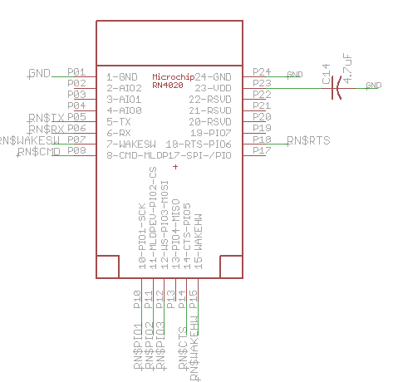

Figure 2 Bluetooth circuit block

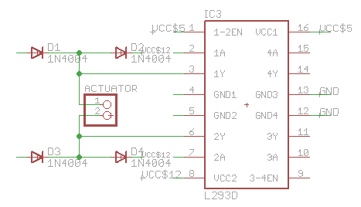

Figure 3 H-bridge circuit block

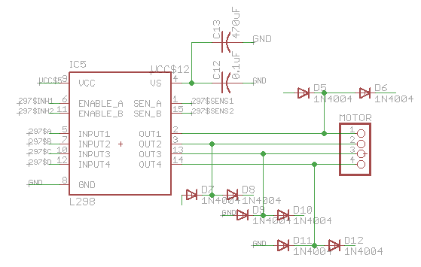

Figure 4 Full bridge circuit block

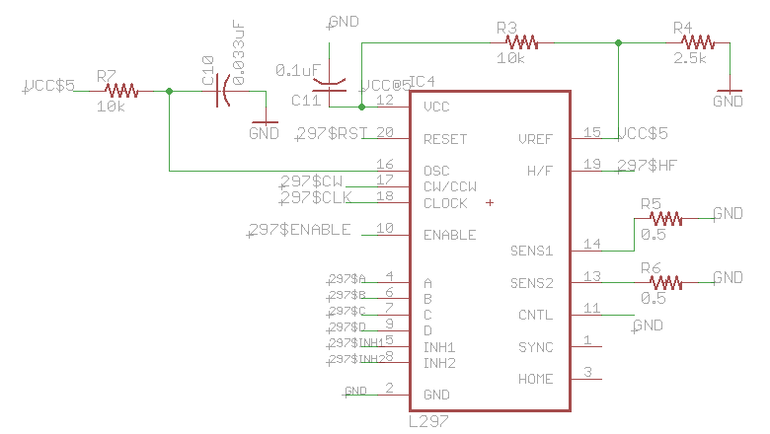

Figure 5 Stepper motor controller circuit block

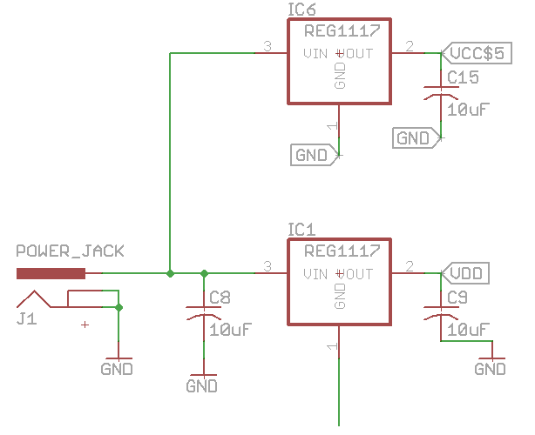

Figure 6 Power supply circuit block

Appendix B: FMECA Worksheet

Table 4 Microcontroller circuit FEMCA

|  |  |  |  |  |  |  |
| --- | --- | --- | --- | --- | --- | --- |
| **Failure No.** | **Failure Mode** | **Possible Causes** | **Failure Effects** | **Method of Detection** | **Criticality** | **Remarks** |
| 1 | No output signal | C1,C2,C3,C4,C5,C6,C7 not working | Unpredictable | No respond on every component. | Low | Assuming voltage supply is normal |
| 2 | Reset signal is always high | Reset pushbutton is broken | Can’t reset the system | Observation | Low | Assuming voltage supply is normal |
| 3 | Reset signal is always low | C6 is shorted | The system is constantly reset itself. | Observation | Low | Assuming voltage supply is normal |
| 4 | Microcontroller is not programmable | ICs are shorted | Microcontroller is broken | No respond on every component. | Medium | Assuming voltage supply is normal |

Table 5 Bluetooth circuit FEMCA

|  |  |  |  |  |  |  |
| --- | --- | --- | --- | --- | --- | --- |
| **Failure No.** | **Failure Mode** | **Possible Causes** | **Failure Effects** | **Method of Detection** | **Criticality** | **Remarks** |
| 4 | Not respond when power on | RN4020 internal module is broken, C14 is shorted and improper voltage input in pin WAKE_HW or WAKE_SW | Unable to communicate with microcontroller | No information displayed on LCD. | Low | LCD will display the status of Bluetooth status as well the order sent by Bluetooth |
| 5 | RN4020 can’t receive or transmit message from/to microcontroller | RN4020 internal module is broken | Unable to send or receive information from Bluetooth module | LCD display nothing while sending or receiving message from/to microcontroller. | Low | LCD will display the status of Bluetooth status as well the order sent by Bluetooth |

Table 6 H-bridge driver circuit FEMCA

|  |  |  |  |  |  |  |
| --- | --- | --- | --- | --- | --- | --- |
| **Failure No.** | **Failure Mode** | **Possible Causes** | **Failure Effects** | **Method of Detection** | **Criticality** | **Remarks** |
| 4 | No output signal or output cannot reach 5v | Zener diodes break down or the H-bridge is broken | H bridge is shorted. Cannot control the component connected to H-bridge driver | Observation, measure the output voltage from H bridge driver | Medium |  |
| 5 | Large noise appears on the output of full bridge driver | Zener diodes break down | unpredictable | No respond on every component. | Medium |  |

Table 7 Full bridge driver circuit FEMCA

|  |  |  |  |  |  |  |
| --- | --- | --- | --- | --- | --- | --- |
| **Failure No.** | **Failure Mode** | **Possible Causes** | **Failure Effects** | **Method of Detection** | **Criticality** | **Remarks** |
| 7 | No output signal  Or output cannot reach 5v | the full bridge driver is broken | Cannot control the component connected to full bridge driver | Observation, Measure the output voltage from full bridge driver | medium |  |
| 8 | Large noise appears on the output of full bridge driver | Opened bypass capacitor | unpredictable | Malfunction appears on some components connected to this full bridge circuit. | medium |  |

Table 8 Stepper motor controller circuit FEMCA

|  |  |  |  |  |  |  |
| --- | --- | --- | --- | --- | --- | --- |
| **Failure No.** | **Failure Mode** | **Possible Causes** | **Failure Effects** | **Method of Detection** | **Criticality** | **Remarks** |
| 4 | No output signal | Stepper motor is broken | Can’t drive the stepper motor. | Observation, check the function of stepper motor | Medium |  |
| 5 | Large noise appears on the output of full bridge driver | Decoupling capacitors are shorted | unpredictable | Malfunction appears on stepper motor | Medium |  |

Table 9 Power supply circuit FEMCA

|  |  |  |  |  |  |  |
| --- | --- | --- | --- | --- | --- | --- |
| **Failure No.** | **Failure Mode** | **Possible Causes** | **Failure Effects** | **Method of Detection** | **Criticality** | **Remarks** |
| 4 | Voltage regulator is short | LD117 is broken | Damage all the ICs and microcontroller. | Touch and observation. The temperature of L293D increases dramatically. | High | Overheat of the system will cause the electrical components burning. |