User Manual

Year: __2017____ Semester: __Spring______ Team: __8___ Project:_________Barbot_____________

Creation Date: ______4/12/2017________________ Last Modified: April 14, 2017

Author: ________Yudi Wu_________________ Email: ________wu553@purdue.edu_____________________

Assignment Evaluation:

|  |  |  |  |  |
| --- | --- | --- | --- | --- |
| **Item** | **Score (0-5)** | **Weight** | **Points** | **Notes** |
| **Assignment-Specific Items** | | | | |
| **Product Description** | 4 | x1 | 4 |  |
| **Product Illustration** | 4 | x2 | 8 |  |
| **Setup Instructions** | 5 | x3 | 15 |  |
| **Usage Instructions** | 5 | x3 | 15 |  |
| **Troubleshooting Instructions** | 5 | x3 | 15 |  |
| **Writing-Specific Items** | | | | |
| **Spelling and Grammar** | 4 | x2 | 8 |  |
| **Formatting and Citations** | 5 | x1 | 5 |  |
| **Figures and Graphs** | 5 | x2 | 10 |  |
| **Technical Writing Style** | 5 | x3 | 15 |  |
| **Total Score** | 95 | | |  |

5: Excellent 4: Good 3: Acceptable 2: Poor 1: Very Poor 0: Not attempted

Comments:

1. Product Description

Have you ever wanted to enjoy a drink at home after daylong working? Have you ever yearned for designing you own cocktail? Barbot makes you dream come true. You can enjoy your favorite drink at any time with just one click on your phone. Except our default menu, you can also customize you own drink. You can choose the types and amounts of the drink. All you need is to download Barbot application on your phone! Barbot can prepare your drink in minutes. Holding a party at home without spending money hiring bartender. Barbot can do all the work for you!

Inside your Barbot package, you should find:

* Barbot
* User manual

There are two modes supported by Barbot:

1. Default Drink Mode

There are total 8 famous cocktail listed in our drink menu. All you need is to choose your drink by click on the menu on your APP. There will be a popup confirmation window to confirm your choice. After you click YES, the drink will be prepared on Barbot.

1. Custom Drink Mode

There are totally 8 liquor listed on our custom menu. You can choose the drink and enter the shot number for each type you want. There will be a popup confirmation window showing your custom recipe. After you click YES, the drink will be prepared on Barbot. If you click No, you can go back to the custom menu and edit your choice.

1. Product Illustrations

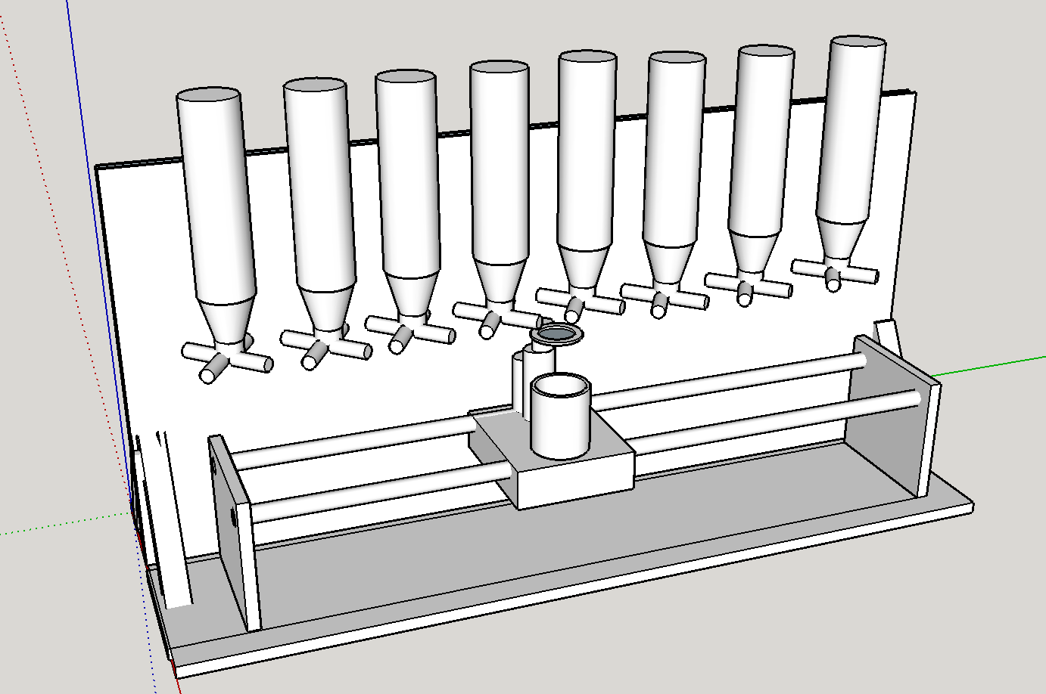

Figure 2.1 Barbot Rendering

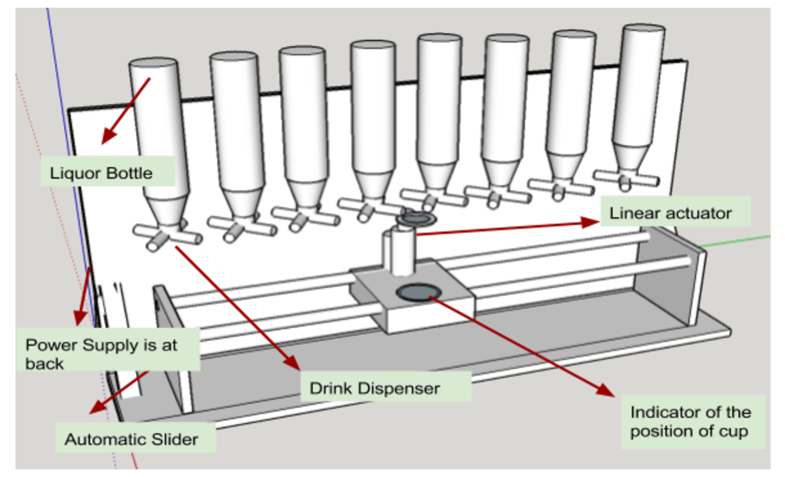

**Figure 2.2 Parts of Barbot**

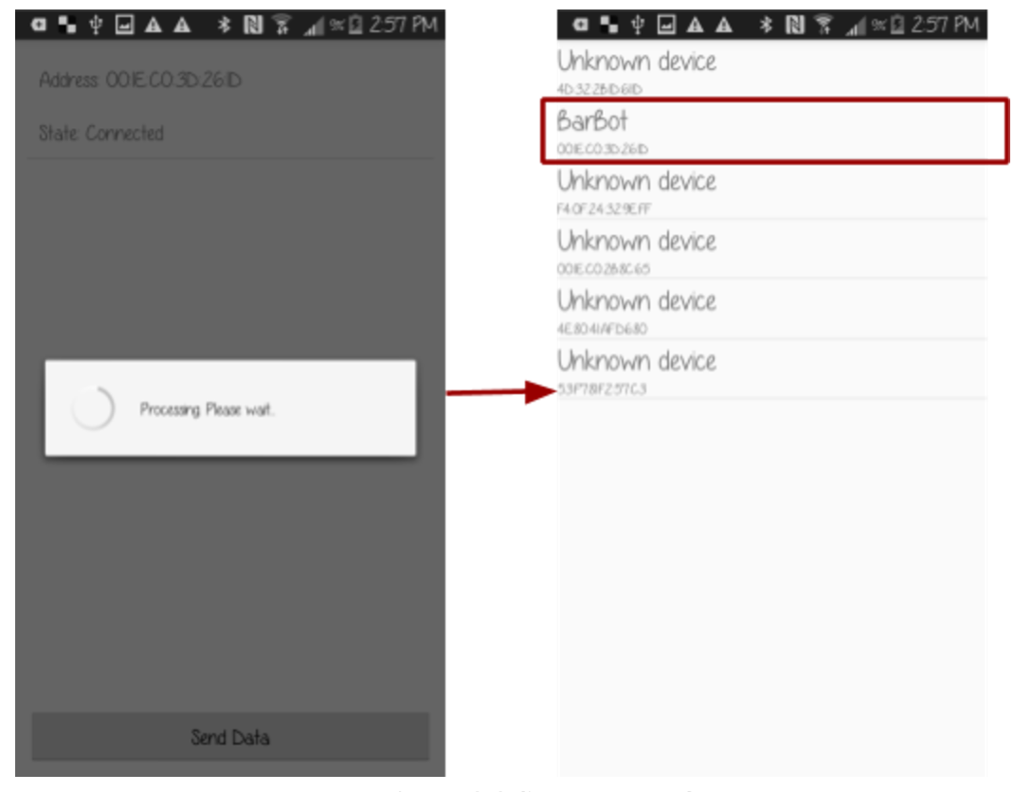

Figure 2.3 Setup page of Bluetooth

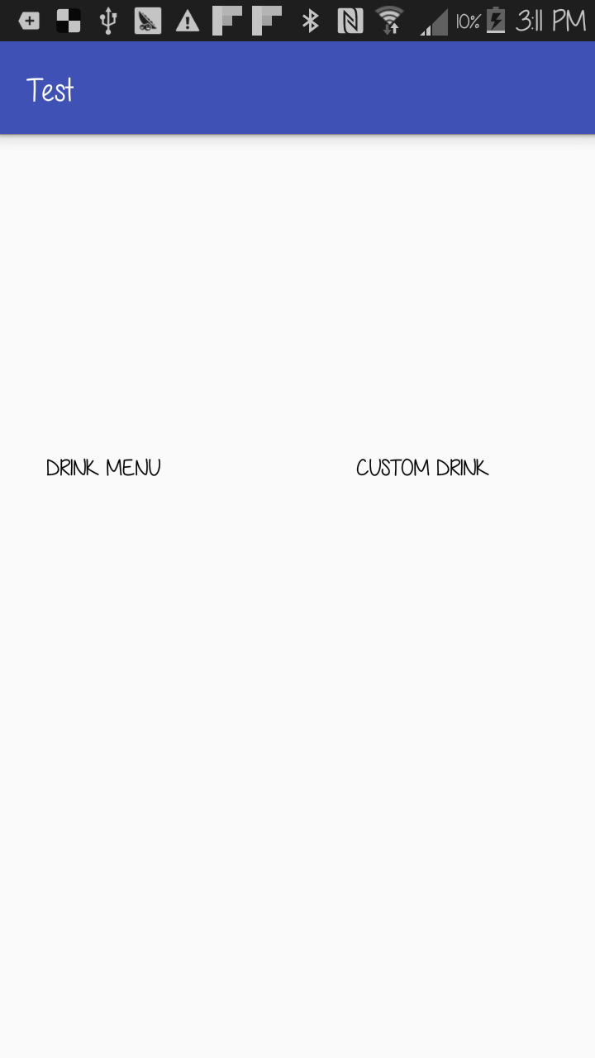

Figure 2.4 Main Menu of Barbot Application

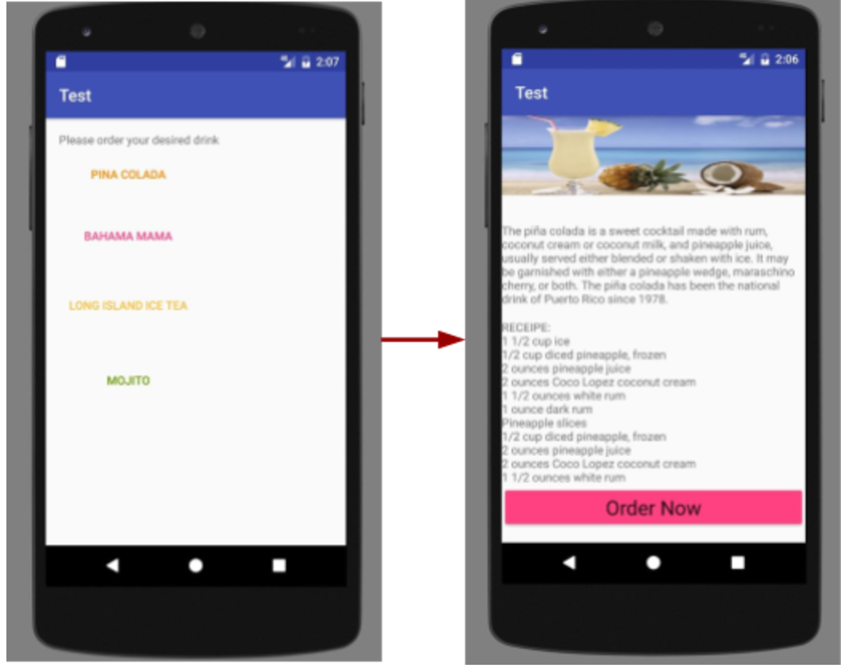

**Figure 2.5 Drink Menu**

1. Setup Instructions

To ensure Barbot can work properly, here are the setup instruction users need to follow:

1. Place Babot on a horizontal plane.
2. Plug Barbot into the outlet on the wall.
3. Place your glass direct on the top of circle sign of the platform. The circle sign signifies the position of the glass should be placed.
4. Turn on Bluetooth on your phone, and connect the Bluetooth of your phone with Barbot.
5. Open you Barbot application.
6. Make you choice of the drink. There are totally two portions on the menu. The first portion is default menu drink, and the second portion is for costuming drink.
7. The above should be repeated after every time you turn on the Barbot.
8. Usage Instructions

Now that you have set up Barbot as per the steps in section 3.0, the following general instructions will help you during you use Barbot. They are broken down into sections for Default Drink Instruction, Custom Drink Instruction, and Maintain Instruction.

Default Drink Instruction:

1. Simply click on your choice, and there will be confirmation page for your choice.
2. Click on YES, Barbot will start preparing your drink.
3. If click on No, you will go back to the menu page, and you can make a new choice. Repeat Default Drink Instruction step 1, 2 and 3.
4. When the drink is ready, there will be an information pop-up stating “Your drink is ready. Enjoy!”

Custom Drink Instruction:

1. Scroll down the menu, you will see custom drink portion.
2. You can make you choice by enter the amount of shots you want in the slot beside the liquor name.
3. You can choose up to 8 shots in total for all the drink you choose.
4. After you make your choice, there will be a confirmation page pop up. If you click YES, Barbot will start preparing your custom drink.
5. If click No, you will go back to the menu page. You can make edit your choice. Repeat step Custom Drink Instruction step 1, 2, 3, 4 and 5.
6. When the drink is ready, there will be an information pop-up stating “Your drink is ready. Enjoy!”

Maintain Instruction:

* If you see liquid around the control module, wipe of the control module ASAP for avoid further damage or unintended danger.
* There is a Reset button on the control module. This button is used for suspending Barbot during its working. Unless critical situation, better don’t play around with that button.
* Don’t forget to unplug Barbot from power source after using it. This will protect the circuit in the control module, which can prolong its lifespan.
* Don’t unplug Barbot while it is working to avoid unpredictable situations when you plug in next time.
* Every time replacing the empty bottle from Barbot, remove the bottle with valve together by trigger the trick behind the valve.

1. Troubleshooting Instructions

* Is Barbot turning on?

Check whether the Barbot has been plugged into the outlet of the wall, and check the status displayed on the LCD.

* Is your phone successfully connected with Barbot?
* Check whether the Bluetooth is turned on on your phone.
* Check whether Barbot is turned on (Check last troubleshooting question).
* Check the LCD on the Barbot. This LCD will display the connection status of Barbot.
* The dispenser can’t dispense the drink
* Check whether the drink bottle is out of drink.
* Check whether you place the Barbot on an uneven plane, which will cause the linear actuator can’t reach the valve.
* If you think the valve is blocked, you can call us on 1 800-820-8820 or email use on [customerService@barbot.com](mailto:customerService@barbot.com), we will then send you a new valve free.
* LCD won't display any information

Check its connectivity with control module

* Did none of the above solutions help?

Reset the Barbot by the Reset push button on the control module, or reattaching the main power cable from the wall outlet and re-plug in.

* Didn’t find you question above?

Please contact us by calling our 24/7 hotline: 1 800-820-8820, or leave us a message with your name, the serial number of Barbot, and a description about the problem you encountered. Our customer service will reach you within 48 hours.