### 实验12 数据持久化

（综合性实验 2学时）

1、实验目的

1. 掌握iOS中数据持久化的使用；
2. 掌握SQLite和CoreData的原理和使用；

2、实验要求

1. 认真填写实验报告，要求附加部分运行界面和主要代码；
2. 对设计好的程序，检查输出是否符合预期，如有错请分析错误原因并解决；

3、实验内容

1. 在命令提示符下熟悉并使用SQLite命令
   1. 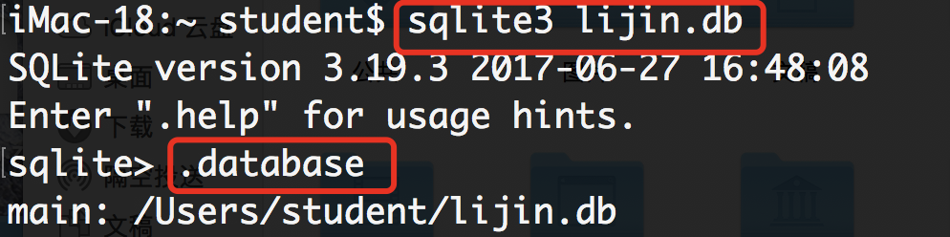新建sqlite3数据库
   2. 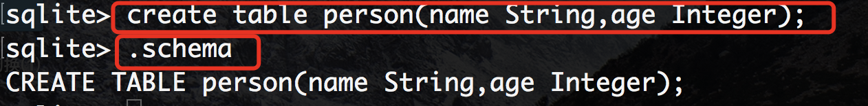新建Person表；
   3. 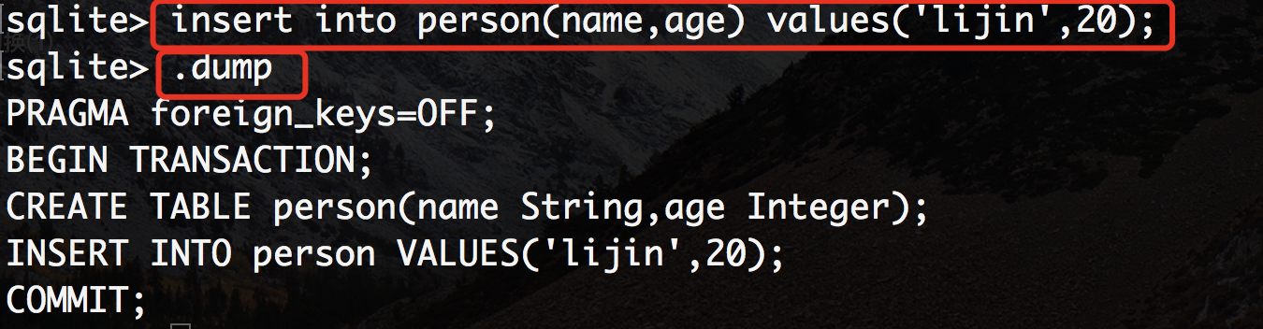插入新的数据；
   4. 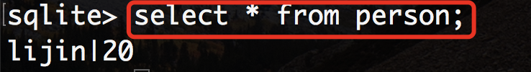查询数据；
2. 采用多MVC和Core Data构造一个Person信息维护程序，要求：
   1. 可插入新数据；
   2. 可删除修改原数据；
   3. 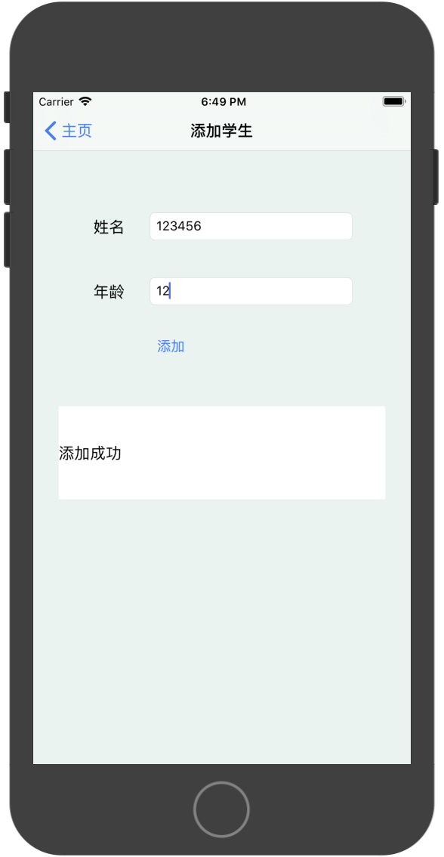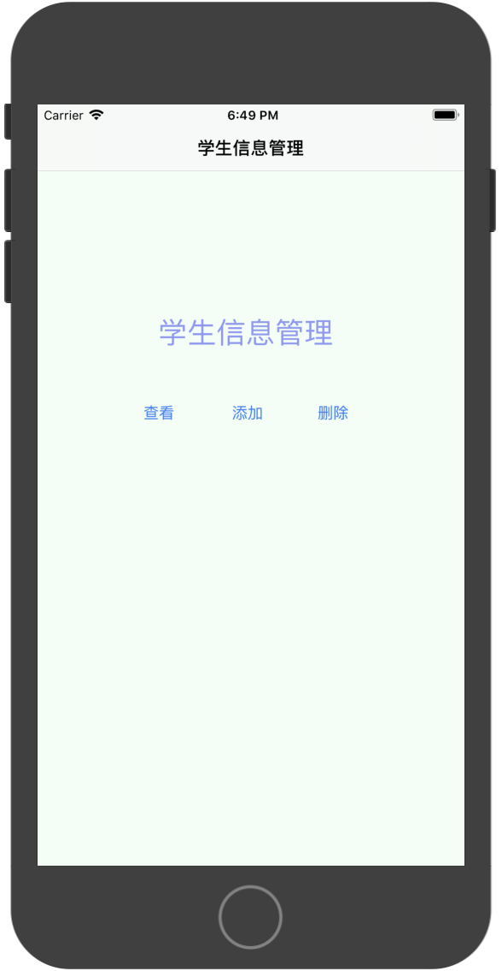可查询特定数据；

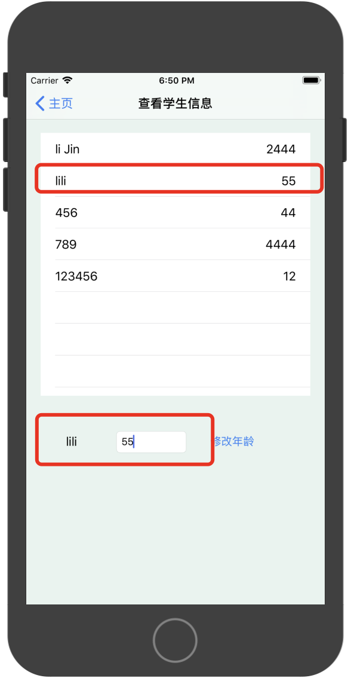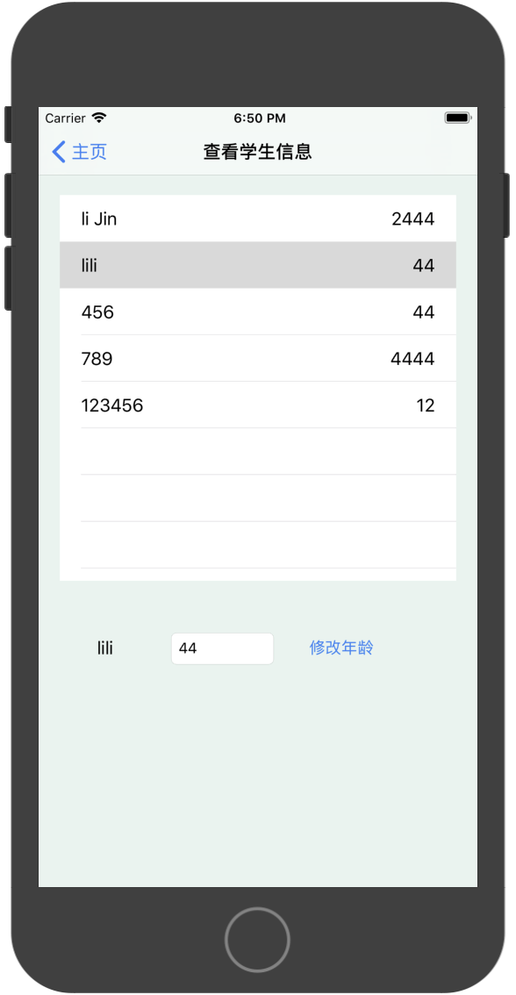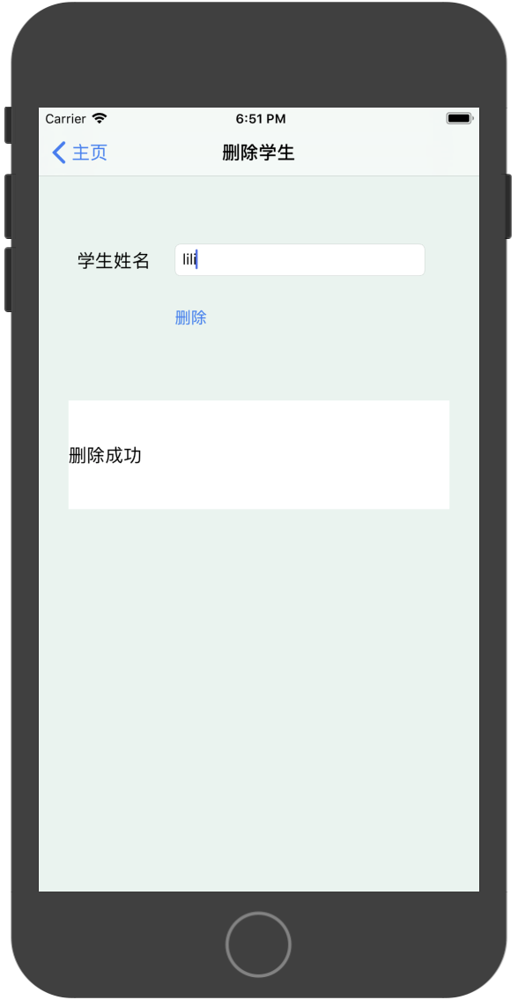

**//查看和修改**

**import** UIKit

*//111*

**import** CoreData

**class** SelectViewController: UIViewController,UITableViewDataSource,UITableViewDelegate {

**@IBOutlet** **weak** **var** tableView: UITableView!

**@IBOutlet** **weak** **var** choseLabel: UILabel!

**@IBOutlet** **weak** **var** ageLabel: UITextField!

*//222*

**var** appDelegate:AppDelegate!

**var** viewContext:NSManagedObjectContext!

*//444*

**var** persons:[Person]?

**override** **func** viewDidLoad() {

**super**.viewDidLoad()

*//333*

appDelegate = UIApplication.shared.delegate **as**? AppDelegate

viewContext = appDelegate.persistentContainer.viewContext

*//555.取对象们*

**let** fetch = NSFetchRequest<Person>(entityName: "Person")

persons = **try**? **self**.viewContext.fetch(fetch)

}

*//-----修改-------*

**@IBAction** **func** update(**_** sender: UIButton) {

**if** **let** name = choseLabel.text,**let** age = Int16(ageLabel.text!) {

**let** fetch = NSFetchRequest<Person>(entityName: "Person")

fetch.predicate = NSPredicate(format: "name = %@", name)

**let** persons = **try**? viewContext.fetch(fetch)

**for** p **in** persons!{

p.age = age

}

}

appDelegate.saveContext()

tableView.reloadData()

}

*//数据源*

**func** tableView(**_** tableView: UITableView, numberOfRowsInSection section: Int) -> Int {

**return** persons!.count

}

*//数据源*

**func** tableView(**_** tableView: UITableView, cellForRowAt indexPath: IndexPath) -> UITableViewCell {

**let** cell = tableView.dequeueReusableCell(withIdentifier: "cell")

*//666.显示对象*

cell?.textLabel?.text = persons![indexPath.row].name

cell?.detailTextLabel?.text = "\(persons![indexPath.row].age)"

**return** cell!

}

*//代理：选中时触发*

**func** tableView(**_** tableView: UITableView, didSelectRowAt indexPath: IndexPath) {

**let** cell = tableView.cellForRow(at: indexPath)

choseLabel.text = cell?.textLabel?.text

ageLabel.text = cell?.detailTextLabel?.text

}

*/\**

*// MARK: - Navigation*

*// In a storyboard-based application, you will often want to do a little preparation before navigation*

*override func prepare(for segue: UIStoryboardSegue, sender: Any?) {*

*// Get the new view controller using segue.destination.*

*// Pass the selected object to the new view controller.*

*}*

*\*/*

}

**//删除**

**import** UIKit

*//0000*

**import** CoreData

**class** DeleteViewController: UIViewController {

**@IBOutlet** **weak** **var** nameTF: UITextField!

**@IBOutlet** **weak** **var** detailTF: UILabel!

*//1111*

**var** appDelegate:AppDelegate!

*//3333*

**var** viewContext:NSManagedObjectContext!

**override** **func** viewDidLoad() {

**super**.viewDidLoad()

*//2222*

appDelegate = UIApplication.shared.delegate **as**? AppDelegate

*//4444*

viewContext = appDelegate.persistentContainer.viewContext

}

**@IBAction** **func** deleteStudent(**_** sender: UIButton) {

**let** name = nameTF.text

*//5555 设置要取的对象*

**let** fetch = NSFetchRequest<Person>(entityName: "Person")

*//6666 设置查询条件*

fetch.predicate = NSPredicate(format: "name = %@", name!)

*//7777 取出对象*

**if** **let** persons = **try**? viewContext.fetch(fetch){

**if** persons.count == 0{

detailTF.textColor = UIColor.red

detailTF.text = "删除失败"

}

**for** p **in** persons{

*//8888 删除对象*

viewContext.delete(p)

detailTF.textColor = UIColor.black

detailTF.text = "删除成功"

}

*//9999 保存修改*

appDelegate.saveContext()

}

}

*/\**

*// MARK: - Navigation*

*// In a storyboard-based application, you will often want to do a little preparation before navigation*

*override func prepare(for segue: UIStoryboardSegue, sender: Any?) {*

*// Get the new view controller using segue.destination.*

*// Pass the selected object to the new view controller.*

*}*

*\*/*

}

**//添加**

**import** UIKit

*//000.引入CoreData类*

**import** CoreData

**class** AddViewController: UIViewController {

**@IBOutlet** **weak** **var** nameTF: UITextField!

**@IBOutlet** **weak** **var** ageTF: UITextField!

**@IBOutlet** **weak** **var** messageTF: UILabel!

*//111.上下文*

**var** appDelegate: AppDelegate!

**var** viewContext: NSManagedObjectContext!

**override** **func** viewDidLoad() {

**super**.viewDidLoad()

*//222.获取上下文*

appDelegate = UIApplication.shared.delegate **as**? AppDelegate

viewContext = appDelegate.persistentContainer.viewContext

}

*//添加*

**@IBAction** **func** add(**_** sender: UIButton) {

**if** **let** name = nameTF.text,**let** age = ageTF?.text{

*//333.创建对象*

**let** person = Person(context: viewContext)

*//444.属性赋值*

person.name = name

**if** **let** ageint = Int16(age){

person.age = ageint

*//555.保存修改*

appDelegate.saveContext()

}**else**{

messageTF.textColor = UIColor.red

messageTF.text = "年龄输入不正确"

}

messageTF.textColor = UIColor.black

messageTF.text = "添加成功"

}**else**{

messageTF.textColor = UIColor.red

messageTF.text = "添加失败"

}

}

}