Public news publishing portal

NewsRead is a community news publishing portal for enabling English-speaking people share news for all themes and commenting news other peoples.

List of using technologies
For creating this project we use.
Server applications
- PHP 5.6 with included libraries for full functionality laravel core.
- MySQL 5.5
- Apache 2.4
PHP Framework
As PHP framework we selected Laravel 5.2. It’s latest stable release on current date.
List of technologies of we use.
Backend
- PHPUnit 5.5.4
- Laravel 5.2 with built-in libraries.
- DOMPDF 0.7 for laravel-side generation pdf.
  - https://github.com/dompdf/dompdf
  - https://github.com/barryvdh/laravel-dompdf

- Image Intervation for clear works with images in laravel core.
  - http://image.intervention.io/getting_started/installation#laravel

Frontend
- Boostrap 4 in frontend for enabling minimal mobile adaptive and nice look.
  - http://v4-alpha.getbootstrap.com/
- SemanticUI in frontend for clever and minimalistic output.
  - http://semantic-ui.com/
- jQuery and jQueryUI

Architecture

Architecture of our application use classical MVC pattern based on framework Laravel. Description about framework core is very large and we don’t report about it, focused only on currently development code.

Use Case diagram
Use case it’s a better way for display project requirements by user roles.
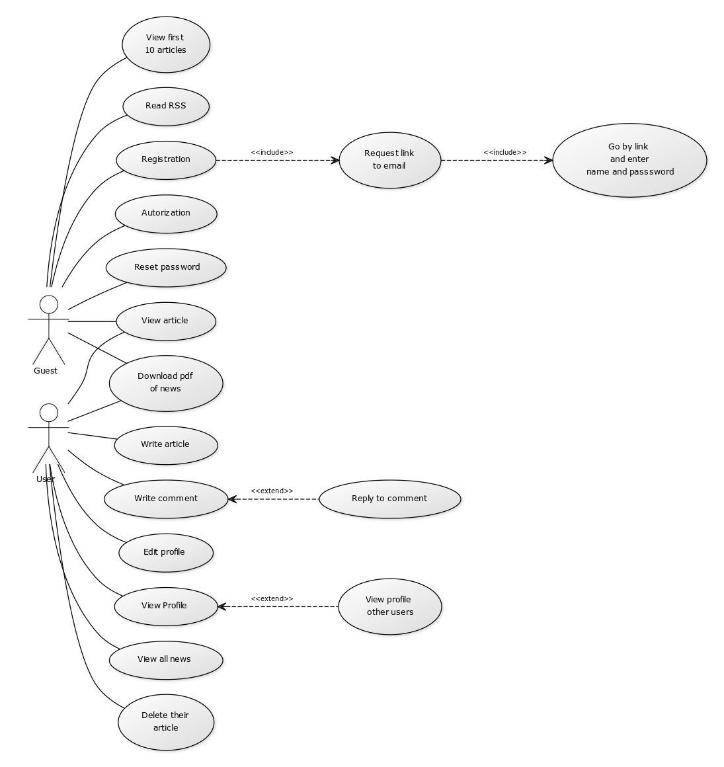

Overall activity diagram

Sequence of registration guest user

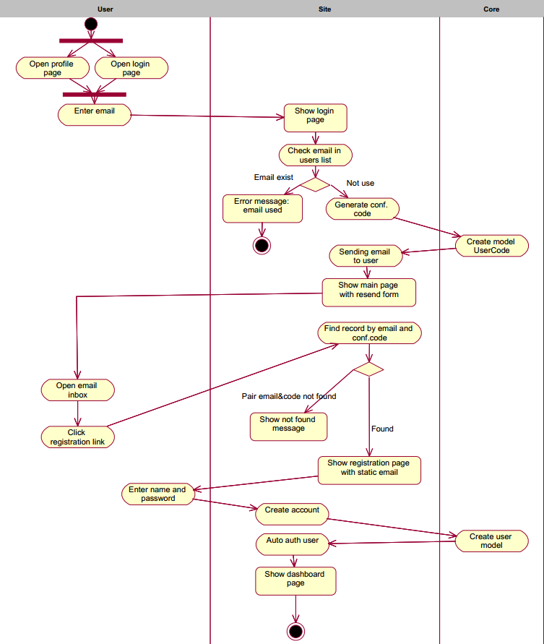

For start state user are not authorized and email not used in system already for clever description processes in system.
Diagram shows registration sequence for guest user. All actions also can be writing as simple list.
- User goes to NewsRead site.
- Pushing login link or link to profile of author.
- Enter email address for registration.
- Getting email message with registration link.
- Go to link and enter name and password.
- Now user creates and authorized.

Sequence of posting news
Algorythm of posting news show in this diagram. We was lowered details of validation and middleware check for show concept of work.
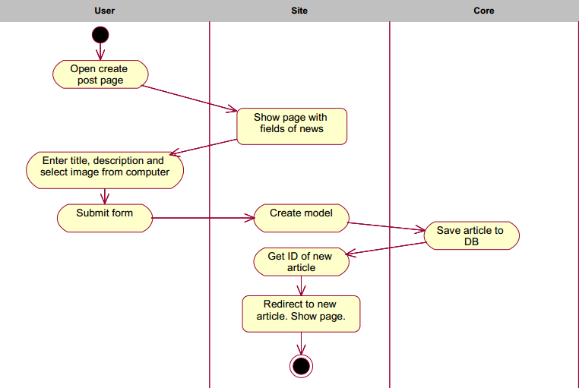
Other functionality features too simple for show in overall activity diagram.

Class diagram
Class diagram it’s a better way for display definite classes and relationship with them.

