Flow chart

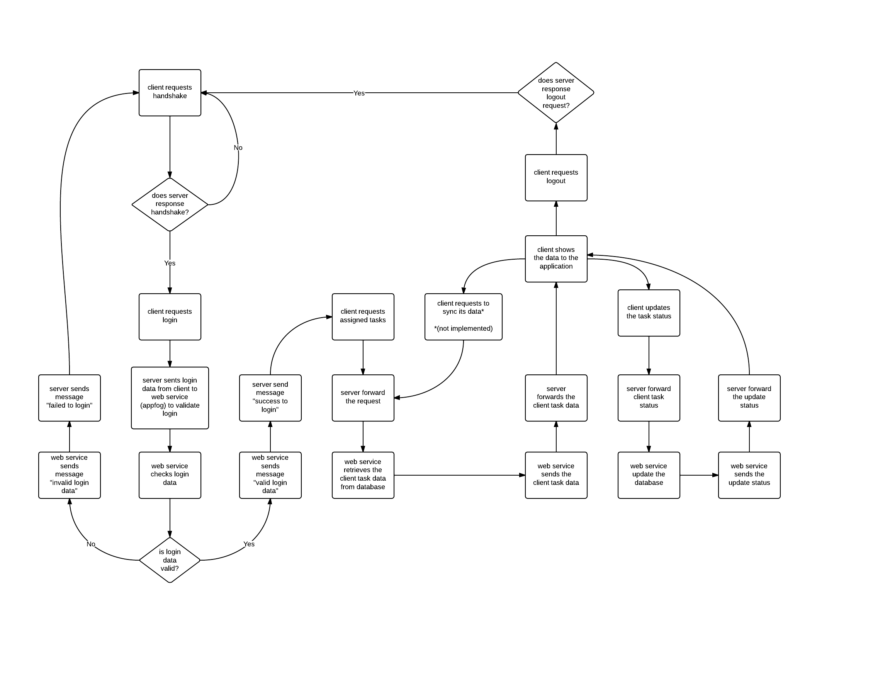

Format pengiriman pesan

Client ke server

|  |  |
| --- | --- |
| **Function** | **Request Message Format** |
| doHandshake() | handshake |
| doLogin(username, password) | login/<username>/<password> |
| doGetTask(username) | getTask/<username> |
| doUpdateTask(taskname,status,username) | update/<taskname>/<status>/<username> |
| doLogout() | Logout/<username> |

Server ke client

|  |  |
| --- | --- |
| **Function** | **Response Message Format** |
| doHandshake() | <success/full> |
| doLogin(username, password) | <Cannot access database/Success login/Username or password incorrect> |
| doGetTask(username) | <rowCount>_<columnCount>_<data1;data2;data3;data4 (separated by “;”)>~<data1;data2;data3;data4>~....~< data1;data2;data3;data4>~ |
| doUpdateTask(taskname,status,username) | success |
| doLogout() | success |

Server ke web service

|  |  |  |
| --- | --- | --- |
| **Function** | **Request Message Format** | **Response Message (in JSON)** |
| doLogin(username, password) | api.php/checklogin/<username>/<password in hash> | <1/0/connection error status> |
| doGetTask(username) | api.php/getTask/<username> | <id_tugas><id_kategori><nama_tugas><deadline><status><tag><attachment><username><status_tugas><nama_kategori> |
| doUpdateTask(taskname,status,username) | api.php/update/<taskname>/<status>/<username> | success |

API address to access Appfog web service: http://tubes4asdasd.aws.af.cm/api.php/