BMD Application Introduction
- BMD Spec:
http://www.blackmagicdesign.com/cn/products/decklink/techspecs/W-DLK-31
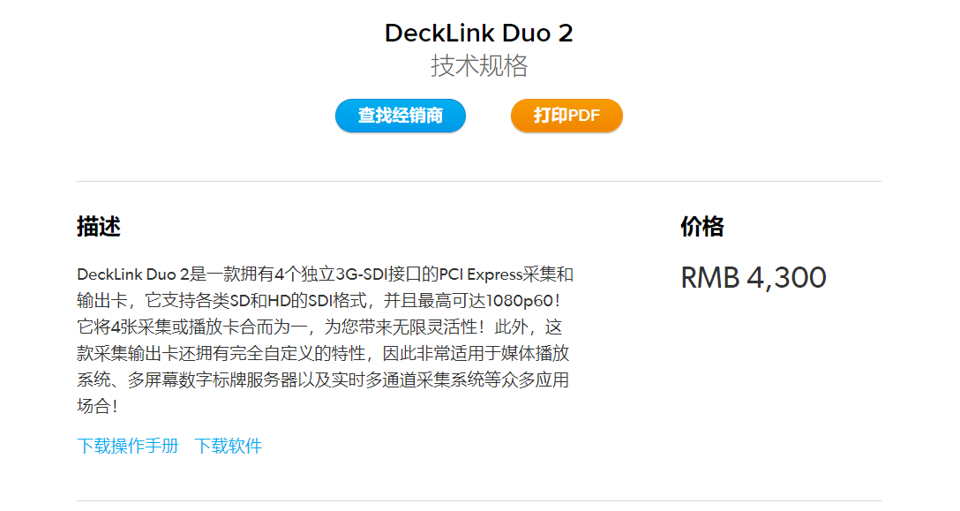

- Decklink Driver Install:
2.1 Download SoftWare Packets
http://www.blackmagicdesign.com/support/family/capture-and-playback
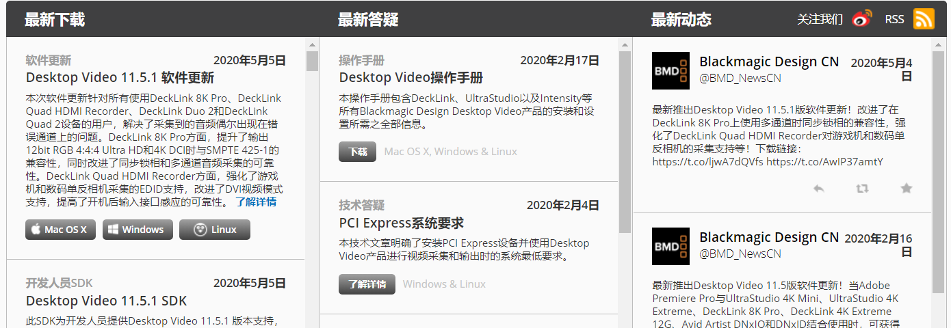
2.2 Install SoftWare Dependencies: sudo apt install dkms
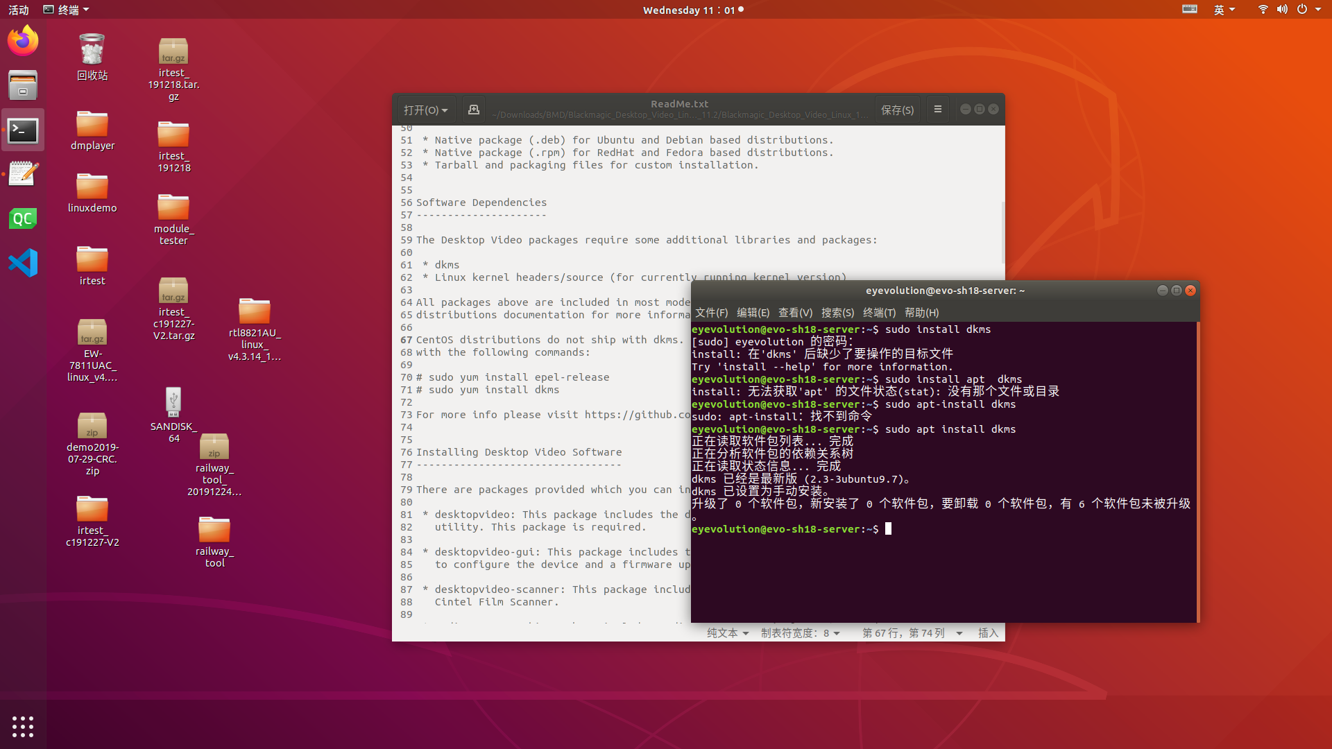
- DeskTopVideo Install
3.1 Desktopvideo Installation Packets file path as below picture
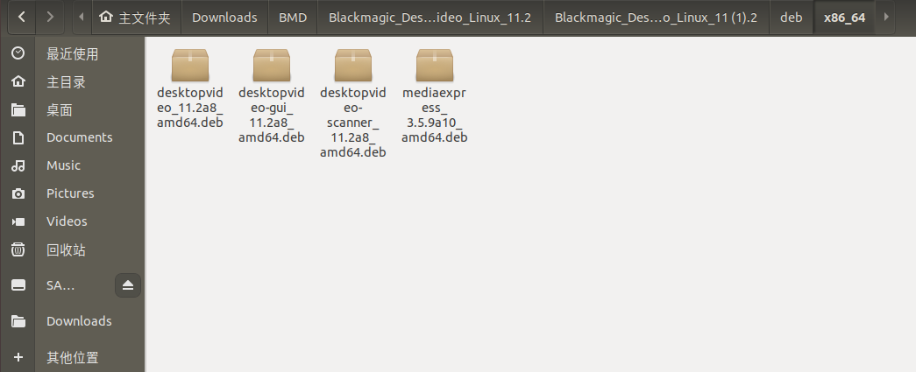
3.2 Desktopvideo Install:
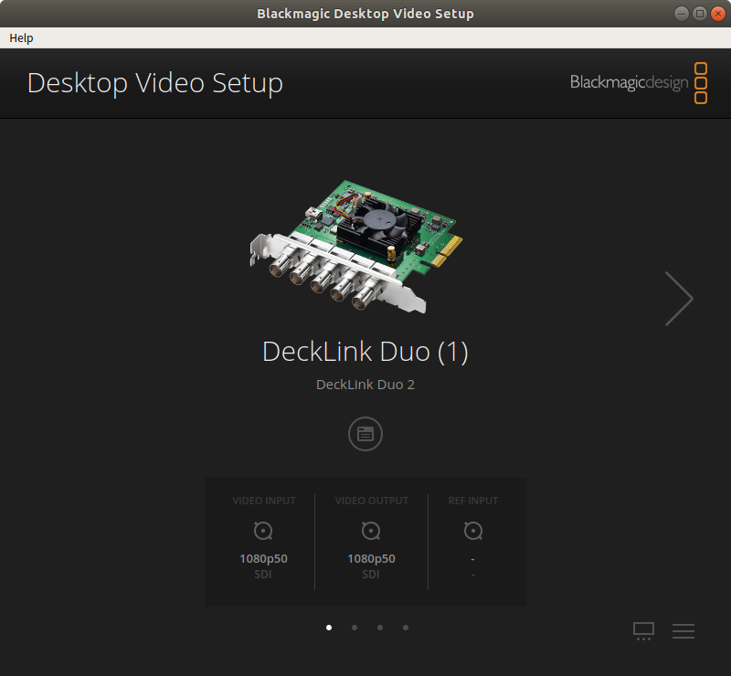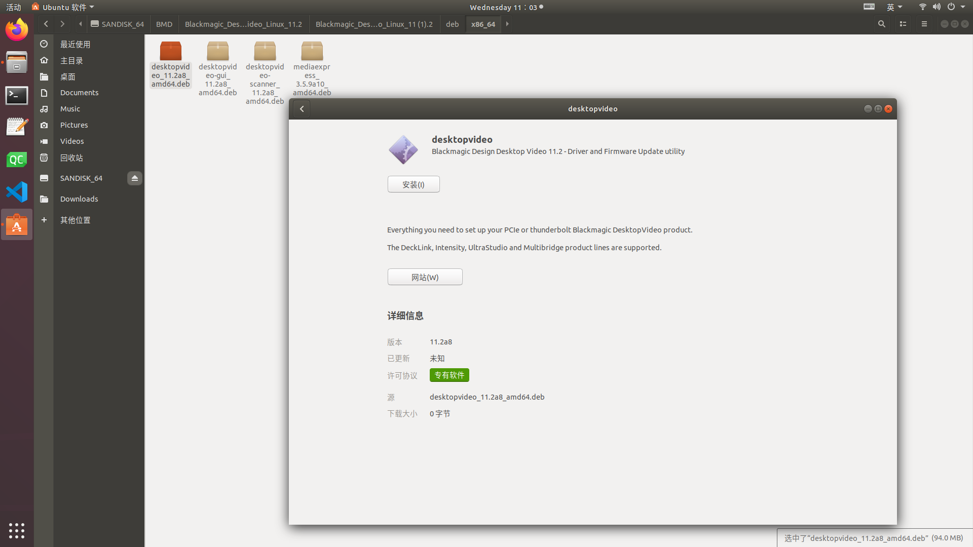
3.3 Desktopvideo-GUI Install: this step must be executed for graphical interface; if not,you can not see the icon of desktopvideo.
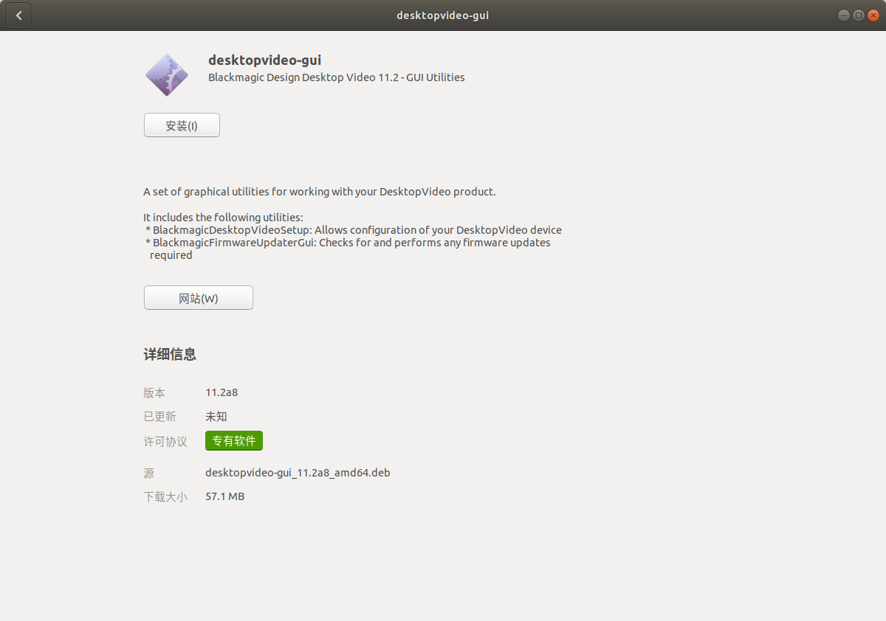
- MediaExpress Install:Capture and Playback video stream by choosing device number
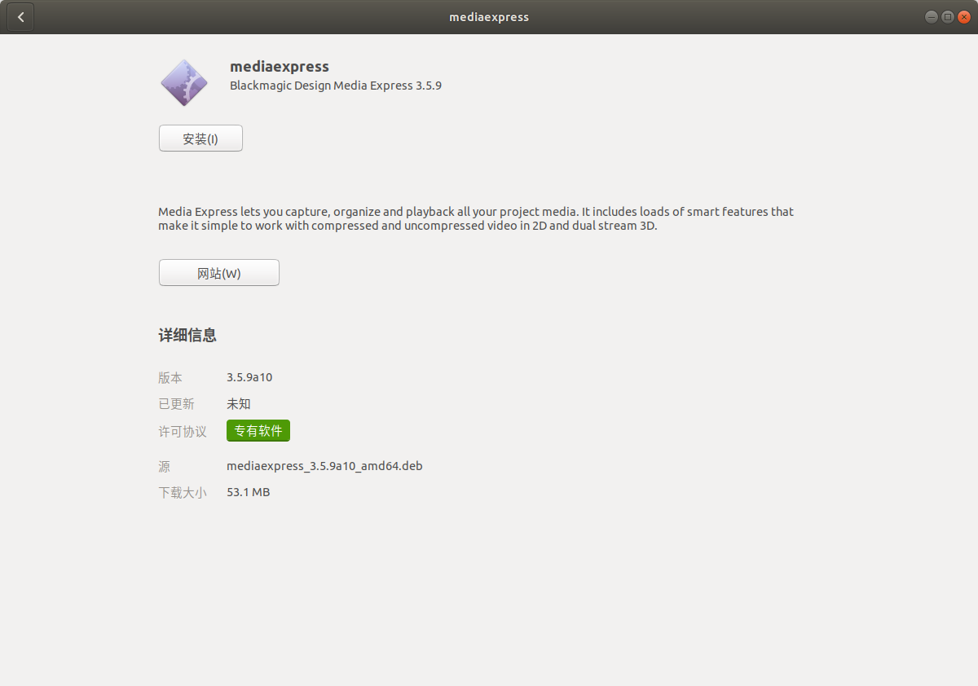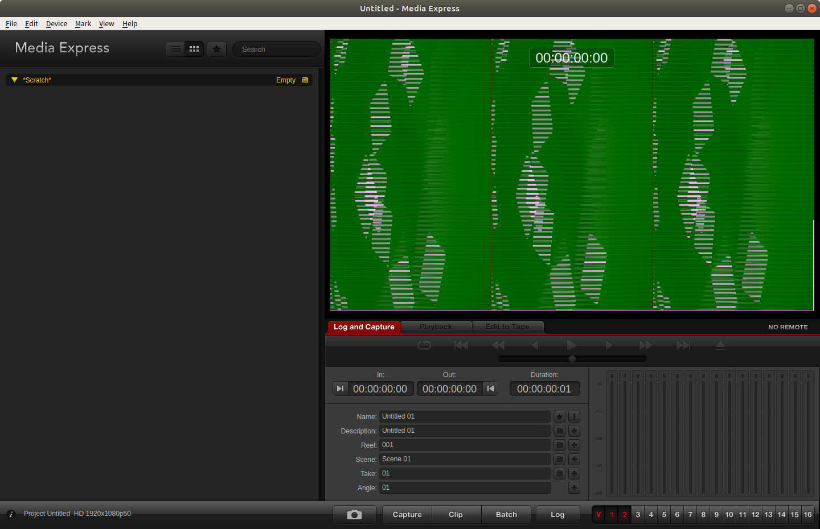

- Duplex & Non Duplex mode setting
