FP.5 Lidar Outlier Examples
- Starting around frame 52, the car in front stops moving. However, the Lidar data continues to vary (in particular, there’s a ring-shaped artifact overlaid on top of the actual car data), and sometimes that results in finite estimated TTCs. Examples are frames 66 (68sec) and 75 (65sec). None of these estimates is particularly small though.
- In frames 6 and 7, lidar detects a row of points that’s closer than the main body of the preceding vehicle. (I’m not entirely sure what, if anything, these points represent on the car; they don’t stand out on the camera overlay.) This causes the speed distance to jump up between frames 5 and 6, and the distance estimate in frame 6 to jump down, collectively resulting in a very low TTC estimate. Between frames 6 and 7, the tailpipe becomes less visible, so while the distance estimate is sensible, the speed is underestimated. Between frames 7 and 8, the tailpipe disappears again, causing the speed estimate to be very low, and the TTC estimate to be very high.

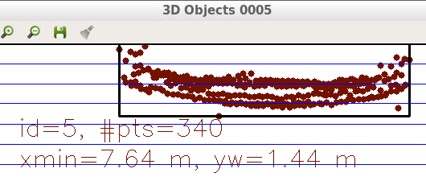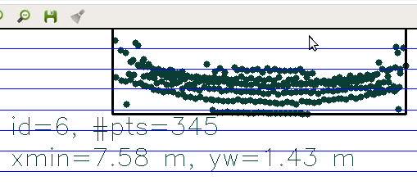
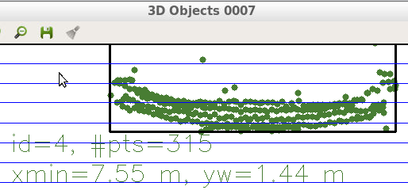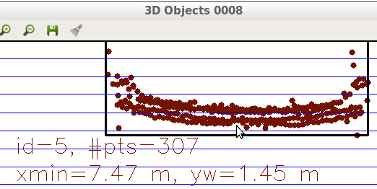

- In frames 50 and 51 a similar pattern (“underestimate, then overestimate”) is repeated, this time because the vehicle in front is getting so close that many of the points are obscured by the ego car itself, and there’s not enough points in the tail lights (the closest part of the vehicle that’s reliably detected) to anchor the estimation.

Finally, note that all the Lidar TTCs are (as best I can tell) times until the bumper of the car in front collides with the Lidar unit, rather than times until it collides with the front of the ego car. At estimated speeds of around 0.6m/s and approximately 2m between the front of the ego car and the lidar unit, there’s approximately 3.5sec between those two times!

