FP.6 Detector/descriptor pair comparisons and outlier analysis
- Detectors varied widely by how good their keypoints were. AKAZE, FAST, SIFT, BRISK, and Shi-Tomasi produced reasonable estimates (slightly deteriorating in this order), while ORB and Harris frequently generated infinite values, corresponding to no change in the median distance between keypoints. This appears to be the result of not forcing keypoints to be far apart. For example, the ORB detector appears to detect many keypoints that cluster together, with small distances within a cluster and large distances between clusters. Within each cluster, keypoints are likely to be detected in identical relative positions from one image to the next, primarily because our resolution is finite at that scale. The distances between clusters do change, but there will not be enough of those to force a median distance ratio that’s different from 1.
Example using the ORB detector, keypoints have been limited to best 100:
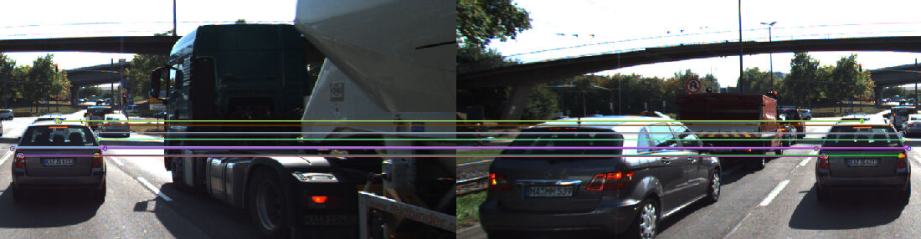
The keypoints are correctly matched between images, but there should be 23 distinct keypoints here for a total of 253 pairwise distances; instead, there’s only 6 meaningful keypoints on the vehicle (two tail lights, two mirrors, right corner of the window, top center of the roof), each of which is detected multiple times. (It’s also possible that the algorithm is picking up road markings for two of the other keypoints.) Since within a cluster of nearby keypoints the distances are unlikely to change due to discretization inherent in the finite pixel sizes, we end up with a “consensus” distance of 1.
This issue could be alleviated by insisting on larger separation between keypoints (a variant of non-maxima suppression).
- For some detectors (BRISK, Shi-Tomasi) using different descriptors occasionally produced substantially different estimates of the TTC. For example, in frame 5, BRISK detector + SIFT descriptor produced a TTC of >30sec. Examining the matches that went into consideration there, several of them are not on the preceding vehicle, but instead on the more distant vehicle in the lane to the right; the time to collision with that vehicle is indeed much larger!
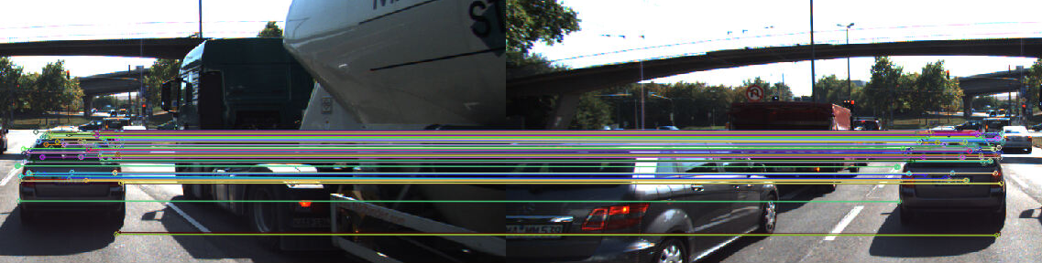
This will generally be a challenge for the camera-based estimation, because even detecting more distant points on the previous car (e.g. rearview mirror rather than nameplate) will skew the estimation (the time when the rearview mirror collides with the forward-facing camera on the ego car is at least a couple seconds later than the time when the nameplate does). Note that this image also illustrates another outlier in a different direction, the point on the shadow of the car on the road surface; it this dominated our estimate, we would compute a TTC that was considerably lower than the truth.
The solution to this appears to be to improve detection of just the rear plane of the vehicle (e.g. the nameplate); more sophisticated bounding box detection methods can presumably assist with that (both by knowing about nameplates, and by being able to classify image pixels as opposed to detecting a rectangular bounding box.

