**PenTac-Toe**

**PenTac-Toe** is a modified version of famous Tic Tac Toe paper-and-pencil game. Below are the rules of PenTac-Toe:

* Instead of having 3x3 grid, PenTac-Toe has **5x5** **grid**.
* There are **two** **players** in this game. First player will be known as **‘X’**, while the second one is known as **‘O’**.
* **Player** **X** always goes **first**.
* Players **alternate** placing Xs and Os on the game board until **win** **condition** **achieved** or all **twenty-five squares** are **filled**.
* The win condition is **placing three consecutive player’s symbol in the game board**, either **horizontal** or **vertical**.
* If **twenty-five turns has passed** and **neither of the player has won the game**, the game will be considered as a **tie**.

Your task is to create this program using C Programming language. Below are the requirements of this program:

* **Figure 1** shows the **initial** screen of the game. This screen will show **5x5 grid** of the board game. A system message will inform **which player** is playing this **turn** and **how** **many** **turn** **has** **passed** since the game is started.

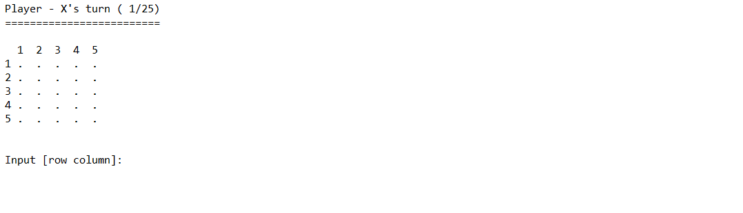

Figure 1. Screenshot of Initial Game Screen

* Player can choose which **cell** in the gameboard to place their symbol by **inputting** **row** **column**. The game will validate that:

1. The player **must** **input** a **valid** **row** **and** **column** value (**numeric** only), refer to **Figure 2**.

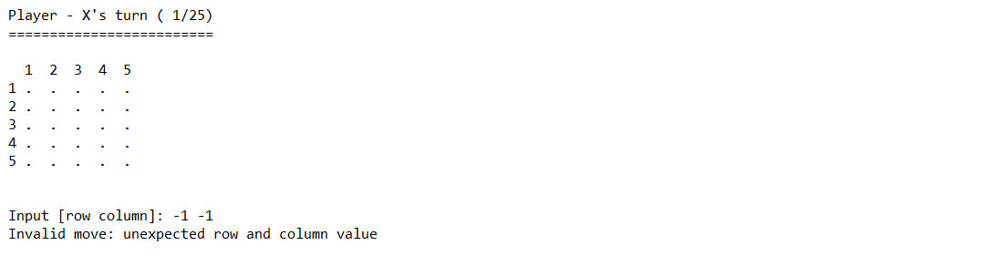

Figure 2. Screenshot of Invalid Cell Input: Invalid Row and Column Value

1. The player **must** **input** a **non** **occupied** **cell**, refer to **Figure 3**.

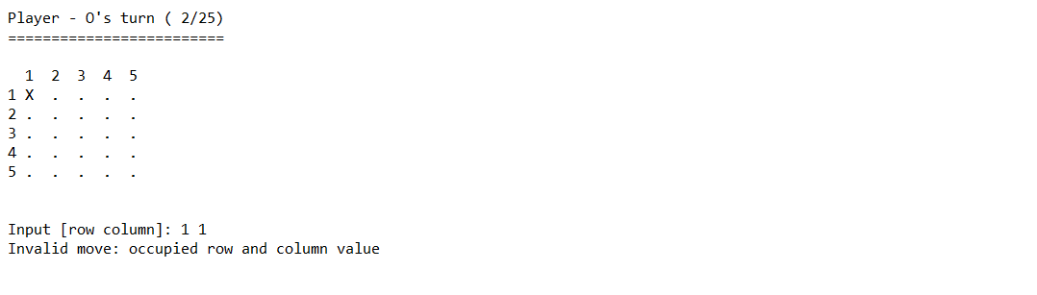

Figure 3. Screenshot of Invalid Cell Input: Choose an occupied cell

The player must **re**-**input** **row** and **column** until the game considers it as a valid movement. **Player can not skip their turn**.

* If the player **managed to place it’s symbol three times consecutively in the game board**, either **horizontal** or **vertical**, then the **game will over** and **this player announced as the winner**, refer to **Figure 4** and **Figure 5**.

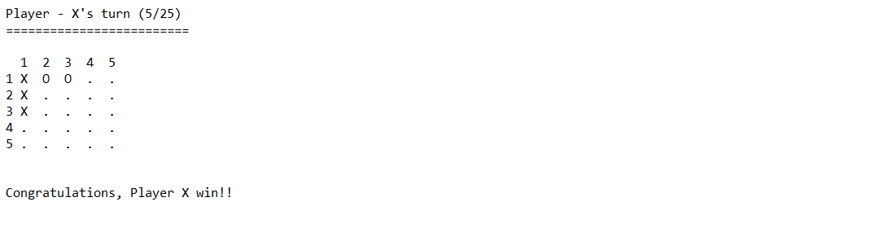

Figure 4. Screenshot of Player X win

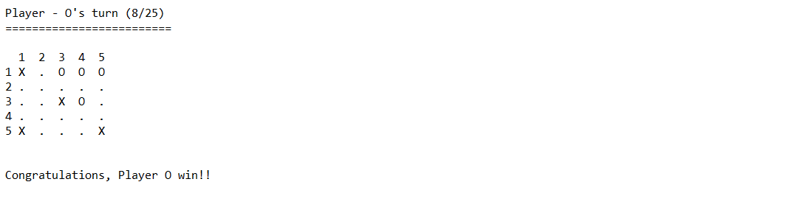

Figure 5. Screenshot of Player O win

* After **twenty-five turns** and **no player has won** yet, then the **game will be over** and considered as **tie**, as refer to **Figure 6**.

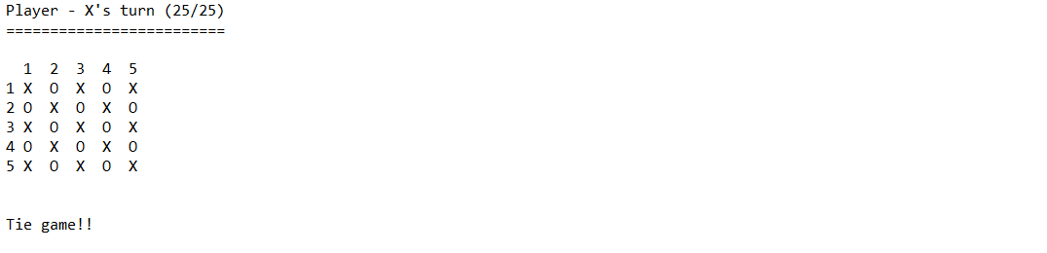

Figure 6. Screenshot of Tie Game Result

**-- Selamat Mengerjakan --**