Gaoxin Huang

Hours
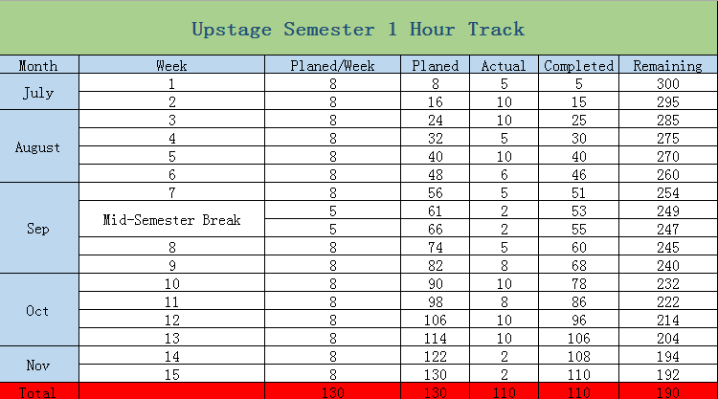

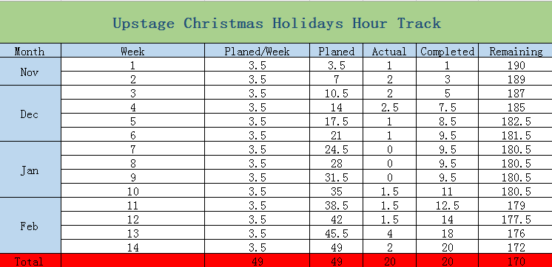

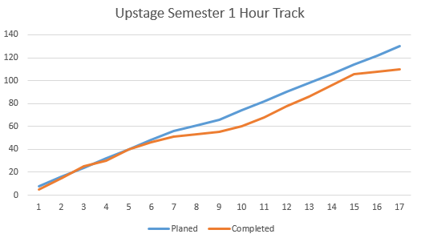
Originally, I planned to complete 150 hours in semester 1. However, I was busy for other classes and their assignments. Indeed, I have completed essential tasks which I got, but I did not have time to expand the tasks and did better in them. Thus, I planned 49 hours to remedy it in my holiday, but I got a job and I spent a lot of time on it and the job project. In this semester, I still have 170 hours to work, I believe I can achieve it and do more contributions to the project.

Tasks
- Project proposal---It is my first task for the project. I did methodology part and skill part. Indeed, I tried to find and use the suitable methodologies and skill to the proposal by what I learnt in the classes. In addition, I gave some ideas and helps to other parts.

- Lean and understand the current project---Our project is a heritage that previous teams leave to us. Thus, I needed and completed to understand the current project. It enables us to design and manage the project.

- Fix Bugs---There are a lot of bugs in current version of the project. In fact, each of us had these bugs to fix. I remembered I fixed one of them was to put save button in suitable position.

- Research in Flash and HTML5---The project is an “old” project with 10 years, so some of techniques need to replace. In this way, I got a task for research in replacement of flash. Then we found HTML5 may be useful for the replacement. Therefore, I did research in comparison of Flash and HTML5.

- Testing Compatibility---In the last semester, I got a task which was testing compatibility in version 3 of project. Indeed, my work was testing whether the latest Chrome supported to our projects.

- Protype (continue) ---To build new UpStage, we need to design the protype at first. It is a big challenge for us, because I, as a student, need to learn the latest techniques for taking them to our project. It is still in process step by step.

- Learning HTML5, JQuery and AngularJS (continue) ---These skills will be working for protype. Learning them for prepare to design the protype of project.

Learning
  - Semi-Professional Environment---I, in this project, am working in a semi-professional environment, which gives me horizons in working companies before my graduation. In fact, it pushes me to adapt working companies in advanced.

  - Problem-Solving Skill---In this project, I faced a few of problems which I have never seen. Thus, I tried to gain ideas in the Internet and discussed with other team members. For instance, I had not heard what the replacement of flash should be. To complete the task, I searched a lot of material on the internet and discuss with my partner to perform the task.

  - Communication---Communication is an essential skill in the project, I, in the project, found and understood the four steps of communication. The first of step is listen. Indeed, listening to ideas and solutions from other team members. Then we need thinking. The third of step is asking, asking some question which we do still not understand. Lastly, we present our idea basing on the above steps.

  - Methodology---Although I learnt a lot of methodologies before I started the project, I really used the methodologies and learnt new methodologies, such as Design Sciences, in the project.

  - Working with Legacy Code--- The vital thing that I have learnt during my time working on UpStage, is the difficulties that are working on an “old” software that needs designed and maintained. Therefore, it pushed me to learn how to maintain and work in legacy code and I got the experience from the project.

  - Programming Language---There are a lot of programming languages in the project, such as Python, CSS, ActionScript, HTML and JavaScript. In addition, the team push me to learn HTML5, JQuery and AngularJS to prepare for the next stage or new UpStage. All of programming languages enable me to obtain competitiveness in my future.

- Version Control Systems---The project offers some professional version control systems for us to control and manage the project, such as GitHub and SVN. In fact, some of the systems are really a requirement in companies’ recruitment.

  - System---The server of project is basic on Debian system, which requests us to understand and operate the system. Thus, I learnt some commands to control and run our project.

Improvement

Working on UpStage has taught me a lot of knowledge and given me work experiences, However, in the last semester, I, as a new member, did some tasks which most was for me to understand the project. In this semester, we will try to be the host of the project and do better than last semester.

