Yue

In the beginning of my project, I allocated 1 hour on each day throughout my final year study. Between July 24th, 2014 and June 21st, 2015, I can contribute 333 hours to my project. Such amount of hours will meet the criteria of 300 hours commitment. At this stage, my actual work time went over my initial estimation by a large amount. I committed 126 hours in the semester 2, 2014, and 147 hours during summer holiday. I would like to commit around 100 hours during semester 1 2015. By committing such amount of work, I will gain sufficient experience in software development practice and research.

Ongoing Activities
I write drafts for our fortnight developer blogs since the beginning. I consider developer blogs are quite useful for keeping the communication between UpStage community and our team. Our clients use developer blogs to track of team activities, and provide advice. I will carry on writing Blogs frequently to make sure UpStage community receives team activities often.

Work Completed in Semester 2, 2014

During semester 1, 2014. I divided my work into 3 areas:
- Bug fixing / Version 3 Code enhancement on ticket #200
- Research topic on Video Streaming technologies
- Participate Regression test

I resolved bug ticket #200 with Mikhail Chen on UpStage Git repository. I researched on Video Streaming technology with Mikhail. Since there was no clear guideline of our research, we performed a breadth-first search on all possible technologies, and evaluated them at my best thoughts. I did not expect my research would become far-fetched. When I realized all team members fell into the same situation, I started doubting performing research in a “breadth-first search” manner as the main method of our research. This experience resulted me looking into the current UpStage implementation and seeking for an alternative research approach. On the day of regression test, I found the current regression tests only validate the UpStage website instance, not the UpStage web application. After I communicated with Takuma Sato, he said we should only focus on the tasks not to question whether the task’s correctness.

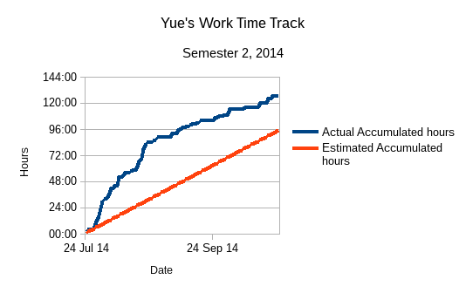

Summer Holiday
I committed 147 hours during summer holiday to obtain sufficient knowledge on the previous teams' work and Design Science. I came up with a research idea for conducting our research in semester 1, 2015. Design Science encourages researchers to come up with an idea/artefact, and use the artefact to evaluate the result of experiments.
UpStage’s requirement is complete. I can use the requirements as artefacts, and build up prototypes accordingly. Throughout the holiday, I monitored NPAPI deprecation via Chromium team blogs. Because of NPAPI deprecation, I promoted Flash-related research over the others. ActionScirpt 3 plays an important role on the client-end of current UpStage product. When I had firm grasp of UpStage’s features, I thought maybe I could write the same features in different technologies without ActionScript (considering ActionScript’s propriety status). Then I found NodeJS, HTML5 Canvas, Bootstrap, CSS3, and JQuery. While implementing part of the features, I also found Bootstrap advocates Mobile-first development. This also meet some desired features from UpStage's shortage ─ Mobile support.
As I worked on my own, I received good advice from UpStage community, and all the information helped me to have better understanding of UpStage.

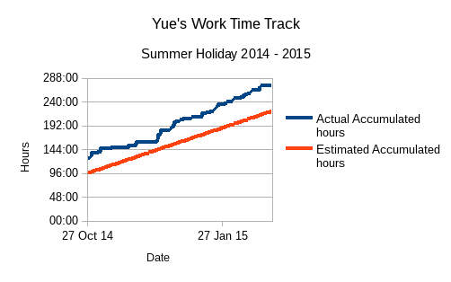

Reflection on Learning
In the last 8 months, I earned valuable experience. Especially in team effort and communication. In addition, I developed communication and technical skills as a software developer and quality assurance. I have summarized my software development and research experience as below:
- Learn from Failures
I make failures during project research and development activities. The mistakes contribute a large amount of experience to my individual development. Among all the mistakes, the outcome of my team's research topics forced me to think whether there is possibly a better way of performing team research. The failures also lead me thinking if we can combine the processes of Design Science and other techniques for the new semester team activities.
- Writing Developer Blogs
Preparing developer Blogs enhances the communication between AUT UpStage Team with the external UpStage community. This increases the chances of receiving feedback/assistance when team has some difficulties, especially in understanding the current implementation.
- Planning and QA are Important
I had a blur understanding on the current implementation. Without the proper guidance, I struggled finding the correct way of learning and contributing to the team. I think, in order to be an efficient and effective team, a solid plan must present for team members to follow. Moreover, a sophisticated QA must periodically verify and validate the team's work. For the new semester, I would propose a different approach to make sure my team is on the right track.
- Team Commitment Drives the Project Outcome
During the work done in the semester 2, 2014 and summer holiday, I concluded that sufficient commitment from each team member will become the most important element towards project success. How to contribute work equally has become an issue among team members. I discussed this situation with lecturer, Jim Buchan. After the discussion, I learned people are different. I think in the next semester, I will try to acknowledge others' work when we address issues with the team environment.
- Questioning Skills
When I started my final year project, I found all my knowledge from previous years did not help me directly. I never formally came across ActionScript and Python. I did not know how to configure a server in Debian system. Neither had I no clue about Design Science. In my first semester, I was busy doing what I was told to do until Anne told the whole team about our research irrelevance to our goal. After that I spent time thinking why and how we did our tasks wrong. I concluded as:
- The whole team is lack of commitment driving our project. Team members leaned to our supervisor for instructions.
- There was little information about what to accomplish, how to achieve the tasks in details, how to manage unforeseen incidents. When there is no clear planning, our project will fall.
- We must take the responsibilities for our work and our project outcome.
Since then I started thinking in: “What are the requirements of UpStage in the motivational document? What need change? Why we make change? What features new technologies should have? Is there any lightweight framework for fast-paced development?” By converting ideas into questions, I could look for answers. I also find questioning helps me on self-directed learning.
- Technical Skills
In the first half of my project, I learned how to setup Debian server instance for UpStage V3. I worked on JavaScript code on the UpStage site. I practised collaboration tools such as Git and SVN.
During summer holiday, I studied how to use Node.JS, HTML5 Canvas, Bootstrap and JQuery to create a responsive single-page web application. I practiced how to use Embedded Javascript template to manage front-end code. I used JQuery to control the events of Node.JS application. I learned how to use JSON package specification and NPM (Node Package Manager) to deploy my Node.JS application.

