Notes for Implementing Machine Learning Models

Yue Wang

**Notes**:

Use bold lower-case characters represent column vectors, for example:

$$x=\left[\begin{matrix}x_{1} \\ \begin{matrix}x_{2} \\ x_{3} \\ …\end{matrix} \\ x_{n}\end{matrix}\right]$$

The row vectors are represented as the transpose of a column vector, for example ***x***T=[*x*1, *x*2…,*xn*].

A matrix is represented by a bold upper case character.

# Decision trees

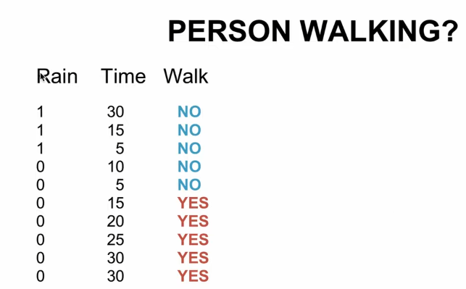

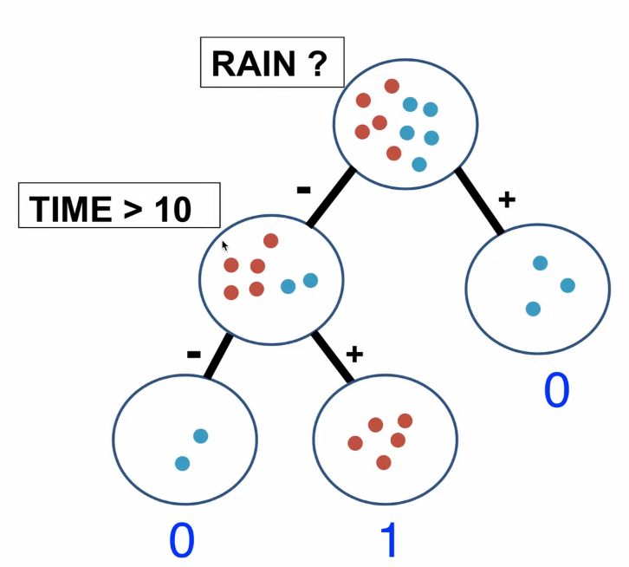

# Linear Regression

The number of examples is *m*, and the number of features is *n*. Each example is a column vector, i.e., the shape of the *i*th example is (*n*, 1), $i∈[1,m]$

$$x^{(i)}=\left[\begin{matrix}x_{1}^{(i)} \\ \begin{matrix}x_{2}^{(i)} \\ x_{3}^{(i)} \\ …\end{matrix} \\ x_{n}^{(i)}\end{matrix}\right]$$

or represented as ***x*** for short,

$$x=\left[\begin{matrix}x_{1} \\ \begin{matrix}x_{2} \\ x_{3} \\ …\end{matrix} \\ x_{n}\end{matrix}\right]$$

Weights ***w*** has the shape (*n*, 1)

$$w=\left[\begin{matrix}w_{1} \\ \begin{matrix}w_{2} \\ w_{3} \\ …\end{matrix} \\ w_{n}\end{matrix}\right]$$

$$\hat{y}=w^{T}x+b$$

Loss function:

$$L_{i}={\left({\hat{y}}^{(i)}-y^{(i)}\right)}^{2}$$

The average loss of the m examples (mean sum of error):

$$J=\frac{1}{m}\sum_{i=1}^{m}{L_{i}}$$

Gradient descent:

$$w=w-α\frac{∂L}{∂w}$$

where,

$$\frac{∂J}{∂w_{i}}=\frac{1}{m}\sum_{i=1}^{m}{2x_{i}\left({{\hat{y}}_{i}-y}_{i}\right)}$$

Vectorization

Use ***X*** to represent all learning examples:

$$X=\left[\begin{matrix}{x^{(i)}}^{T} \\ \begin{matrix}{x^{(2)}}^{T} \\ {x^{(3)}}^{T} \\ …\end{matrix} \\ {x^{(m)}}^{T}\end{matrix}\right]$$

The shape of ***X*** is (*m*, *n*), *m* is number of examples, and *n* is the number of features. The vectorized form of ***y*** is:

$$y=\left[\begin{matrix}y_{1} \\ \begin{matrix}y_{2} \\ y_{3} \\ …\end{matrix} \\ y_{m}\end{matrix}\right]=X∙w+b$$

$$\frac{∂L}{∂w}=\left[\begin{matrix}\frac{∂L}{∂w_{1}} \\ \begin{matrix}\frac{∂L}{∂w_{2}} \\ \frac{∂L}{∂w_{3}} \\ …\end{matrix} \\ \frac{∂L}{∂w_{n}}\end{matrix}\right]$$

$$\frac{∂J}{∂w}=\frac{1}{m}\left(X^{T}∙(\hat{y}-y)\right)$$

$$w=w-α\frac{∂H}{∂w}=$$

And gradient of ***b*** is similar.

Pay attention how the vectorization of gradient descent is done in Python codes. (Note that the equation/codes of linear regression and logistic regression are the same, perceptron has the similar form)

# Logistic regression

The notation is very similar to the linear regression.

One modification is made in this implementation. We add 1 to each example so that we do not have to add the *b*.

$$x=\left[\begin{matrix}{\begin{aligned}1 \\ x\end{aligned}}_{1} \\ \begin{matrix}x_{2} \\ x_{3} \\ …\end{matrix} \\ x_{n}\end{matrix}\right]$$

$$z=w^{T}x$$

$$\hat{y}=a=σ\left(z\right)=\frac{1}{1+e^{-z}}$$

Loss function:

$$L\left(\hat{y},y\right)=L\left(a,y\right)=-\left[ylog\left(a\right)+(1-y)log⁡(1-a)\right]$$

The cost function *J* is the average loss of the m examples (mean sum of error):

$$J=\frac{1}{m}\sum_{i=1}^{m}{L_{i}}=\frac{1}{m}\sum_{i=1}^{m}{L({{\hat{y}}_{i}}^{\left(j\right)},{y_{i}}^{(j)})}$$

Gradient descent:

$$\frac{dL}{da}=-\frac{y}{a}+\frac{1-y}{1-a}$$

$$\frac{dL}{dz}=\frac{dL}{da}\frac{da}{dz}=\left(-\frac{y}{a}+\frac{1-y}{1-a}\right)a\left(1-a\right)=a-y$$

$$\frac{dL}{{dw}_{i}}=(\hat{y}-y)x_{i}$$

For a single sample:

$$w_{i}=w_{i}-α(\hat{y}-y)x_{i}$$

For gradient descent of a batch (averaged gradient):

$$\frac{∂J}{∂w_{i}}=\frac{1}{m}\sum_{i=1}^{m}{\frac{dL}{{dw}_{i}}}=\frac{1}{m}\sum_{j=1}^{m}{({{\hat{y}}_{i}}^{(j)}-{y_{i}}^{(j)}){x_{i}}^{(j)}}$$

$$w_{i}=w_{i}-α\frac{∂J}{∂w_{i}}=w_{i}-α\frac{1}{m}\sum_{i=1}^{m}{({\hat{y}}_{i}-y_{i})x_{i}}$$

Vectorization

Use ***X*** to represent all learning examples:

$$X=\left[\begin{matrix}{x^{(1)}}^{T} \\ \begin{matrix}{x^{(2)}}^{T} \\ {x^{(3)}}^{T} \\ …\end{matrix} \\ {x^{(m)}}^{T}\end{matrix}\right]$$

The shape of ***X*** is (*m*, *n*), *m* is number of examples, and *n* is the number of features. The vectorized form of ***y*** is:

$$y=\left[\begin{matrix}y_{1} \\ \begin{matrix}y_{2} \\ y_{3} \\ …\end{matrix} \\ y_{m}\end{matrix}\right]$$

$$\hat{y}=sigmoid\left(X∙w\right)=σ(X∙w)$$

Gradient descent:

where,

(Note that the equation/codes of linear regression and logistic regression are the same, perceptron has the similar form)

# Perceptron

Perceptron can only be used for linearly separatable data sets. Label of y is either 0 or 1.

Activation function *g*(*z*) is a step function:

$$\hat{y}=g\left(z\right)=g(w^{T}x)=\left\{\begin{aligned}1, if z≥0 \\ 0,ifz<0\end{aligned}\right.$$

The equation for updating weight *w*, is the same to logistic regression.

$$w_{i}=w_{i}-α(\hat{y}-y)x_{i}$$

Use the updating rule above for all the samples that are predicted wrong. When all samples are correctly predicted, stop.

(Note that the equation/codes of linear regression and logistic regression are the same, perceptron has the similar form)

# Principal component analysis (PCA) and singular value decomposition (SVD)

Use ***X*** to represent all learning examples:

$$X=\left[\begin{matrix}{x^{(1)}}^{T} \\ \begin{matrix}{x^{(2)}}^{T} \\ {x^{(3)}}^{T} \\ …\end{matrix} \\ {x^{(m)}}^{T}\end{matrix}\right]$$

The shape of ***X*** is (*m*, *n*), *m* is number of examples, and *n* is the number of features. The vectorized form

PCA steps:

Step 1: compute mean of *X*.

Step 2: subtract mean from *X*. Note the examples with mean subtracted as *B*.

Step 3: compute covariance matrix of rows of B. the covariance is noted as *C*. Since *B* is the matrix with mean subtracted, we can use the following equation.

$$C=\frac{1}{m}B^{T}∙B$$

The covariance can also be computed using np.cov(*B*T). This function assumes that each column is an example, so we transpose *B*.

Step 4: compute eigen values and eigen vectors of *C*.

Method 1 of computing the eigen values/vectors of C: compute eigen vectors directly, e.g., np.linalg.eig(*C*)

Method 2 of computing the eigen values/vectors of C: use SVD.

$$C=UΣV^{T}={\left[\begin{matrix}u_{1} & … & u_{n}\end{matrix}\right]}_{n×n}{\left[\begin{matrix}\begin{matrix}σ_{1} & & \\ & … & \\ & & σ_{m}\end{matrix} \\ 0\end{matrix}\right]}_{n×m}{\left[V^{T}\right]}_{m×n}$$

dimensions: *C* is *n*×*n*, *U* is *n*×*n*, *V*T is *m*×*n*. Note that *σ*1≥ *σ*2≥…>0, and ***u****i* is the eigen vector corresponds to *σi*.

Step 5: keep the first *r* columns of *U*, note as *U*reduce, . And the compressed data, *Z* is:

$${\left[Z\right]}_{m×r}={\left[X\right]}_{m×n}∙{\left[U_{reduce}\right]}_{n×r}$$

To reconstruct the compressed Z back to the original dimension:

$${\left[X'\right]}_{m×n}={\left[Z\right]}_{m×r}∙{\left[{U_{reduce}}^{T}\right]}_{r×n}$$

# Adaboost

Create an ensemble classifier $H_{t}\left(X\right)=\sum_{t=1}^{T}{α_{t}∙h_{t}\left(X\right)}$.

Differentiate weights *αt* and *wi*: *αt* is the voting weights for the weak learner *ht*, *wi* is the weights in training that related to the ith example.

The number of examples is *n*. Iterate *T* times, i.e., ensemble *T* weak learners.

|  |  |  |  |
| --- | --- | --- | --- |
| **Adaboost Algorithm** | | | |
|  | *wi* = 0 (*i* = 0, 1, 2, …, *n*) | | |
|  | **for** *t*=1:*T* **do** | | |
|  |  | Fit a weak learner *ht* (e.g., stump) to the training set using weights ***w***. | |
|  |  | **if** *ε* >0.5 **then** | |
|  |  |  | Flip the weak learner’s, i.e., *ht*, prediction (e.g., if *ht* predict 1 when ***x*** > threshold, now *ht* will predict -1 when *x* > threshold) |
|  |  | **end** |  |
|  |  | compute weighted error: $ε=\sum_{k:{\hat{y}}_{k}≠y_{k}}^{n}{w_{i}}$ $α_{t}=\frac{1}{2}ln\frac{ε}{1-ε}$  save *ht* and *αt* in a list $w_{i}=w_{i}e^{-α_{t}h_{t}(x_{i})y_{i}}$ , (*i* = 0, 1, 2, …, *n*)  renormalize $w_{i}=\frac{w_{i}}{\sum_{i=1}^{n}{w_{i}}}$ | |
|  | **end** |  |  |

In line 3, a weak learner *ht* (e.g., stump) is fit for the training set using weights ***w***. There are two ways to do this:

1. Fit a weak learner *ht* (e.g., stump) for *X*sample sampled from *X* (with replacement) with probability being selected equals to *wi*. The shape of *X*sample and *X* are the same. This corresponds to parameter method = “resample” in function fit of class Adaboost.
2. Try all features and threshold and compute the cost weighted by ***w***. This corresponds to parameter method = “exhaustive” in function fit of class Adaboost.
3. Use weighted Gini index or entropy. (This is not implemented).